Python packaging and modules in a picture

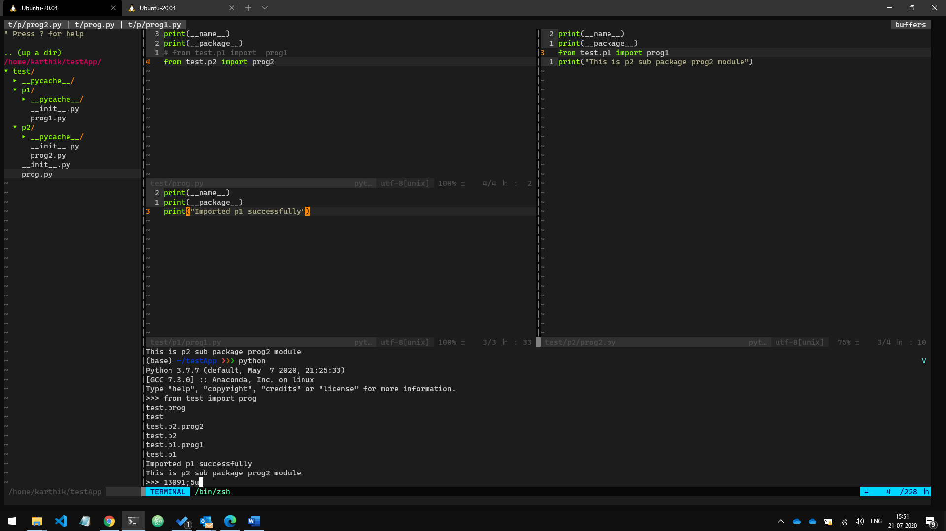

Alternate

Python -m test.prog