Software Requirements
Specification

Bumble BnB

Suhas Voolla
Neel Perumandla
Jayden Park
Rishi Gadiyar
Ronak Reddy
Yash Karandikar

Table of Contents
1. Introduction 1
1.1 Purpose 1
1.2 Scope 1
1.3 Definitions, acronyms, and abbreviations 1
2. Overall description 3
2.1 Product perspective 3
2.2 Product functions 3
2.3 User characteristics 4
2.4 Constraints 4
2.5 Assumptions and dependencies 5
3. Specific requirements 5
3.1 External interface Requirements 5
3.1.1 User interfaces 5
3.1.2 Hardware interfaces 7
3.1.3 Software interfaces 7
3.1.4 Communications interfaces 7
3.2 Functional requirements 7
3.2.1 User Class 1 - The Renter 7
3.2.2 User Class 2 - Home Owner 10
3.2.3 User Class 3 - The Administrator 13
3.3 Non-Functional Requirements 15
4. Prioritization and Release Plan 21
4.1 Choice of prioritization method 21
Appendix I: Release Plan 22

i

1. Introduction

This section gives a scope description and overview of everything included in this SRS document. Also, the purpose for this document is described and a list of abbreviations and definitions is provided.

1.1 Purpose
The purpose of this document is to give a detailed description of the requirements for the “Bumble BnB” (also referred to as BBB) software. The document will contain the functional requirements of the software system, as well as the environmental/design constraints (otherwise described as non-functional requirements) in a detailed manner regarding the Bumble BnB platform. This document is primarily intended for developers to follow as a roadmap when implementing the platform, as well as upper-level managers and clients as a reference point for what to expect. This section will also contain definitions used throughout the document.

1.2 Scope
“Bumble BnB” is a web application (and possibly a mobile application as well), intended to help people find properties to rent for things like vacations, as well as other short-term stays. It also helps property owners, as it’s an easy way to rent out your property in the short term. The application will be free to use, and should be easily accessible via the webpage, as well as a mobile app if that is developed.

Property owners can log in to the website and publish their property to make it available for rent. Owners can add pictures, videos, and list out amenities, room capacity, and any other required details for possible tenants. After, owners can set a rate and location, and publish their property to the site. Once a property is published to the site, an admin will have to manually approve it to be visible to customers to ensure the property is real.

Users can use the database of properties sourced by the owners to swipe through properties, and find one they like, and rent it. All of our information will be located on a centrally located database on the cloud. This includes data like profiles for both owners and users, preferences of a user, and properties they’ve rented before, and much more.

1.3 Definitions, acronyms, and abbreviations

Table
1

-

Definitions

Term | Definition
BBB | BumbleBNB – an app for renters to rent property for the short-term using an innovative swiping mechanic
Renter | Someone who interacts with the BBB platform, for the purpose of temporarily renting a property
Homeowner | Someone who interacts with the BBB platform, for the purpose of renting out a property they own to Renters.
Admin/Administrator | System administrator who is given specific permission for managing and controlling the system (duties involve banning misaligned rental properties, approving properties to be listed on the platform, dealing with customer reviews of properties)
Stakeholder | Any person who has interaction with the system who is not a developer.
DESC | Description
DEP | Dependency
FR | Functional Requirement
GIST | A short, simple description of the concept
METER | The process or device used to establish location on a SCALE
MUST | The minimum level required to avoid failure
PLAN | The level at which good success can be claimed
RAT | Rationale (Reasoning for including something as a functional requirement)
SCALE | The scale of measure used by the requirement
WISH | A desirable level of achievement that may not be attainable through available means

1.5 Overview
The remainder of this document includes three chapters and an appendix. The second chapter provides a detailed explanation of the product and its general scope of functionality. This will also include a basic block diagram to show how all of the high-level services connect, along with text descriptions of the services.
The third chapter provides a detailed description of the functional/non-functional requirements of the software and a description of the different system interfaces.
The fourth chapter deals with the prioritization of the requirements. It includes a motivation for the chosen prioritization methods and discusses why other alternatives were not chosen.
The Appendix at the end of the document includes a release plan for the product, with a timeline, as well as extra diagrams if necessary.

2. Overall description
This section provides a comprehensive overview of the system, detailing its interactions with other systems and its core functionalities. It identifies the various stakeholders, outlining the features available to each. Finally, system constraints and assumptions are presented.

2.1 Product perspective
Our system will primarily consist of a web application, that will be written in a framework that could allow it to be ported to a mobile platform eventually. The web application will have two different interfaces: one for the renters, and one for property owners. For renters, the app will allow them to find properties and rent them out by communicating with property owners. For property owners, the app will allow them to list out their properties for rental, and validate renters to rent their property.
The application will need to interface with a communication platform on the system (usually something like calling, texting, or some kind of IM platform), in order to facilitate contact between the renter and the property owner.
Since our product stores large amounts of data on users as well as listings and bookings, a database will be required for our product. The database will be accessed by and written to by both the renter side and the property owners side. Communication with the database will happen via an API of some sort that’ll communicate through the web.
The web app should be restricted to use as little space in its bundle as possible, to avoid slow loading times. For this case, we will be setting an arbitrary limit of 100 megabytes of JavaScript code to be sent over the browser for every page requested by the user.
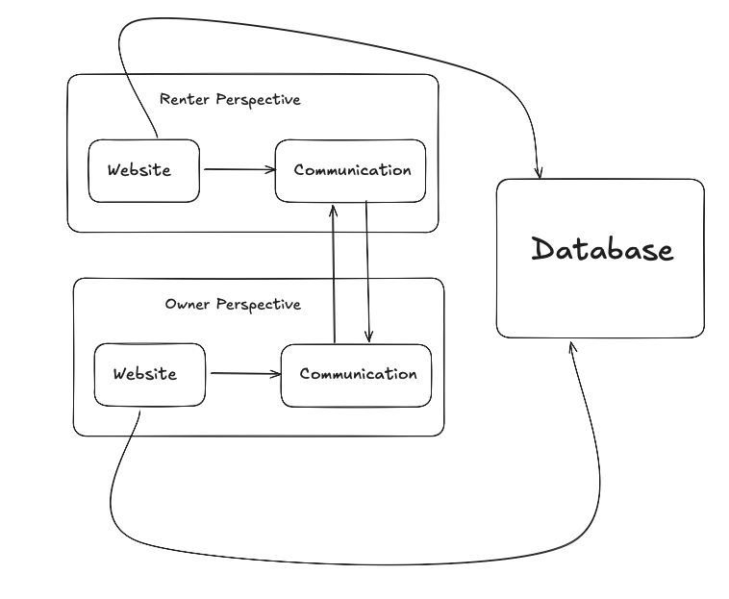
Figure 1 - Overall Block Diagram

2.2 Product functions
Within the web application, users will be able to type in a place where they want to stay, as well as the dates that they would like to stay in that location for. After that, a results page will be pulled up with all available properties in that location, as to which users can filter by price, distance, and other relevant factors.
Search results will be presented as a list of options, originally sorted by price, but users will be able to change the sort when required. The list will come as a set of cards, with each card containing a picture, price, rating, and title. When a user clicks on a card, they can see more details, such as amenities, and place a request to book the property.
For property owners, they are able to create an account, which will take them to their list of properties that they have available. They can then click a button to publish a new property, and this will allow them to enter details such as the price. When users request their property, the homeowner will get information about the user, and they can choose to either approve or reject the request.
Finally, admins will be able to moderate rule-breaking users and fake properties.

2.3 User characteristics
For our product, we have three types of users that will be interacting with the system: people who are looking for a property (renters), people who have properties to rent out (property owners), as well as administrators. All of these users use the system in different manners, so they have different requirements, and no user can be more than 1 type of user at a time (due to system constraints).
Renters will be able to use the web app to search for properties, and submit a request to book a property owner’s property. Renters must be able to search for a property based on locations and dates, and they must be able to filter by more criteria, like zip code and price. After, renters shall be able to look at property details and submit a photo.
Property owners will be able to use the web app to publish their properties at a set rate per night. Once the property is published, they can get renters to sign up to use their property, and owners can approve or deny the request. Once owners approve or deny the request, they shall be able to send a request for payment that the renter should pay.
Administrators interact with the web app to approve new properties to ensure they’re real, and handle reports from owners/renters. Admins shall have the ability to ban both owners and renters from the platform.

2.4 Constraints
The platform is constrained to run only on a web browser. Since there are different form-factors/screen sizes for web browsers, as well as different web browsers with different program implementations, the interface should be responsive and should be able to run on all web browsers.
The application also needs to be consistently connected to the internet in order to run. This is because the application needs to fetch data such as properties and contacts through the database, which will be connected via the internet. Therefore, this makes it crucial that the application always has internet access.
There are also constraints on the platform’s uptime and security, which are detailed in the non-functional requirements sections.

2.5 Assumptions and dependencies
Our primary assumptions about the product is that it’ll always be used on computers that support modern JavaScript, as we will be using modern programming practices to ensure the app is responsive to all users. For older devices, undefined behavior is possible, like parts not loading, thereby making the application not work as intended, or not work at all.
In addition, we will assume that all websites have consistent access to the internet, and a messaging platform. Without the internet, the website would not work at all as the app could no longer quickly fetch updates from the database. In addition, without access to some sort of messaging platform, users could not text property owners to get their property, or vice versa.

3. Specific requirements
This section contains all of the functional and quality requirements of the system. It gives a detailed description of the system and all its features.

3.1 External interface Requirements
This section provides a detailed description of all inputs into and outputs from the system. It also gives a description of the hardware, software and communication interfaces and provides basic prototypes of the user interface.

3.1.1 User interfaces
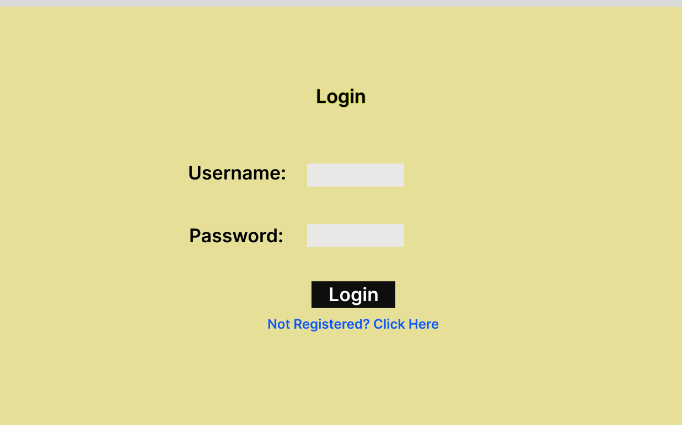
A first-time user of the web application shall see the log-in page when he/she opens the application, see Figure 2. If the user has not registered, he/she shall be able to do that on the log-in page.
Figure 2 - Login Page
A logged-in renter shall be able to see the search page directly when the application is opened, see Figure 3. Here, the renter can search for listings and filter the results. The list view for the results is shown. By default, listings are not filtered. The sorting header allows the user to sort the results according to daily rate, rating in stars, and zip code. Each result item includes information about the listing, including the number of beds, the number of baths, who posted the listing, the location of the listing, and the average rating of the listing.
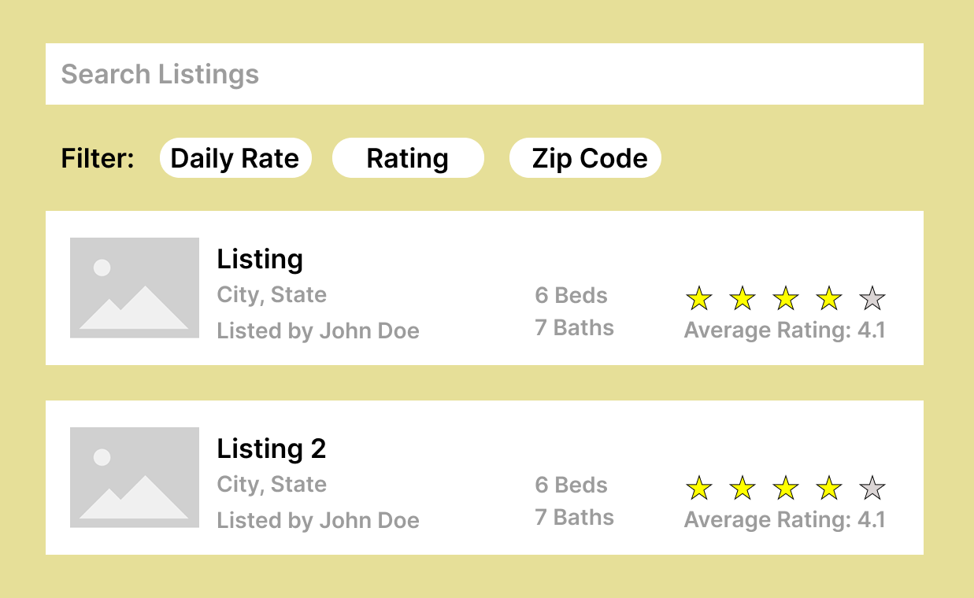
Every user shall have a profile page where they can see and edit their information, see Figure 4.
Figure 3
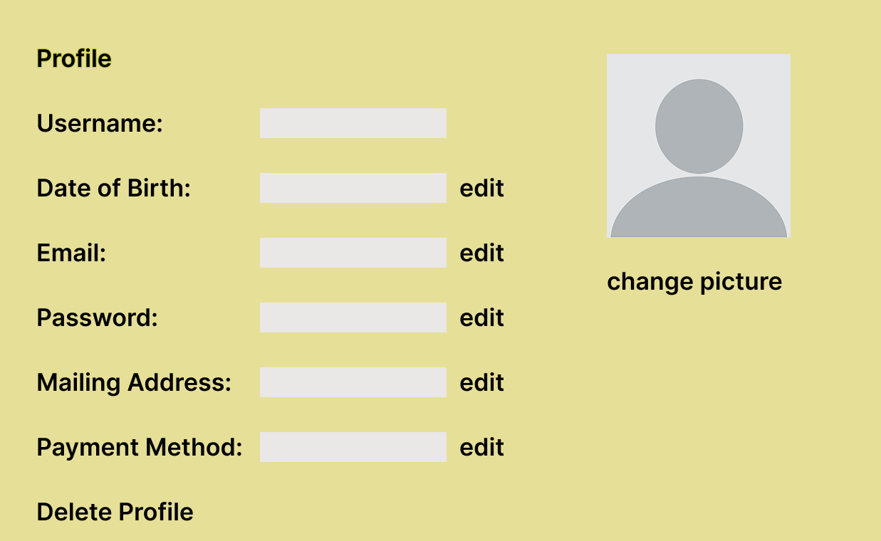
When a listing in the list is pressed, it opens another view which provides a more detailed description of the listing, pictures of the listing, the comments, and the average rating, see Figure 5.
Figure 4
When posting a listing, the homeowner needs to input the number of beds, the number of baths, the address, and pictures of the listing, as seen in Figure 6.
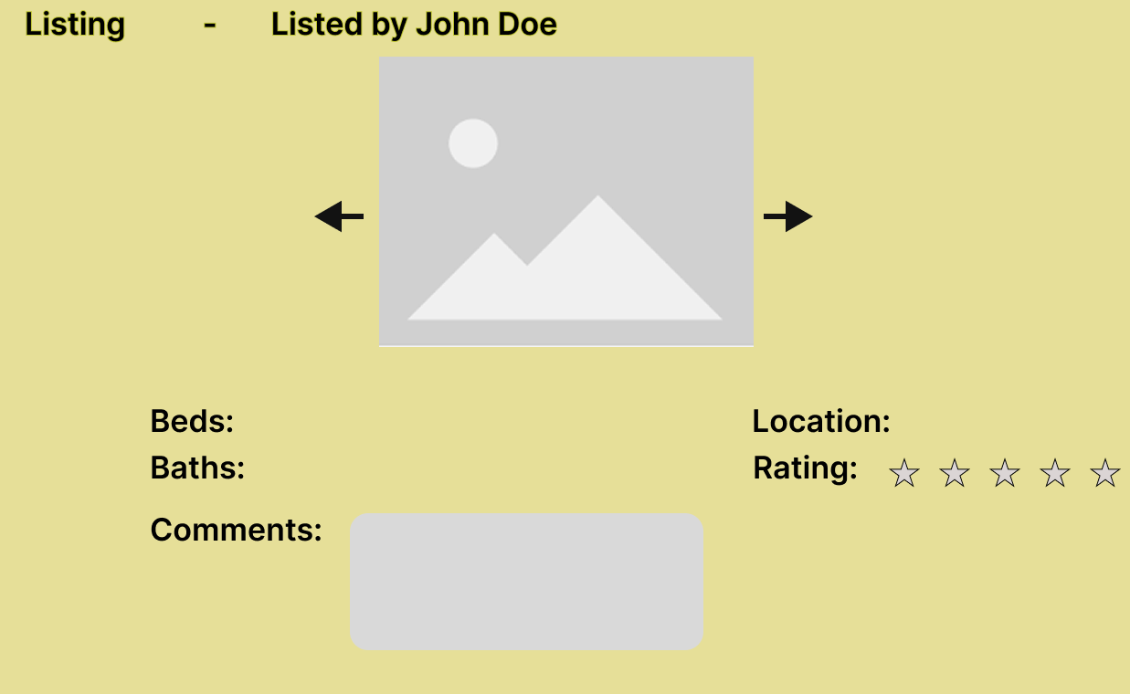
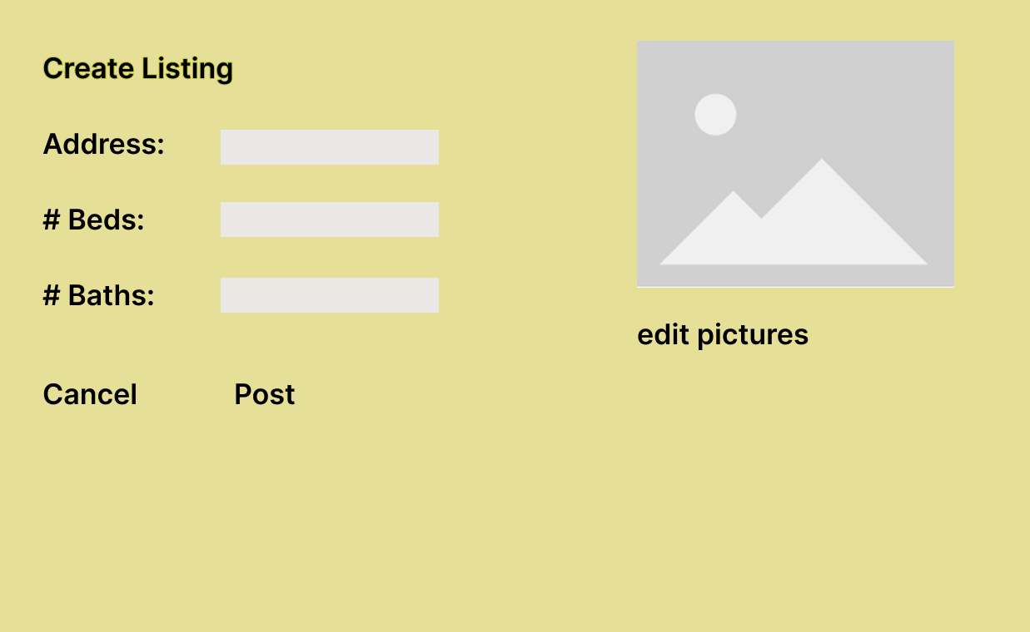
Figure 5
Figure 6
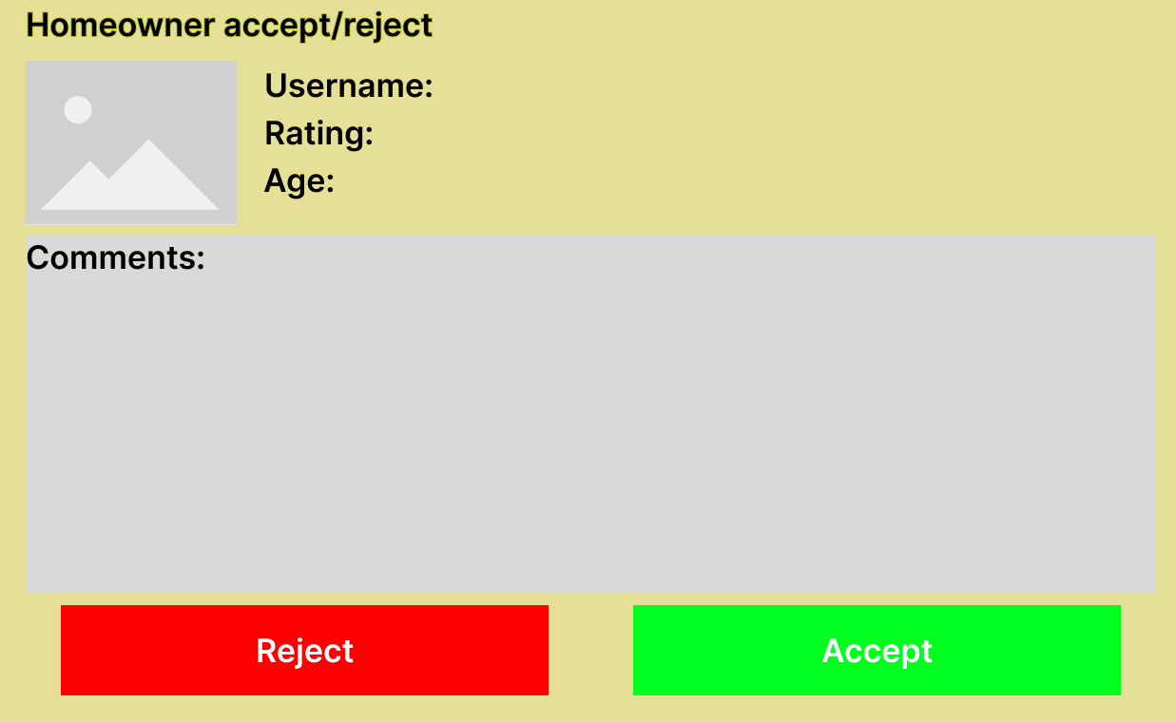
When a renter applies to rent a property, the homeowner can either accept or reject a renter, see Figure 7. This screen displays information about the renter, including their profile picture, name, age, and the renter’s average rating. The screen also displays any comments that previous homeowners have left regarding the renter.
Figure 7

3.1.2 Hardware interfaces
Since the web application doesn’t have any designated hardware, it does not have any direct hardware interfaces. The hardware connection to the web server is managed by the web browser.

3.1.3 Software interfaces
The communication between the database and the web application consists of operations concerning both reading and modifying the data.

3.1.4 Communications interfaces
The communication between the different parts of the system is important since they depend on each other. However, in what way the communication is achieved is not important for the system and is therefore handled by the underlying operating systems and web browsers for the web application.

3.2 Functional requirements
This section includes the requirements that specify all the fundamental actions of the software system.

3.2.1 User Class 1 - The Renter
3.2.1.1 Functional requirement 1.1

ID: FR1
TITLE: Open the Web Application
DESC: A renter shall be able to open the web application through a URL on their browser.
RAT: In order for a renter to open the web application.
DEP: None
3.2.1.2 Functional requirement 1.2
ID: FR2
TITLE: Register Renter Account
DESC: A renter shall be able to create an account by providing their first name, last name, middle initial (if any), date of birth, mailing address, email address, driver's license and state, and default credit card information. The renter must also select a username and a password to create the account.
RAT: In order for a renter to store their information for future bookings and to track their rental history.
DEP: FR1
3.2.1.3 Functional requirement 1.3
ID: FR3
TITLE: Log into Renter Account
DESC: A registered renter shall be able to log into their account using their chosen username and password.
RAT: In order for a renter to access account-specific functions like updating information, booking with saved details, or canceling a reservation.
DEP: FR2
3.2.1.4 Functional requirement 1.4
ID: FR4
TITLE: Manage Renter Information
DESC: A logged-in renter shall be able to manage their information.
RAT: In order for a renter to keep their personal and payment information up-to-date.
DEP: FR3
Scenario: Edit Renter Information
Given the renter is logged-in, the renter shall be able to edit all of their information except for their username. This includes adding different credit cards to their account.
Scenario: Delete Renter Account
Given the renter is logged-in, the renter shall be able to delete their account, removing their information from the system’s database.

3.2.1.5 Functional requirement 1.5
ID: FR5
TITLE: Search for a Property
DESC: A renter shall be able to search for a rental by entering the destination, check-in date, check-out date, and the number of bedrooms needed. The system will then display all available rental properties that match the criteria.
RAT: In order for a renter to find rental properties that meet their specific needs for location, dates, and size.
DEP: FR1
3.2.1.6 Functional requirement 1.6
ID: FR6
TITLE: Sort Property Listings
DESC: After searching for a property, a renter shall be able to reorder the displayed list of available properties by the daily rate, the zip code, or by the current rating (# of stars).
RAT: In order for a renter to more easily compare the search results based on their priorities.
DEP: FR5
3.2.1.7 Functional requirement 1.7
ID: FR7
TITLE: Rent a Property
DESC: After selecting a property, a logged-in renter will be shown the total price, including a 12% tax. The renter can book the property by either logging in or by entering their name and credit card details. The system shall then produce an invoice with a reservation number.
RAT: In order for a renter to complete the booking process for a selected property.
DEP: FR3, FR5
3.2.1.8 Functional requirement 1.8
ID: FR8
TITLE: Cancel a Property Reservation
DESC: A logged-in renter shall be able to cancel a reservation by providing the reservation number. A reservation can only be canceled if the current date is at least 5 days before the rental check-in date. The renter will be refunded the total amount to their credit card, minus a 3% cancellation fee. If the renter cancels within 5 days of the reservation, they shall not receive a refund.
RAT: In order for a renter to cancel their booking if their plans change.
DEP: FR3, FR7
3.2.1.9 Functional requirement 1.9
ID: FR9
TITLE: Rate a Rented Property
DESC: A logged-in renter shall be able to provide feedback on a property they have rented by using the reservation number. The feedback shall consist of textual comments and a score from 1-10 stars. This rating can be anonymous if the renter wants.
RAT: In order for a renter to share their experience with other potential renters and the property owner.
DEP: FR3, FR7

3.2.2 User Class 2 - Home Owner
3.2.2.1 Functional requirement 2.1
ID: FR10
TITLE: Homeowner Registration
DESC: Given that a homeowner has opened the web application, the homeowner shall be able to register through the sign-up page. The homeowner must provide their first name, last name, middle initial (if any), mailing address, email address, driver's license, and state. The homeowner must also select a unique username and a password to create the account.
RAT: In order for a homeowner to register and use the application.
DEP: FR1
3.2.2.2 Functional requirement 2.2
ID: FR11
TITLE: Homeowner Login
DESC: Given that a homeowner has registered, the homeowner shall be able to log in to the web application using their email and password.
RAT: In order for a homeowner to access their account and manage listings.
DEP: FR1, FR10
3.2.2.3 Functional requirement 2.3
ID: FR12
TITLE: Update Homeowner Information
DESC: Given that a homeowner is logged in, the homeowner shall be able to update their personal information, such as email or password. The homeowner shall not be able to change their user name.
RAT: To allow homeowners to maintain accurate account details.
DEP: FR11
3.2.2.4 Functional requirement 2.4
ID: FR13
TITLE: Delete Homeowner Account
DESC: Given that a homeowner is logged in, the homeowner shall be able to delete their account. All associated data will be removed.
RAT: To provide homeowners with control over their data and account longevity.
DEP: FR11
3.2.2.5 Functional requirement 2.5
ID: FR14
TITLE: Create Property Listing
DESC: Given that a homeowner is logged in, the homeowner shall be able to create a new property listing by providing details such as address, features, photos, and price.
RAT: To enable homeowners to offer their properties for rent.
DEP: FR11
3.2.2.6 Functional requirement 2.6
ID: FR15
TITLE: Upload Listing Pictures
DESC: Given that a homeowner is creating or editing a property listing, the homeowner shall be able to upload multiple pictures associated with the property.
RAT: To provide visual information for potential renters.
DEP: FR11, FR14
3.2.2.7 Functional requirement 2.7
ID: FR16
TITLE: Accept Renter Application
DESC: Given that a homeowner has received a renter application for their property, the homeowner shall be able to review the application and accept the renter.
RAT: To allow homeowners to manage and approve renters for their properties.
DEP: FR7, FR14
3.2.2.8 Functional requirement 2.8
ID: FR17
TITLE: Reject Renter Application
DESC: Given that a homeowner has received a renter application for their property, the homeowner shall be able to review the application and reject the renter.
RAT: To allow homeowners to manage and decline renters for their properties.
DEP: FR7, FR14
3.2.2.9 Functional requirement 2.9
ID: FR18
TITLE: Manage Listings
DESC: A logged-in homeowner shall be able to manage their property listings, including updating and deleting them.
RAT: To allow a homeowner to maintain appropriate and current listings.
DEP: FR11, FR14
Scenario: Edit Listing Information
Given the homeowner is logged-in, the homeowner shall be able to edit all of the information of any of their listings.
Scenario: Delete Listing
Given the homeowner is logged-in, the homeowner shall be able to delete any of their listings.

3.2.2.10 Functional Requirement 2.10
ID: FR19
TITLE: Leave Renter Review
DESC: A homeowner shall be able to leave a review of the renter based on the condition of the home after the renter used it.
RAT: To allow a homeowner inform other homeowners of the renter’s reputation
DEP: FR11

3.2.3 User Class 3 - The Administrator
3.2.3.1 Functional requirement 3.1
ID: FR20
TITLE: Log into Administrator Account
DESC: A registered administrator shall be able to log into their account using their chosen username and password.
RAT: In order for an administrator to log in to the web-portal.
DEP: FR1
3.2.3.2 Functional requirement 3.2
ID: FR21
TITLE: Log into a Sample User Account View
DESC: A registered administrator shall be able to switch into a sample user account view.
RAT: In order for an administrator to access and view through a sample user’s account.
DEP: FR17
Scenario: Enter Renter View
Given the administrator is logged in, the administrator shall be able to see the renter’s perspective of the website by switching their current viewing mode.
Scenario: Enter Homeowner View
Given the administrator is logged in, the administrator shall be able to see the homeowner’s perspective of the website by switching their current viewing mode.

3.2.3.3 Functional requirement 3.3
ID: FR22
TITLE: Manage Renter Accounts
DESC: A registered administrator shall be able to edit existing renter accounts.
RAT: In order for an administrator to manage renter accounts.
DEP: FR17
Scenario: Edit Renter Account
Given the administrator is logged in, the administrator shall be able to edit a renter’s account info.
Scenario: Delete Renter Account
Given the administrator is logged in, the administrator shall be able to delete a renter’s account.
3.2.3.4 Functional requirement 3.4
ID: FR23
TITLE: Manage Homeowner Accounts
DESC: A registered administrator shall be able to edit existing homeowner accounts.
RAT: In order for an administrator to manage homeowner accounts.
DEP: FR17
Scenario: Edit Homeowner Account
Given the administrator is logged in, the administrator shall be able to edit a homeowner’s account info.
Scenario: Delete Homeowner Account
Given the administrator is logged in, the administrator shall be able to delete a homeowner’s account.
3.2.3.5 Functional requirement 3.5
ID: FR24
TITLE: Manage Listings
DESC: A registered administrator shall be able to edit existing listings
RAT: In order for an administrator to manage listings.
DEP: FR17
Scenario: Edit Listing
Given the administrator is logged in, the administrator shall be able to edit a listing’s info.
Scenario: Delete Listing
Given the administrator is logged in, the administrator shall be able to delete a listing.
3.2.3.6 Functional requirement 3.6
ID: FR25
TITLE: Delete Comments and Ratings
DESC: A registered administrator shall be able to delete comments and ratings associated with listings.
RAT: In order for an administrator to manage comments and ratings.
DEP: FR17

3.3 Non-Functional Requirements
3.3.1 System Availability
ID: QR1
TAG: SystemAvailability
GIST: The uptime of the web application.
SCALE: The percentage of time the website is operational over a one-year period.
METER: Uptime measured by an external monitoring service.
MUST: The system must be available 98% of the time.
PLAN: The system will be available 99.5% of the time.
WISH: The system will have 99.9% availability.
3.3.2 Platform Constraint
ID: QR2
TAG: Portability
GIST: The application is limited to a web platform.
DESC: The application must be designed and implemented to run exclusively as a website accessible via a web browser.
3.3.3 Internet Connectivity Requirement
ID: QR3
TAG: OperationalConstraint
GIST: The application requires an internet connection.
DESC: The application must be connected to the internet to access property details, process bookings, and perform all core functions.
3.3.4 Booking Effectiveness
ID: QR4
TAG: TransactionReliability
GIST: The success rate of the booking function.
SCALE: The percentage of booking attempts that complete successfully.
METER: Measured during system testing by simulating 10,000 valid booking requests.
MUST: 99.9% of booking attempts must be completed successfully.
PLAN: 99.99% of booking attempts will be completed successfully.
WISH: 100% of booking attempts will be completed successfully.
3.3.5 Concurrency Control
ID: QR5
TAG: ConcurrencyControl
GIST: Prevention of double-booking a property.
SCALE: The rate of failure to prevent two users from booking the same property for the same overlapping time period.
METER: Measured during stress tests simulating 1,000 simultaneous booking attempts on a single property.
MUST: The system must have a 0% failure rate (i.e., never allow a double-booking).
PLAN: The system will have a 0% failure rate.
WISH: The system will have a 0% failure rate.
3.3.6 Data Accuracy
ID: QR6
TAG: DataAccuracy
GIST: The accuracy of displayed property information.
SCALE: The percentage of property listings free of critical errors (e.g., wrong address, price).
METER: Measured by quarterly audits of a random 10% sample of listings.
MUST: The data must be 99.5% accurate.
PLAN: The data will be 99.9% accurate.
WISH: The data will be 100% accurate.
3.3.7 Password Security
ID: QR7
TAG: DataSecurity
GIST: Protection of user account passwords.
DESC: All user passwords must be salted and hashed using an encryption algorithm before being stored in the database.
3.3.8 Credit Card Security
ID: QR8
TAG: DataSecurity
GIST: Protection of credit card information.
DESC: All credit card information must be encrypted both in transit (using TLS 1.2 or higher) and at rest (using AES-256) to ensure it is protected from unauthorized access.

3.3.9 Invalid Renter Login
ID: QR9
TAG: AccessControl
GIST: Handling login attempts for non-existent renter accounts.
DESC: If a user attempts to log into a renter account that does not exist, the login must fail and a notification must be displayed.
3.3.10 Invalid Homeowner Login
ID: QR10
TAG: AccessControl
GIST: Handling login attempts for non-existent homeowner accounts.
DESC: If a user attempts to log into a homeowner account that does not exist, the login must fail and a notification must be displayed.
3.3.11 Invalid Admin Login
ID: QR11
TAG: AccessControl
GIST: Handling login attempts for non-existent admin accounts.
DESC: If a user attempts to log into an admin account that does not exist, the login must fail and a notification must be displayed.
3.3.12 Renter Account Lockout
ID: QR12
TAG: AccessControl
GIST: Temporary lockout for renter accounts after failed logins.
DESC: After three consecutive failed login attempts for a valid renter account, that account must be temporarily locked for 15 minutes.

3.3.13 Homeowner Account Lockout
ID: QR13
TAG: AccessControl
GIST: Temporary lockout for homeowner accounts after failed logins.
DESC: After three consecutive failed login attempts for a valid homeowner account, that account must be temporarily locked for 15 minutes.
3.3.14 Admin Account Lockout
ID: QR14
TAG: AccessControl
GIST: Temporary lockout for admin accounts after failed logins.
DESC: After three consecutive failed login attempts for a valid admin account, that account must be temporarily locked for 15 minutes.
3.3.15 Singular Account Role
ID: QR15
TAG: AccountIntegrity
GIST: An account must have a single, exclusive role.
DESC: A user account must be designated as either a "renter" or a "homeowner" and cannot be both simultaneously.
3.3.16 Renter Username Uniqueness
ID: QR16
TAG: Uniqueness
GIST: Renter usernames must be unique.
DESC: The system must enforce that no two renter accounts can have the same username.

3.3.17 Homeowner Username Uniqueness
ID: QR17
TAG: Uniqueness
GIST: Homeowner usernames must be unique.
DESC: The system must enforce that no two homeowner accounts can have the same username.
3.3.18 Admin Username Uniqueness
ID: QR18
TAG: Uniqueness
GIST: Admin usernames must be unique.
DESC: The system must enforce that no two admin accounts can have the same username.
3.3.19 System Modularity
ID: QR19
TAG: Maintainability
GIST: The application architecture should be modular.
DESC: The application must be built with a modular architecture, allowing for new features to be developed and integrated with minimal impact on existing functionality.
3.3.20 Review Content Moderation
ID: QR20
TAG: ContentModeration
GIST: Policy for user-submitted review content.
DESC: The system must provide a mechanism to prevent or remove user-submitted property reviews that contain hateful or abusive comments.

4. Prioritization and Release Plan
In order to get a view of how to divide the requirements into different releases and what requirements should be included in which release, a prioritization of the requirements is needed. This section discusses the choice of prioritization methods and gives a suggestion of how the release plan for these requirements could look like.

4.1 Choice of prioritization method
When prioritizing the requirements the ten most important ones were picked out first. This was done with a simple “1 to 10” ranking method, with one being “not important” and ten “very important”. Based on the elicitation meetings, and the perceived ideas of what was important to the different stakeholders, a number was set for each requirement. The numbers were then summed up for each requirement and the ten with the highest score were chosen to be prioritized with the cost value approach. The results, which are red-marked, can be seen in Appendix I and as shown, it turned out to be five functional requirements and five quality requirements. These requirements were then prioritized according to the cost value approach and the results can be viewed under Appendix II.
The remaining requirements were prioritized according to the “Five-Way Priority Scheme” as shown in Appendix III. This method was chosen since it gives the different stakeholders the same importance and has a wide enough range for determining which requirement is more important than the other [3]. However, in this prioritization process, the development team was not included as a stakeholder since the different features were not considered to be as important to them as for the other stakeholders.
Other methods for prioritization, such as the hundred-dollar test and the yes-no vote, were also considered. The hundred-dollar test is quite similar to the five-way priority scheme, since it also gives a wide range for ranking the requirements. However, it is more easily misused since someone could save all their money and put them on a requirement that they think is very important [3]. Others might not agree that this requirement is important but it might still get the most votes since one person cared about it [3].
The yes-no vote method might be fairly simple to carry out, however the range is too narrow. For instance, if two requirements are not very important it would be hard to determine which of those requirements that is more important than the other [3].
In conclusion, weighing the disadvantages and advantages of these methods against each other lead us to choose the five-way priority scheme.
4.2 Release Plan
The requirements were grouped into three releases based on priority and dependency. Each release was designed to produce a fully functional application.
- Release 1 (Foundation and Core Features): Includes requirements essential for making the system usable, such as account creation, login, property search, booking, and basic administrative controls. Security and availability requirements are also integrated from the beginning.
- Release 2 (Enhancements and Value-Adds): Includes requirements that make the system more attractive but are not strictly necessary for core functionality, such as advanced search sorting, richer listing management features, and additional moderation capabilities.
- Release 3 (Optional and Stretch Features): Contains requirements that may be discarded in case of delays or budget overruns, such as expanded content moderation, more advanced reporting

Appendix I: Release Plan
Req ID | Dependencies | Description | Motivation | Release | Duration (est.)
FR1 | – | Open web application | Fundamental access point to system. | 1 | 1
FR2 | FR1 | Register renter account | Enables renters to use core booking features. | 1 | 3
FR3 | FR2 | Log into renter account | Required for renters to access and manage bookings. | 1 | 2
FR4 | FR3 | Manage renter information | Keeps user data current. | 1 | 2
FR5 | FR1 | Search for property | Core function to browse rentals. | 1 | 4
FR6 | FR5 | Sort property listings | Helps renters organize results. | 2 | 2
FR7 | FR3, FR5 | Rent a property | Core functionality to complete bookings. | 1 | 5
FR8 | FR3, FR7 | Cancel reservation | Enhances flexibility for renters. | 2 | 2
FR9 | FR3, FR7 | Rate rented property | Adds community feedback value. | 2 | 2
FR10 | FR1 | Register homeowner account | Essential for property supply. | 1 | 3
FR11 | FR10 | Homeowner login | Required for listing management. | 1 | 2
FR12 | FR11 | Update homeowner information | Keeps account details accurate. | 2 | 1
FR13 | FR11 | Delete homeowner account | Provides homeowners with account control. | 3 | 1
FR14 | FR11 | Create property listing | Enables rentals to exist in the system. | 1 | 4
FR15 | FR14 | Upload listing pictures | Improves listing attractiveness. | 2 | 2
FR16 | FR7, FR14 | Accept renter application | Critical for property management. | 1 | 3
FR17 | FR7, FR14 | Reject renter application | Complements acceptance process. | 1 | 2
FR18 | FR11, FR14 | Manage listings | Core functionality for homeowners. | 1 | 4
FR19 | FR11, FR14, FR16 | Leave a review about the renter | Improves homeowners ability to evaluate potential renters
FR20 | FR1 | Log into admin account | Required for system oversight. | 1 | 2
FR21 | FR20 | Log into sample renter/homeowner view | Supports admin monitoring. | 2 | 3
FR22 | FR20 | Manage renter accounts | Core admin function. | 1 | 2
FR23 | FR20 | Manage homeowner accounts | Core admin function. | 1 | 2
FR24 | FR20 | Manage listings (admin) | Ensures listings are appropriate. | 1 | 3
FR25 | FR20 | Delete comments/ratings | Content moderation. | 2 | 2
QR1 | – | System availability (≥98%) | Ensures users can access service. | 1 | Continuous
QR2 | – | Platform = Web only | Architectural constraint. | 1 | Continuous
QR3 | – | Internet connectivity required | Core operational requirement. | 1 | Continuous
QR4 | – | Booking effectiveness ≥99.9% | Prevents booking failures. | 1 | Continuous
QR5 | – | Prevent double bookings | Ensures rental integrity. | 1 | Continuous
QR6 | – | Data accuracy ≥99.5% | Protects user trust. | 2 | Continuous
QR7–QR8 | – | Password & credit card encryption | Ensures security of sensitive data. | 1 | Continuous
QR9–QR14 | FR2, FR10, FR19 | Invalid login & account lockout protections | Security for all user classes. | 1 | 2
QR15–QR18 | – | Account role & username uniqueness | Prevents identity conflicts. | 1 | 2
QR19 | – | Modular architecture | Ensures maintainability. | 2 | Continuous
QR20 | – | Review content moderation | Protects from abuse. | 3 | Continuous

