Violent words in news articles

Here, we visualize and analyze the percentage of violent words occurring in different types of news articles. Our hypothesis is that articles about presidential debates show a similar percentage to articles about violent events such as the Syrian War and Hurricane Sandy, but higher ratios than more neutral articles covering the California Drought or the Nobel Peace Prize.

The plot below shows the percentage for each individual article, grouped by type:

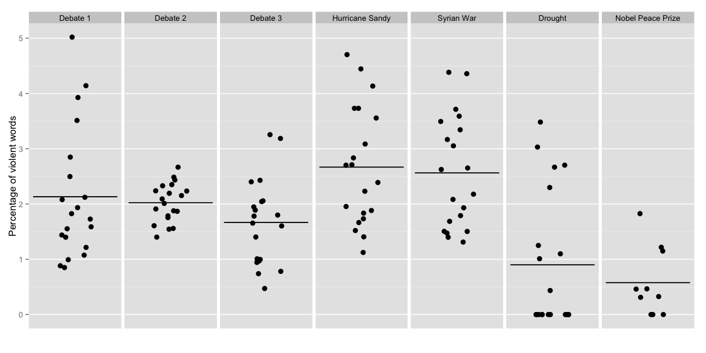

|  |  |  |  |
| --- | --- | --- | --- |
| article | m | sd | n |
| Debate 1 | 2.131 | 1.182 | 20 |
| Debate 2 | 2.025 | 0.35 | 20 |
| Debate 3 | 1.668 | 0.776 | 20 |
| Hurricane Sandy | 2.669 | 1.075 | 20 |
| Syrian War | 2.562 | 1.013 | 20 |
| Drought | 0.899 | 1.232 | 20 |
| Nobel Peace Prize | 0.576 | 0.62 | 10 |

Let's do some stats: Linear Regression with Debate 1 as control level:

|  |  |  |  |  |
| --- | --- | --- | --- | --- |
| term | estimate | std.error | statistic | p.value |
| Debate 1 (Intercept) | 2.131 | 0.2154 | 9.897 | 0 |
| Debate 2 | -0.1066 | 0.3045 | -0.3502 | 0.7268 |
| Debate 3 | -0.4634 | 0.3045 | -1.522 | 0.1307 |
| Hurricane Sandy | 0.5373 | 0.3045 | 1.764 | 0.0802 |
| Syrian War | 0.4305 | 0.3045 | 1.413 | 0.16 |
| Drought | -1.233 | 0.3045 | -4.047 | 9e-05 |
| Nobel Peace Prize | -1.556 | 0.373 | -4.171 | 6e-05 |

Dependent variable:

violent_ratio

articleDebate 2

-0.107

(0.305)

articleDebate 3

-0.463

(0.305)

articleHurricane Sandy

0.537*

(0.305)

articleSyrian War

0.430

(0.305)

articleDrought

-1.233***

(0.305)

articleNobel Peace Prize

-1.556***

(0.373)

Constant

2.131***

(0.215)

Observations

130

R2

0.347

Adjusted R2

0.315

Residual Std. Error

0.963 (df = 123)

F Statistic

10.888*** (df = 6; 123)

Note:

*p<0.1;* ***p<0.05;*** p<0.01

stargazer(mod)

% Table created by stargazer v.5.2 by Marek Hlavac, Harvard University. E-mail: hlavac at fas.harvard.edu % Date and time: Mon, Aug 17, 2015 - 15:49:46