Visualizing the survey data

Here is an overview of the questions:

|  |  |
| --- | --- |
| code | text |
| Q1 | Who won last night’s debate |
| Q2 | How confident are you about this? |
| Q3 | According to the polls, how much of a lead did the Candidate (you selected) have after the debate? |
| Q4 | Who receives more votes on election day? |
| Q5 | How confident are you about this? |
| Q6 | How many votes does the winner receive (than the loser)? |
| Q7 | What do you think Candidate A’s political affiliation is? |
| Q9 | Who would you vote for? |

## Who won the debate?

Let's start with Question 1 and 2, who the winner of the debate was:

|  |  |  |  |
| --- | --- | --- | --- |
| Candidate | No Violence | Weak Violence | Strong Violence |
| 1 | 0.429 | 0.792 | 0.912 |
| 2 | 0.571 | 0.208 | 0.088 |

The more violent language, the clearer the winner. In control condition, basically 50/50.

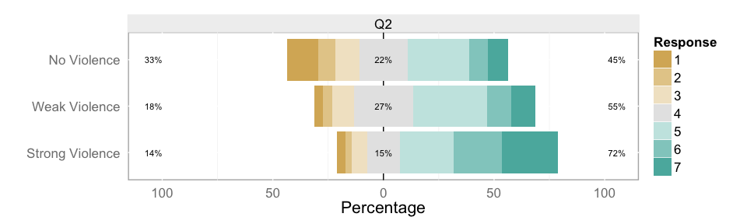

Also more confidence in violent conditions.

We can also try to weigh the votes (see Fausey&Matlock paper). TO BE DONE

## Lead of selected candidate at polls

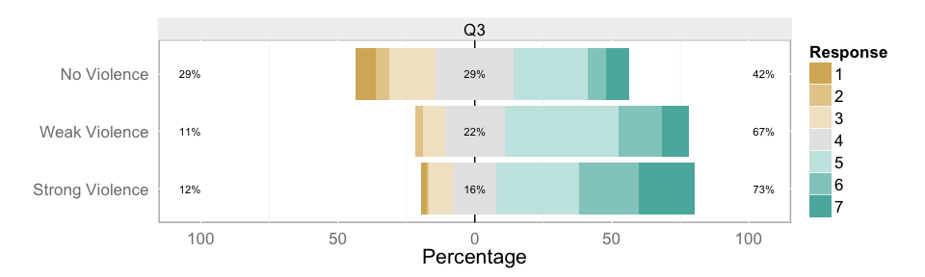

## Election: Who wins the election by how many votes?

Same result as with debate (to be expected). More violence leads to more Candidate 1 selections.

|  |  |  |  |
| --- | --- | --- | --- |
| Candidate | No Violence | Weak Violence | Strong Violence |
| 1 | 0.479 | 0.743 | 0.873 |
| 2 | 0.521 | 0.257 | 0.127 |

Confidence?

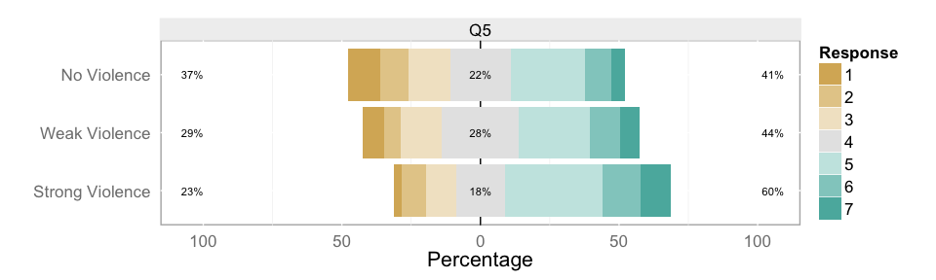

Margin of victory:

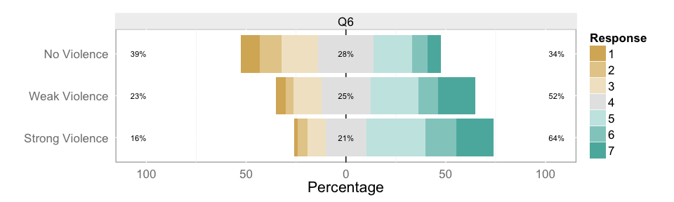

## Political Affiliation

What political affiliation does Candidate A have:

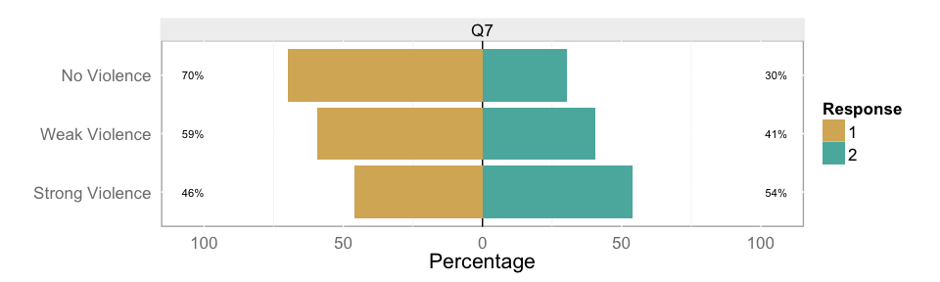

## Who would you vote for

|  |  |  |  |
| --- | --- | --- | --- |
| Candidate | No Violence | Weak Violence | Strong Violence |
| 1 | 0.227 | 0.564 | 0.696 |
| 2 | 0.773 | 0.436 | 0.304 |

