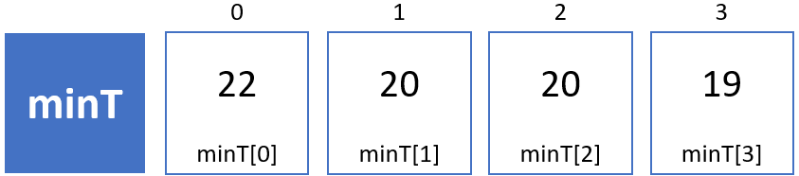

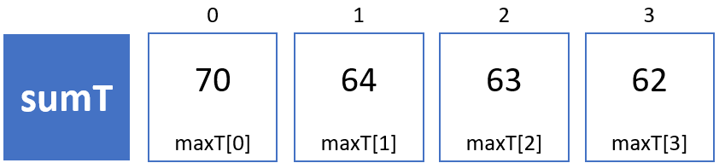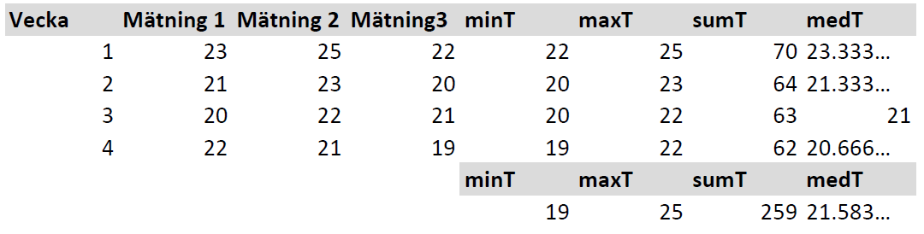



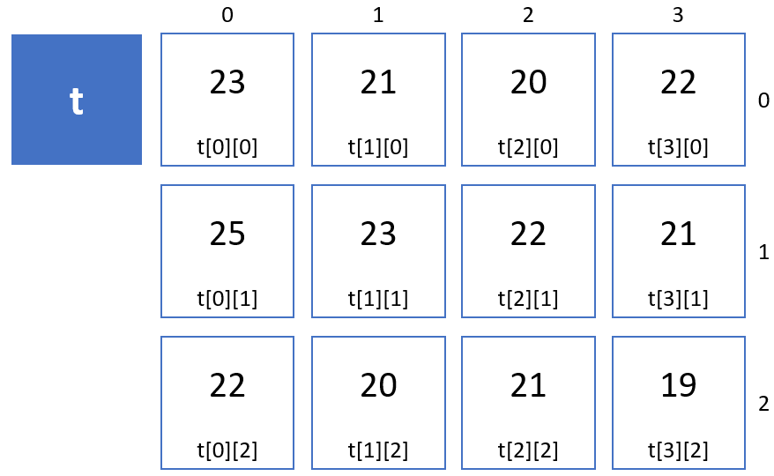

**double** minTemp = 19.0;  
**double** maxTemp = 25.0;  
**double** sumTemp = 259.0;  
**double** medelTemp = 21.58333…;