Alumni Project Assignment 1

IT7320 Development and Testing of Software

Hamish RALFE - DYLAN TILLER - Luke Hamer

2017

Contents

Project Description 2

Project Development Plan 2

Project Requirements 2

Project Tools 2

Screenshots and Descriptions 3

First Commit 3

Package Explorer showing the project, Git repository, and the history of commits 3

Local repository linked to the remote repository 4

Importing the working project from the GitHub to Eclipse 4

Conflicting Commits 5

Class Diagram 7

Appendices 8

Appendix A 8

# Project Description

This project report details our development of the Alumni application. It consists of a Project plan, Requirements, Tools, Screen shots and descriptions of development processes in Eclipse, Git and Github, and lastly a class diagram.

This Alumni application was developed to meet the need of Weltec for an application which student and administrator users can use to store personal, contact and academic data. The users also need to be able to search for student and they can edit the data to allow for maintenance and updates to the data stored in the MYSQL database.

The solution to this need was to develop the program in Java and to store the data in a MYSQL database. The developed application meets the functionality requirements and can be expanded if required to store and display new information.

# Project Development Plan

Refer to Appendix A

# Project Requirements

The requirements for this project were found by analysis by the Project Team on Weltec needs and by interviewing three students from Weltec on what would be important to them in a simple Alumni application. The requirements chosen were as follows:

1. Database storage of student details
2. Application front end for input and update of student details
3. Student details stored are
   1. Student ID
   2. First Name
   3. Last Name
   4. Email address
   5. Course Studied

# Project Tools

The project used common tools for software development. They were as following:

* Eclipse Oxygen with Window Builder extension
* Git for Eclipse
* Github
* MySQL

# Screenshots and Descriptions

The following screenshots and descriptions document our completion of the project and assignment requirements.

### First Commit

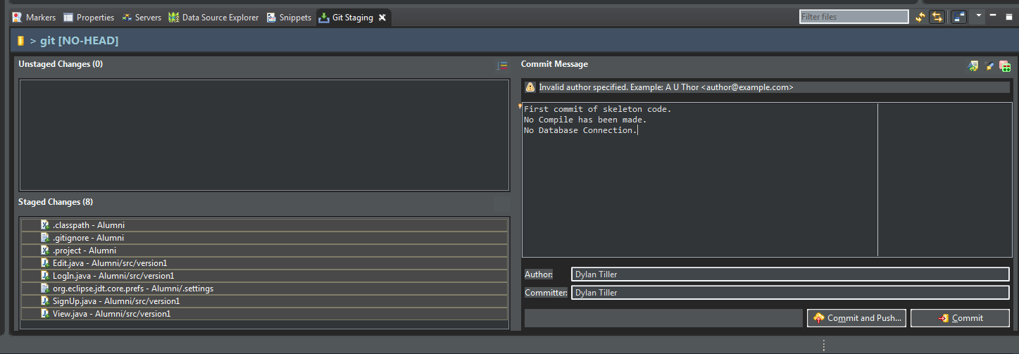

Figure 1: Dylan creating first commit of Skeleton code

### Package Explorer showing the project, Git repository, and the history of commits

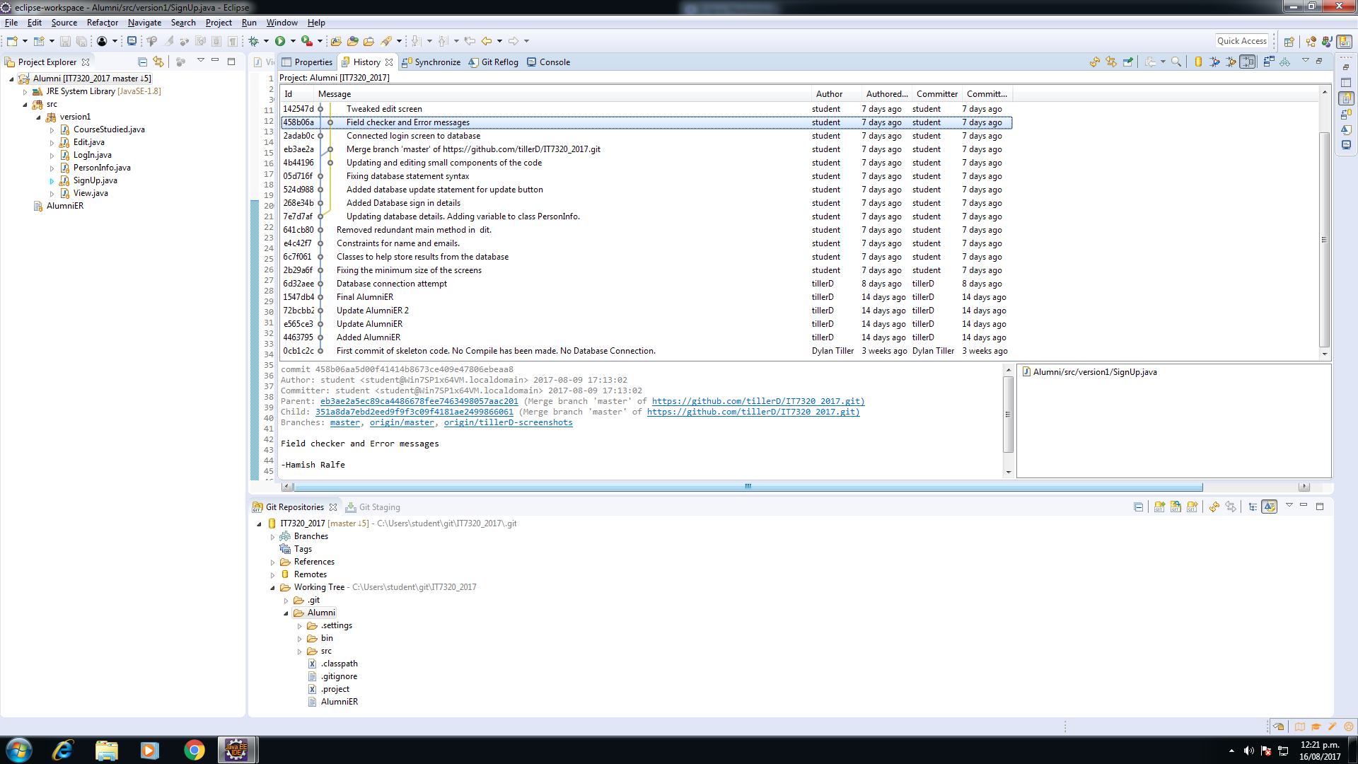

Figure 2: View of almost complete project showing the Project classes in Package Explorer, the GIt repository and the history of commits.

### Local repository linked to the remote repository

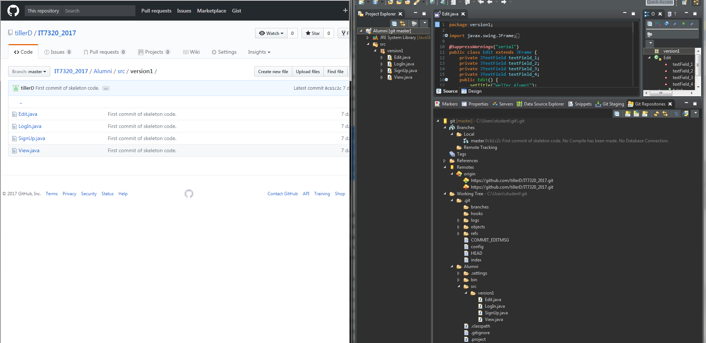

Figure 3: View of Github beside Eclipse Git, the connection between both has been made. A Push Branch to the upstream procedure was just performed to record the changes in the remote repository.

### Importing the working project from the GitHub to Eclipse

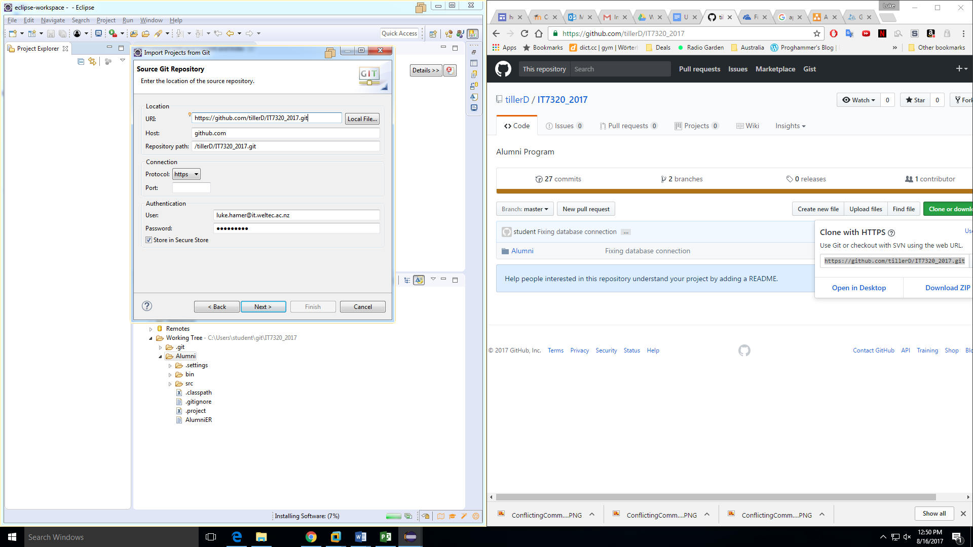

Figure 4: Importing using URI from GitHub

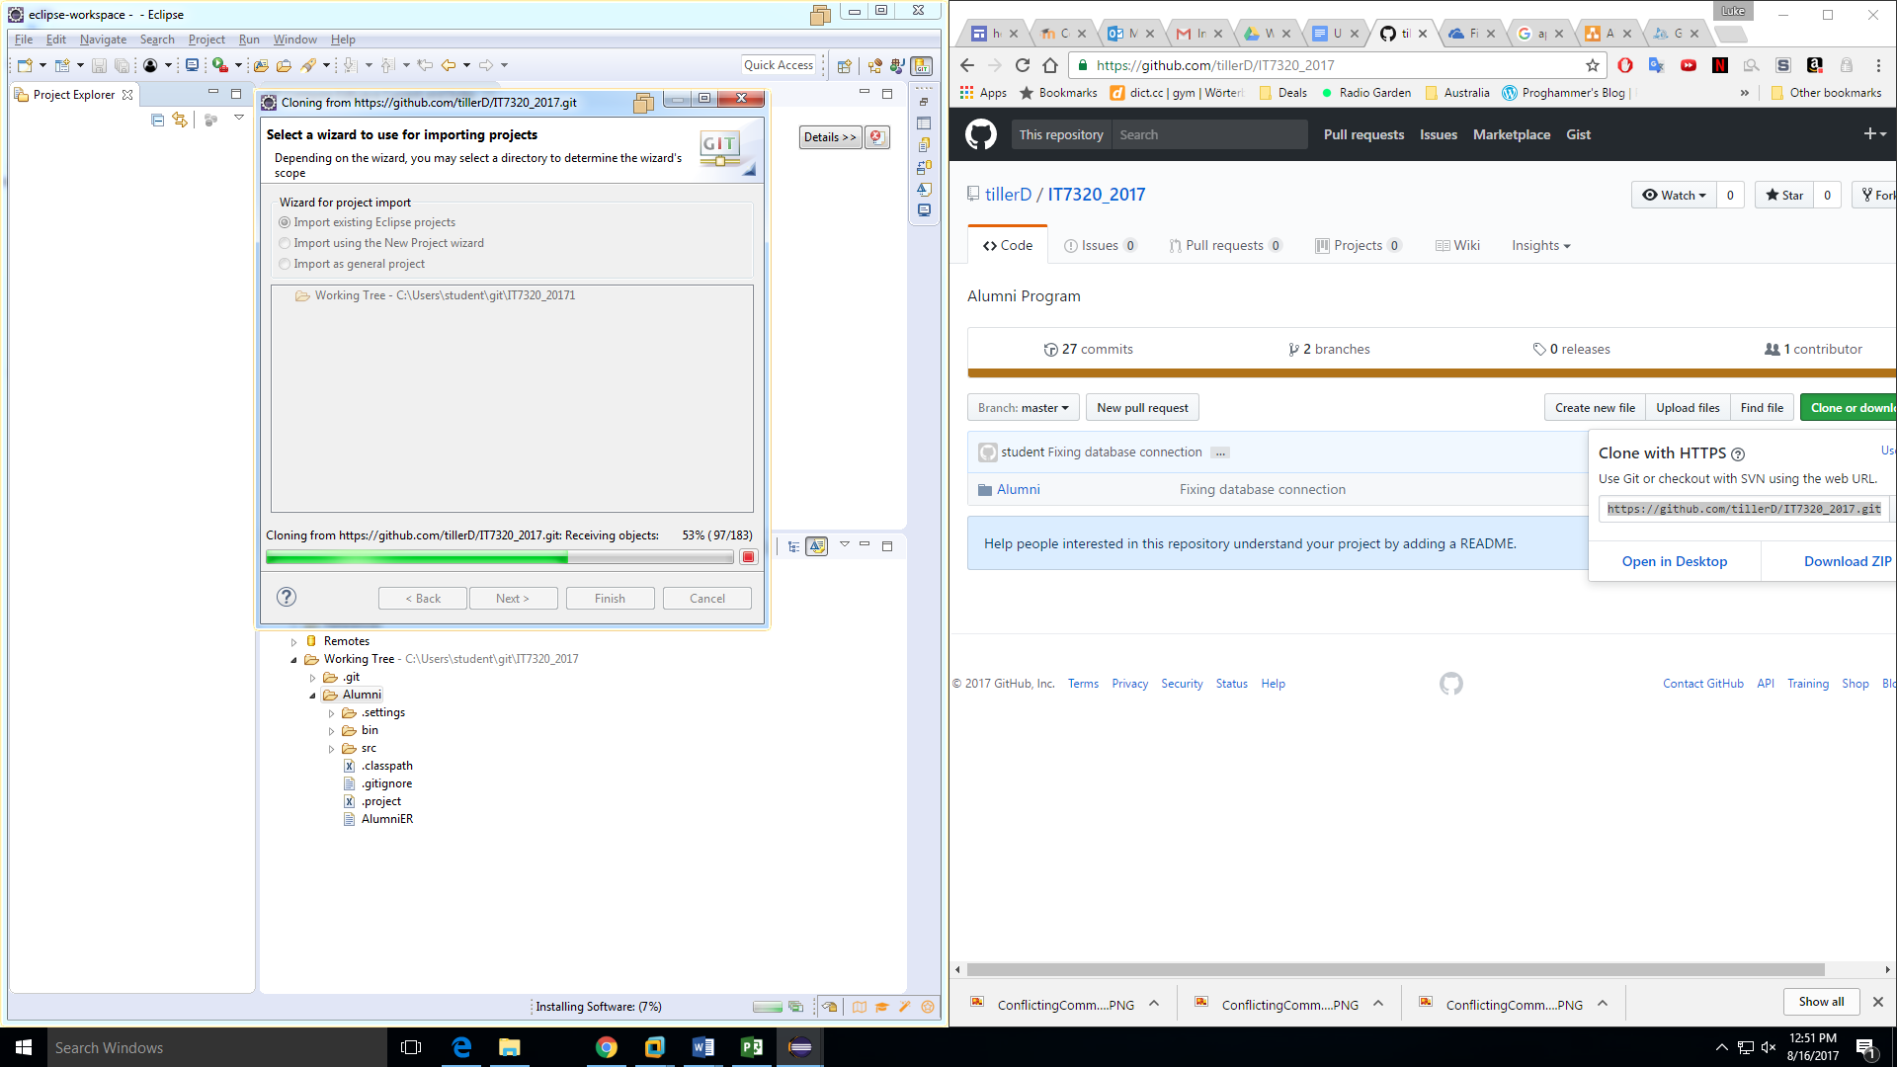

Figure 5: View of GitHub and Eclipse during importing project from GitHub to Eclipse

### Conflicting Commits

If there was an error, resolve this issue by pulling the changes first from the remote repository and then pushing the new change to upstream

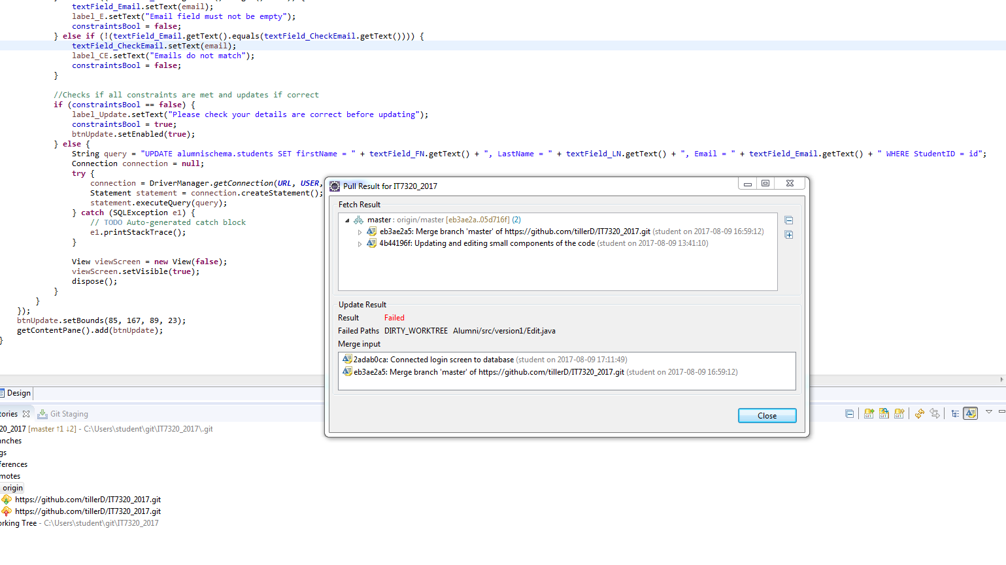

Figure : Error pop-up showing that commits are conflicting

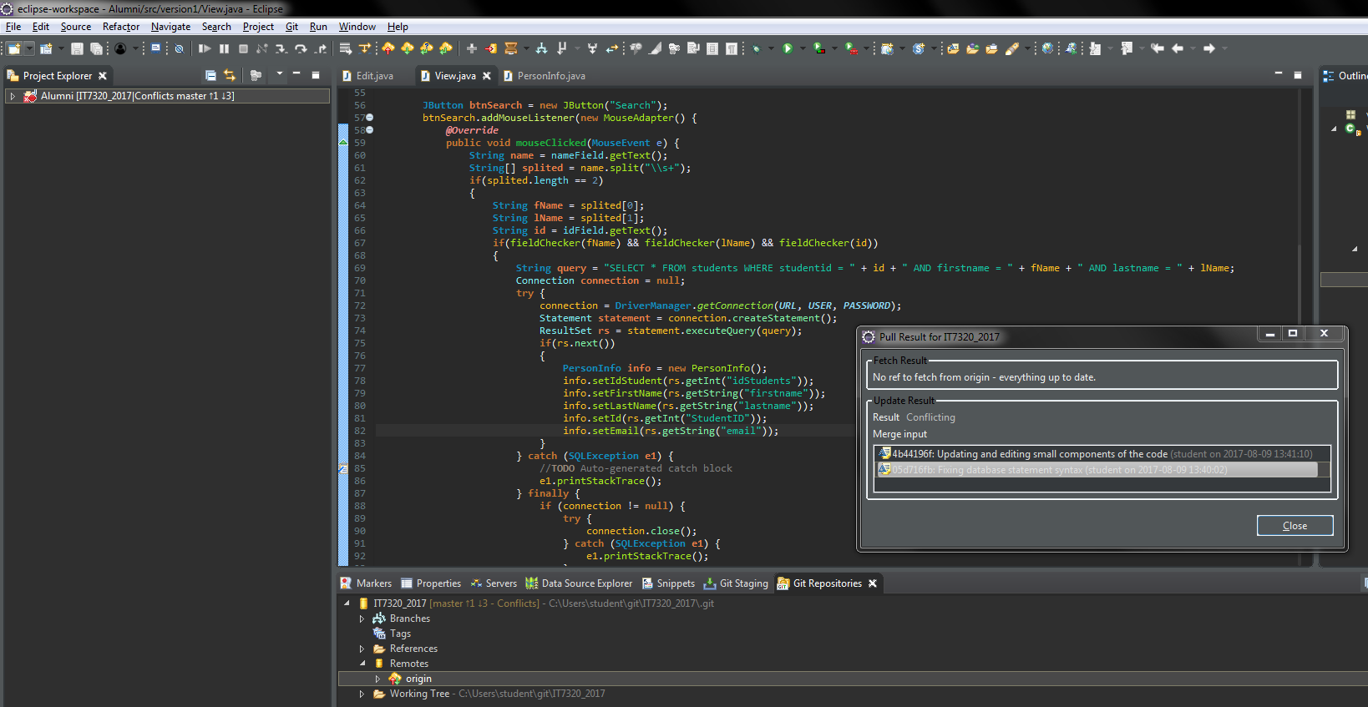

Figure : Figure 6: Message showing results of pull

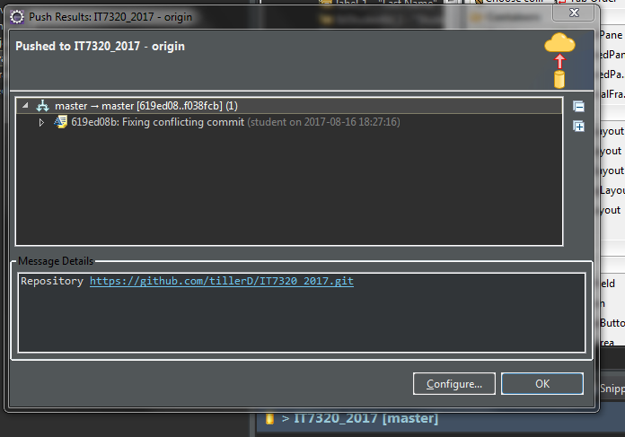

Figure : Message showing results of push

# Class Diagram

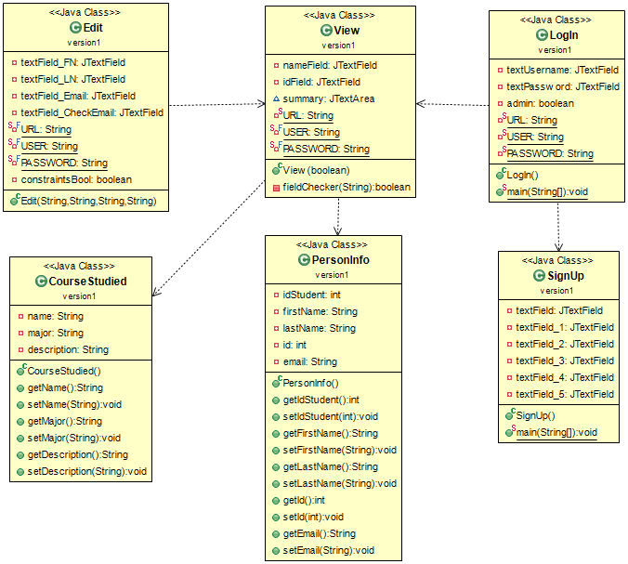

Figure 9: Java Class Diagram of Alumni Application

# Appendices

### Appendix A



Figure 10: Gantt chart of Project Plan