Alumni Project Assignment 1

IT7320 Development and Testing of Software

Hamish RALFE - DYLAN TILLER - Luke Hamer

2017

Contents

Summary of Report Contents 2

Project and Development Plan 2

Screenshots and Descriptions 2

Eclipse’s Package Explorer 2

Working Project 2

Git Repository 2

History of Commits 2

Local Repository linked to Remote Repository 2

Git 2

GitHub 2

Conflicting Commits 2

Error 2

Resolution 2

GitHub Repositories 2

Class Diagram 3

# Summary of Report Contents

This project report details our development of an Alumni software. It consists of a Project plan, Screen shots and descriptions of development processes in Eclipse, Git and Github, and lastly a class diagram.

This Alumni software was developed to meet the need of Weltec for an application which student and administrator users can use to store personal, contact and academic data. The users also need to be able to search for student and if they are an administrator they can edit the data to allow for maintenance and updates to the data stored in the MYSQL database.

The solution to this need was to develop the program in Java and to store the data in a MYSQL database. The developed application meets the functionality requirements and can be expanded if required to store and display new information.

# Project and Development Plan

# Screenshots and Descriptions

## Eclipse’s Package Explorer

### Working Project

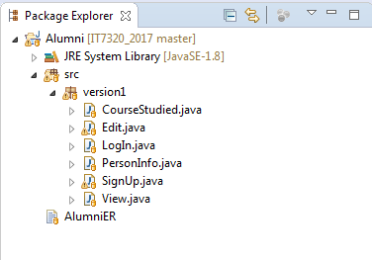

### Git Repository

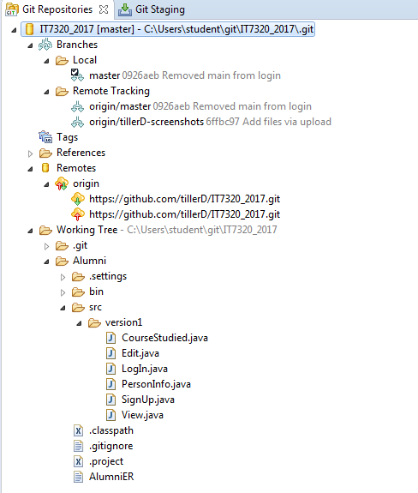

### History of Commits

## Local Repository linked to Remote Repository

### Git

### GitHub

## Conflicting Commits

### Error

### Resolution

## GitHub Repositories

# Class Diagram