**Till Payments Integration**

Version 21.1.0



Table of Contents

1. Overview 2-2

1.1 Compatibility 2-3

1.2 Limitations, Constraints 2-3

1.3 Privacy, Payment 2-3

2. Integration Components 2-3

2.1 Components 2-3

2.1.1 Signature Generation 2-3

2.1.2 Prepare Redirect 2-3

2.2 Adding the cartridge in SFCC UX Studio 2-4

2.3 Business Manager Configurations 2-4

2.3.1 Activating the cartridge in Business Manager 2-4

2.3.2 Enable Cartridge Module 2-5

2.3.3 Importing Metadata 2-5

2.3.4 Type Extensions 2-5

2.3.5 Payment Methods 2-7

2.3.6 Payment Processors 2-7

2.3.7 HTTP Service 2-7

3. Testing 3-7

3.1 Storefront Checkout flow 3-7

3.1.1 Till Payments Credit Card 3-9

3.1.2 Till Payments APM PayPal 3-10

3.2 Backend Transaction 3-12

4. Operations, Maintenance 4-13

4.1 Availability 4-14

4.2 Support 4-14

5. Known Issues 5-14

6. Release History 6-15

# Overview

This document describes the technical integration of Till Payments link cartridge.

Till Payments services all verticals in need for multi-step payment services.

Till provides a cartridge to integrate with Salesforce Commerce Cloud (SFCC). The cartridge allows SFCC storefront to intregrate with Till Payments payment service.

## Compatibility

This Cartridge works best with the SFRA version of 5.0.1 and compatibility mode 19.10

## Limitations, Constraints

## Privacy, Payment

This integration requires access to the following customer data elements: Billing Address, Shipping Address, Order Details and Customer Profile.

## Supported Locales

This Cartridge supports the following Locales

* English (Australia)
* English (United States)
* English (United Kingdom)

# Integration Components

## Components

Till Payments Integration has the following cartridges.

* **int_tillpayment_sfra -** This cartridge has controllers and other script files necessary for integration on SFRA site.
* **bm_tillpayment -** Business Manager extension cartridge for transaction management.

### Signature Generation

To begin the checkout of a customer that chooses Till Payments method on your website, Till Payments implements a signing mechanism based on HMAC-SHA512 to prevent against malicious attacks and hijacking of browser session.

### Prepare Redirect

Once signature is generated, a post request will send to the Till Payments gateway with transaction information in application/x-www-form-url encoded format for redirection to Till Payments page.

## Adding the cartridge in SFCC UX Studio

To upload the cartridges into the SFCC server, you first need to add the cartridges in SFCC UX Studio. In order to do this, follow these instructions.

1. In UX Studio, select in the menu File > Import.
2. In the import dialog, select General > Existing Projects in the workspace and click on 'Next'.
3. Ensure 'Select archive file' is selected and select the compressed cartridge file by clicking on the 'Browse' button.
4. Click on 'Finish' button to import the cartridges.
5. Studio will now ask you if you want to link the cartridge to your active DigitalServer connection. Click on yes or manually link the cartridge to your server by checking the project under project references in the server connection properties.

## Business Manager Configurations

For the Till Payments integration to work, the following needs to be configured in the Business manager.

### Activating the cartridge in Business Manager

Before the Till Payments functionality can become available to Site, the cartridges have to be added to the cartridge path of the Site. In order to do this, follow the following instructions:

1. Log into Business Manager.
2. Navigate to Administration > Sites > Manage Sites.
3. Click on the site name and on the next page go to the 'Settings' tab.
4. In the 'Cartridges' input field add 'int_tillpayment_sfra' in front of base cartridge.
5. Click on 'Apply' button.
6. To activate the cartridge for the Sandbox/Development/Production instances repeat steps 4 and 5 after selecting the appropriate instance from the 'Instance Type' dropdown menu.
7. Repeat steps 3 to 6 for each site that is to use Till Payments.
8. Go to 'Manage the Business Manager site'.
9. In the Cartridges input field add ‘bm_tillpayment:int_tillpayment_sfra:app_storefront_base’
10. Click on 'Apply' button.

### Enable Cartridge Module

To enable Cartridge module,

1. Go to Administration > Organization > Roles & Permissions.
2. Click on "Administrator" and click on "Business Manager Modules" tab.
3. In Select Context dialog, check your site ID checkbox and click on "Apply" button.
4. Find ‘Till Payment’ and check the checkbox to enable it.
5. Press ‘Update’ button

### Importing Metadata

For the Till Payments integration to work, the following object structures (metadata) needs to be imported and configured in the Business manager. Follow the below steps:

1. In the cartridge bundle find **metadata/** **tillpayment-meta-import** folder.
2. Find the **sites** folder and inside it find **RefArch** folder.
3. Rename this RefArch folder to the ID of your site. If you have multiple sites to which these meta has to be imported, then copy and paste this RefArch folder to replicate for other sites. Renames those folders with ID of corresponding sites.
4. In the cartridge bundle, inside **metadata** folder compress tillpayment-meta-import folder to generate **tillpayment-meta-import.zip** file.
5. Go to Business Manager Menu > Administration > Site Development > Site Import & Export
6. Under Import: Upload Archive: Ensure that the radio button with label **Local** is enabled (Else click on the radio button to enable it)
7. Click on Choose File input field, select the tillpayment-meta-import.zip file from open dialog box and click on upload button
8. After finishing the upload, from the Archives list click the radio button corresponding to **tillpayment-meta-import.zip** and click on Import button
9. Click on OK button of the confirmation box asking, “Are you sure that you want to import the selected archive?”

### Type Extensions

* **Custom site preference**

**After the successful metadata import following attributes should have been created:**

In Business Manager, navigate to the Merchant Tools > Site Preferences > Custom Preferences. Custom site preference groups with the ID ‘Tillpayment’ will be available after the successful import of metadata. Please select it and edit the attributes according to your Till Payments account data.

For each site, set the values for your site preferences.

**Group ID: Tillpayment**

1. **Enable Tillpayment** (ID - enableTillpayment, Type - Boolean) - To enable or disable Till Payments and its functionality in a single point.
2. **Payment Mode** (ID - tillPaymentMode, Type - enum-of-string) – Mode of payment, ‘Preatuhorize’ OR ‘Debit’.
3. **Shared Secret** (ID - tillpaymentXmlSharedSecret, Type - String) – Shared Secret Key of Till Payments.
4. **API Username** (ID - tillpaymentApiUsername, Type - String) – API Username of Till Payments.
5. **API Password** (ID - tillpaymentApiPassword, Type - password) - API Password of Till Payments.
6. **API Key** (ID - tillpaymentApiKey, Type - String) – API Key of Till Payments.
7. **APM extraData** (ID - tillpaymentApmExtraData, Type - Text) – extraData object part of the APM connector in Till Payments
8. **3D Secure Mode** (ID - tillpayment3DSecureMode, Type - enum-of-string) – 3D Secure Mode of Till Payments Credit Card.

### Payment Methods

Under Merchant Tools > Ordering > Payment Methods,

check that payment methods with IDs ‘CREDIT_CARD’ and ‘TILL_APM’ are created.

### Payment Processors

Under Merchant Tools > Ordering > Payment Processors,

check that payment processors with IDs ‘TILLPAYMENT_CREDIT’ and ‘TILLPAYMENT_APM’ are created.

Assign payment processor ‘TILLPAYMENT_CREDIT’ to payment method ‘CREDIT_CARD’.

Assign payment processor ‘TILLPAYMENT_APM’ to payment method ‘TILL_APM’.

### HTTP Service

Under Administration > Operations > Services,

check that services with IDs ‘tillpayments.api.service’ is created.

# Testing

Once the cartridge is installed and integrated based on instructions, please try to place an order on your sandbox to test the functionality.

## Storefront Checkout flow

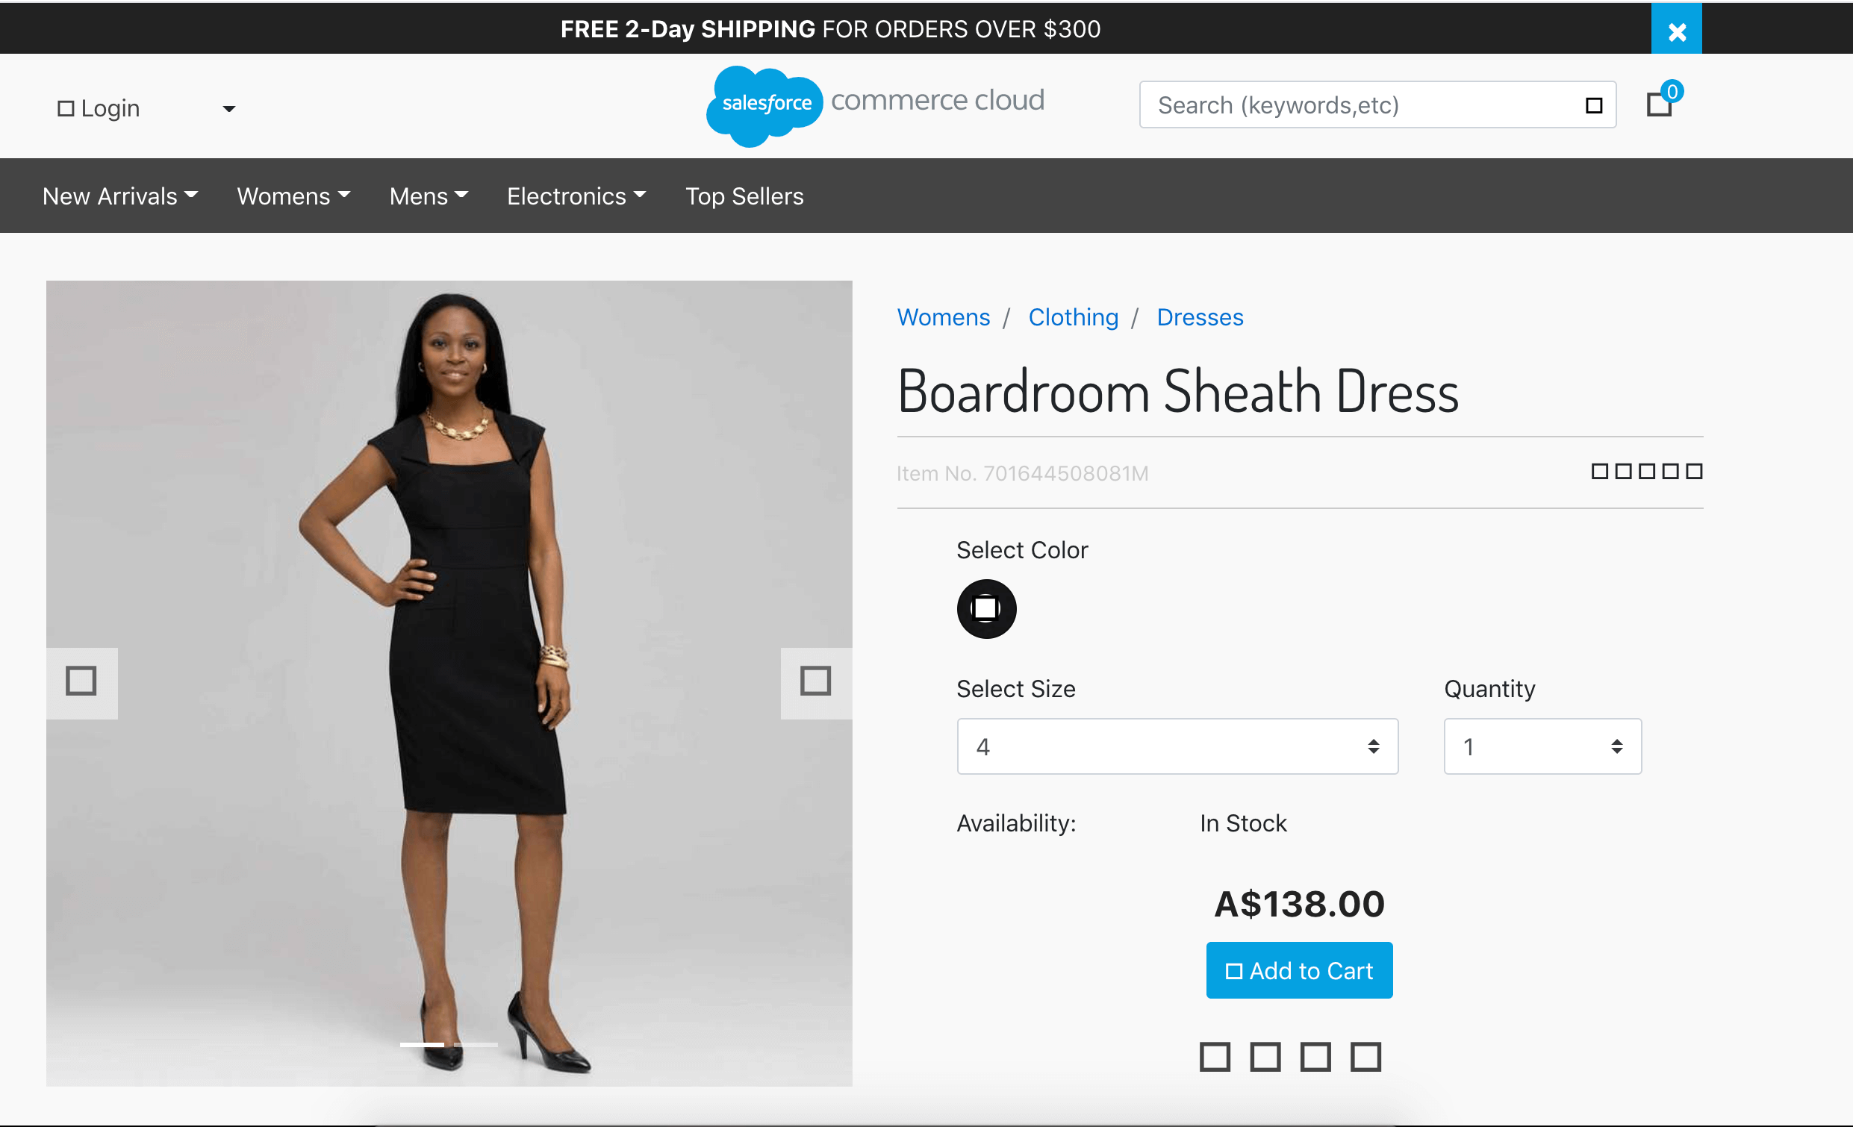

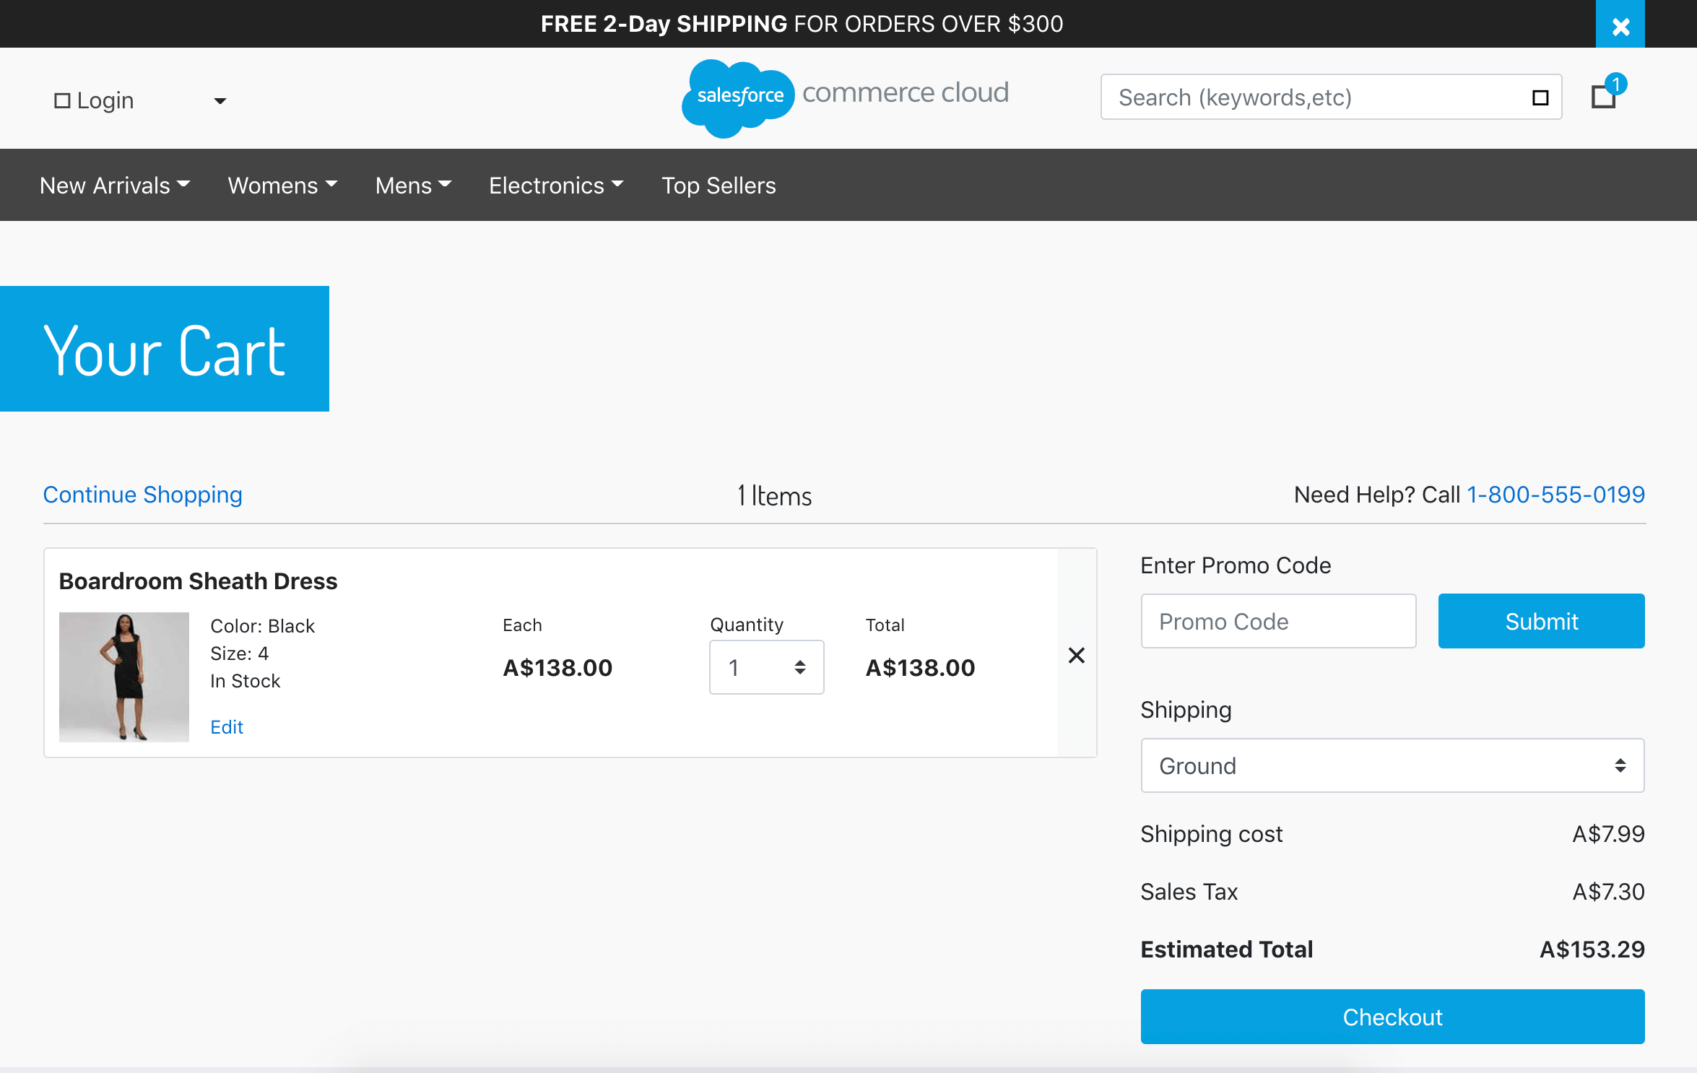

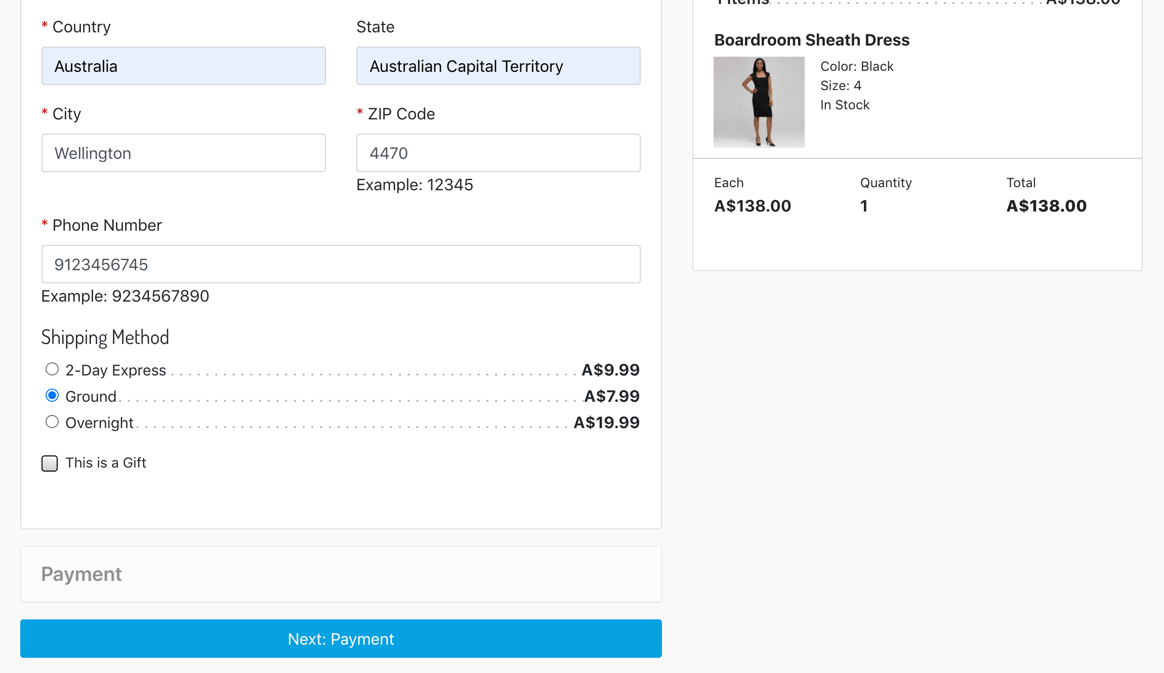

### Till Payments Credit Card

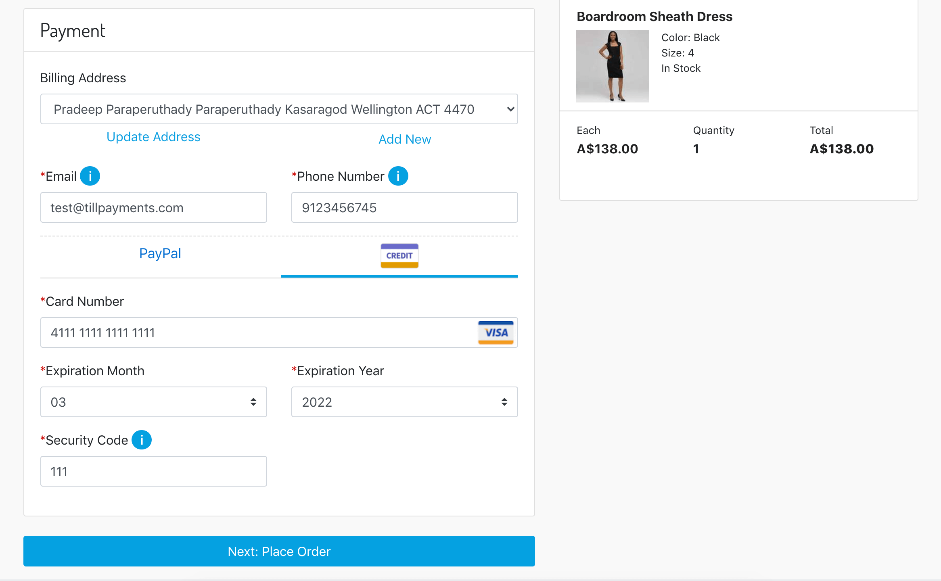

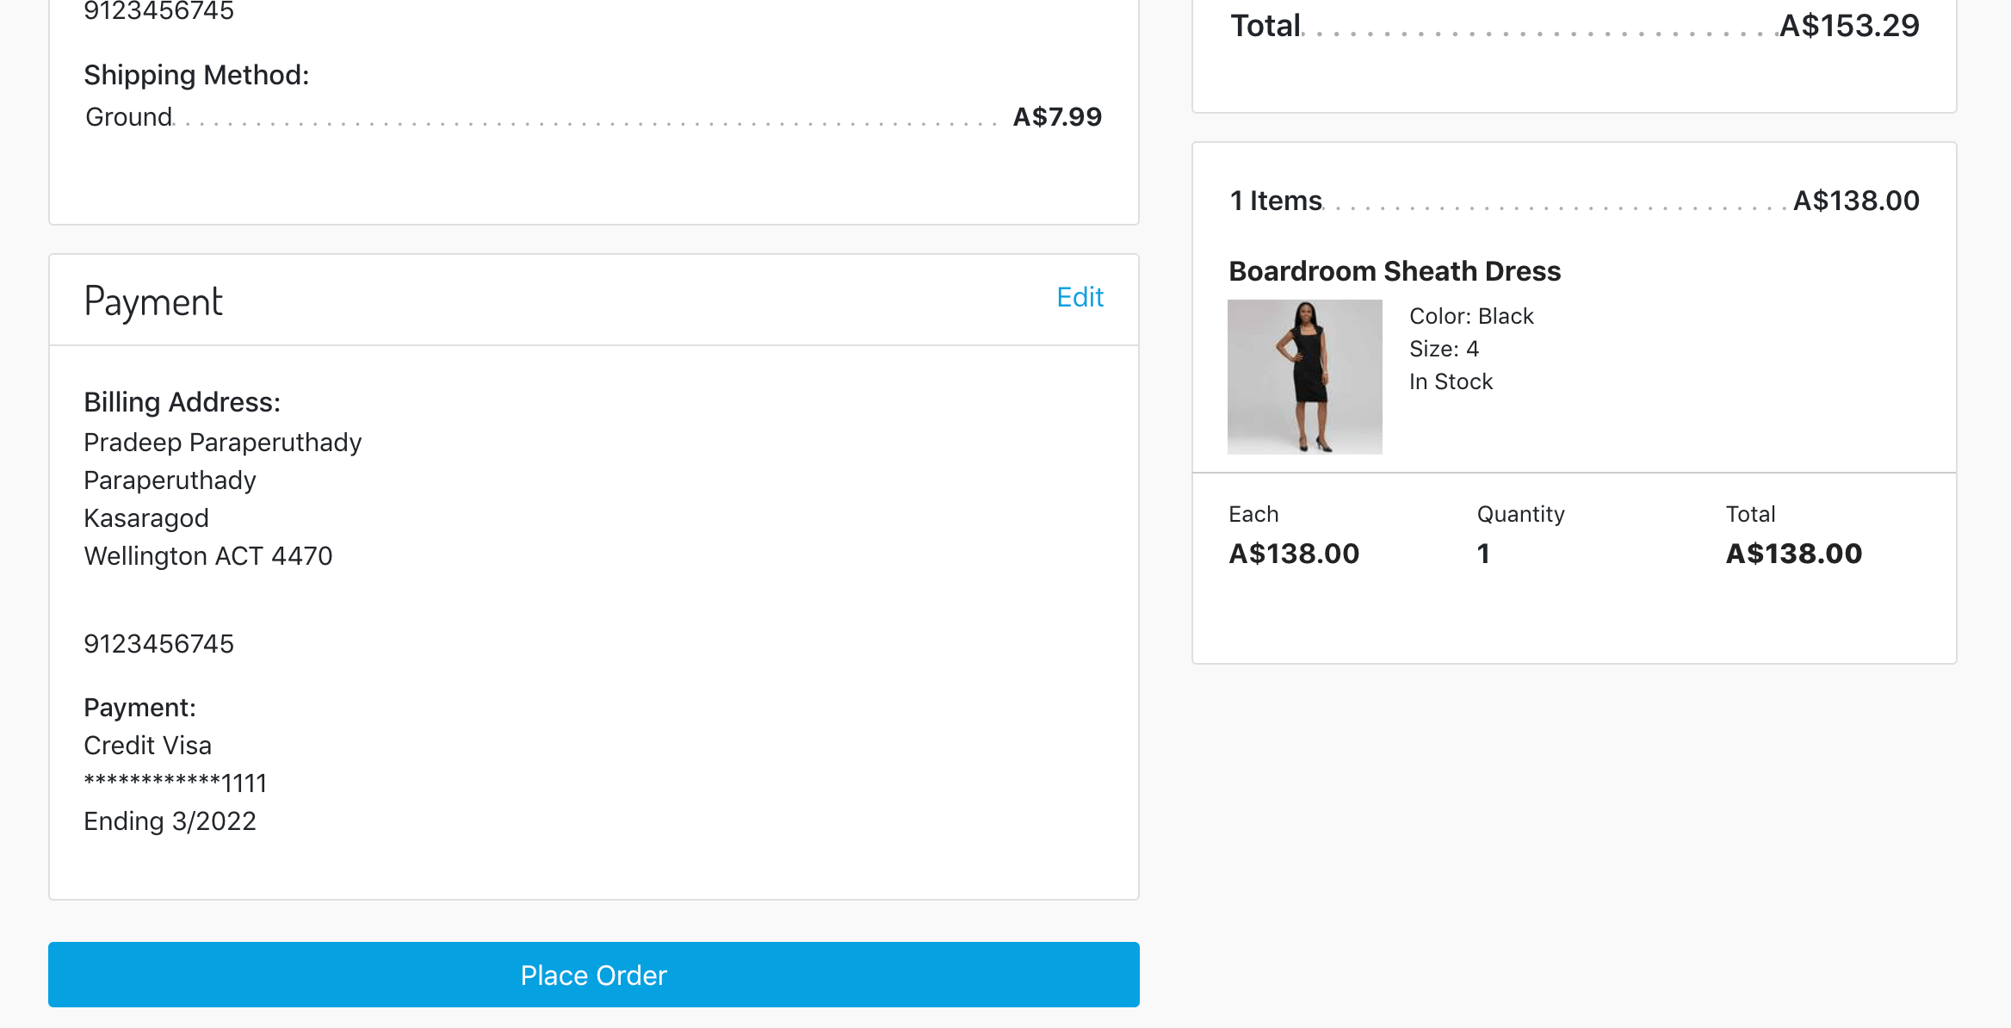

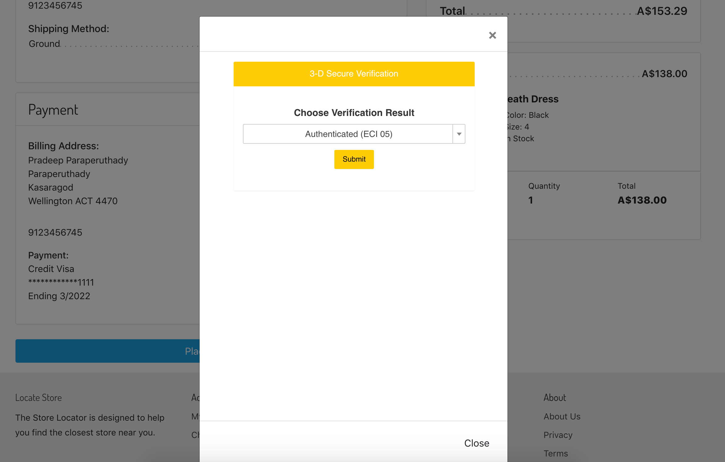

### Till Payments APM PayPal

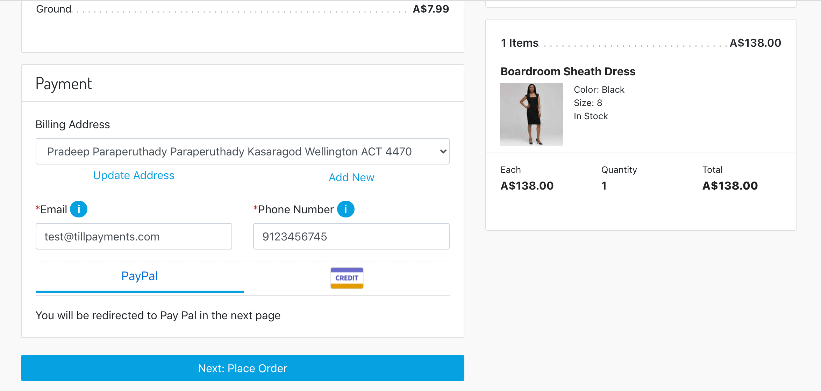

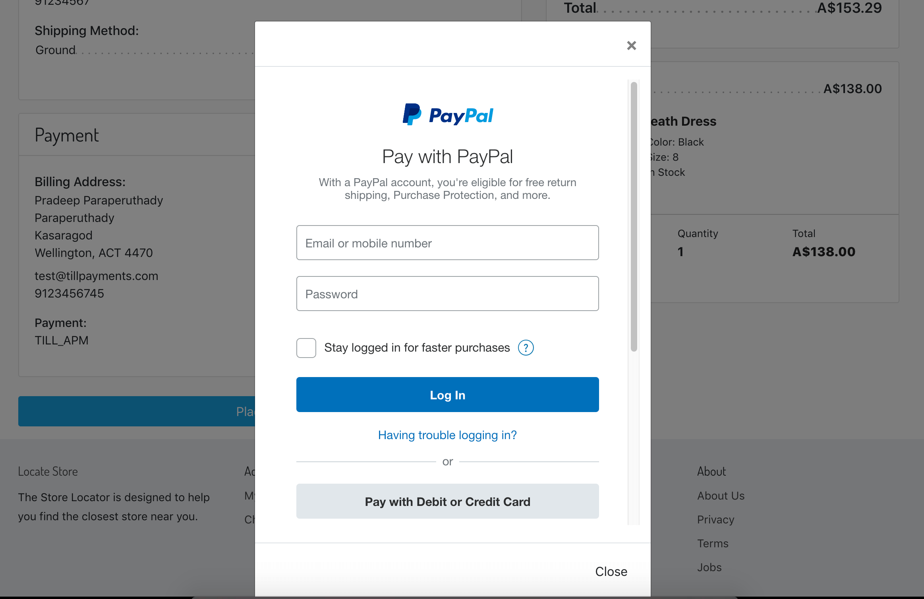

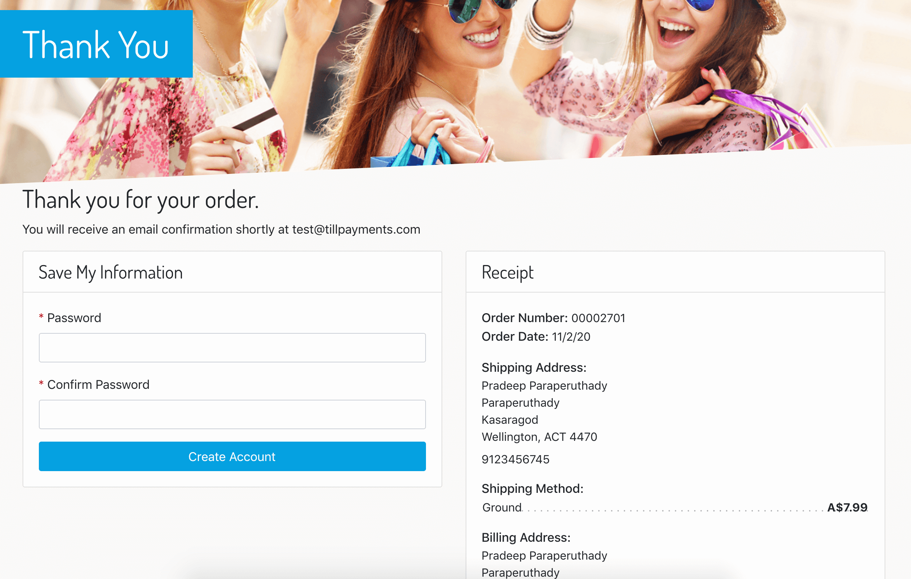

## Backend Transaction

* Go to Merchant Tools > Till Payment > Transactions Management:

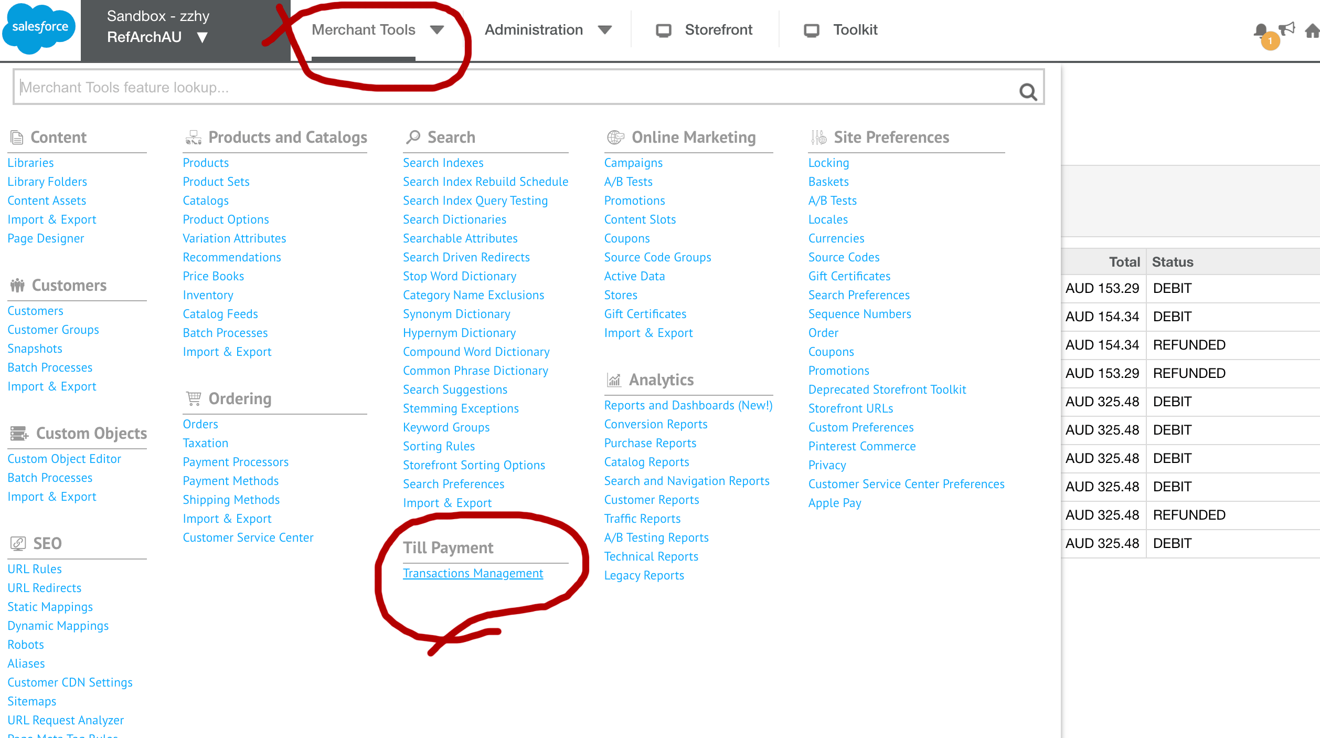

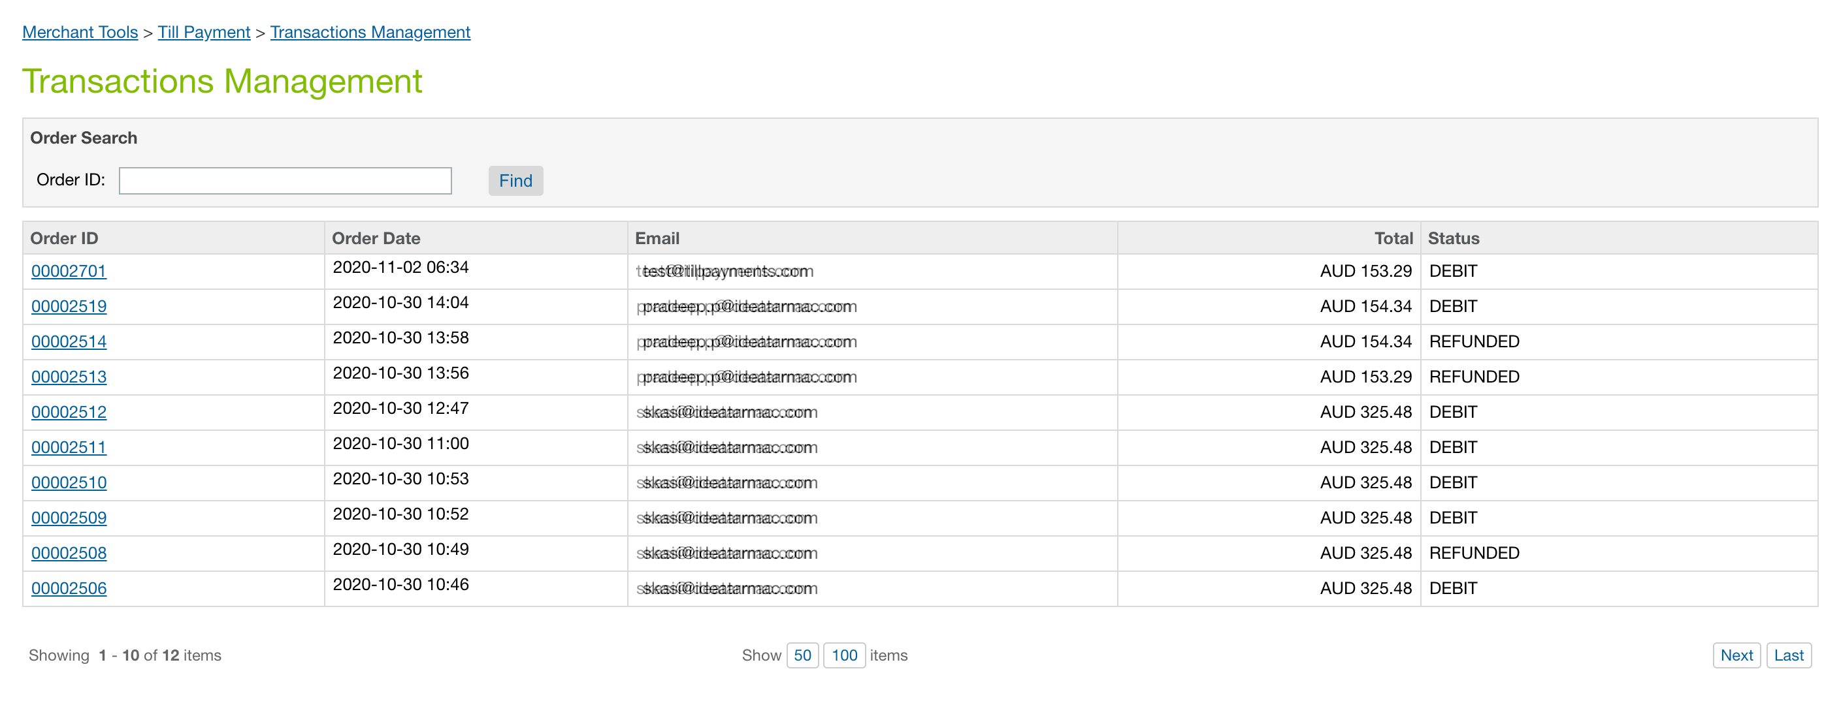

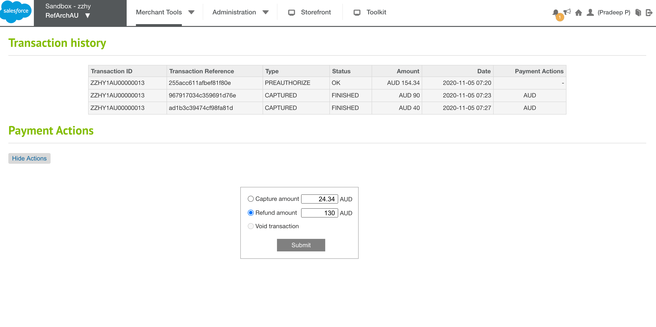

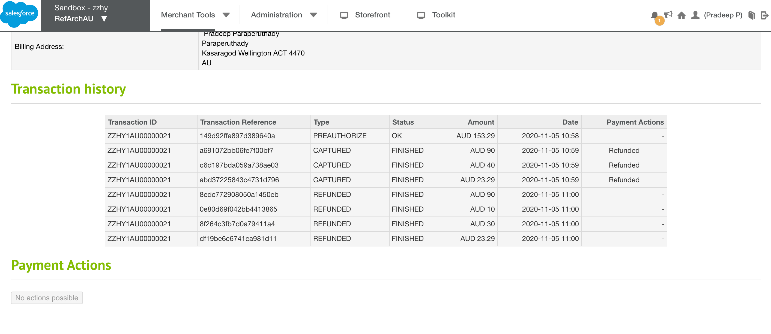

# Operations, Maintenance

## Availability

If Till Payments API service is down, customers will see the following error message when they try to place an order.  
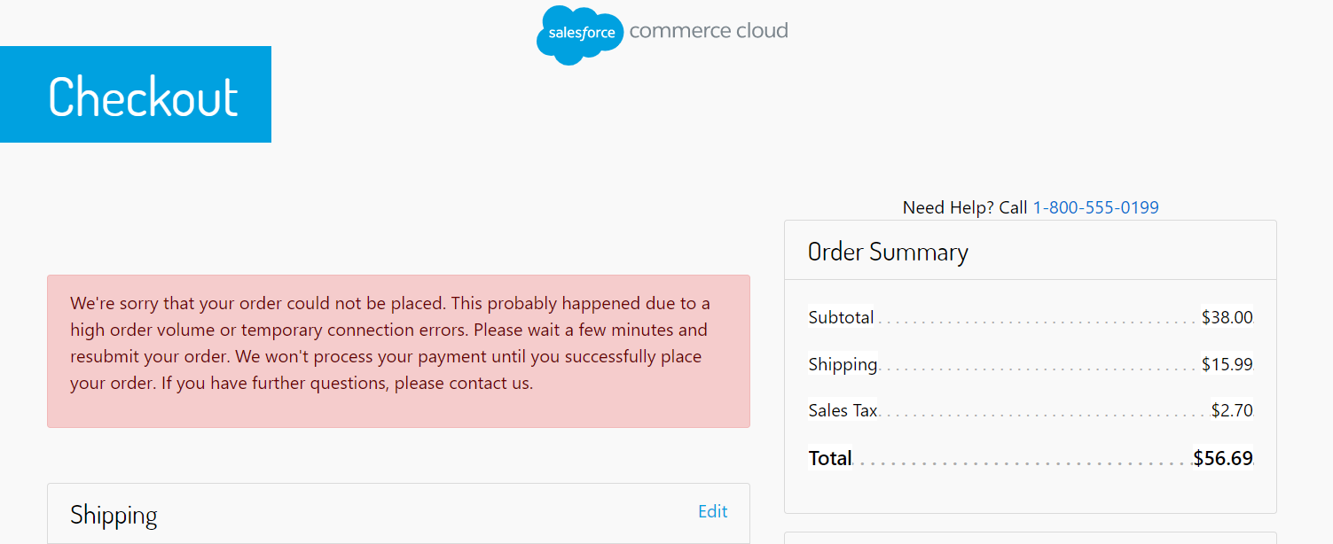

There will be errors detailing the exact issue in custom-tillpayment-ecom-…log and service-tillpayments-ecom…log log files which will look something like below.

ERROR PipelineCallServlet|998628096|Sites-RefArch-Site|CheckoutServices-PlaceOrder|PipelineCall|FKp9Wjm6Bb custom.service.tillpayments.xml.version.service.HEAD [] service=tillpayments.xml.version.service status=SERVICE_UNAVAILABLE errorCode=0 errorMessage=The service is not enabled

If Till Payments API service is down, then contact the Support team. Details are in Support section.

## Support

For any issues or support related enquiries for merchants, please contact us at support@tillpayments.com

# Known Issues

None

# Release History

|  |  |  |
| --- | --- | --- |
| **Version** | **Date** | **Changes** |
| 21.1.0 | 07-Apr-2021 | Initial release |