Digital Image Processing
Exercise 1
Group:
Members: Till Rohrmann (Matriculation number: 343756)

Input picture:
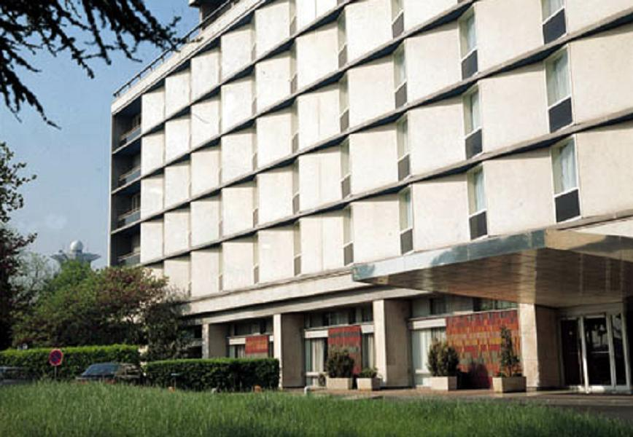

Output picture:
