Exercise 4: Decision Trees and Random Forests

Tilman Marquart

Baptiste Piofret

Maxime Gatineau

Group 14

University of Southern Denmark

*Spring Semester 2020*

4.1: Decision trees

4.1.1

PC2 brings the highest information gain with a threshold of around 0.4. This would be the best split for our decision tree

4.1.2

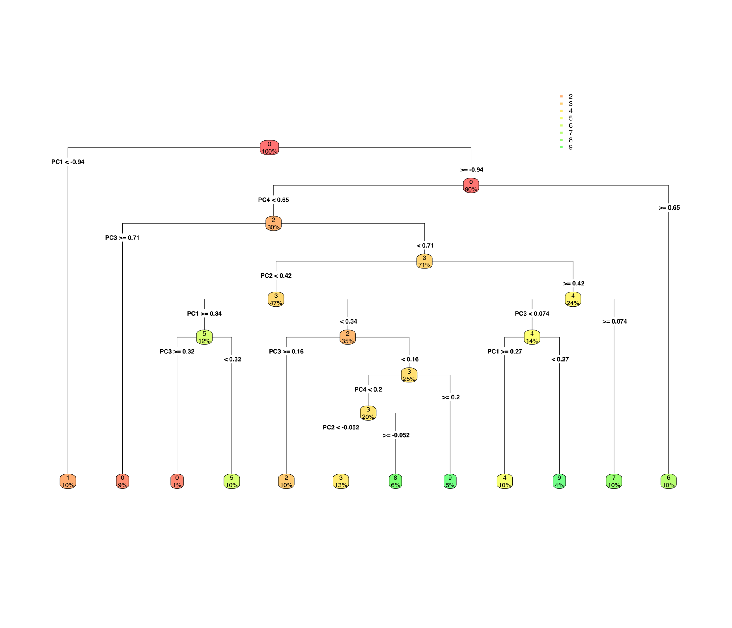

A decision tree for dataset of one person. Using a threshold (decision point) on 5 PCA Components to make its decisions. The percentage is the percentage of data at this specific node.

4.1.3

We performed cross validation on a decision tree using the full parameters and data set and we got the following results for the accuracy: 67.5875, 66.0625, 67.6750, 66.9125 and 65.6500.

We can see that the tree alone is not very accurate and that is why we need to combine a lot of trees to have a more accurate prediction. That is what a random forest is about.

4.2: Random forests

We used the data as 'All persons in' for the training and testing sets.

We performed a PCA on the data and kept 25 PC which gave us 90% of the variance. It allowed us to reduce the runtimes and to get relatively reliable data to use.

As a starting point, we used the default values for the number of trees and the depth of each tree: 500 and 6 respectively. To validate our random forest classifier, we used a cross-validation on 5 different test sets of 20% each, once again to get a runtime we could work with.

The accuracies from this cross validation are: 96.61, 96.21, 96.58, 96.75 and 96.73. Our classifier is reliable.

We then proceeded to evaluate the impact of the number of trees and the depth of each tree on the accuracy of the random forest.

We started with the set default number of trees (500) and changed the depth:

And then with the set default depth of 6 and changed the number of trees:

We can see that the accuracy goes up when we reduce the depth of the trees for a set number of trees and with a greater number of trees for a set depth.

We cannot increase indefinitely the number of trees because the runtime increases with the number of trees in the forest.