Character Images

LPC
I need the largest variety of both player and non-player character images/animations as I can get, and I found a treasure trove of decent looking assets created by the Liberated Pixel Cup (LPC) community, at http://lpc.opengameart.org. All LPC assets are released under CC-BY 3.0, so no worries there.

There are even web apps that will create sprite sheets for you, with an amazing level of variety: http://gaurav.munjal.us/Universal-LPC-Spritesheet-Character-Generator, and http://idrisdev.net/LPCGenerator. The Idris app is newer and claims to have fix some things, but non of it’s “Sara” images work and I always end up using Gaurav’s instead.

LPC-Converter App
I created a utility (appbase/lpc-converter) that will convert the sprite sheet images created by these sites into a 512x512 texture of only the animations I need for Heroes’ Path. After FileOptimizer shrinks these PNG texture files down they are only 14k each. I ended up with animation cells for standing, walking, give/take, fighting, casting, blinking, and dead. Only walking and the give/take animations have multiple cells/frames. Here is a cheatsheet or key image that defines what the cells in these texture images are:

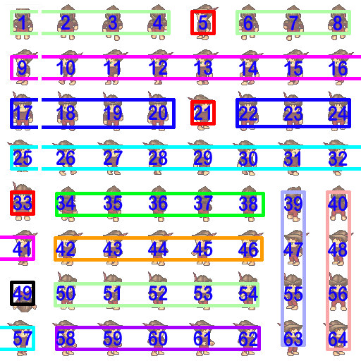

Here is the code that also helps define what each cell is used for:

switch (POSE)
{
case Pose::Standing:
{
switch (DIRECTION)
{
case su::Direction::Left: { return { 9 }; }
case su::Direction::Right: { return { 25 }; }
case su::Direction::Up: { return { 1 }; }
case su::Direction::Down:
case su::Direction::Count:
default: { return { 17 }; }
}
}
case Pose::Walking:
{
switch (DIRECTION)
{
case su::Direction::Left: { return { 10,11,12,13,14,15,16,41 }; }
case su::Direction::Right: { return { 26,27,28,29,30,31,32,57 }; }
case su::Direction::Up: { return { 2,3,4,1,6,7,8 }; }
case su::Direction::Down:
case su::Direction::Count:
default: { return { 18,19,20,17,22,23,24 }; }
}
}
case Pose::GiveTake:
{
switch (DIRECTION)
{
case su::Direction::Left: { return { 42,43,44,45,46 }; }
case su::Direction::Right: { return { 58,59,60,61,62 }; }
case su::Direction::Up: { return { 34,35,36,37,38 }; }
case su::Direction::Down:
case su::Direction::Count:
default: { return { 50,51,52,53,54 }; }
}
}
case Pose::Fight:
{
switch (DIRECTION)
{
case su::Direction::Left: { return { 47 }; }
case su::Direction::Right: { return { 63 }; }
case su::Direction::Up: { return { 39 }; }
case su::Direction::Down:
case su::Direction::Count:
default: { return { 55 }; }
}
}
case Pose::Cast:
{
switch (DIRECTION)
{
case su::Direction::Left: { return { 48 }; }
case su::Direction::Right: { return { 64 }; }
case su::Direction::Up: { return { 40 }; }
case su::Direction::Down:
case su::Direction::Count:
default: { return { 56 }; }
}
}
case Pose::Blink:
{
switch (DIRECTION)
{
case su::Direction::Left: { return { 5 }; }
case su::Direction::Right: { return { 21 }; }
case su::Direction::Up: { return { 1 }; }
case su::Direction::Down:
case su::Direction::Count:
default: { return { 33 }; }
}
}
case Pose::Dead:
case Pose::Count:
default: { return { 49 }; }
}

LPC Character Combinations
There are too many possible combinations of LPC character assets to just sit down and create all the ones I need. I’ve decided not to implement code in the game engine to randomly create combinations, so I’ll need to document some combinations here to keep track.

Settings to Ignore:
Spike, Bracelet, Belt, Buckle, Necklace, Weapon, Ammo, Shield, Quiver

Eye Color:
- The only eye colors that don’t look crazy are: blue, brown, green, and gray.
- Eye color is not noticeable enough to warrant saving a distinct combination.

Skin Color:
- Only using: Light, Dark, Tanned, and Tanned2.
- When the skin color is dark: (6x2=12)
* The only hair styles that look correct are: Plain, Bedhead, Messy1, Messy2, Mohawk, and Shorthawk.
* The only hair colors that look correct are: Raven (black), Whiteblonde (which comes off as light-brown), and maybe Green and Brunette
- When the skin color is NOT dark: (3x)
* Warrior:
* Warrior

Settings that should be used to make unique NPCs.
- Nose: Big, and Button
- Ear: Big, and Elven
- Hair: Shorthawk, Longhawk, Messy1, Messy2, Mohawk
- Hair Color: Dark Blonde (only for males with plain hair style), Green, Red
- Skin Color: Tanned (this color just seems to stand out)
- Legs: Red pants instead of Magenta
- Cape & Cape Clip
- Hat
- Tiara (Hat) (female only)
- Jacket
- Hat Cloak Hood

LPC Character Patterns

Warriors:
- Sex=male [1]
- Skin & Hair: [6]
* Light Skin: body=light, hair=plain_blonde/plain_brunette/plain_raven [6]
* Dark Skin: body=dark, hair=plain_raven/plain_brunette/plain_white [3]

- “Plate”: armor=chest_plate&greaves=metal&shoes=boots_metal&arms=plate
* (Uses all Skin&Hair combinations from above, so 6 each.)
* ManAtArms
* Gladiator shoulders=leather

- “Plate-Soldier”: hat=chain
* (Can’t see hair, so only 2 each.)
* Sergeant
* Major shoulders=leather

- “Plate-Knight”: gloves=metal&hat=helmet_metal
* (Can’t see skin or hair, so only 1.)

- “Leather”: armor=chest_leather&legs=pants_magenta
* ((Uses all Skin&Hair combinations from above, so 6 each.))
* Poor
* Thug shoulders=leather
* Circus1 bracers=leather
* Thug2 shoulders=leather&bracers=leather
-
* IronArms arms=plate
* IronRich arms=plate&shoulders=leather
-
* Private1 mail=chain
* Private2 mail=chain&shoulders=leather
* Private3 mail=chain&bracers=leather
* Private4 mail=chain&shoulders=leather&bracers=leather
-
* Common1 greaves=metal
* Common2 greaves=metal&shoulders=leather
* Circus2 greaves=metal&bracers=leather
* Common3 greaves=metal&shoulders=leather&bracers=leather
-
- “Leather-Soldier”: =shoes_brown&hat=chain
* (Can’t see hair, so only 2 each.)
* Specialist1 shoulders=leather
* Specialist2 shoulders=leather&bracers=leather
-
* Corporal1 arms=plate
* Corporal2 arms=plate&shoulders=leather
-
* Private1st1 mail=chain
* Private1st2 mail=chain&shoulders=leather
* Private1st3 mail=chain&bracers=leather
* Private1st4 mail=chain&shoulders=leather&bracers=leather
-
* Priavte2nd1 greaves=metal
* Priavte2nd2 greaves=metal&shoulders=leather
* Priavte2nd3 greaves=metal&bracers=leather
* Priavte2nd4 greaves=metal&shoulders=leather&bracers=leather

Commoners:

- “Monk”:
* (I came up with 16 of these. All bald with robe skirt, dark or tanned2, various belts and bracers.)

- “Girl”: sex=female&clothes=gown&gown-underdress=1&eyes=green&body=light
* Hair: loose_,ponytail2_,unkempt_,princess_

- “Woman”: sex=female&body=light&clothes=gown&gown-underdress=1&gown-overskirt=1
* Hair: pixie_,shoulderl_,shoulderr_,swoop_
- “Maid”:

- “Rags”

