MLA0104 – Artificial Intelligence and Expert Systems
CO5 – Assessment Tool 3
Modelling Comparative Analysis Assignment
Automobile Fault Diagnosis
Production Rules • Propositional Logic • First-Order Logic • Prolog
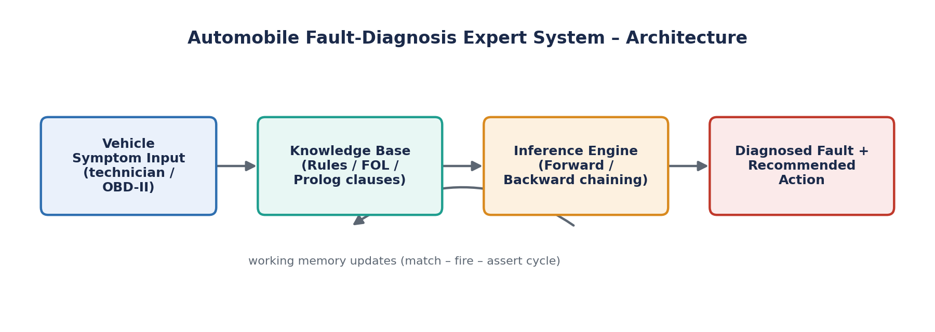
Figure 1: High-level architecture of the automobile fault-diagnosis expert system
Student Name: ____________________________
Register Number: ____________________________
GitHub Repository: github.com/tiloksaitejmannarapu-arch/MLA-0104/tree/main/C05AT-3

1. Problem Statement & Objectives
Automobile service centres must turn a small set of symptoms reported at the service bay — engine overheating, starting failure, abnormal noise, poor mileage, and dashboard warning indicators — into a reliable diagnosis of the underlying vehicle fault and a recommended corrective action. Today this judgement rests almost entirely on the experience of the attending mechanic, which makes outcomes inconsistent across technicians, slow at busy service floors, and prone to missed or delayed diagnoses for less experienced staff.
This report addresses that gap by building a knowledge-based diagnostic system that encodes a mechanic's reasoning as formal, machine-processable knowledge. The same body of domain knowledge is expressed through four modelling paradigms of increasing formal power — production rules, propositional logic, first-order logic (FOL), and Prolog — so their relative suitability for automotive diagnosis can be assessed directly rather than assumed.

1.1 Domain
The domain is fault diagnosis at an automobile service centre. The knowledge base reasons over one vehicle at a time on the basis of observed symptoms, and derives (a) the most likely faulty subsystem and (b) a recommended corrective action. The FOL and Prolog formulations generalise the same rule set across an entire fleet of vehicles using a variable, whereas the production-rule and propositional-logic formulations are illustrated for a single vehicle.

1.2 Objectives
- Identify the entities, observable facts, derived conditions, and fault categories relevant to automobile diagnosis.
- Construct a complete set of IF–THEN production rules linking symptoms to faults and recommended actions.
- Formalise the same knowledge in propositional logic (connectives, implications) and first-order logic (predicates, variables, quantifiers).
- Implement an executable Prolog program — facts, rules, and queries — that reproduces the diagnostic behaviour.
- Demonstrate forward chaining (data-driven) and backward chaining (goal-driven) reasoning over the rule base.
- Compare all four approaches on expressiveness, inference mechanism, complexity, scalability, and explainability, and recommend the most suitable approach for deployment.

2. Domain Knowledge & Facts
The knowledge base distinguishes observed symptoms (reported directly by the technician or an OBD-II reader), derived conditions (intermediate facts produced by combining symptoms), and faults (the diagnostic conclusions the system is built to reach). Every fact is scoped to a specific Vehicle so the same knowledge can be reused across the whole service floor.

2.1 Entities and Attributes
- Vehicle (V) — the car under diagnosis, identified by a registration ID (e.g., V101).
- Symptom (S) — an observable or derived condition of the vehicle.
- Fault (F) — a diagnostic conclusion identifying a faulty subsystem.
- Recommendation (R) — the corrective action associated with a fault.

2.2 Symptom / Fact Inventory
ID | Symptom / Condition | Type | Description
OS1 | low_coolant | Observed | Coolant reservoir level below the minimum mark
OS2 | high_temp_gauge | Observed | Temperature gauge needle in the red zone
OS3 | weak_battery | Observed | Battery voltage measured below ~11.8 V
OS4 | starter_clicks | Observed | Starter motor clicks but the engine does not turn over
OS5 | engine_knock | Observed | Metallic knocking sound from the engine bay
OS6 | belt_squeal | Observed | High-pitched squeal from an accessory belt
OS7 | poor_fuel_economy | Observed | Fuel consumption noticeably below the rated average
OS8 | clogged_air_filter | Observed | Air filter visibly obstructed on inspection
OS9 | check_engine_lamp | Observed | Check-engine / MIL lamp illuminated
OS10 | oil_pressure_lamp | Observed | Oil-pressure warning lamp active
DS1 | overheating | Derived | Engine temperature has exceeded a safe operating limit
DS2 | no_start | Derived | Engine fails to start on ignition
DS3 | abnormal_noise | Derived | An unusual sound is present during operation
DS4 | low_mileage | Derived | Kilometres-per-litre performance is below expectation
DS5 | warning_active | Derived | At least one dashboard warning lamp is active
Table 1: Symptom and derived-condition inventory used across all four models

2.3 Fault (Conclusion) Inventory
ID | Diagnosed Fault | Meaning
F1 | cooling_system_fault | Radiator, coolant, or thermostat malfunction
F2 | starting_system_fault | Battery, starter motor, or alternator malfunction
F3 | engine_internal_fault | Internal engine wear or mechanical damage
F4 | fuel_efficiency_fault | Clogged filter, injector fouling, or carburation issue
F5 | electronic_control_fault | Sensor or ECU malfunction not explained by another fault
Table 2: Fault categories the expert system is designed to reach

2.4 Relationships
- indicates(Symptom, Condition) — a symptom or symptom pair points toward a derived condition.
- leads_to(Condition, Fault) — a derived condition confirms a specific fault.
- has_symptom(Vehicle, Symptom) — links an observed condition to a specific vehicle.
- has_fault(Vehicle, Fault) — links a diagnosed fault to a specific vehicle.
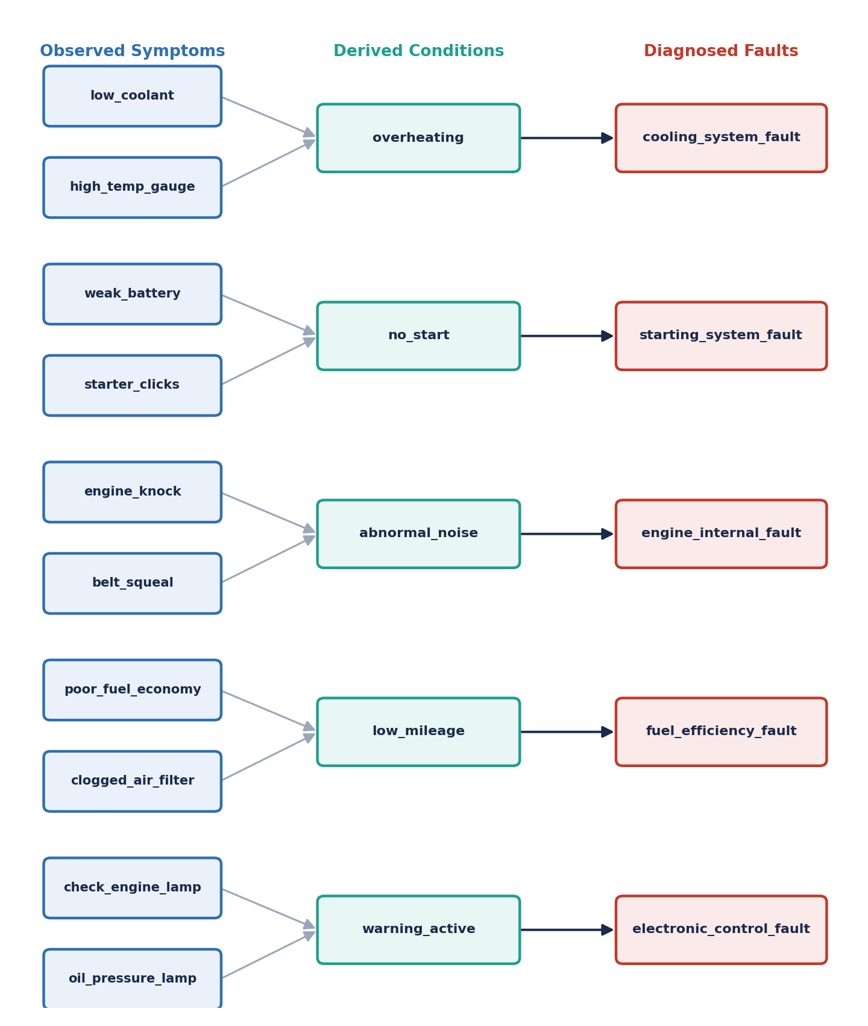
Figure 2: Symptom-to-fault relational network — the same structure that FOL predicates and Prolog clauses generalise over every vehicle V

3. Production Rule Model
Production rules capture domain knowledge as condition–action (IF–THEN) pairs. A rule fires as soon as its condition is satisfied by the current working memory, and the resulting conclusion is added as a new fact. Ten diagnostic rules (R1–R10) map symptoms onto faults, and five recommendation rules (R11–R15) map each fault onto a corrective action — fifteen rules in total.
Rule | IF (Condition) | THEN (Conclusion)
R1 | low_coolant(V) AND high_temp_gauge(V) | overheating(V)
R2 | overheating(V) | cooling_system_fault(V)
R3 | weak_battery(V) AND starter_clicks(V) | no_start(V)
R4 | no_start(V) | starting_system_fault(V)
R5 | engine_knock(V) OR belt_squeal(V) | abnormal_noise(V)
R6 | abnormal_noise(V) AND engine_knock(V) | engine_internal_fault(V)
R7 | poor_fuel_economy(V) AND clogged_air_filter(V) | low_mileage(V)
R8 | low_mileage(V) | fuel_efficiency_fault(V)
R9 | check_engine_lamp(V) OR oil_pressure_lamp(V) | warning_active(V)
R10 | warning_active(V) AND NOT overheating(V) AND NOT no_start(V) | electronic_control_fault(V)
R11 | cooling_system_fault(V) | recommend(V, inspect_radiator_coolant)
R12 | starting_system_fault(V) | recommend(V, inspect_battery_starter)
R13 | engine_internal_fault(V) | recommend(V, inspect_engine_internals)
R14 | fuel_efficiency_fault(V) | recommend(V, replace_filter_service_fuel_system)
R15 | electronic_control_fault(V) | recommend(V, run_obd_scan)
Table 3: Complete production rule set for automobile fault diagnosis

3.1 How Conclusions Are Derived
The rule engine repeatedly scans the rule base for a rule whose condition is fully satisfied, fires it, and asserts its conclusion as a new fact. This match–fire–assert cycle repeats until no further rule can fire (forward chaining) or until a chosen goal fact has been proved or disproved (backward chaining). For example, once low_coolant and high_temp_gauge are both known for a vehicle, R1 fires to add overheating, which then satisfies R2 and yields cooling_system_fault — this chained firing lets the system reach multi-step conclusions from raw symptoms alone.

4. Propositional Logic Model
Each symptom and fault becomes an atomic proposition (true or false), and every production rule is rewritten as a logical implication built from AND (∧), OR (∨), NOT (¬) and IMPLIES (→).

4.1 Propositions
Symbol | Proposition | Symbol | Proposition
p1 | low_coolant | p11 | abnormal_noise
p2 | high_temp_gauge | p12 | engine_internal_fault
p3 | overheating | p13 | poor_fuel_economy
p4 | cooling_system_fault | p14 | clogged_air_filter
p5 | weak_battery | p15 | low_mileage
p6 | starter_clicks | p16 | fuel_efficiency_fault
p7 | no_start | p17 | check_engine_lamp
p8 | starting_system_fault | p18 | oil_pressure_lamp
p9 | engine_knock | p19 | warning_active
p10 | belt_squeal | p20 | electronic_control_fault
Table 4: Propositional symbols for the automobile fault-diagnosis domain

4.2 Logical Formulas
(p1 ∧ p2) → p3 // low coolant & high temp gauge → overheating
p3 → p4 // overheating → cooling system fault
(p5 ∧ p6) → p7 // weak battery & starter clicks → no start
p7 → p8 // no start → starting system fault
(p9 ∨ p10) → p11 // knock or squeal → abnormal noise
(p11 ∧ p9) → p12 // abnormal noise + knock → engine internal fault
(p13 ∧ p14) → p15 // poor economy & clogged filter → low mileage
p15 → p16 // low mileage → fuel efficiency fault
(p17 ∨ p18) → p19 // check-engine or oil warning → warning active
(p19 ∧ ¬p3 ∧ ¬p7) → p20 // warning, no overheating/no-start → electronic control fault

4.3 Sample Inference (Modus Ponens)
Given p1 = TRUE and p2 = TRUE for a vehicle, Modus Ponens applied to the first formula yields p3 (overheating); applying Modus Ponens again on p3 → p4 yields p4 (cooling_system_fault):
1. p1 (given: low_coolant = TRUE)
2. p2 (given: high_temp_gauge = TRUE)
3. p1 ∧ p2 (conjunction, 1 & 2)
4. (p1 ∧ p2) → p3 (rule R1 as implication)
5. p3 (Modus Ponens, 3 & 4) => overheating
6. p3 → p4 (rule R2 as implication)
7. p4 (Modus Ponens, 5 & 6) => cooling_system_fault
This derivation is formally valid and easy to verify, but propositional logic has no notion of “vehicle” as a variable — a full, duplicated set of twenty propositions and rules would be required for every additional car, which does not scale to a fleet of any real size.

5. First-Order Logic Model
First-order logic removes propositional logic's scalability problem by introducing variables, predicates, and quantifiers, so a single rule applies to every vehicle instead of being duplicated per vehicle.

5.1 Predicates
- CoolantLow(V), TempGaugeHigh(V), Overheating(V), CoolingSystemFault(V)
- WeakBattery(V), StarterClicks(V), NoStart(V), StartingSystemFault(V)
- EngineKnock(V), BeltSqueal(V), AbnormalNoise(V), EngineInternalFault(V)
- PoorFuelEconomy(V), CloggedAirFilter(V), LowMileage(V), FuelEfficiencyFault(V)
- CheckEngineLamp(V), OilPressureLamp(V), WarningActive(V), ElectronicControlFault(V)
- HasFault(V, F) — a generic relation linking vehicle V to fault type F

5.2 Quantified Rules
∀V (CoolantLow(V) ∧ TempGaugeHigh(V) → Overheating(V))
∀V (Overheating(V) → CoolingSystemFault(V))
∀V (WeakBattery(V) ∧ StarterClicks(V) → NoStart(V))
∀V (NoStart(V) → StartingSystemFault(V))
∀V (EngineKnock(V) ∨ BeltSqueal(V) → AbnormalNoise(V))
∀V (AbnormalNoise(V) ∧ EngineKnock(V) → EngineInternalFault(V))
∀V (PoorFuelEconomy(V) ∧ CloggedAirFilter(V) → LowMileage(V))
∀V (LowMileage(V) → FuelEfficiencyFault(V))
∀V (CheckEngineLamp(V) ∨ OilPressureLamp(V) → WarningActive(V))
∀V (WarningActive(V) ∧ ¬Overheating(V) ∧ ¬NoStart(V) → ElectronicControlFault(V))

5.3 Ground Instance and Existential Query
Substituting the constant V101 for the variable V grounds the universal rule into a specific case:
CoolantLow(V101) ∧ TempGaugeHigh(V101) → Overheating(V101)
An existential statement expresses service-centre-wide queries, such as “is there any vehicle currently in for service with a cooling system fault”:
∃V ( HasFault(V, cooling_system_fault) )

6. Prolog Model & Implementation
The first-order rules translate almost directly into Prolog Horn clauses (head :- body), giving an executable version of the knowledge base. Facts represent observed symptoms per vehicle; rules derive conditions, faults and recommendations; queries drive both forward- and backward-style reasoning.

6.1 Facts and Rules
% -------- Facts: observed symptoms per vehicle --------
symptom(v101, low_coolant).
symptom(v101, high_temp_gauge).
symptom(v101, check_engine_lamp).
symptom(v102, weak_battery).
symptom(v102, starter_clicks).
symptom(v103, engine_knock).
symptom(v103, belt_squeal).
symptom(v104, poor_fuel_economy).
symptom(v104, clogged_air_filter).

% -------- Rules: derived conditions --------
overheating(V) :-
symptom(V, low_coolant),
symptom(V, high_temp_gauge).

no_start(V) :-
symptom(V, weak_battery),
symptom(V, starter_clicks).

abnormal_noise(V) :- symptom(V, engine_knock).
abnormal_noise(V) :- symptom(V, belt_squeal).

low_mileage(V) :-
symptom(V, poor_fuel_economy),
symptom(V, clogged_air_filter).

warning_active(V) :- symptom(V, check_engine_lamp).
warning_active(V) :- symptom(V, oil_pressure_lamp).

% -------- Rules: fault derivation --------
cooling_system_fault(V) :- overheating(V).
starting_system_fault(V) :- no_start(V).
engine_internal_fault(V) :- once(abnormal_noise(V)), symptom(V, engine_knock).
fuel_efficiency_fault(V) :- low_mileage(V).
electronic_control_fault(V) :-
warning_active(V),
\+ overheating(V),
\+ no_start(V).

% -------- Rules: recommended action --------
recommend(V, inspect_radiator_coolant) :- cooling_system_fault(V).
recommend(V, inspect_battery_starter) :- starting_system_fault(V).
recommend(V, inspect_engine_internals) :- engine_internal_fault(V).
recommend(V, replace_filter_service_fuel_system) :- fuel_efficiency_fault(V).
recommend(V, run_obd_scan) :- electronic_control_fault(V).

% -------- Top-level diagnosis predicate --------
diagnose(V, Fault, Recommendation) :-
( cooling_system_fault(V) -> Fault = cooling_system_fault
; starting_system_fault(V) -> Fault = starting_system_fault
; engine_internal_fault(V) -> Fault = engine_internal_fault
; fuel_efficiency_fault(V) -> Fault = fuel_efficiency_fault
; electronic_control_fault(V) -> Fault = electronic_control_fault
; Fault = no_fault_detected
),
( Fault == no_fault_detected -> Recommendation = none
; recommend(V, Recommendation) ).

6.2 Sample Queries and Outputs
?- cooling_system_fault(v101).
true.

?- diagnose(v101, Fault, Rec).
Fault = cooling_system_fault,
Rec = inspect_radiator_coolant.

?- diagnose(v102, Fault, Rec).
Fault = starting_system_fault,
Rec = inspect_battery_starter.

?- diagnose(v103, Fault, Rec).
Fault = engine_internal_fault,
Rec = inspect_engine_internals.

?- diagnose(v104, Fault, Rec).
Fault = fuel_efficiency_fault,
Rec = replace_filter_service_fuel_system.

?- findall(V-F, (member(V,[v101,v102,v103,v104]),
diagnose(V,F,_)), Results).
Results = [v101-cooling_system_fault, v102-starting_system_fault,
v103-engine_internal_fault, v104-fuel_efficiency_fault].
Because diagnose/3 uses if-then-else (->) in a fixed priority order, Prolog's own SLD-resolution backward search performs both the matching of facts against rule bodies and the backtracking across alternatives — the same mechanism demonstrated manually in Section 7.

6.3 Repository
The Prolog source file, test vehicles, and console transcripts for this problem are maintained in the GitHub repository referenced in Section 10.

7. Forward & Backward Chaining
Both reasoning strategies are demonstrated on the same working example: vehicle V101, with observed facts low_coolant(V101) and high_temp_gauge(V101).

7.1 Forward Chaining (Data-Driven)
Forward chaining starts from the known facts and repeatedly fires any rule whose condition is fully satisfied, asserting new facts until no more rules can fire.
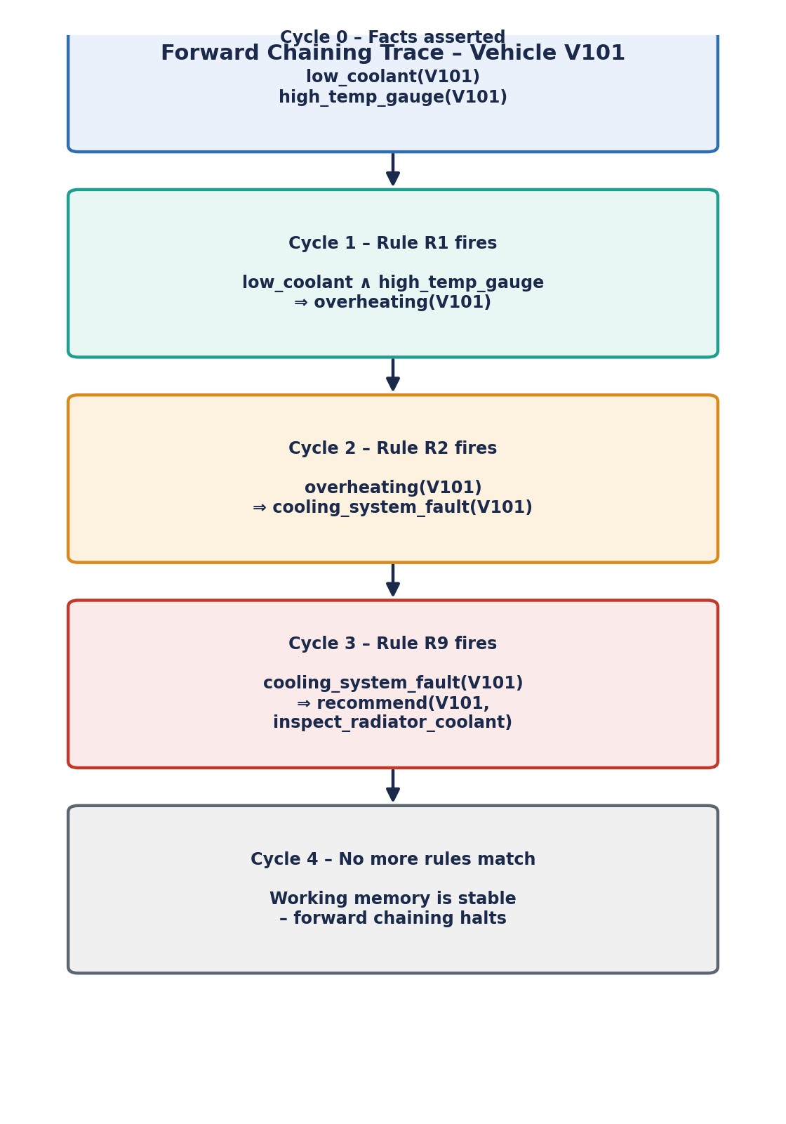
Figure 3: Forward-chaining trace from raw symptoms to the diagnosed fault for vehicle V101

7.2 Backward Chaining (Goal-Driven)
Backward chaining starts from a goal — a hypothesis to verify — and works backward, recursively reducing it to sub-goals until each sub-goal is matched against a known fact. Here the goal is: “Does V101 have a cooling_system_fault?”
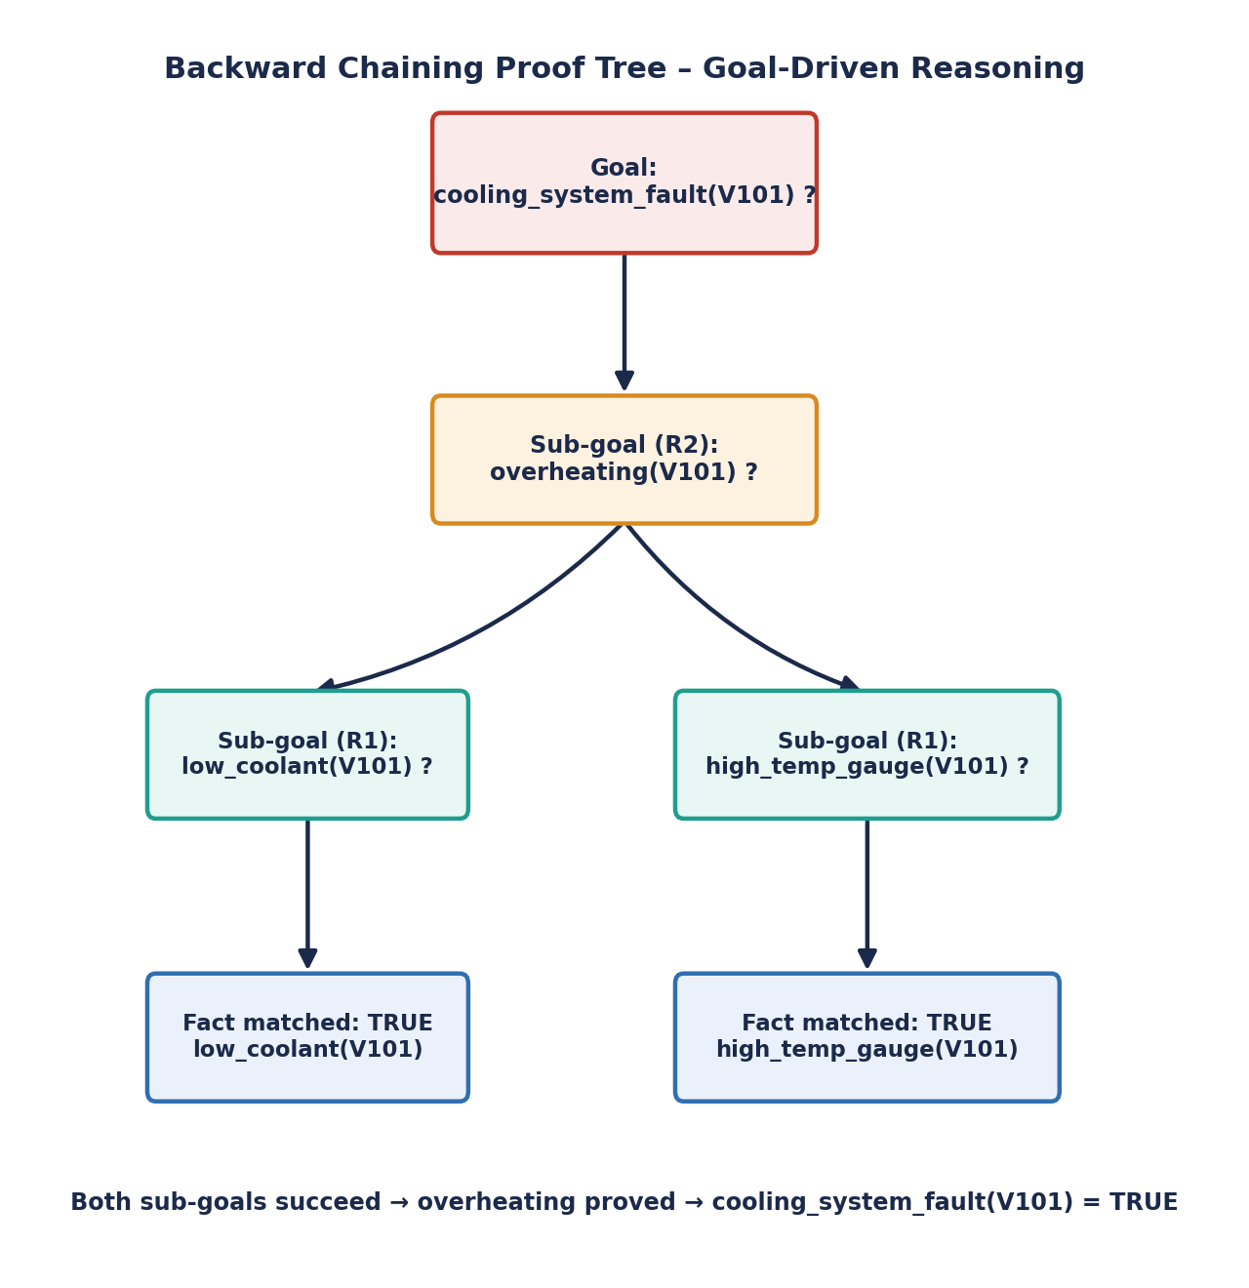
Figure 4: Backward-chaining proof tree for the goal cooling_system_fault(V101)

7.3 Comparison of the Two Traces
- Forward chaining is exhaustive and data-driven — useful when all symptoms are known upfront and every possible conclusion is wanted (e.g., a full vehicle health report).
- Backward chaining is goal-driven and typically more efficient when only a specific hypothesis needs verifying (e.g., a customer asks “is my overheating due to the cooling system?”), since it only explores facts relevant to that goal.
- Prolog's default resolution strategy is backward chaining, matching the trace in Figure 4 directly; forward chaining must be simulated explicitly (e.g., using assert/1 in a loop), since it is not Prolog's native mode.

8. Comparative Analysis of Modelling Approaches
The compulsory comparative table below evaluates all four models against the parameters specified in the assignment brief, followed by a radar-chart visualisation of their relative strengths.
Parameter | Production Rules | Propositional Logic | First-Order Logic | Prolog
Knowledge Representation | IF–THEN condition–action pairs | Atomic propositions + connectives | Predicates, variables, quantifiers | Facts & Horn-clause rules
Expressiveness | Moderate | Low | High | High
Rule Representation | Explicit, human-readable rules | Logical implications | Quantified formulas | head :- body clauses
Inference Mechanism | Pattern matching / rule firing | Modus ponens / resolution | Resolution + unification | SLD resolution + unification
Forward Chaining | Naturally supported | Possible, manual | Possible, less natural | Must be simulated (assert)
Backward Chaining | Supported (goal search) | Possible, manual proof | Naturally suited | Native default strategy
Handling Relationships | Weak (flat facts) | Very weak (no relations) | Strong (relations, variables) | Strong (unification)
Scalability | Moderate | Poor | Good | Good
Explainability | High (visible rule trace) | Moderate | Moderate (proof trees) | High (query trace)
Ease of Implementation | Easy (simple rule engine) | Easy | Moderate | Moderate (needs Prolog)
Suitability for the Problem | Good | Limited | Very good | Excellent
Table 5: Compulsory comparative table across the four modelling approaches
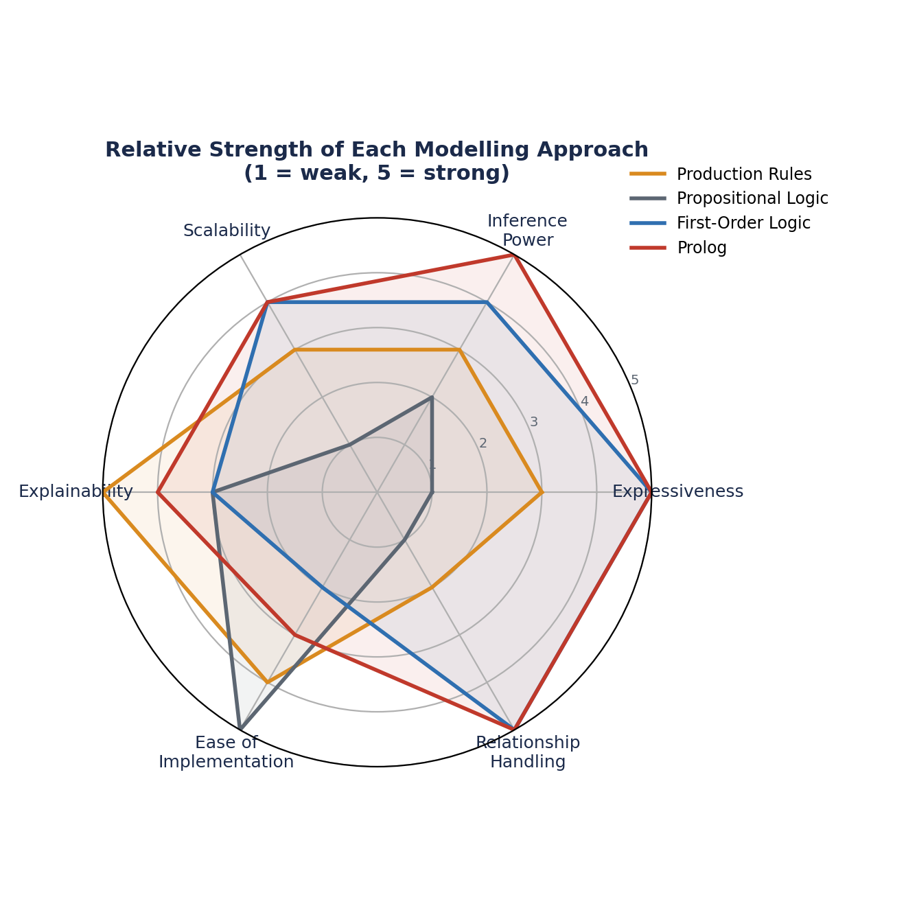
Figure 5: Relative strength of each modelling approach across six key parameters (1 = weak, 5 = strong)

8.1 Discussion
- Expressiveness & relationships: propositional logic is the weakest because it cannot generalise across vehicles; FOL and Prolog are strongest because variables and unification let one rule apply to any vehicle.
- Inference & chaining: production rules and Prolog both support goal-driven (backward) reasoning naturally, but forward chaining is clean only in production rules and (with simulation) Prolog; FOL's resolution can drive either style but needs an external control strategy.
- Scalability & explainability: production rules and Prolog scale well because rules/clauses are modular and can be added independently, and both give the clearest, most human-readable trace of why a conclusion was reached.
- Ease of implementation: propositional logic and production rules are simplest to hand-build; Prolog needs an interpreter but then executes the logic directly, avoiding a separately written inference engine.

9. Results, Discussion and Recommended Model
All four models were validated on the same four sample vehicles (V101–V104) and produced identical diagnostic conclusions, confirming that the knowledge was translated consistently across representations: V101 → cooling_system_fault, V102 → starting_system_fault, V103 → engine_internal_fault, and V104 → fuel_efficiency_fault.

9.1 Recommended Model
Prolog is recommended as the primary implementation approach for this automobile fault-diagnosis system. It combines the expressiveness and generality of first-order logic — variables, unification, one rule per fault class instead of one per vehicle — with an executable inference engine that requires no separate reasoning layer to be built. Its native backward-chaining behaviour matches how a service advisor typically interacts with the system: starting from a suspected fault and checking whether the evidence supports it, while forward-style behaviour can still be added for full vehicle health scans.

9.2 Role of the Other Models
- Production rules remain valuable as the authoring format: mechanics can review and edit IF–THEN rules without learning Prolog syntax, and these rules are then compiled into Prolog clauses.
- Propositional logic is useful only as a teaching / verification aid for single-vehicle reasoning; it is not recommended for deployment because it cannot generalise.
- First-order logic serves as the conceptual bridge between human-readable production rules and the executable Prolog program, and is useful for formally proving the correctness of the rule set.

9.3 Limitations and Possible Improvements
- The current model is purely deterministic (Boolean); real diagnostic symptoms often carry uncertainty, so adding certainty factors or a probabilistic layer (e.g., a Bayesian network) would better reflect real-world ambiguity.
- The knowledge base is currently static; integrating live OBD-II sensor data feeds would let symptom facts be asserted automatically rather than entered manually.
- Conflict resolution between simultaneously firing rules (e.g., a vehicle with both overheating and a no-start condition) could be made more sophisticated with rule priorities or salience values.

10. Conclusion, References & GitHub Repository

10.1 Conclusion
This report modelled an automobile fault-diagnosis problem across four knowledge-representation paradigms of increasing expressive power — production rules, propositional logic, first-order logic, and Prolog — and demonstrated both forward and backward chaining over the resulting rule base. The comparative analysis shows a clear expressiveness/generality gradient, with Prolog offering the best overall balance of expressiveness, executability, explainability and ease of scaling to a full fleet of vehicles, making it the recommended approach for a deployable service-centre diagnostic tool, while production rules remain the most natural authoring format for domain experts.

10.2 References
- Russell, S., & Norvig, P. (2021). Artificial Intelligence: A Modern Approach (4th ed.). Pearson.
- Bratko, I. (2011). Prolog Programming for Artificial Intelligence (4th ed.). Addison-Wesley.
- Giarratano, J. C., & Riley, G. (2005). Expert Systems: Principles and Programming (4th ed.). Course Technology.
- Clocksin, W. F., & Mellish, C. S. (2003). Programming in Prolog (5th ed.). Springer.
- SWI-Prolog Reference Manual. https://www.swi-prolog.org/pldoc/doc_for?object=manual

10.3 GitHub Repository
The Prolog source file, knowledge-base models, and test cases for this automobile fault-diagnosis assignment are maintained at:
github.com/tiloksaitejmannarapu-arch/MLA-0104/tree/main/C05AT-3

