METADATAGAMES

Web Services

Draft v1.0

Introduction

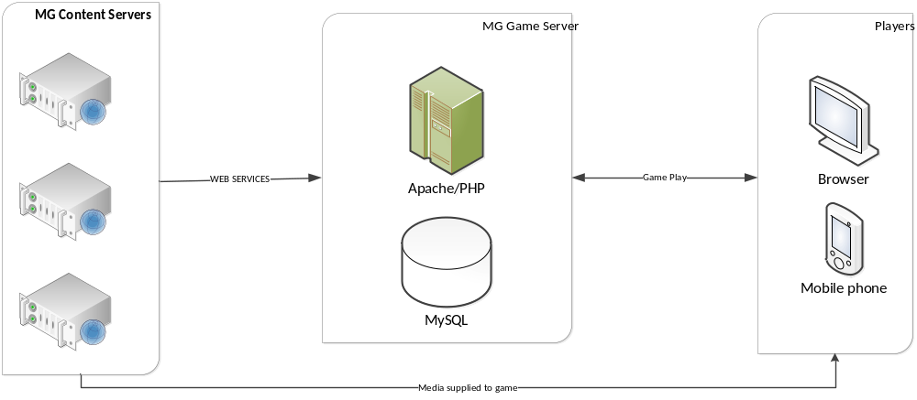

The API will allow MG Content Server to synchronize his content with MG Game Server.

MG Content Server will register to MG GAME SERVER and authentication token will be return as result .

Authentication for each request will be included in the post. This will be based on MD5 hash of a valid user(TOKEN). The TOKEN can be obtained from the MG GAME SERVER.

The API will be implementing SOAP based services with PHP

Production environment URL (SSL):
https://metadatagames.domain

Status type
Status type will be returned for every call to the service. It will tell if there is error or not.

Status
Attribute | Type | Description
status | String | It’ll contain status message, set from server, so it can be display in UI. If the call to operation is success the status message will be empty. If there is error or warning the server will set a message which have to be display on the UI.
statusCode | StatusCode | It’ll contain status code for errors, warnings or success.

StatusCode
Attribute | Type | Description
code | int | It’ll contain integer value for errors, warnings or success.
name | String | It’ll contain string value for errors, warnings or success.
SUCCESS 0
LOGON_ERROR 1
FATAL_ERROR 2
NOT_FOUND 3
SUCCESS_WITH_WARINGS 4
CANNOT_DELETE 5
……………

MG GAME API
Operations | Params | Return |  | Description
register | String username  String email  String password  String name  String url  String logoUrl  String description |  | Status status  String token |  | Register new institution MG Content Server  Authentication token will be return on success. This token will be used by MG Content Server for each request  Create institution account
updateProfile | String name  String url  String logoUrl  String description |  | Status status  String token |  | Register new institution MG Content Server  Authentication token will be return on success. This token will be used by MG Content Server for each request  Create institution account
createCollection  updateCollection  deleteCollection | String token  CollectionDTO collection |  | Status status |  | Create, update and delete operation for collection
createMedia | String token  MediaDTO media |  | Status status |  | Create new media, this operation will be used when institution upload new media file to create a record in MG Game Server database about institution’s media
deleteMedia | String token  Integer id |  | Status |  | Remove not process media
assignMediaToCollections | String token  AssignMediaDTO assign |  | Status status |  | Assign media file to collections, this operation will be used when institution assign a media file to collections to create record in MG Game Server database
assignMediasToCollections | String token  AssignMediaDTO[] assigns |  | Status status |  | Assign multiple media files to collections, this operation will be used when institution assign a media files to a collection to create record in MG Game Server database
createLicense  updateLicense  deleteLicense | String token  LicenseDTO license |  | Status status |  | Create, update and delete operation for license
 |  |  |  |  |  |  | email  password  newPassword | Status status | Change merchant password

Revision Sheet

Release No. | Date | Revision Description
1.0 | 08-2013 | MG GAME SERVER API implementation

Appendix – Project Contacts
Project manager, Sirma Solution
Nikolay Kondikov (Sirma Solution)
nikolay.kondikov@sirma.bg

Stephan Arabadjiev (Sirma Solution)
stephan.arabadjiev@sirma.bg

