METADATAGAMES

Push Notification

Draft v1.0

Node.js setup instruction

- Download and install Node.js server (http://nodejs.org/download/)
- Go to metadata games server subdirectory `nodejs`
- Install required packages described in package.json. Run npm install


- Open setting.js and setup mgapi url and the server port
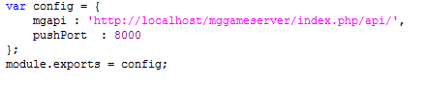

- Go to metadata games server subdirectory `protected\data` and open for edit fbvsettings.php. Set pushUrl

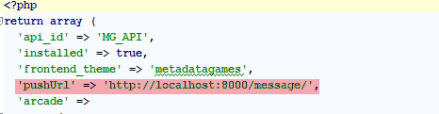

- Go back to metadata games server subdirectory `nodejs`
- Run push notification server, node server.js
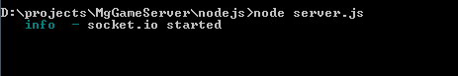

Note: Production deployment set real domain for node.js push server and make sure that the port is opened

Keep a node.js server up with Forever

http://blog.nodejitsu.com/keep-a-nodejs-server-up-with-forever

Revision Sheet
Release No. | Date | Revision Description
1.0 | 09-2013

