METADATAGAMES

Content Server Setup

Draft v1.0

Install MG Content Server

- Get the source from gitorious
- Open and edit protected/data/ fbvsettings.php
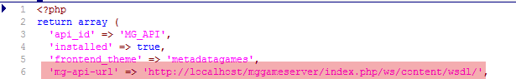
You have to set the MG Game Server url. In future we have to replace localhost with MG Game Server production domain.
- Go through MG Content Server install process
- Last step of installation you have to register MG Content Server to MG Game Server

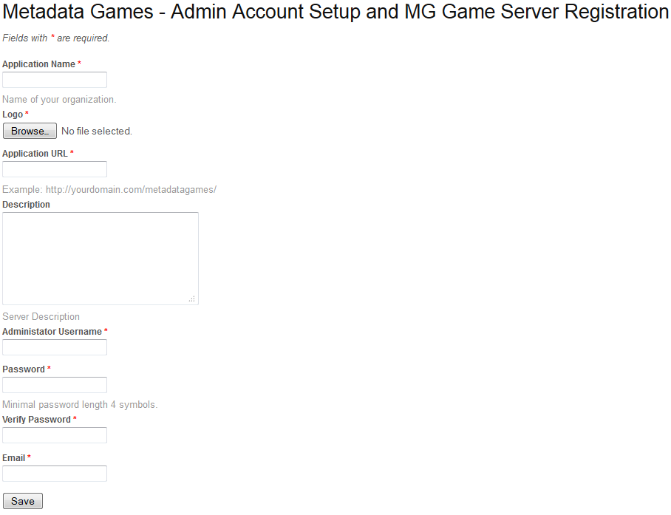
- Application name - the name of institution
- Logo – you have to upload institution’s logo
- Application URL – this is the real url where MG Content Server is installed for example http://localhost/mgc/
- Administrator Username and Password – this username can be used for login on MG Content Server as for login on MG Content Server, user will have one account for both servers
- Click on Save button will register MG Content Server to MG Game Server

- Go to MG Game Server and activate institution and his account, see bellow:
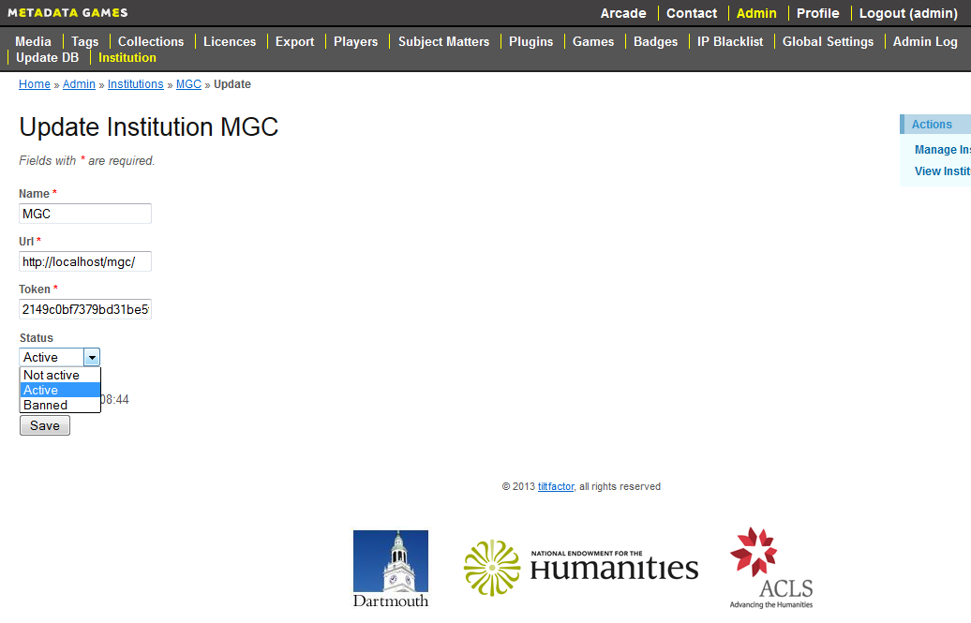

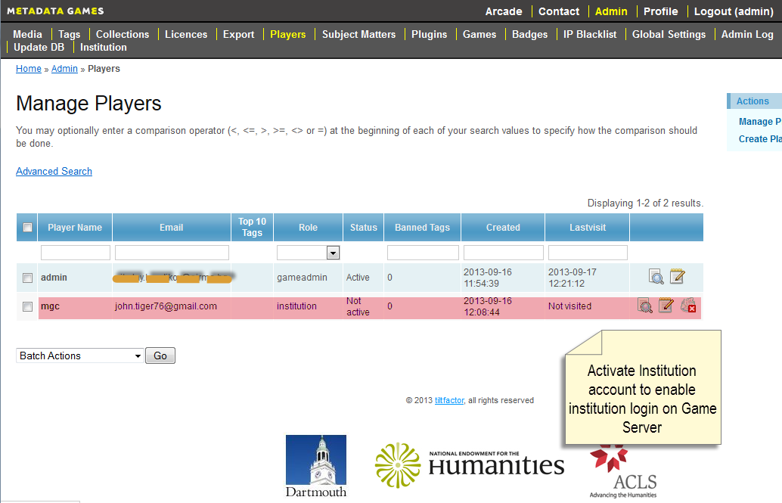

Revision Sheet
Release No. | Date | Revision Description
1.0 | 09-2013

