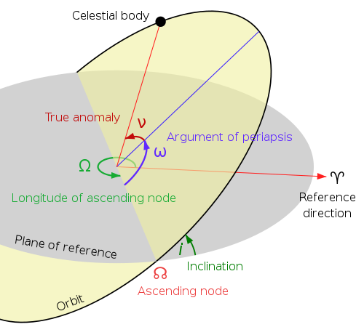
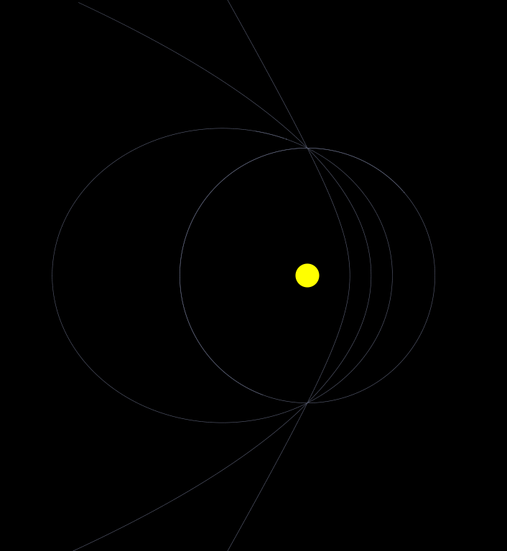

p
Hyperbolic (e = 2)
Parabolic (e = 1)
Elliptical (e = 0.5)
Circular (e = 0)

Screenshot of finished program (annotated)

Controls:

Up/Down: Increase/Decrease size of planets (realistic sizes cannot be seen)
Right/Left: Increase/Decrease running speed (it is more accurate at lower speeds)
PgUp/PgDown: Increase/Decrease trail length
Scroll: Zoom
F: Change camera focus
L: Lock/Unlock camera rotation
R: Reset camera rotation
Mouse: Rotate Camera

Analysis

This project is in the field of astrodynamics, the study of the mechanics of orbits in solar systems. This subject is very difficult to give a visual intuition of – the textbooks are full of difficult equations, and few give a real demonstration of how the different variables affect orbits.

This project aims to provide a useful simulation where users can input initail conditions and see a visual representation of various orbits. This can be used for students trying to learn more about astrodynamics, and teachers trying to give a visual demonstration.

*** Third party

Objectives:

1. Accurately model simple Keplerian orbits – circular, elliptical, parabolic, and hyperbolic
2. Provide a tool to add bodies with classical orbital elements, and provide explanation:

Semi-latus rectum | the distance between two bodies at right angles to the “periapsis” (minimum point)
Eccentricity | A measure of the shape of the orbit, illustrated below
Inclination | the angle between the orbital plane and the reference plane
Longitude of the ascending node | the angle from the reference direction anticlockwise to the point where the orbiting body rises above the reference plane
Argument of periapsis | the angle from the ascending node anticlockwise to the periapsis.
True anomaly | he angle from the periapsis anticlockwise to the current position of the body.
3. Ideally, be able to simulate motion in non-classical systems – e.g another star entering the solar system
4. Render the 3D system into 2D convincingly.
5. Be able to place one or more cameras anywhere in the system and provide controls for zoom/rotation/etc.
6. Be able to pause the simulation and modify variables at any point.
7. Provide a capability to save and load systems to/from the hard drive.

Design

This is split into three main areas: Mechanics, UI, and Graphics, which have been approached seperately. Mechanics deals with calculations of how the bodies are affected with time, UI deals with the user interface, and Graphics deals with the display of the simulation to the user while it is running

Mechanics

There are two main ways to simulate orbits: Directly from newton’s laws, or by the patched conic approximation.

Newton’s Laws: Calculate the instantaneous acceleration on a body exactly, then assume it is constant for a finite interval and move all bodies slightly

Patched Conic Approximation: Assume all trajectories follow the shape of conic sections, and patch the sections together wherever bodies move from orbiting one body to orbiting another.

Here is a comparison

Newton’s Laws | Patched-Conic Approximation
Can model complex interactions accurately (e.g binary star systems) | More accurate for simple systems (eg. our solar system)
Without enough processing power, it will either run slowly or inaccurately | Can run arbitrarily fast
 | Less processor intensive

I decided early on that the mechanics should be done directly from newton’s laws of gravitation if possible rather than then simplified 2-body problem, since it gives much greater flexibility in the types of situations which can be modelled. This does however mean that the program will run slightly slower and small errors will accumulate. After a small amount of prototyping I decided that these problems were not too major to handle.

Mathematical Structures:

We will use some basic mathematical structures to make 3D calculations easier: the 3-Vector, which stores 3 real numbers, and can be used for storing positions, velocities, and so on, and the 3x3 Matrix, which makes operations on 3-Vectors like rotation easier.

Structures.cs, Lines 10-124

Bodies:

There must be a data structure which holds a body in the system. This will be stored in RAM as the program is running, but also must be able to be saved to disk.

The required fields are:

Name – the name of the Body
Parent – the body this body is orbiting
StdGrav – the standard gravitational parameter of the body. This is equivalent to the body’s mass multiplied by the constant “G”, but is used more often than the mass so this will be stored instead
Position – the current position of the body
Velocity – the current velocity of the body
Color – the color of the body

This should be able to be constructed from the six orbital elements, so we will make a class containing the elements and use this for the constructor:

Structures.cs, Lines 375-424 and 282-339

We also need a class to store the planetary system as a whole, which requires the following fields:

Bodies – a list of the bodies in the system
Centers – the indexes in bodies of the system which can be focused on when the system is drawn.

The planetary system class will also handle all of the mechanics of the system. As it was decided to use Newton’s laws, the instantaneous acceleration on each body must be calculated first.

Pseudocode:
foreach body A in bodies:
foreach body B in bodies:
accelerationA ← accelerationA + b.stdGrav/(distance between them squared)
accelerationB ← accelerationB + a.stdGrav/(distance between them squared)

This runs in O(n²) time, which is acceptable. This calculation should be in a function called GetAcceleration().

The PlanetarySystem class will include a method TimeStep(step), which takes the instantaneous accelerations and assumes they are constant for a small time “step” in seconds, and modifies the bodies.

PlanetarySystem.cs Lines 55-63

The calculations should be encapsulated within the class and run asynchronously to the other processes. Public Start(), StartAsync(), and Stop() functions should be provided.

PlanetarySystem.cs Lines 64-72

Graphics:

Gtk# was chosen for this project as a graphics library since it is used professionally, has good support, and runs well on Linux with the Mono runtime.

The graphics processor should extract the bodies from each class

Tests

