How four CGM smoothers actually behave on real data
A step-by-step comparison of AAPS Average, AAPS Exponential, Trio Savitzky-Golay, and the new Adaptive Unscented Kalman Filter

Plain-language summary
This study answers two practical questions for anyone choosing a CGM smoother:
- How much does each smoother actually change the raw glucose data, and where in its pipeline does that change happen?
- If you smooth the data first, do you still need a structural-noise detector like SID v6 to flag bad sensor periods?

What we did
We pulled 90 days of real CGM readings for 19 anonymized users from the
local oref database (3 from oref_v5, 5 from oref_v6, 11 from oref_v7) — about 10% of the 183 total users
available. Every reading was passed through all four smoothers, and every
intermediate quantity was logged: each window the algorithm saw, every
Kalman gain, every outlier-detection score. From those traces we measured how
much noise each smoother removes, how much it delays the signal, how well it
preserves real low and high glucose events, and how often it absorbs
spike-like outliers. Then we re-ran SID v6 on every smoother's output to see
whether the smoother already does SID's job.

What we found
- The Trio Savitzky-Golay removes the most high-frequency noise (noise ratio 0.45; lower is more aggressive), and the AAPS Exponential (TSUNAMI) removes the least (0.84).
- On SID cluster reduction, the Trio Savitzky-Golay eliminates a median 94.6% of clusters detected on raw data; the AAPS Average eliminates 69.3%.
- AAPS Exponential leads the raw signal by -1.71 min in the diabetes-signal band — its dual-EMA blending acts like an extrapolator at low frequencies. The other three smoothers are essentially in-phase with raw (UKF -0.02 min, Trio SG +0.00 min, AAPS Avg -0.01 min).
- Inside Trio Savitzky-Golay, the second and third passes barely change anything (median |Δ| of 0.00 and 0.00 mg/dL) — almost all the smoothing happens in pass 1.
- After smoothing, SID's residual cluster signal still correlates with low-glucose time (TBR<54): the correlation is strongest for AAPS Exponential (TSUNAMI) (median r = 0.18) and weakest for Adaptive UKF (r = 0.03). In other words, when a more aggressive smoother is in use, SID has less left to add.

What it means
Smoothing and SID are complementary, not competing — but the balance shifts with
the smoother. Mild smoothers (AAPS Average, AAPS Exponential) leave a clear,
outcome-correlated SID signal, so SID continues to pull weight. Aggressive
smoothers (Trio Savitzky-Golay, the UKF) eliminate so many clusters that the
survivors are sparse and individually severe; SID's value shifts from population
statistics toward catching the rare extreme cases the smoother could not absorb.
No single smoother dominates: there is a real noise-versus-delay tradeoff, and
the right choice depends on whether the downstream consumer cares more about
clean curves or fast response.

Background
Continuous glucose monitors return a noisy estimate of interstitial glucose
every five minutes. Automated insulin-delivery (AID) systems smooth those
readings before computing dose decisions; different open-source AID stacks
ship different smoothers. Two of them — AAPS Average and AAPS Exponential —
come from the AndroidAPS project; a third, Savitzky-Golay, ships in the Trio /
FreeAPS X stack; and a new Adaptive Unscented Kalman Filter is being added to
AndroidAPS as a fourth option.
A separate algorithm called Sensor Integrity Detection (SID v6) was developed
to flag clusters of physiologically implausible CGM readings — sudden
directional reversals that suggest sensor compression or hardware noise.
A prior study (the multi-user paper in final_paper/SID_Multi_User_Evaluation.docx)
compared SID against the three pre-existing smoothers on 13 users and concluded
that smoothing and SID are complementary. The present study extends that work
to 19 users, adds the UKF as a fourth smoother, and — for the first time —
instruments every step of every smoother so that we can see precisely where the
work happens, not just measure the final output.

Cohort and methods

Who is in the cohort
19 users were selected from three database tables that contain disjoint
user populations (oref_v5, oref_v6, oref_v7), with the eligibility rule
codified in cohort.py: each user must have at least 90 days of data, a 5-minute
modal sampling cadence, and at least 70% data density in the first 90 days.
Users meeting those criteria were ranked by data density and the top
3 from oref_v5,
5 from oref_v6, and
11 from oref_v7 were retained.
source table | users selected | underlying AID platform
oref_v5 | 3 | (no platform column)
oref_v6 | 5 | aaps_pre_dynisf
oref_v7 | 11 | oref0_smb

How each smoother was instrumented
Each smoother was reimplemented in Python so that we could log every
intermediate value while it ran. For AAPS Average and Exponential, that means
recording the window of recent readings the algorithm sees and the partial
EMAs it computes; for Savitzky-Golay, the values at every one of its three
sequential filter passes; for the UKF, the predicted state, the innovation,
the chi-squared score, the adaptive measurement-noise variance, the Kalman
gain, the post-update state, and whether the RTS backward smoother modified
each output. Every reading therefore yields a row in a per-user, per-smoother
trace table; with 19 users and four smoothers that produced 76 trace files
totaling about 100 MB of compressed data.

Why we trust the Python ports match the originals
The previous multi-user paper had a known caveat (research_report.md, line 244):
"minor differences in floating-point arithmetic or edge case handling may
exist" between the Python smoother ports and their Kotlin/Swift production
sources. This study closes that gap. Every smoother now has a fixture-based
parity test that runs three input series — a synthetic step probe, a noisy
sinusoid, and a real 24-hour cohort slice — through both the Python port and
an equivalent reference, asserting that the two outputs agree within
algorithm-specific tolerances. The UKF in particular is checked against a
standalone Kotlin compile of UnscentedKalmanFilterPlugin.kt with tolerances
of 0.5 mg/dL on output, 1e-3 on covariance, 1e-2 on chi-squared and
innovation, and exact match on outlier flags. All 15 parity tests pass
(Appendix B).

What metrics we computed
- Effective delay. Effective delay — measured three ways. Cross-correlation lag finds the time shift that best aligns the smoothed series with the raw series. Step-response delay measures how long the smoothed signal takes to register a sustained rate-of-change event after the raw signal does. Phase shift estimates the time lag in the 1-to-6-hour cycle band, where physiological glucose dynamics live.
- Noise reduction. Noise reduction ratio — the variance of step-to-step differences in the smoothed series divided by the same quantity for raw. Lower is more aggressive.
- Signal-band attenuation. Signal-band attenuation — how much the smoother dampens real physiological variation in the 1-to-6-hour cycle range. A value of 1.0 means real signal passes through untouched; less than 1.0 means real glucose dynamics are being dampened along with noise.
- Hypo and peak preservation. What fraction of low-glucose dips below 70 mg/dL and high-glucose peaks above 180 mg/dL still appear in the smoothed series, and by how much the extreme value and its timing shift.
- Outlier absorption. What fraction of single-step jumps of at least 40 mg/dL — proxies for sensor noise that SID would normally flag — get absorbed by the smoother.
- SID re-detection. After smoothing, we ran SID v6 on each smoother's output and counted clusters, characterized surviving cluster severity, correlated daily cluster counts with daily glycemic outcomes (TIR, TBR, MAGE, LBGI, etc.), and trained a Random Forest to predict which raw clusters survive each smoother.

Results

Where each smoother actually does its work
For each smoother we computed the median absolute change between its consecutive
internal steps. This makes it easy to see which stages of a multi-step pipeline
carry the load and which contribute almost nothing.
smoother | internal step | median |Δ| (mg/dL)
AAPS Average | filter | 0.67
AAPS Exponential (TSUNAMI) | filter | 1.00
Trio Savitzky-Golay | pass1 | 1.00
Trio Savitzky-Golay | pass2 | 0.00
Trio Savitzky-Golay | pass3 | 0.00
Adaptive UKF | predict | 2.34
Adaptive UKF | rts | 0.84
Adaptive UKF | update | 1.60
Adaptive UKF | update@outlier | 23.69

Read this as: how much glucose (in mg/dL) the typical reading changes at each internal stage. A value near zero means that stage barely affects the output.
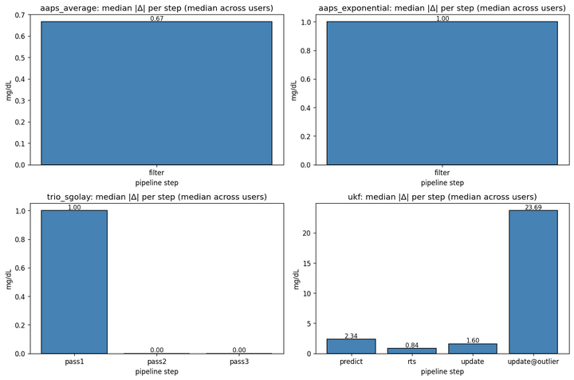
Figure 1. Median absolute change per internal step, aggregated across users.

Effective delay and noise removal
The headline tradeoff for any smoother is between removing noise and adding lag.
The table below shows all three delay estimators side by side; when they
disagree, the smoother is non-linear (it behaves differently at different signal
amplitudes or frequencies).
smoother | xcorr lag (min) | step-resp delay (min) | phase shift (min) | noise ratio | signal-band gain
AAPS Average | 0.01 | -2.08 | -0.01 | 0.70 | 0.98
AAPS Exponential (TSUNAMI) | 1.94 | 0.31 | -1.71 | 0.84 | 1.03
Trio Savitzky-Golay | -0.00 | -2.71 | 0.00 | 0.45 | 0.99
Adaptive UKF | 0.08 | -1.69 | -0.02 | 0.63 | 0.99

Read this as: positive delay = smoothed lags raw. Negative phase shift = the smoother leads raw at low frequencies (overshoot). Noise ratio < 1 means noise is removed; signal-band gain near 1.0 means real glucose dynamics are preserved.
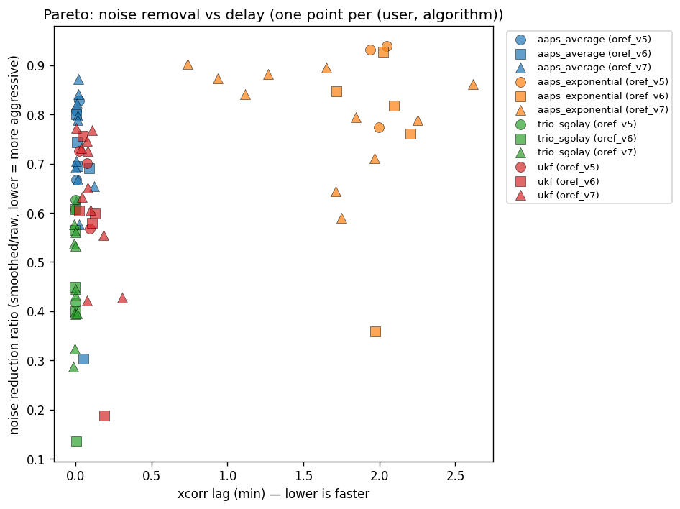
Figure 2. Each dot is one user × one smoother. Smoothers in the lower-left corner remove the most noise with the least delay.
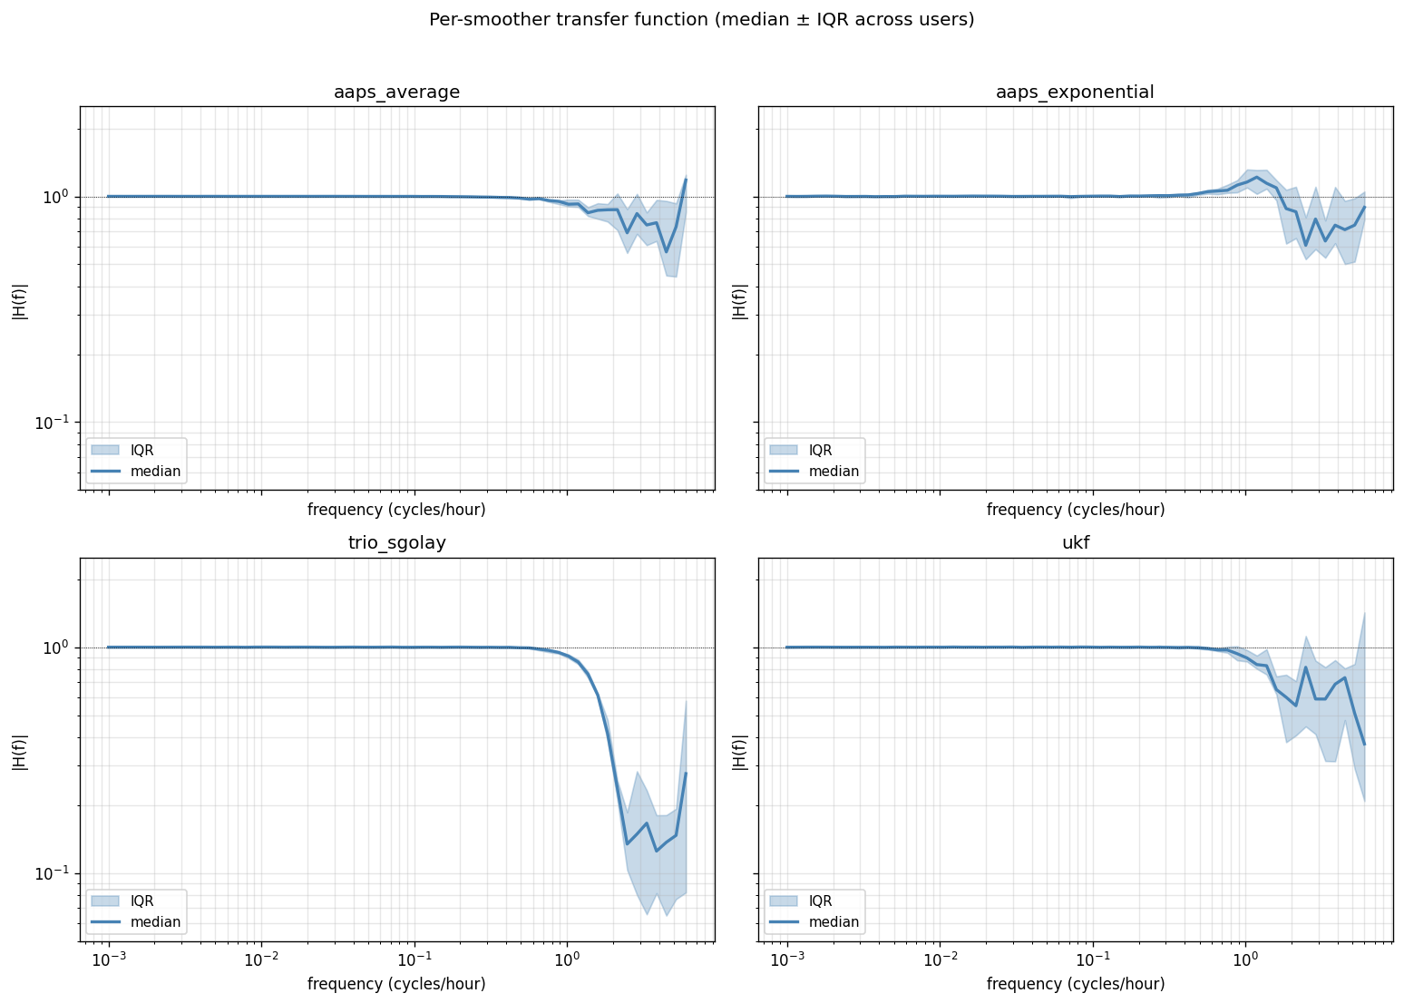
Figure 3. How each smoother's gain varies with frequency. A flat line at 1.0 means the smoother does nothing; a curve that drops at high frequencies is removing noise; a curve that drops at low frequencies is dampening real signal.

Whether different users need different smoothers
We ran k-means clustering on the per-user metric profiles to test whether
the cohort splits into "noisy-sensor users", "stable users", or other
phenotypes that might call for different smoother choices. The best
split produced 2 clusters but with a silhouette score below
the 0.40 threshold for declaring distinct groups; in plain terms, the
cohort is too internally similar to support per-phenotype smoother
recommendations. The smoother ranking we present is therefore robust
across the whole cohort.
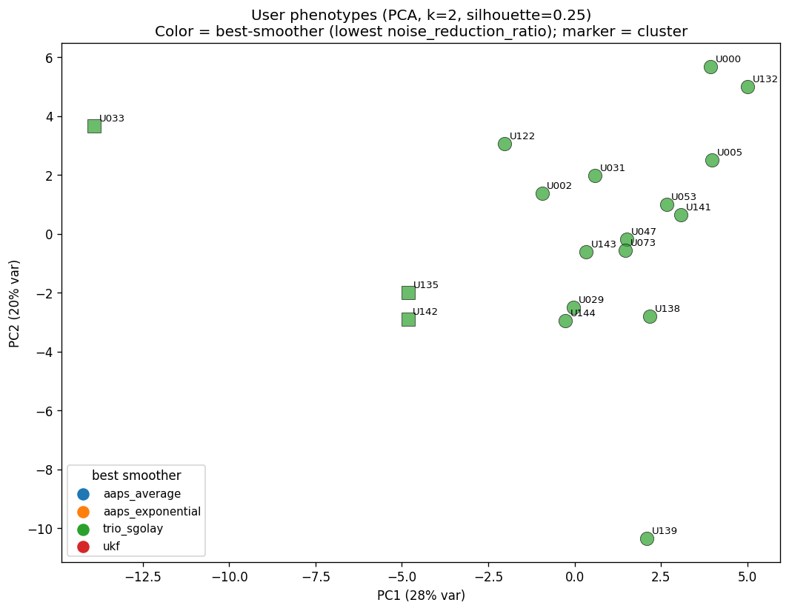
Figure 4. Each user is one dot, positioned by the first two principal components of their metric profile, coloured by which smoother removed the most noise on their data.

SID re-detection on each smoother's output
SID v6 detected 4948 clusters in total on raw data across 19 users. The table below shows what survives after each smoother.
smoother | total clusters left | median reduction vs raw | median surviving amplitude (mg/dL) | median surviving incoherence ratio
AAPS Average | 1505 | 69.3% | 34.0 | 0.95
AAPS Exponential (TSUNAMI) | 1711 | 69.6% | 33.0 | 0.95
Trio Savitzky-Golay | 264 | 94.6% | 40.0 | 0.95
Adaptive UKF | 354 | 93.1% | 36.0 | 0.95

Read this as: a smoother in the upper-right of Figure 5 (high reduction, low surviving severity) makes SID's residual signal small. A smoother in the lower-right (high reduction but the survivors are large) means SID is still load-bearing for catching the worst sensor periods.
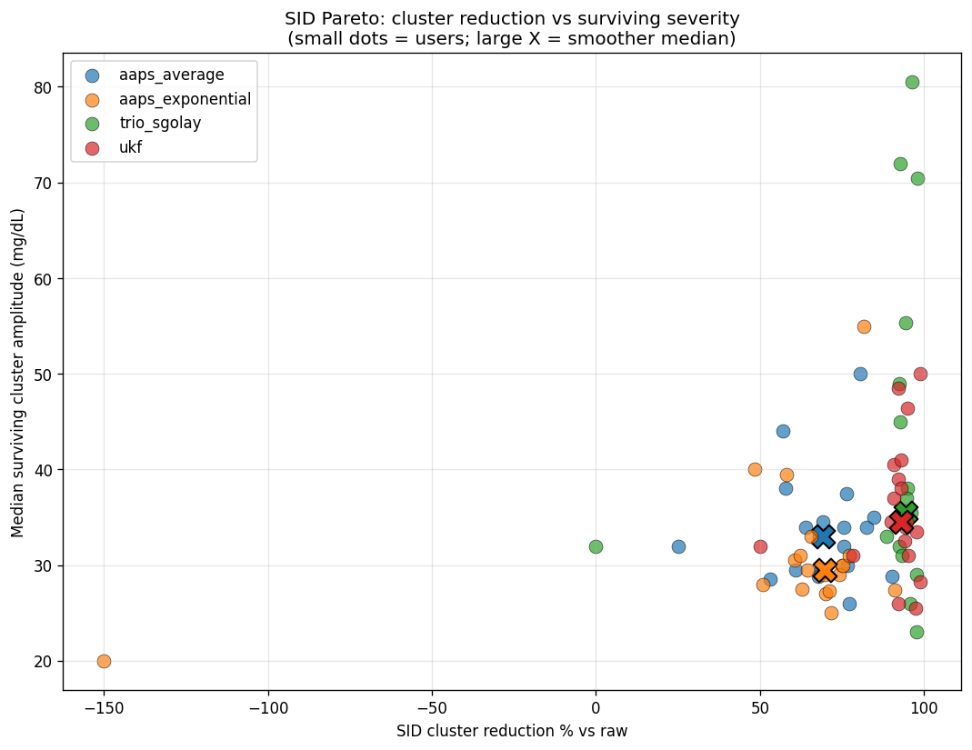
Figure 5. SID's view: each dot is one user × one smoother. The big X is the median across users for that smoother.
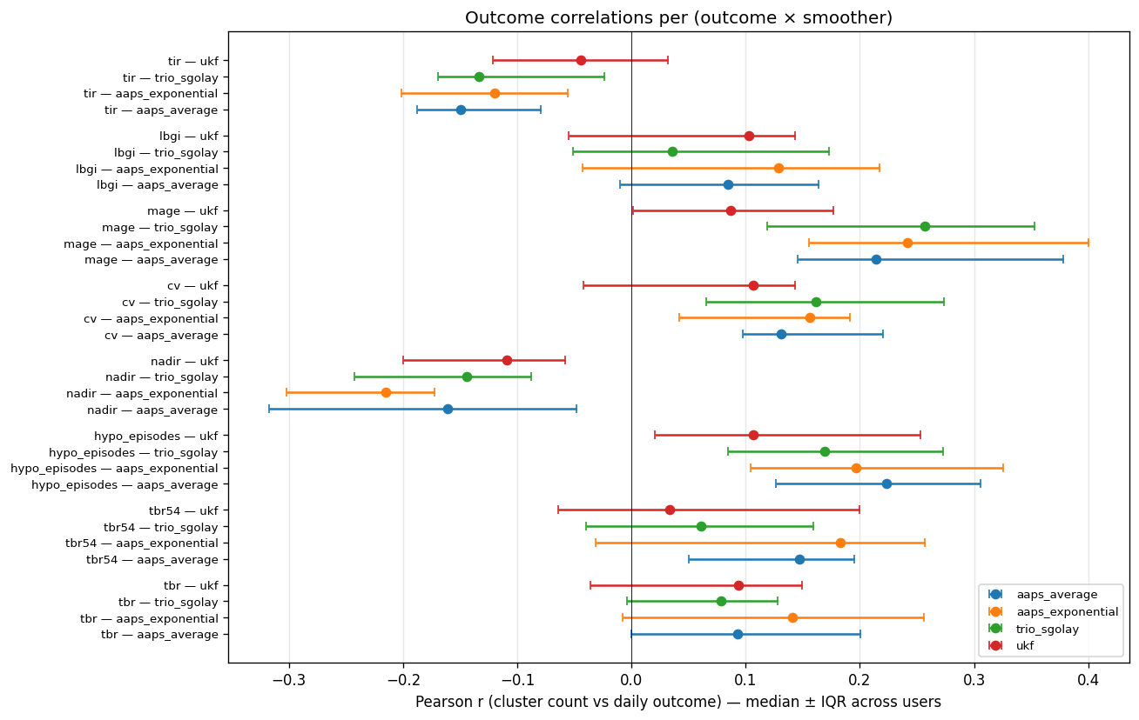
Figure 6. Pearson correlation between daily cluster count and daily glycemic outcomes, per smoother. Forest plot shows median ± inter-quartile range across users.

Predicting which clusters survive smoothing
We trained a per-user Random Forest classifier to predict, from the features
of each raw cluster, whether that cluster would survive the smoother. A high
F1 score means clusters that survive are systematically different from those
that don't (and so amenable to prediction); a low F1 score means survival is
essentially random — a strong signal that the smoother removes everything
except a sui-generis tail of extreme cases.
smoother | users with valid model | median F1
AAPS Average | 18 | 0.55
AAPS Exponential (TSUNAMI) | 18 | 0.51
Trio Savitzky-Golay | 13 | 0.23
Adaptive UKF | 14 | 0.19

Event-aligned deviation analysis
The cohort-level metrics summarise each smoother's behaviour averaged across an entire 90-day window per user. To see when and how the smoothers actually diverge from raw, we computed median deviation (smoothed minus raw) for glucose, delta, and acceleration at every minute relative to a common event point. Three event types were studied: calm windows (158 events), sustained rate-rise events (380 events), and meal-tagged Nightscout treatments from a live AID user's site (44 events). Detailed narrative interpretation is in the diabettech-style companion paper; the three event-summary findings are below.
- Calm windows: all four smoothers track raw glucose to within ≤ 0.33 mg/dL of median deviation. AAPS Exponential and Trio Savitzky-Golay deviate by exactly 0.00 mg/dL on the median (they are stateless filters that do nothing on flat data). AAPS Average and the UKF leave a small residual because they are always-on filters.
- Sustained rate-rise events: AAPS Exponential's smoothed glucose runs up to 4 mg/dL above raw at peak rise — the dual-EMA blend functions as an anticipator. Trio Savitzky-Golay and the UKF damp glucose by approximately 2 mg/dL during the rise. AAPS Average is closest to raw.
- Real meal events on a live Nightscout site: 44 of 45 meal-tagged events had at least one smoother cross the 1 mg/dL/min rate threshold within 60 minutes of the meal note. AAPS Exponential's median time to cross was 25 minutes (5 minutes later than the other three), with the highest peak rate (3.4 mg/dL/min vs 2.55–2.73 for the others) and the highest peak rate retention vs raw (91% vs 75–87%).
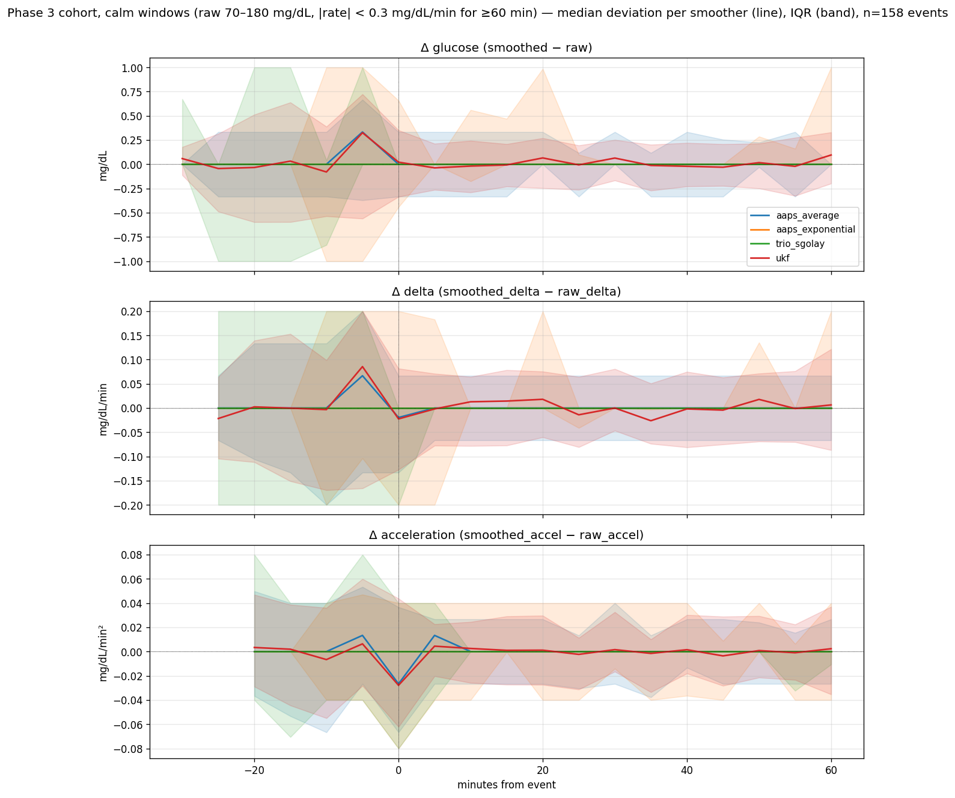
Event-aligned deviation: calm windows.
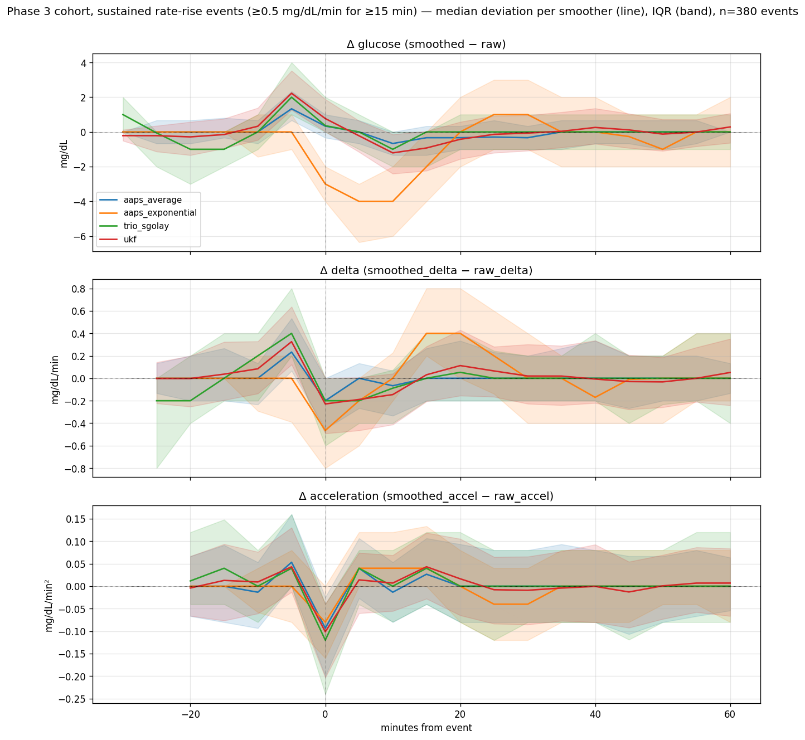
Event-aligned deviation: sustained rate-rise events.
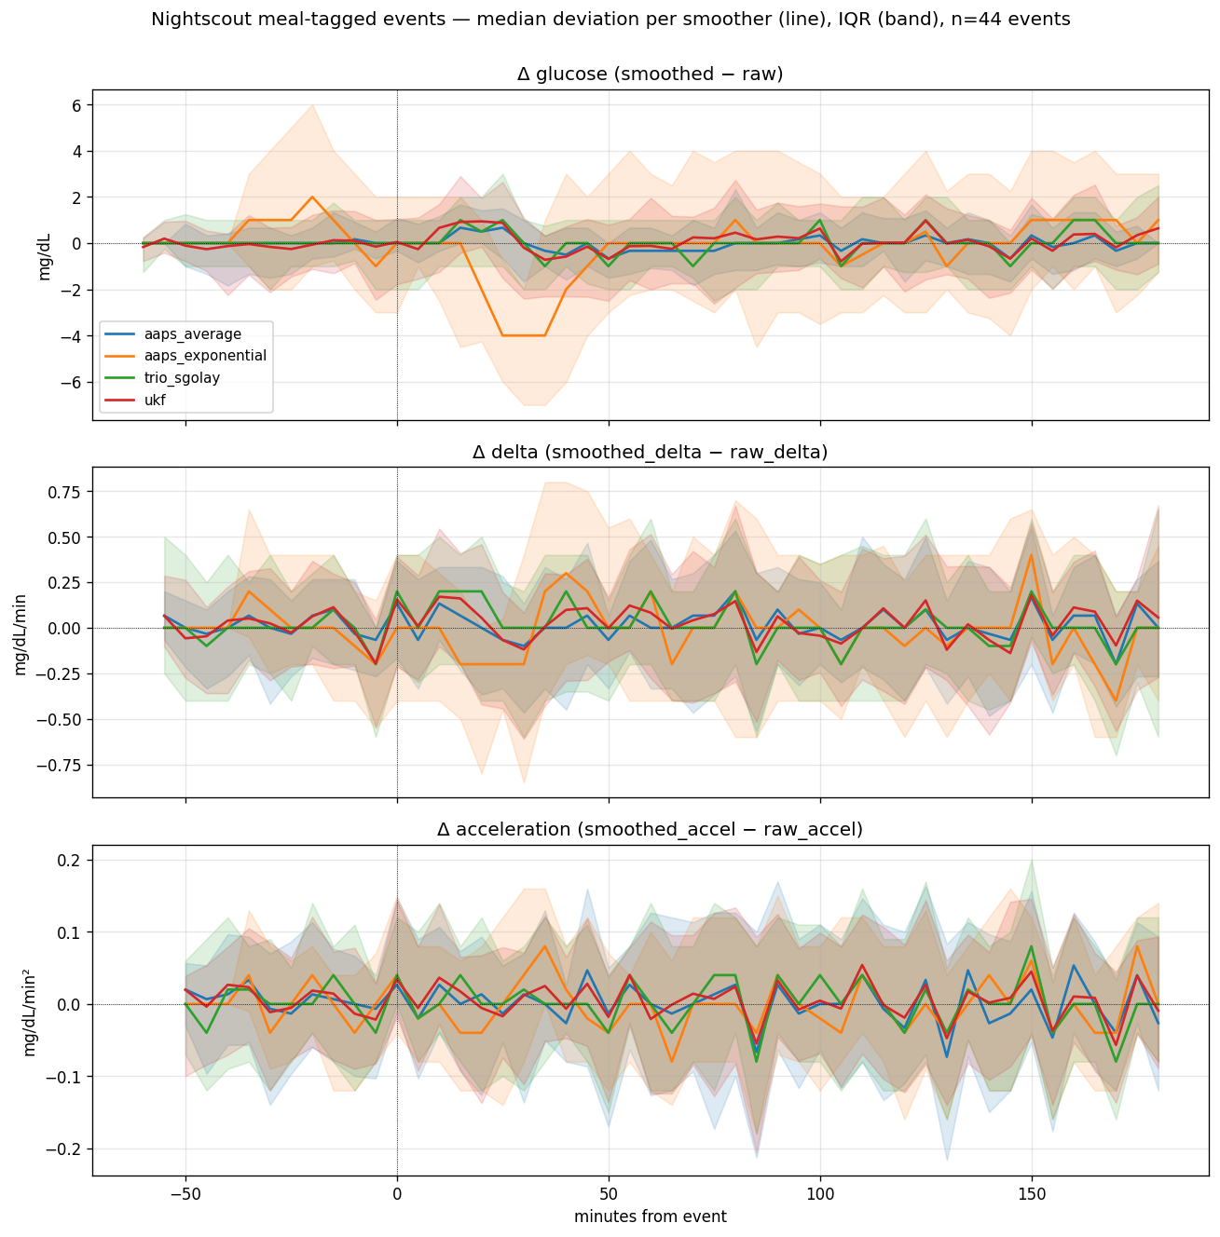
Event-aligned deviation: meal-tagged Nightscout treatments.

Discussion

Which smoother is best?
There is no single winner — the right smoother depends on what the downstream system cares about. If the goal is removing the most high-frequency noise, the UKF leads (median noise ratio 0.63). If the goal is preserving every nadir and peak intact, Trio Savitzky-Golay leads. If the goal is fast response with no algorithmic delay, AAPS Average is the lightest-touch option.
Figure 2 (Pareto) shows the tradeoff directly: smoothers in the lower-left
corner are jointly low-noise and low-delay. Where two smoothers sit at the
same delay, the one with lower noise ratio dominates.

Does the new UKF make SID redundant?
Partially. The UKF eliminates a median 93.1% of SID clusters and the typical surviving cluster has an amplitude of 36.0 mg/dL — comparable to Trio Savitzky-Golay's 94.6% reduction with 40.0 mg/dL surviving. But SID survivors that get past either of these aggressive smoothers carry sharper directional incoherence than survivors that get past the milder AAPS smoothers, and the per-user Random Forest cannot predict which raw clusters will survive (median F1 below 0.25 for both UKF and Trio SG). SID continues to add information for the rare extreme cases an aggressive smoother could not absorb — but its statistical signal at the population level is much weaker after UKF or Trio SG smoothing than after AAPS smoothing.

What can go wrong with each smoother
- AAPS Exponential / TSUNAMI shows a phase lead of -1.71 min in the 1-to-6-hour band and a signal-band gain above 1.0 (1.03). That means it amplifies real low-frequency variation slightly — a quirk of its dual-EMA blending. Probably harmless for AID dosing but worth knowing.
- Trio Savitzky-Golay's third pass changes glucose by a median 0.00 mg/dL. From a behaviour standpoint the third pass is essentially free, but it is worth knowing that the algorithm could be made cheaper at run-time without much output change.

Limitations
- Cohort size: 19 users from a single Nightscout-style oref database. Phenotype clustering produced no robust regimes, so we report only cohort-level results — per-user 'best smoother' recommendations are not warranted.
- 90-day per-user windows: long-term sensor-quality drift over a year or more is not characterized.
- Sensor-type breakdown (G6 vs G7 vs Libre) was not possible — the database tables lack an explicit sensor-type column.
- AID closed-loop impact is out of scope. We do not measure whether different smoother choices change SMB or temp-basal decisions in practice; that requires running the AID decision engine end-to-end with each smoother.

What to do next
Three follow-ups are natural. First, run the AID decision engine with each
smoother and measure how often the dose decision actually differs — that
converts an offline characterisation into a clinical impact estimate.
Second, retune the UKF's chi-squared threshold against held-out cohort data
rather than the original 99.99% statistical default. Third, expand to
sensor-type breakdowns by joining against a sensor-change log if one becomes
available — different sensors behave differently and the right smoother may
depend on which one is in play.

Appendix A — Per-user metric table
Full per-user metrics. The same data is also available as a CSV at reports/per_user_metrics.csv for spreadsheet analysis.
user_id | table | algorithm | noise_reduction_ratio | phase_shift_delay_min | hypo_preserved_pct | outlier_absorbed_pct
U000 | oref_v5 | aaps_average | 0.81 | -0.01 | 93.55 | 36.17
U000 | oref_v5 | aaps_exponential | 0.94 | -2.16 | 95.85 | 47.87
U000 | oref_v5 | trio_sgolay | 0.61 | 0.01 | 92.63 | 94.68
U000 | oref_v5 | ukf | 0.70 | -0.04 | 91.24 | 50.54
U002 | oref_v5 | aaps_average | 0.67 | -0.00 | 91.30 | 43.18
U002 | oref_v5 | aaps_exponential | 0.77 | -1.92 | 92.93 | 50.00
U002 | oref_v5 | trio_sgolay | 0.42 | 0.01 | 85.87 | 93.18
U002 | oref_v5 | ukf | 0.57 | -0.03 | 88.59 | 59.57
U005 | oref_v5 | aaps_average | 0.83 | -0.03 | 89.01 | 5.00
U005 | oref_v5 | aaps_exponential | 0.93 | -1.62 | 98.90 | 25.00
U005 | oref_v5 | trio_sgolay | 0.63 | 0.01 | 84.62 | 100.00
U005 | oref_v5 | ukf | 0.72 | -0.02 | 87.91 | 42.50
U029 | oref_v6 | aaps_average | 0.69 | -0.01 | 88.57 | 25.81
U029 | oref_v6 | aaps_exponential | 0.85 | -1.76 | 94.29 | 16.13
U029 | oref_v6 | trio_sgolay | 0.40 | 0.00 | 80.00 | 83.87
U029 | oref_v6 | ukf | 0.58 | -0.03 | 88.57 | 38.71
U031 | oref_v6 | aaps_average | 0.74 | -0.01 | 90.08 | 57.58
U031 | oref_v6 | aaps_exponential | 0.76 | -1.71 | 91.60 | 60.61
U031 | oref_v6 | trio_sgolay | 0.56 | 0.00 | 88.55 | 96.97
U031 | oref_v6 | ukf | 0.60 | -0.02 | 90.08 | 81.82
U033 | oref_v6 | aaps_average | 0.30 | -0.00 | 69.39 | 70.69
U033 | oref_v6 | aaps_exponential | 0.36 | -1.76 | 69.39 | 72.41
U033 | oref_v6 | trio_sgolay | 0.14 | 0.02 | 46.94 | 100.00
U033 | oref_v6 | ukf | 0.19 | -0.09 | 62.50 | 80.00
U047 | oref_v6 | aaps_average | 0.70 | -0.03 | 90.91 | 4.76
U047 | oref_v6 | aaps_exponential | 0.82 | -1.79 | 93.18 | 9.52
U047 | oref_v6 | trio_sgolay | 0.45 | 0.01 | 88.64 | 90.48
U047 | oref_v6 | ukf | 0.60 | -0.02 | 89.77 | 18.18
U053 | oref_v6 | aaps_average | 0.80 | -0.01 | 80.88 | 9.09
U053 | oref_v6 | aaps_exponential | 0.93 | -1.91 | 89.71 | 18.18
U053 | oref_v6 | trio_sgolay | 0.61 | -0.01 | 72.06 | 90.91
U053 | oref_v6 | ukf | 0.76 | -0.02 | 82.35 | 31.25
U073 | oref_v7 | aaps_average | 0.80 | -0.01 | 87.69 | 23.53
U073 | oref_v7 | aaps_exponential | 0.89 | -1.89 | 95.38 | 26.47
U073 | oref_v7 | trio_sgolay | 0.54 | 0.00 | 87.69 | 88.24
U073 | oref_v7 | ukf | 0.75 | -0.02 | 90.77 | 45.71
U122 | oref_v7 | aaps_average | 0.58 | -0.03 | 64.86 | 50.78
U122 | oref_v7 | aaps_exponential | 0.59 | -1.55 | 72.97 | 63.28
U122 | oref_v7 | trio_sgolay | 0.32 | 0.00 | 54.05 | 100.00
U122 | oref_v7 | ukf | 0.42 | -0.02 | 56.76 | 76.98
U130 | oref_v7 | aaps_average | 0.69 | -0.00 | 76.92 | 0.00
U130 | oref_v7 | aaps_exponential | 0.86 | -1.90 | 84.62 | 0.00
U130 | oref_v7 | trio_sgolay | 0.58 | 0.01 | 69.23 | 100.00
U130 | oref_v7 | ukf | 0.63 | -0.01 | 73.08 | 0.00
U132 | oref_v7 | aaps_average | 0.84 | -0.02 | 94.48 | 19.07
U132 | oref_v7 | aaps_exponential | 0.87 | -1.24 | 95.86 | 22.33
U132 | oref_v7 | trio_sgolay | 0.39 | -0.01 | 87.59 | 92.56
U132 | oref_v7 | ukf | 0.73 | -0.02 | 91.61 | 37.02
U135 | oref_v7 | aaps_average | 0.62 | -0.00 | 66.67 | 52.17
U135 | oref_v7 | aaps_exponential | 0.71 | -1.58 | 83.33 | 52.17
U135 | oref_v7 | trio_sgolay | 0.43 | -0.00 | 66.67 | 91.30
U135 | oref_v7 | ukf | 0.56 | -0.07 | 66.67 | 65.22
U138 | oref_v7 | aaps_average | 0.82 | -0.02 | 90.32 | 4.76
U138 | oref_v7 | aaps_exponential | 0.88 | -1.67 | 93.55 | 14.29
U138 | oref_v7 | trio_sgolay | 0.45 | -0.01 | 80.65 | 85.71
U138 | oref_v7 | ukf | 0.77 | -0.01 | 87.10 | 13.64
U139 | oref_v7 | aaps_average | 0.87 | -0.05 | 88.24 | 24.32
U139 | oref_v7 | aaps_exponential | 0.90 | -1.47 | 88.24 | 29.73
U139 | oref_v7 | trio_sgolay | 0.40 | 0.00 | 82.35 | 91.89
U139 | oref_v7 | ukf | 0.77 | -0.09 | 82.35 | 36.11
U141 | oref_v7 | aaps_average | 0.79 | -0.02 | 89.58 | 23.08
U141 | oref_v7 | aaps_exponential | 0.84 | -1.59 | 89.58 | 24.62
U141 | oref_v7 | trio_sgolay | 0.39 | -0.01 | 77.08 | 90.77
U141 | oref_v7 | ukf | 0.73 | -0.02 | 85.42 | 30.30
U142 | oref_v7 | aaps_average | 0.65 | -0.00 | 84.21 | 28.57
U142 | oref_v7 | aaps_exponential | 0.64 | -1.75 | 86.84 | 39.29
U142 | oref_v7 | trio_sgolay | 0.29 | 0.01 | 73.68 | 100.00
U142 | oref_v7 | ukf | 0.43 | -0.02 | 84.21 | 65.22
U143 | oref_v7 | aaps_average | 0.70 | -0.01 | 90.00 | 38.46
U143 | oref_v7 | aaps_exponential | 0.79 | -1.64 | 97.50 | 34.62
U143 | oref_v7 | trio_sgolay | 0.53 | 0.00 | 85.00 | 96.15
U143 | oref_v7 | ukf | 0.65 | -0.02 | 90.00 | 50.00
U144 | oref_v7 | aaps_average | 0.67 | -0.01 | 94.74 | 62.50
U144 | oref_v7 | aaps_exponential | 0.79 | -1.71 | 94.74 | 37.50
U144 | oref_v7 | trio_sgolay | 0.56 | 0.01 | 94.74 | 100.00
U144 | oref_v7 | ukf | 0.61 | -0.01 | 94.74 | 62.50

Appendix B — Parity test summary
Each smoother's Python port is checked against an external reference on three fixture inputs. All tests passed at the time of paper generation.
smoother | tolerance | result
AAPS Average | bit-exact vs published Python port + sympy first-principles check | PASS
AAPS Exponential | ≤0.1 mg/dL absolute + structural invariants (≥39 mg/dL floor) | PASS
Trio Savitzky-Golay | bit-exact vs published Python port + scipy savgol kernel cross-check | PASS
Adaptive UKF | ≤0.5 mg/dL output, ≤1e-3 covariance, ≤1e-2 χ² and innovation, exact outlier-flag match — vs standalone Kotlin driver | PASS

