Dynamic ISF — analysis of the v1 and v2 equations
2026-06-07 (same-window outcome test §3.6 added 2026-06-09) · Tim Street / Claude · Data: 171 people using open-source AID systems

Summary
Dynamic ISF sets correction sensitivity from total daily dose (TDD) and current glucose. v1 (Chris Wilson) makes the sensitivity anchor inversely proportional to TDD. v2 makes it inversely proportional to TDD squared, and uses the glucose term ln(BG/divisor) with glucose floored at divisor+1. We ran each person’s real glucose and insulin history through both equations, about 9 million glucose readings across 171 people, and compared the sensitivity each one would have produced.
The two equations differ on both axes. Because v1 keeps a +1 in its glucose log and v2 does not, the ratio between them changes with glucose: v2 produces a far higher ISF at low glucose and only a modest one when high. Across the cohort v2 is the gentler equation almost everywhere, giving a weaker correction than v1 on 92% of readings (a median of 3.0×, rising to roughly 53× below 80 mg/dL and easing to about 1.5× above 200). That low-glucose behaviour is sensible hypo protection.
The TDD exponent is the problem. Sensitivity calculated independently from each person’s own data scales as roughly TDD^−0.5, or shallower; v2 assumes TDD^−2. As a between-person predictor of sensitivity, v2 is the worst of every form we tested (median error around 171 mg/dL per unit against measured sensitivity), and its overall level sits well above where observed sensitivity lies. So v2’s glucose behaviour points the right way while its TDD scaling and level are off.
A separate, outcome-anchored test backs this up: rescaling the loop’s own glucose prediction to each candidate ISF on 62,751 identical overnight windows, a person’s tuned static ISF predicts the realised drop about as well as the loop itself and better than either dynamic equation, v2 worst — the same ranking, reached from outcomes rather than from the equations (§3.6).

1. The two equations
Both derive a blended TDD, then a sensitivity anchor at normal target, then scale that by glucose.
 | sensitivity anchor at normal target | implied TDD law
v1 | 1800 / (TDD · ln(target/divisor + 1)) | ISF ∝ 1/TDD
v2 | 2300 / (ln(target/divisor) · TDD² · 0.02) | ISF ∝ 1/TDD²
v2 uses ln(BG/divisor) (no +1) in both the anchor and the glucose scaler, with glucose floored at divisor+1 so the log stays positive. In long form, at target 99 mg/dL, divisor 75, high cap 210:
v1: ISF(BG) = 1800 / ( TDD · ln(BG_capped/75 + 1) )
v2: ISF(BG) = 115000 / ( TDD² · ln(BG_floored/75) ) BG_floored = max(BG, 76)
The glucose terms are not the same (ln(BG/75+1) for v1, ln(BG/75) for v2), so the ratio between the two equations depends on glucose. It is largest at low glucose, where the v2 log falls toward zero as BG approaches its floor, and shrinks to a small margin when glucose is high. The cohort numbers for this are in §3.1.

2. Method in brief
For each person, every glucose reading was passed through both equations using the TDD their device would have computed: device-logged TDD for Trio, and for AAPS and OpenAPS users a TDD reconstructed from raw delivery records (boluses plus temp-basal segments over the profile basal, on a 5-minute grid) through the same five-window blend. Relative timestamps were re-anchored to absolute time and checked against recorded hour-of-day, with median join coverage of 99.4%. The equation implementations carry 25 unit tests against hand-computed fixtures, covering the v2 glucose floor, the glucose-dependent v1/v2 ratio, both branches of the TDD blend, and the missing-data gates. The companion methodology paper has the full pipeline.
For 114 people we also have sensitivity calculated directly from their own data, by regressing glucose change on insulin absorbed over fasting windows. That serves as the ground truth for the TDD law.

3. Results

3.1 The v2/v1 ratio depends on glucose
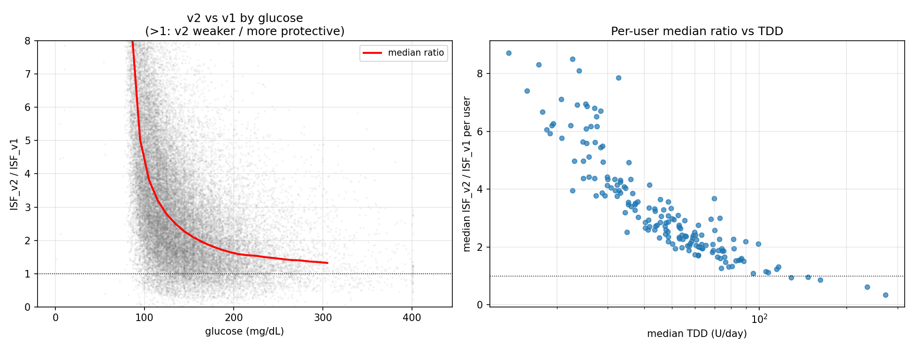
v2 vs v1: ratio vs glucose (left) and per-user ratio vs TDD (right)
Median ISF_v2/ISF_v1 by glucose band (170 users, 9.5M readings):
glucose band | median ISF_v2 / ISF_v1
40–80 | 53×
80–100 | 6.2×
100–120 | 3.5×
120–150 | 2.5×
150–200 | 1.9×
200–360 | 1.5×
v2 gives a higher ISF, meaning a weaker correction, on 92% of readings, a median of 3.0×. The very high ISF below about 100 mg/dL (close to no correction at all) comes from the ln(BG/divisor) term and the glucose floor, and amounts to strong hypo protection.

3.2 Which TDD law does observed sensitivity follow?
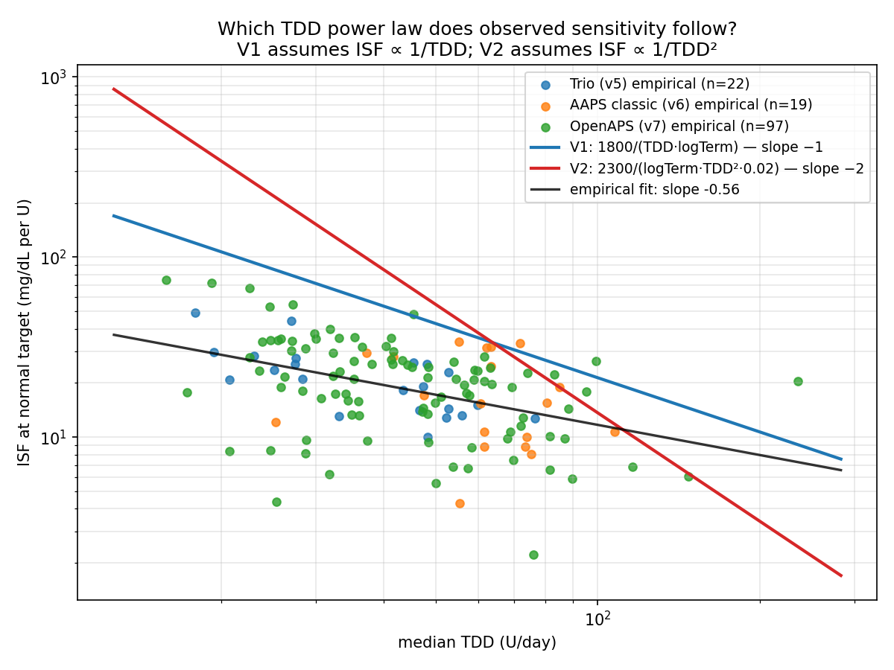
Log-log ISF vs TDD: observed points, v1 slope −1, v2 slope −2, fitted slope −0.56
On a log-log plot v1 has slope −1 and v2 slope −2, while the calculated sensitivities follow a fitted slope near −0.56: shallower than v1 and far from v2. Both equations over-steepen the TDD dependence, and v2, with twice the log-space slope, does so twice as hard. The choice of glucose term has no bearing on this; the TDD exponent is still −2.

3.3 Agreement with calculated sensitivity (and tuned profiles)
Scoring each form as a between-person ISF predictor under leave-one-user-out cross-validation, against measured sensitivity (n=114) and tuned-profile ISF (n=138):
candidate | median |err| vs measured | log-err | within ±30%
K/√TDD (v-next) | 6.2 | 0.30 | 45%
1700-rule | 16.2 | 0.61 | 15%
v1 (TDD⁻¹) | 26.0 | 0.81 | 7%
v2 (TDD⁻²) | 171 | 2.32 | 2%
v2 is the worst between-person predictor by a wide margin. On top of the over-steep TDD exponent, its level sits far above observed sensitivity. The ranking holds against tuned profiles too (v2 median error around 124 against 12.8 for √TDD).

3.4 Implementation validation against device-calculated ISF
The v1 implementation reproduces what devices actually computed. For the nine Trio users on the logarithmic form, replayed v1 tracks the device’s logged ISF with stable per-person offsets (median per-reading log-correlation 0.60, ratio IQR 0.29), the offsets reflecting the unmodelled adjustment factor, divisor and autosens. Four users had switched the units of their logged ISF mid-history, and a per-reading correction resolves all four.

3.5 Per-person view
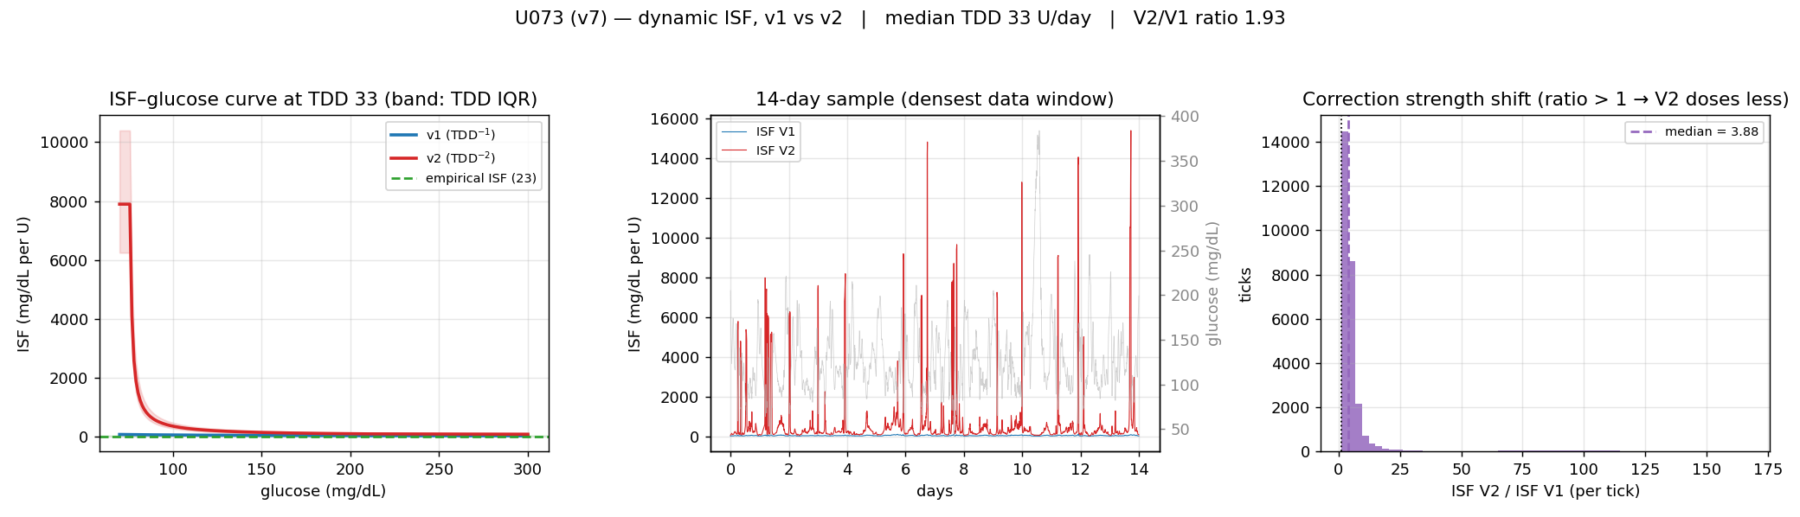
Example per-person page
A page like this exists for each of the 170 people: the ISF–glucose curves at their TDD, a two-week sample of dynamic-ISF traces over real glucose, and the per-reading ratio.

3.6 Same-window outcome test: which ISF predicts the realised drop?
The results above compare the ISF each equation would have computed. A separate test asks which ISF best predicts the glucose drop that actually happened. The loop’s IOB-based glucose prediction is linear in ISF — predicted drop = ISF × an activity integral that does not depend on ISF — so on any window we can take the loop’s own prediction (made with the ISF it ran) and rescale it to any candidate ISF, then compare to the observed end glucose. Every ISF form is tested on the same window, which removes the between-person confound that the cross-validation in §3.3 cannot: each person’s outcomes only ever score their own equation there, whereas here all four forms are scored on one shared set of windows.
Over 62,751 overnight, carbohydrate-screened, four-hour windows from 89 people (v1’s +1 makes its prediction well defined throughout; AAPS users excluded for the same TDD-reconciliation reason as elsewhere), scoring error as observed end glucose minus predicted end glucose:
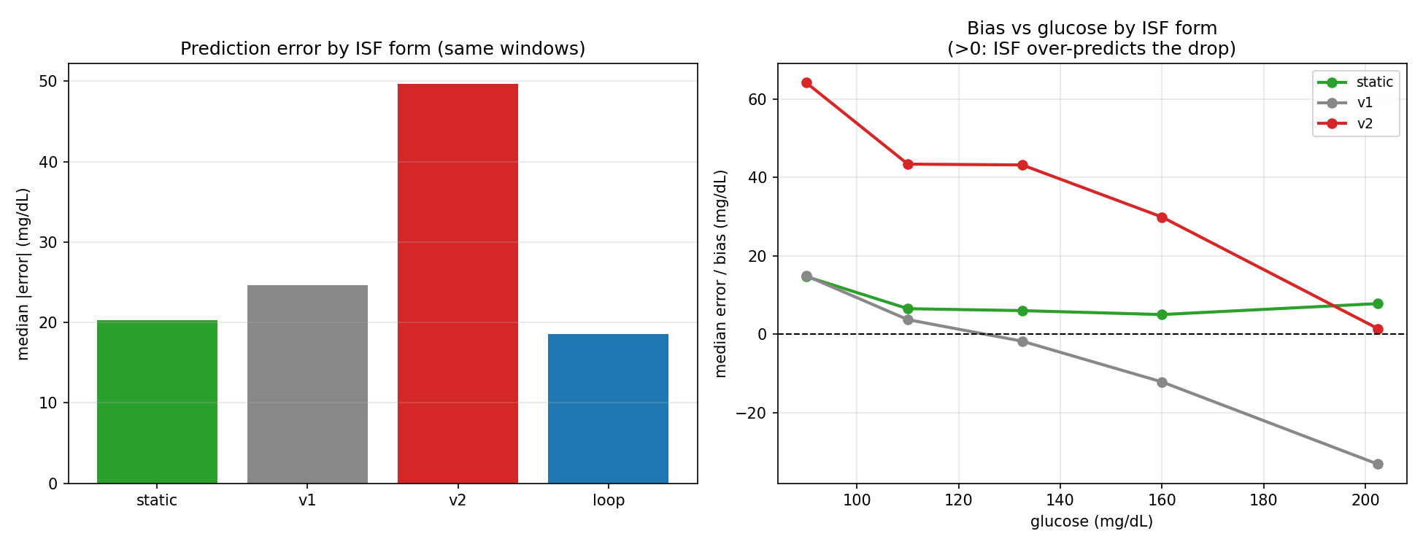
Prediction error by ISF form (left) and bias vs glucose (right)
ISF form | median |error| (mg/dL) | bias
loop (what ran) | 18.6 | +7.4
static (tuned profile ISF) | 20.3 | +6.6
v1 (TDD⁻¹) | 24.6 | −10.4
v2 (TDD⁻²) | 49.7 | +25.2
The person’s tuned static ISF is within 1.7 mg/dL of the loop’s own calibrated ISF and beats either dynamic equation; v2 is more than twice as far off as static. Counting which form is the single best predictor per person (80 people with enough windows), the loop wins for 35, static for 24, v1 for 17 and v2 for only 4.
The bias-by-glucose panel shows why the dynamic forms lose. v1’s error is strongly glucose-dependent — it over-predicts the drop at low glucose (+14.9 mg/dL in the 80–100 band) and badly under-predicts it when high (−33.2 in the 175–230 band) — which is the 1/TDD curve coupling sensitivity too tightly to glucose. v2 over-predicts the drop almost everywhere (its correction is too weak), worst at low glucose. A near-constant static ISF carries no such glucose-linked error.
This is the outcome-anchored counterpart to §3.2–3.3 and reaches the same conclusion from the other direction: a well-tuned static level is hard to beat, both dynamic equations are worse, and v2 is worst.

4. Reading the result
v2’s glucose behaviour is defensible. More ISF, and so less insulin, at low glucose is the hypo protection a correction curve should provide, and it lines up with the glucose-dependent ISF seen in the Diabeloop and power-law work. Two problems remain.
The TDD exponent is too steep, −2 against an observed −0.5, which makes v2 the worst-fitting between-person predictor of any form tested. And the overall level is about 3× too high, so corrections come out weak across the board: not only for the lighter-dosing majority but at high glucose too, where v2 is still around 1.5× gentler than v1 above 200 mg/dL and more aggression is usually wanted.
So v2 offers good hypo protection but its TDD scaling and level are wrong. The better TDD law is a √TDD level set per person from their own data — the direction the cross-validation supports (§3.3) — keeping v2’s useful low-glucose protection without its steep TDD exponent or high level.

5. Caveats
- Counterfactual replay: the main comparison (§3.1–3.5) is of the ISF each equation would have computed, not closed-loop outcomes. The same-window test in §3.6 partly addresses this by scoring each ISF against the realised glucose drop, but it still rescales the loop’s own linear prediction rather than re-running the controller, so second-order effects (changed insulin delivery feeding back into later IOB and glucose) are not captured.
- Basal approximation: AAPS exports lack temp-basal records, so basal TDD for those 39 users uses the profile schedule.
- The calculated-sensitivity benchmark is per-person and may be biased low by unrecorded carbohydrate or endogenous-glucose effects; it tests the between-person TDD law.
- Single cohort: open-source AID users, mostly 2016–2023, with n = 114/138 for the calculated-sensitivity analyses.

Reproducibility
- Implementation and tests: inv008/dynisf.py, inv008/tests/
- v1 vs v2 comparison: inv008/compare_v1_v2.py → results/v1_v2_comparison.*, charts/inv008/fig_v1_v2.png
- Same-window outcome test: inv008/head_to_head.py → results/head_to_head.{json,md}, results/head_to_head_windows.parquet, charts/inv008/fig_head_to_head.png
- Pipeline and candidate search: inv008/, fit_best_isf.py
- Repository: github.com/tim2000s/dynamic-isf-calculations

Addendum, 27 August 2026
The observation here that the equations sit above where observed sensitivity lies has been replicated across 1,679 people in six Jaeb trial cohorts, with a ratio of measured to entered sensitivity between 0.30 and 0.92 and no estimate reaching 1.0. The gap is a property of observational measurement rather than of the entered settings, which Paper 4 had already tested against outcomes. See Dynamic-ISF-7.

