Dynamic ISF — analysis of the v1 and v2 equations
2026-06-07 (same-window outcome test §3.6 added 2026-06-09) · Tim Street / Claude · Data: 171 people using open-source AID systems
Audit update, 16 September 2026: the V2 replay used the intended no-+1 equation with divisor/floor 75/76. The delta-IOB estimator is not independent physiological ground truth, so the claimed physiological TDD exponent and square-root recommendation are withdrawn. The equation replay and within-model prediction comparison remain valid. See DYNAMIC-ISF-AUDIT-2026-09.md.

Summary
Dynamic ISF sets correction sensitivity from total daily dose (TDD) and current glucose. v1 (Chris Wilson) makes the sensitivity anchor inversely proportional to TDD. v2 makes it inversely proportional to TDD squared, and uses the glucose term ln(BG/divisor) with glucose floored at divisor+1. We ran each person's real glucose and insulin history through both equations, about 9 million glucose readings across 171 people, and compared the sensitivity each one would have produced.
The two equations differ on both axes. Because v1 keeps a +1 in its glucose log and v2 does not, the ratio between them changes with glucose: v2 produces a far higher ISF at low glucose and only a modest one when high. Across the cohort v2 is the gentler equation almost everywhere, giving a weaker correction than v1 on 92% of readings (a median of 3.0×, rising to roughly 53× below 80 mg/dL and easing to about 1.5× above 200). That low-glucose behaviour is sensible hypo protection.
The TDD exponent is the problem within the tested proxy. The delta-IOB sensitivity proxy scales as roughly TDD^−0.5, or shallower; v2 assumes TDD^−2. As a between-person predictor of the delta-IOB proxy, v2 is the worst of every form we tested (median error around 171 mg/dL per unit). Its overall level sits well above the proxy. This comparison does not establish which TDD exponent describes physiological insulin sensitivity.
A separate within-loop prediction test gives the same ranking. Rescaling the loop's own glucose prediction to each candidate ISF on 62,751 selected overnight windows, a person's tuned static ISF predicts the realised drop about as well as the loop itself and better than either dynamic equation, with v2 worst. Because this reuses the loop's prediction model and selects windows using future glucose, it is predictive evidence rather than an independent physiological measurement.

1. The two equations
Both derive a blended TDD, then a sensitivity anchor at normal target, then scale that by glucose.
 | sensitivity anchor at normal target | implied TDD law
v1 | 1800 / (TDD · ln(target/divisor + 1)) | ISF ∝ 1/TDD
v2 | 2300 / (ln(target/divisor) · TDD² · 0.02) | ISF ∝ 1/TDD²
v2 uses ln(BG/divisor) (no +1) in both the anchor and the glucose scaler, with glucose floored at divisor+1 so the log stays positive. In long form, at target 99 mg/dL, divisor 75, high cap 210:
v1: ISF(BG) = 1800 / ( TDD · ln(BG_capped/75 + 1) )
v2: ISF(BG) = 115000 / ( TDD² · ln(BG_floored/75) ) BG_floored = max(BG, 76)
The glucose terms are not the same (ln(BG/75+1) for v1, ln(BG/75) for v2), so the ratio between the two equations depends on glucose. It is largest at low glucose, where the v2 log falls toward zero as BG approaches its floor, and shrinks to a small margin when glucose is high. The cohort numbers for this are in §3.1.

2. Method in brief
For each person, every glucose reading was passed through both equations using the TDD their device would have computed: device-logged TDD for Trio, and for AAPS and OpenAPS users a TDD reconstructed from raw delivery records (boluses plus temp-basal segments over the profile basal, on a 5-minute grid) through the same five-window blend. Relative timestamps were re-anchored to absolute time and checked against recorded hour-of-day, with median join coverage of 99.4%. The equation implementations carry 27 unit tests against hand-computed fixtures, covering the v2 glucose floor, the glucose-dependent v1/v2 ratio, both branches of the TDD blend, and the missing-data gates. The companion methodology paper has the full pipeline.
For 114 people the repository also fits glucose change against delta IOB over fasting windows. This provides an observational comparison target. It does not serve as physiological ground truth because in-window delivery changes IOB and is selected by the closed-loop controller.

3. Results

3.1 The v2/v1 ratio depends on glucose
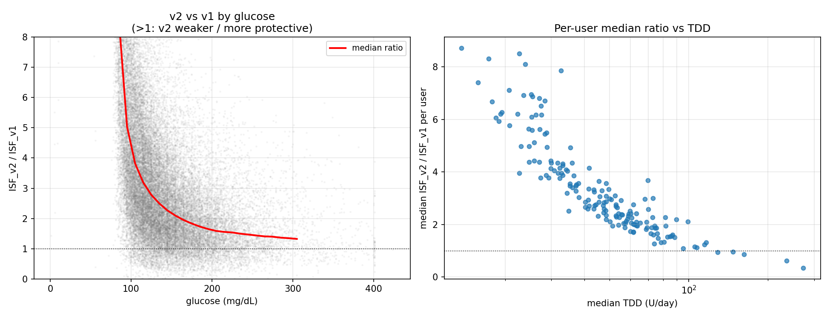
Median ISF_v2/ISF_v1 by glucose band (170 users, 9.5M readings):
glucose band | median ISF_v2 / ISF_v1
40–80 | 53×
80–100 | 6.2×
100–120 | 3.5×
120–150 | 2.5×
150–200 | 1.9×
200–360 | 1.5×
v2 gives a higher ISF, meaning a weaker correction, on 92% of readings, a median of 3.0×. The very high ISF below about 100 mg/dL (close to no correction at all) comes from the ln(BG/divisor) term and the glucose floor, and amounts to strong hypo protection.

3.2 Which TDD law does the delta-IOB proxy follow?
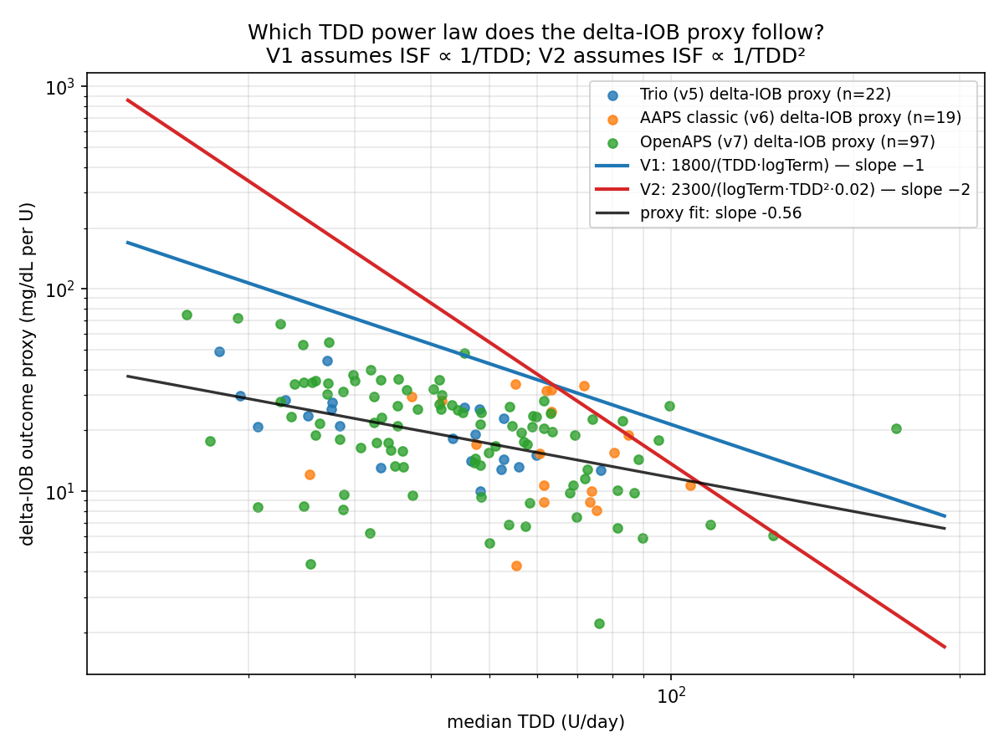
On a log-log plot v1 has slope −1 and v2 slope −2, while the delta-IOB outcome proxy follows a fitted slope near −0.56. This is shallower than v1 and far from v2. It shows how the equations compare with that proxy. It does not show which TDD law physiological insulin sensitivity follows, because new delivery changes IOB during the interval and the controller selects delivery in response to glucose.

3.3 Agreement with the delta-IOB proxy and tuned profiles
Scoring each form as a between-person ISF predictor under leave-one-user-out cross-validation, against the delta-IOB proxy (n=114) and tuned-profile ISF (n=138):
candidate | median |err| vs proxy | log-err | within ±30%
K/√TDD (v-next) | 6.2 | 0.30 | 45%
1700-rule | 16.2 | 0.61 | 15%
v1 (TDD⁻¹) | 26.0 | 0.81 | 7%
v2 (TDD⁻²) | 171 | 2.32 | 2%
v2 is the worst between-person predictor of the delta-IOB proxy by a wide margin. Its level sits far above that proxy. The ranking holds against tuned profiles too (v2 median error around 124 against 12.8 for √TDD).
The next check concerns software implementation, not physiological validity.

3.4 Device-log implementation validation
The v1 implementation reproduces what devices actually computed. For the nine Trio users on the logarithmic form, replayed v1 tracks the device's logged ISF with stable per-person offsets (median per-reading log-correlation 0.60, ratio IQR 0.29), the offsets reflecting the unmodelled adjustment factor, divisor and autosens. Four users had switched the units of their logged ISF mid-history, and a per-reading correction resolves all four.

3.5 Per-person view
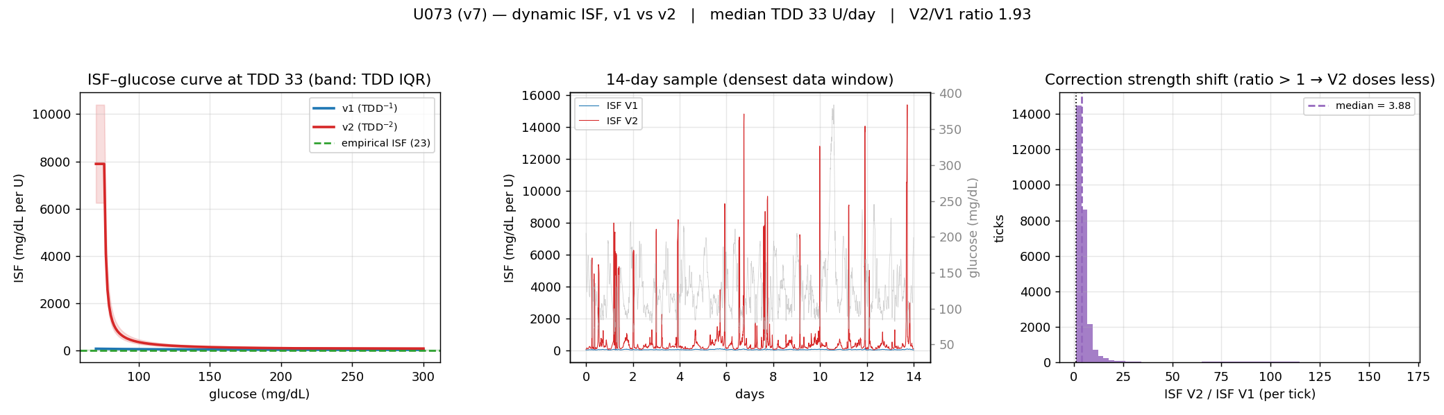
A page like this exists for each of the 170 people: the ISF–glucose curves at their TDD, a two-week sample of dynamic-ISF traces over real glucose, and the per-reading ratio.

3.6 Same-window outcome test: which ISF predicts the realised drop?
The results above compare the ISF each equation would have computed. A separate within-loop prediction test asks which rescaled ISF best predicts the glucose drop that actually happened. The loop's IOB-based glucose prediction is linear in ISF — predicted drop = ISF × an activity integral that does not depend on ISF — so on any window we can take the loop's own prediction (made with the ISF it ran) and rescale it to any candidate ISF, then compare to the observed end glucose. Every ISF form is tested on the same window, which removes the between-person confound that the cross-validation in §3.3 cannot: each person's outcomes only ever score their own equation there, whereas here all four forms are scored on one shared set of windows.
Over 62,751 overnight, future-rise-screened, four-hour windows from 89 people (v1's +1 makes its prediction well defined throughout; AAPS users excluded for the same TDD-reconciliation reason as elsewhere), scoring error as observed end glucose minus predicted end glucose:
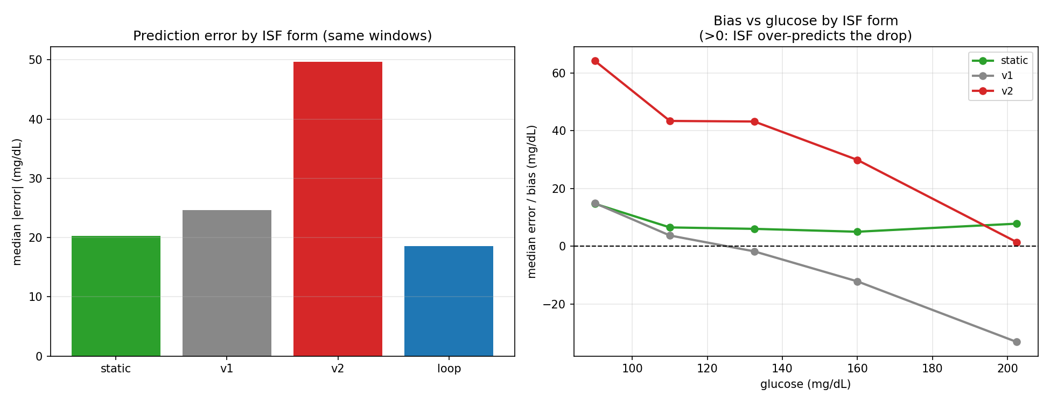
ISF form | median |error| (mg/dL) | bias
loop (what ran) | 18.6 | +7.4
static (tuned profile ISF) | 20.3 | +6.6
v1 (TDD⁻¹) | 24.6 | −10.4
v2 (TDD⁻²) | 49.7 | +25.2
The person's tuned static ISF is within 1.7 mg/dL of the loop's own calibrated ISF and beats either dynamic equation; v2 is more than twice as far off as static. Counting which form is the single best predictor per person (80 people with enough windows), the loop wins for 35, static for 24, v1 for 17 and v2 for only 4.
The bias-by-glucose panel shows why the dynamic forms lose within this model. V1's error is strongly glucose-dependent. With error defined as observed end glucose minus predicted end glucose, its positive error at low glucose means it predicts too large a drop, while its negative error at high glucose means it predicts too small a drop. V2 has positive error almost everywhere, so it predicts too large a drop. A near-constant static ISF carries less glucose-linked error in these selected windows.
This is a predictive comparison inside the loop's own linear IOB model, not an independent measurement of insulin action. Within that scope, a well-tuned static level is hard to beat, both dynamic equations are worse, and v2 is worst.

4. Reading the result
V2 provides strong low-glucose protection. More ISF produces less insulin near the configured floor. The observational analysis does not establish that its glucose curve represents physiological sensitivity.
The TDD exponent is steep relative to the fitted proxy, −2 against about −0.5, which makes v2 the worst-fitting between-person predictor of that proxy among the forms tested. Its overall level is about 3× the proxy level, so corrections come out weak across the board: not only for the lighter-dosing majority but at high glucose too, where v2 is still around 1.5× gentler than v1 above 200 mg/dL and more aggression is usually wanted.
V2 offers strong low-glucose protection, but its TDD scaling and level performed poorly against the tested outcomes. The square-root form fitted the observational targets better. This does not establish a physiological TDD law or support a dosing recommendation.

5. Caveats
- Counterfactual replay: the main comparison (§3.1–3.5) is of the ISF each equation would have computed, not closed-loop outcomes. The same-window test in §3.6 partly addresses this by scoring each ISF against the realised glucose drop, but it still rescales the loop's own linear prediction rather than re-running the controller, so second-order effects (changed insulin delivery feeding back into later IOB and glucose) are not captured.
- Basal approximation: AAPS exports lack temp-basal records, so basal TDD for those 39 users uses the profile schedule.
- The delta-IOB benchmark is a per-person outcome proxy affected by in-window delivery, unrecorded carbohydrate, endogenous-glucose effects and controller feedback. It does not identify a physiological TDD law.
- Single cohort: open-source AID users, mostly 2016–2023, with n = 114/138 for the proxy/profile analyses.

Reproducibility
- Implementation and tests: inv008/dynisf.py, inv008/tests/
- v1 vs v2 comparison: inv008/compare_v1_v2.py → results/v1_v2_comparison.*, charts/inv008/fig_v1_v2.png
- Same-window outcome test: inv008/head_to_head.py → results/head_to_head.{json,md}, results/head_to_head_windows.parquet, charts/inv008/fig_head_to_head.png
- Pipeline and candidate search: inv008/, fit_best_isf.py
- Repository: github.com/tim2000s/dynamic-isf-calculations

