Dynamic ISF: withdrawn v-next proposal and current evidence status
2026-06-07; audited 2026-09-16 · Tim Street / Claude
This document records a model proposed in June 2026 and the evidence that led to its withdrawal. It is not a dosing recommendation. The full technical review is in DYNAMIC-ISF-AUDIT-2026-09.md.

Summary
The proposed v-next model combined three ideas:
- an ISF anchor proportional to 1/√TDD;
- a per-person constant, K_user;
- a glucose curve adapted from a Diabeloop quartic.
The model fitted two historical targets better than Dynamic ISF v1 or v2. One target was the person's entered profile ISF. The other was a coefficient calculated from glucose change and change in IOB during fasting windows.
The audit changes the interpretation. The change-in-IOB coefficient is an observational outcome proxy, not an independent measurement of insulin action. New insulin is delivered during the window, the controller chooses that delivery in response to glucose, and unrecorded carbohydrate and endogenous glucose remain possible. The fitted 1/√TDD relationship therefore does not establish a physiological TDD law. The same problem affects constants derived from that proxy.
The proposal is withdrawn for live dosing. It can still be used as a named candidate in simulation, shadow replay or a prospective study designed to identify insulin effect.

1. The historical model
At normal target, the proposed sensitivity was:
ISF = K_user / √TDD
At other glucose levels:
v1: ISF(BG) = 1800 / (TDD · ln(BG_capped/75 + 1))
v2: ISF(BG) = 115000 / (TDD² · ln(BG_floored/75))
v-next: ISF(BG) = (K_user / √TDD) · g(BG)
For the standard rapid-acting configuration, including NovoRapid, v2 uses divisor 75 and floors glucose at 76 mg/dL. The author-confirmed v2 equation does not contain +1 in its logarithm.
The proposed glucose function was:
q(BG) = 272 − 3.121·BG + 0.01511·BG² − 3.305e-5·BG³ + 2.69e-8·BG⁴
g(BG) = q(BG) / q(99)
The Tier 1 form anchored K_user to the existing profile ISF. The Tier 2 form replaced the profile anchor with the change-in-IOB proxy. Tier 2 is invalid as a physiological calibration. Tier 1 preserves the person's entered level at their reference TDD, but the added TDD and glucose responses remain unvalidated.

2. What the historical fit showed
The candidate equations were scored by leave-one-user-out cross-validation against entered profile ISF in 138 people and the change-in-IOB proxy in 114 people.
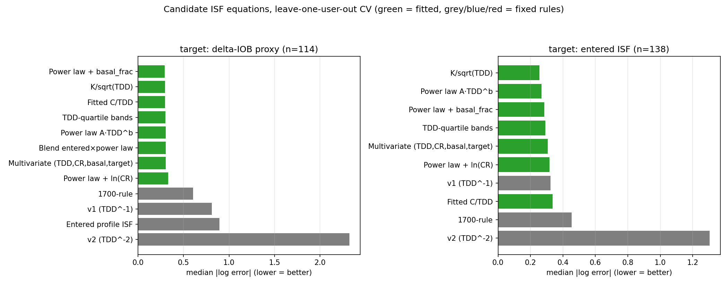
target | best simple candidate | median log error | interpretation
entered profile ISF | 355/√TDD | 0.256 | predicts how this cohort had configured ISF
change-in-IOB proxy | approximately 145/√TDD | 0.297 | predicts an observational closed-loop coefficient
These are valid predictive descriptions of those targets. They are not physiological constants. The apparent exponent near −0.5 may reflect controller behaviour, treatment patterns, selection of fasting windows, residual carbohydrate and the construction of the proxy itself.
V2 performed poorly against both targets. That comparison remains useful for understanding how different the equations are, but it does not prove that the square-root candidate is the correct biological relationship.

3. What survives the audit

Equation arithmetic
The implementations of v1, v2 and the candidate v-next equation are reproducible. The v2 replay already used the author-confirmed no-+1 form. Unit tests now include explicit checks that the v2 floor follows the configured divisor, 75/76 for standard rapid-acting insulin and 55/56 for the alternative configuration.

Direct equation comparison
V2 generally produces a much higher ISF than v1 in this cohort, especially near its glucose floor. The v2-to-v1 ratio depends on both glucose and TDD. This is a mathematical comparison of equation outputs and remains valid.

Predictive comparison within the loop model
In the selected overnight windows, a tuned static ISF and the loop's own ISF prediction produced smaller prediction errors than v1 or v2. This is a comparison within the loop's linear IOB prediction model. It is not an independent measurement of physiological sensitivity.

Glucose-shape result
After changing the shape analysis from shuffled folds to contiguous time folds, the best fitted power exponent remained k = 0. Adding a glucose-dependent multiplier did not improve median absolute error. The analysed windows therefore provide no predictive support for adding the proposed glucose curve. They do not prove that glucose can never affect insulin sensitivity.

4. Why the dosing proposal is withdrawn
Four identification problems matter.
- Change in IOB is not absorbed insulin. IOB changes because insulin acts, because new insulin is delivered, and because time passes through the assumed action curve.
- Delivery is endogenous. A closed-loop system gives more or less insulin in response to glucose and trend. Insulin delivery is therefore correlated with the outcome being explained.
- Carbohydrate screening is incomplete. A future-rise filter uses information from the outcome interval and cannot prove that carbohydrate effect is absent. Separate post-COB work found evidence consistent with carbohydrate action outlasting the recorded COB model.
- The action-balance estimator is model dependent. It uses model-derived IOB and suggested delivery. Suggested SMB and temporary basal are not always confirmed enacted delivery.
These limitations affect the claimed TDD exponent, the proposed constants, and the idea that a short observational window can set a person's physiological ISF. They do not invalidate the equation replay itself.

5. Appropriate future use
The v-next equation may be retained as a research candidate, with these restrictions:
- no live dosing recommendation from the retrospective fits;
- no claim that 1/√TDD is a physiological law;
- no use of the historical Tier 2 constant as measured ISF;
- evaluation first in simulation or shadow mode;
- prospective validation using confirmed delivery, explicit carbohydrate handling and a design that separates insulin exposure from controller response.
A prospective study should compare a static profile, v1, v2 and the candidate v-next form on pre-specified safety and glucose outcomes. It should use non-overlapping evaluation periods and report results by TDD, glucose, insulin formulation and controller type.

Reproducibility
- Equations and tests: inv008/dynisf.py, inv008/tests/
- Historical candidate search: fit_best_isf.py, results/best_isf_fit_results.{json,md}
- Predictive glucose-shape test: inv008/gradient_isf_fit.py, results/gradient_isf_fit.{json,md}
- Same-window comparison: inv008/head_to_head.py, results/head_to_head.{json,md}
- Audit: DYNAMIC-ISF-AUDIT-2026-09.md

