Does insulin sensitivity vary with both glucose and total daily dose, and is there a clear relationship between the three?
  - Testing both dynamic ISF equations against 1,684 people in seven public study archives
Tim Street
25 August 2026

The question
A pump holds one number that decides how hard it corrects: how far one unit of insulin moves glucose. Most people arrive at it from the 1800 rule, which divides 1800 by total daily dose, TDD from here on, then adjust it when corrections land too hard or too soft.
Dose and TDD are separate things throughout what follows. A dose is one delivery, a bolus or a basal increment. TDD is the total across a day, and it is what both equations key on.
Dynamic ISF replaces that fixed number with a calculated one. The algorithm works out a fresh sensitivity every few minutes from how much insulin the person has been using and where their glucose sits.
Two versions exist and they disagree about how much TDD should count. The original, v1, keeps the 1800 rule’s shape. Double the TDD and sensitivity halves. The revised version, v2, squares the TDD term. Double the TDD and sensitivity falls to a quarter.
Compare somebody on 20 units a day with somebody on 60. v1 makes the second person’s corrections three times smaller per unit. v2 makes them nine times smaller.
The two do cross, but far higher up than the coefficients alone suggest, and the crossing point moves with glucose. At 150 mg/dL it sits at 101 units a day, at 120 mg/dL at 130, and near target at 194. Only 53 of the 1,678 people here, 3.2% of them, run above the crossing point at any realistic glucose. So for almost everybody in these archives v2 reads a higher sensitivity than v1 and therefore gives the weaker correction: 6.8 times weaker at 15 units a day, 2.5 times at 40, 1.3 times at 80.
Both versions also cut sensitivity when glucose runs high, on the reasoning that insulin works less well up there.
I tested all of it against seven public study archives.

What the archives show
TDD changes sensitivity, close to the way v1 says. Sensitivity falls as TDD rises, at an exponent near the one the 1800 rule assumes and a little shallower. Four methods agree, and one of them could have found nothing.
Glucose changes sensitivity too, in the direction opposite to both equations. They make insulin work best near target and worst when glucose is high. It works worst near target, where the body defends against a further fall, and slightly better when glucose is high.
The two axes do not multiply the way both equations multiply them. Each treats the glucose term as the same whatever the TDD. It is not.
Food explains a real share of what the glucose term picks up. For four hours after a logged meal, measured sensitivity turns negative: glucose climbs while insulin acts, because carbohydrate keeps arriving after the absorption model stops counting it.
Asked to predict the overnight fall, a static 1800 rule beat both equations. v2 missed by four times as much as anything else on the list.

What that means for somebody running one
Running v1, the TDD half holds up. The glucose half points the wrong way but stays small enough to cost little.
Running v2, nothing here supports the squared TDD term. It never beat the alternatives for a single person out of 1,626, and it fails hardest at low TDD. Squaring the TDD hands a child on ten units a day a sensitivity of several thousand, which turns a correction into almost nothing.
Running neither, the 1800 rule already in most pumps describes these archives well, and it out-predicted every dynamic version tested.
The people who built these equations worked from that same rule of thumb, and the rule survives this analysis in good shape.

The archives
Seven public study archives, about 1,700 people, ages 2 to 82, TDD from 7 to 107 units.
Study | System in use | People | Food logged | Median days | Median TDD
Loop | Do-it-yourself Loop, fixed sensitivity | 842 | yes | 397 | 38.6 U
REPLACE-BG | Pump and sensor, nothing automating | 196 | yes | 246 | 41.9 U
DCLP3 | Control-IQ, adults and adolescents | 112 | no | 183 | 50.0 U
DCLP5 | Control-IQ, ages 6 to 13 | 100 | no | 203 | 37.4 U
PEDAP | Control-IQ, ages 2 to 5 | 98 | no | 273 | 13.6 U
IOBP2 | Bionic pancreas | 336 | no | 93 | 49.0 U
Two rows carry more weight than the rest.
REPLACE-BG ran in 2015 on a pump and a sensor with no algorithm between them. No machine chose anyone’s insulin by watching their glucose, and that turns out to matter more than its size suggests.
Loop and REPLACE-BG also recorded meals. Only in those two can I exclude a meal rather than guess at one.
Screening leaves 708,106 usable overnight stretches from 1,659 people, each contributing at least forty.

Measuring what a unit did
No archive records insulin on board, what the algorithm predicted, or usually even a sensitivity setting. All of it comes back from the basal and boluses that were delivered.
The method is the obvious one. Take a stretch of time overnight. Measure how far glucose fell. Add up the insulin acting across that stretch from every dose that contributed, using a six hour curve. Divide.
Two things decide whether that division means anything.

Insulin an algorithm chose measures the algorithm
An algorithm delivers more insulin exactly when glucose refuses to come down. Compare the fall against all the insulin that acted and more insulin goes with less falling, so the answer turns negative. That would say insulin raises glucose. It does not. The calculation has measured the controller’s policy.
I split insulin by when it was decided. Insulin already present when a stretch opens was committed before anything in that stretch happened, so it cannot answer glucose the stretch has yet to record.
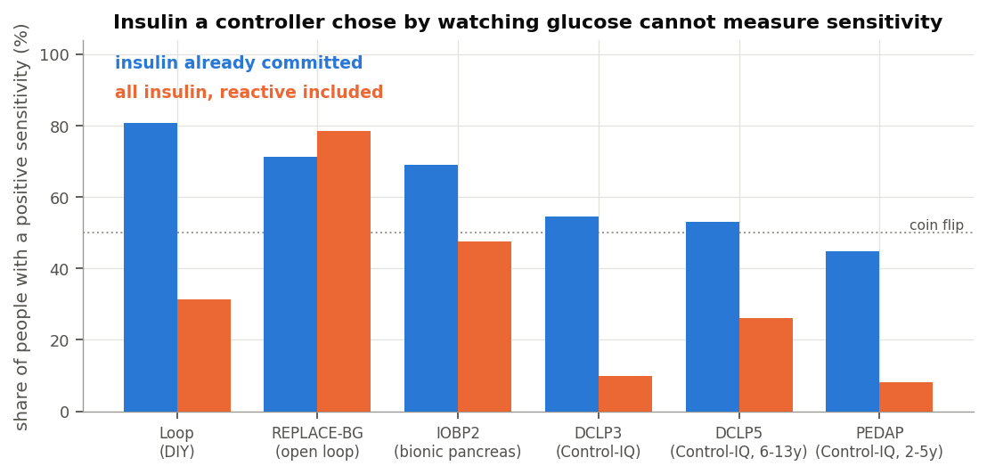
The confound, made visible
The share of people whose sensitivity comes out positive drops from 78% to 8% as the controller grows more reactive, then climbs back once I use committed insulin only. REPLACE-BG stands apart, because nothing chose its insulin.
That is why 196 people from a decade ago outweigh their number here.

Basal is not free
Across any stretch, glucose changes by insulin action minus the glucose the liver puts out. Basal cancels that output. So a correct basal rate holds glucose flat, and fall divided by insulin returns zero. Zero basal error, not zero sensitivity.
Run that naive division and it returns 3 to 9 mg/dL per unit against entered settings of 25 to 60. Everything below therefore measures each stretch against what that person’s glucose usually does at that hour, and against how much insulin usually acts by then. What is left is the effect of the insulin that was not routine, which is what a correction is.

Checking the arithmetic against something recorded
Loop wrote down its own insulin on board at every bolus. Nowhere else in these archives did an app record its internal state, so I can rebuild that number from the pump data and compare.
Across 158 people the rebuild tracks Loop’s own figure at a correlation of 0.927, typically within a third of a unit. Something outside my own assumptions confirms the delivery arithmetic.
Reaching it needed the basal profile, which no settings file in the archive holds, because Loop counts insulin on board net of scheduled basal. Every temp basal record turns out to carry the rate it overrode.

Does TDD change sensitivity?
Yes, by close to the amount the 1800 rule assumes.

What the equations actually put in the TDD slot
Both equations key on a figure they call a total daily dose, and the comparator used throughout this analysis computes it exactly as the plugins do. It is worth setting out, because the name suggests something steadier than what arrives.
The recent part is a weighted average across the last eight hours. The most recent four hours carry a weight of 1.4 and the four before that carry 0.6. Those weights sum to 2, so a flat eight hours gives twice a four hour total, and multiplying by 3 scales it to a 24 hour equivalent. Call that the eight hour figure.
The blend then takes a third from the eight hour figure, a third from yesterday’s total and a third from a seven day average. When the eight hour figure falls below 75% of the seven day average, which happens in 36.7% of the overnight windows here, the seven day term is replaced by a quantity derived from the eight hour figure itself. In those cases roughly two thirds of the blend traces back to the last eight hours.
Measured against each person’s own true average daily total, the blended figure runs from 0.72 at the tenth percentile to 1.14 at the ninetieth, across 960 people. It moves across about 41% of a daily total inside a single record.
So the quantity these equations vary sensitivity on updates several times an hour and leans hardest on the last eight hours, particularly overnight when delivery runs below a person’s daily average. The within-person exponent below measures how sensitivity tracks that figure as it moves, which is what the algorithm acts on, rather than how it tracks a person’s settled daily total.

What people had entered
Of the 596 people with a sensitivity factor on record, 581 also have enough pump data for a TDD.
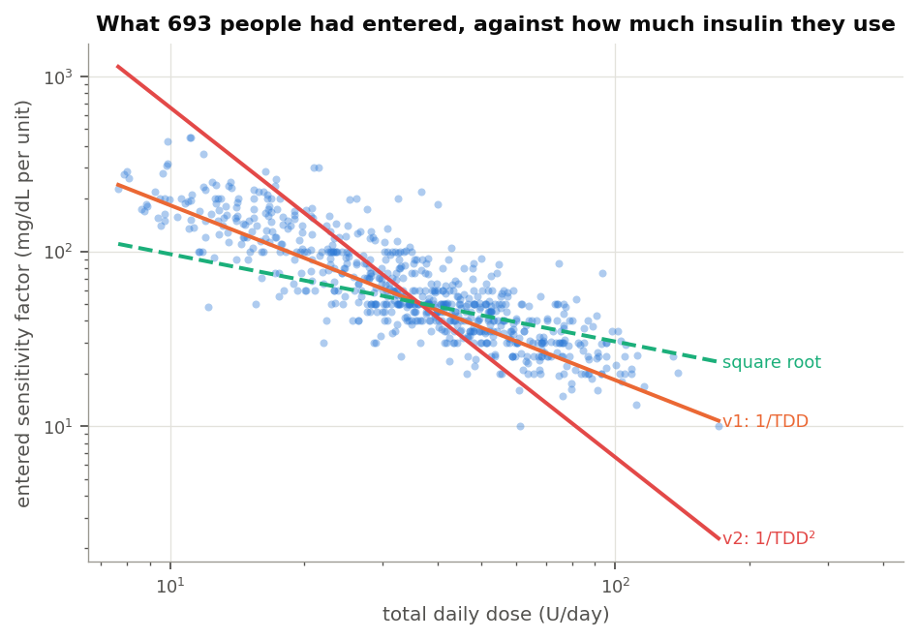
Entered sensitivity against TDD
The slope against TDD is -0.979, with a 95% interval from -1.030 to -0.934. An exponent of -1 is the 1800 rule, so that interval sits on it.
Multiplying each person’s sensitivity by their TDD gives a median of 2067. v1 works out to 2139. If the rule holds, that product should not drift with TDD. It does not: the two correlate at +0.024. The same test on v2’s squared version returns +0.859, which is a rule failing across the whole range.
One caveat belongs here rather than in a footnote. An entered setting records a decision, not a measurement, and most people reach it through the 1800 rule. Finding that people sit on 1800 over TDD partly measures how far that rule reaches into practice.
The circle does not close the other way. Nothing in practice pushes anyone towards a squared law, and nothing people run looks like one.
Carb ratios follow more loosely. Multiplying each carb ratio by TDD gives a median of 411, so the 500 rule describes practice less tightly.

What glucose actually did
Measuring from the glucose response gives a shallower relationship. Between people it comes to -0.83. Within one person, which is what these equations do several times an hour, it comes to -0.645 across 1,313 people, standard error 0.033, with roughly three quarters sharing the direction.
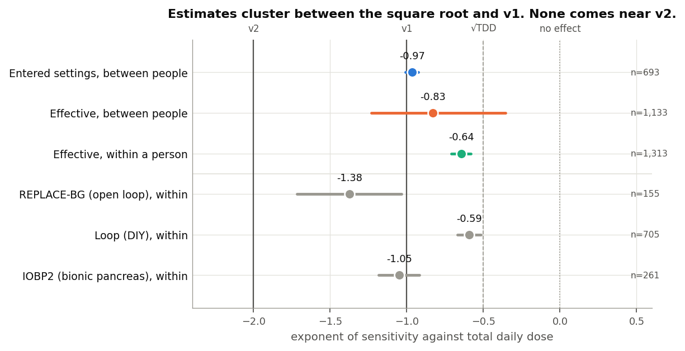
Exponents measured by each method
An exponent of -1 halves sensitivity when TDD doubles. An exponent of -2 quarters it. An exponent of -0.65 multiplies it by about 0.64.
Both estimates land between the square root and v1. Neither approaches v2.

The same question at every reading
Those estimates fit a line through each person’s data. The direct alternative computes a sensitivity at every glucose reading and sets it beside what each equation calculates at that moment.
At each reading I look back six hours, total the insulin that acted from every contributing dose, and compare the glucose change against what that person’s glucose usually does over the same six hours at that hour. Only stretches with no recorded food qualify. That yields 1,408,861 readings from 1,004 people.
The level comes out too low to read. Dividing one noisy number by another drags the middle of the distribution towards zero. The exponent survives, and I can check it by running the same calculation on the numbers v1 and v2 themselves produce, where the answer is known.
Series | Exponent recovered | Correct answer
Measured sensitivity | -0.843 (95% CI -0.970 to -0.720) | unknown, that is the question
v1’s own output | -1.026 | -1
v2’s own output | -2.085 | -2
The method recovers a known answer to about 0.03. On real data it returns -0.843, landing on the -0.83 that a different method produced above.
The same readings show how far the equations sit from the measurement. v1 runs about two and a half times high and lands within 30% of the measured value 16% of the time. v2 runs five and a half times high and lands within 30% 9% of the time.

A fourth method that assumes no shape
The three estimates above all fit a shape and read off its parameter, so each answer depends on the shape chosen. A gradient boosted model chooses none. Given 687,067 stretches from 1,660 people it could find sensitivity falling with TDD, rising with it, moving in steps, or ignoring TDD entirely.
What matters is how insulin action and TDD interact, not what TDD does on its own. TDD shifts the overnight fall for reasons unconnected to sensitivity, because people on more insulin differ in other ways. Sensitivity multiplies insulin, so the interaction is where it lives.
TDD | Shift in sensitivity the model attributes to TDD
15 U | +0.28 mg/dL per unit
25 U | +0.06
34 U | +0.06
43 U | +0.02
55 U | 0.00
77 U | -0.04
It falls steadily without being asked to, and flattens above roughly forty units a day. That is the shape a shallow exponent makes, not a steep one. The magnitudes are shifts around the model’s own baseline and carry the same shrinkage as everything else here.

Does glucose level change sensitivity?
Yes, opposite to the direction both equations assume.
A trap sits in this one. Glucose starting high falls further than glucose starting low whatever insulin does, partly through renal clearance and partly because high values tend to come down. Near target the body pushes back. Let glucose explain the size of the fall, then ask whether the fall per unit also depends on glucose, and the first answer arrives labelled as the second.
Every calculation here separates the two. Only the part saying a unit itself did more or less carries the claim.
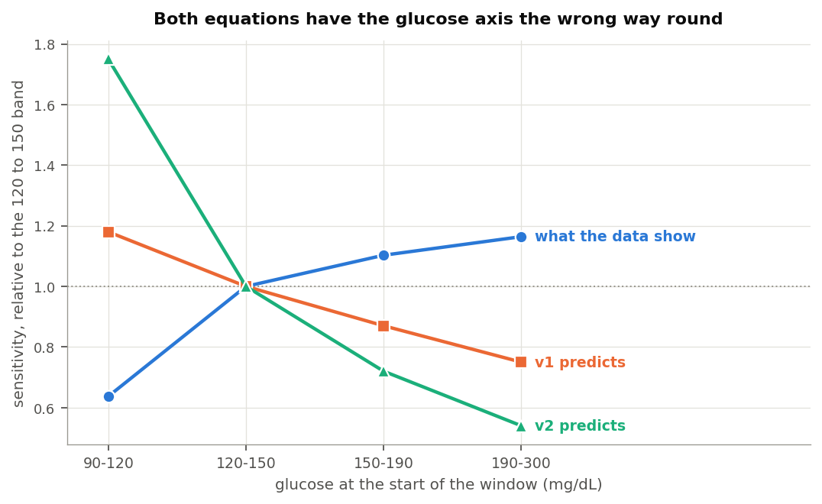
Sensitivity by glucose band against both equations
Glucose | Measured | v1 assumes | v2 assumes
90 to 120 mg/dL | 0.64 | 1.18 | 1.75
120 to 150 | 1.00 | 1.00 | 1.00
150 to 190 | 1.10 | 0.87 | 0.72
190 to 300 | 1.16 | 0.75 | 0.54
Those figures scale the 120 to 150 band to 1.00.
A unit does about a third less near target than mid-range, then slightly more as glucose climbs. Both equations run the other way.
The per-reading calculation says the same in real units, fitting nothing.
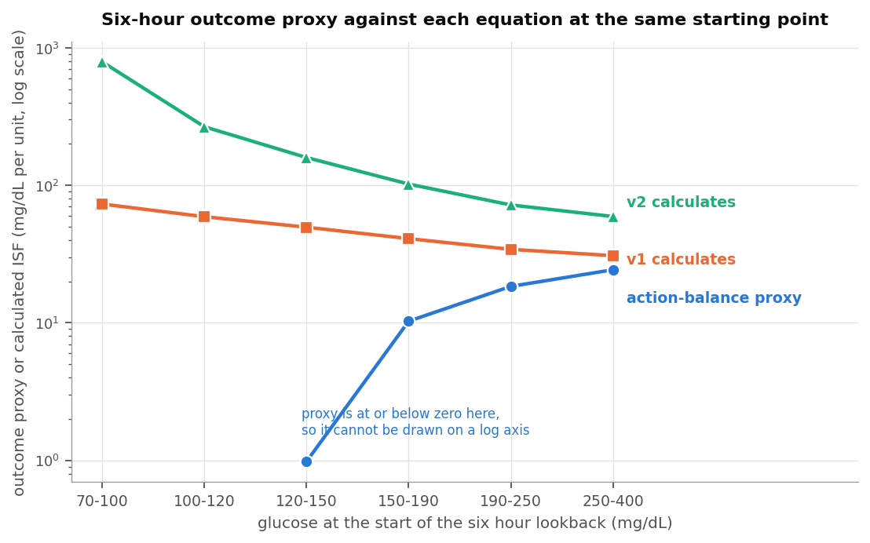
Measured sensitivity against both equations at the same reading
Glucose | Measured | v1 calculates | v2 calculates
70 to 100 mg/dL | -0.0 | 72.9 | 791.5
100 to 120 | -1.5 | 58.7 | 261.5
120 to 150 | 1.8 | 49.1 | 158.2
150 to 190 | 11.3 | 40.5 | 100.3
190 to 250 | 21.1 | 33.8 | 70.4
250 to 400 | 26.9 | 30.5 | 58.0
Three methods return that reversal. The third fits no curve to anything.
In practice both equations correct hardest where insulin works best and ease off where it works least. The near-target end deserves the attention. That is where the body defends against a hypo, and both equations read the defence as high sensitivity and dose into it.
The glucose term stays small enough not to do much either way. Out of sample, six glucose shapes including both equations’ own landed within 0.05 mg/dL of each other, and the flat shape won. I had set the bar at 0.5 mg/dL before a glucose term could earn its place. The best of them cleared under a tenth of that.

Do the two combine as the equations assume?
No.
Both multiply a TDD term by a glucose term, which assumes the glucose profile looks the same at 15 units a day and at 80.
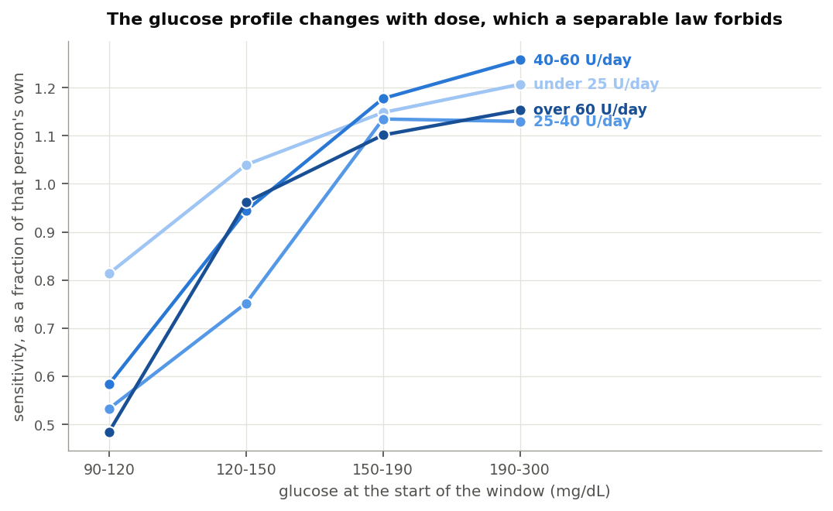
Glucose profile at each TDD band
TDD | 90 to 120 | 120 to 150 | 150 to 190 | 190 to 300
Under 25 U | 0.81 | 1.04 | 1.15 | 1.21
25 to 40 U | 0.53 | 0.75 | 1.14 | 1.13
40 to 60 U | 0.58 | 0.94 | 1.18 | 1.26
Over 60 U | 0.48 | 0.96 | 1.10 | 1.15
Those rows would have to match for either equation to hold. The dip near target runs mild under 25 units a day and about twice as deep above it. Fitting the interaction directly returns -0.444, roughly half the size of the TDD term.
One thing behaves. Comparing across people, somebody’s glucose profile tracks their TDD not at all, at a rank correlation of -0.017 over 971 people. The two axes tangle within a person, not between them.

Sensitivity, or food?
Both explanations predict the same measurement. Sensitivity really falling when glucose runs high and when recent TDD runs large would mean the equations describe something real. Carbohydrate still absorbing after the model stops counting it would raise glucose, make insulin look weak, and enlarge recent TDD because the person ate. The two look identical from the outside.
Loop and REPLACE-BG recorded meals, so time since eating tells them apart.
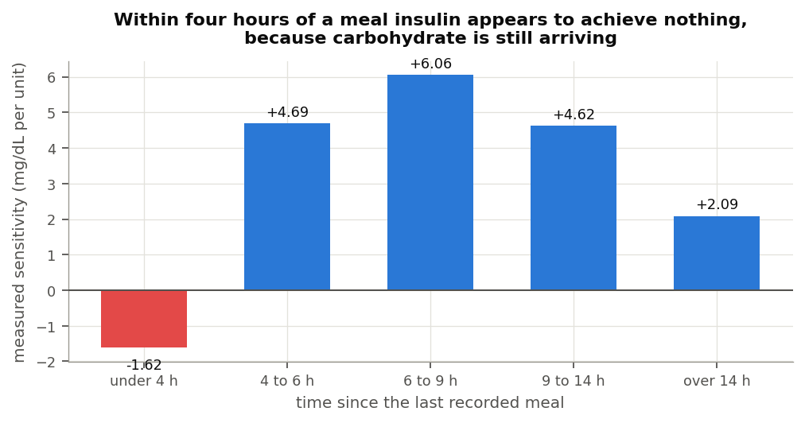
Measured sensitivity by time since the last meal
Within four hours of a logged meal, measured sensitivity reads -1.62 mg/dL per unit. Nothing has a negative sensitivity. The number says glucose rose while insulin acted, which is carbohydrate arriving after the absorption model wrote it off. By six to nine hours out it reaches 6.06.
That is the absorption tail, measured directly.
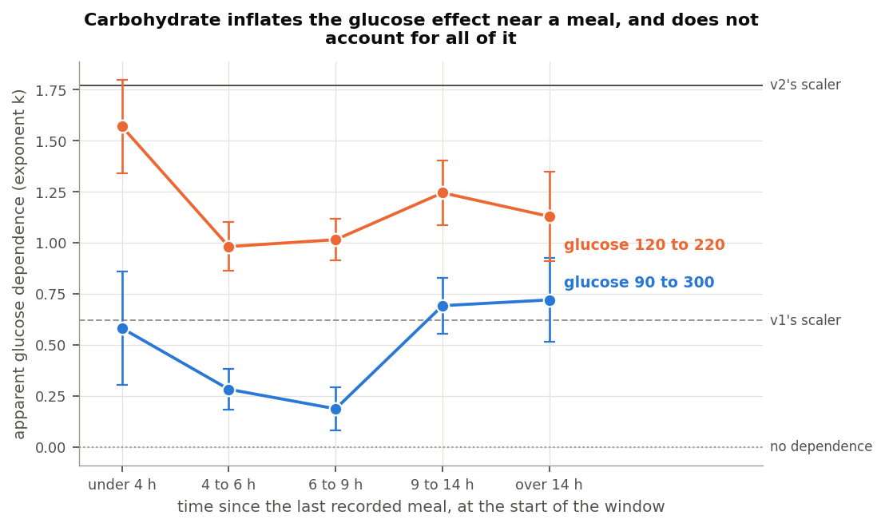
Apparent glucose dependence by time since the last meal
The apparent glucose effect follows the same curve, running about three times larger near a meal than in clean fasting. So food drives a real share of what the glucose term responds to.
It does not drive all of it. Well clear of a meal some glucose dependence remains.
TDD behaves differently. Holding recent carbohydrate constant keeps 83% of it.
Group | Before | Holding food constant | Kept
Loop | -0.586 | -0.500 | 85%
REPLACE-BG | -1.443 | -0.978 | 68%
Together | -0.648 | -0.539 | 83%
The TDD half describes something mostly real. The glucose half is substantially food.

Predicting the night
Each candidate gets a per-person offset, fitted on that person’s first 70% of nights and scored on the rest. That favours the equations. Most overnight insulin is basal, and charging the liver to a sensitivity factor would blame it for work it never had.
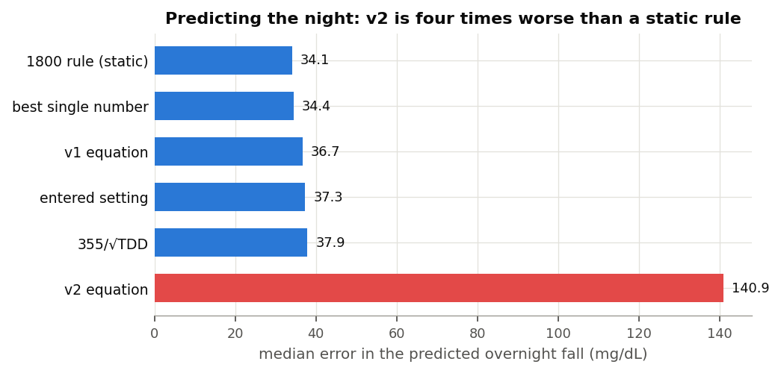
Predicted overnight fall by candidate
Candidate | Typical miss
Static 1800 rule | 34.1 mg/dL
Best single value for that person | 34.4
v1 | 36.7
The person’s own entered setting | 37.3
355 over the square root of TDD | 37.9
v2 | 140.9
Of 1,626 people the best candidate was a single fitted value for 638, the static 1800 rule for 587, the square root form for 195, v1 for 135, and their own setting for 71. It was v2 for none.
v2 also misses in one direction rather than merely scattering. Glucose fell 41 mg/dL further than it predicted, at the median, which is what believing each unit does several times its real work looks like from the outside. Its worst ground is low TDD, where its typical miss reaches 322 mg/dL below twenty units a day. The miss shrinks as TDD climbs, reaching 83 mg/dL above 64 units a day, because its sensitivity approaches v1’s as the daily total rises towards the crossing point. Even there it misses by more than twice anything else.

Could the method be producing this?
Building people whose sensitivity follows a chosen rule, then running them through the same machinery, answers that.
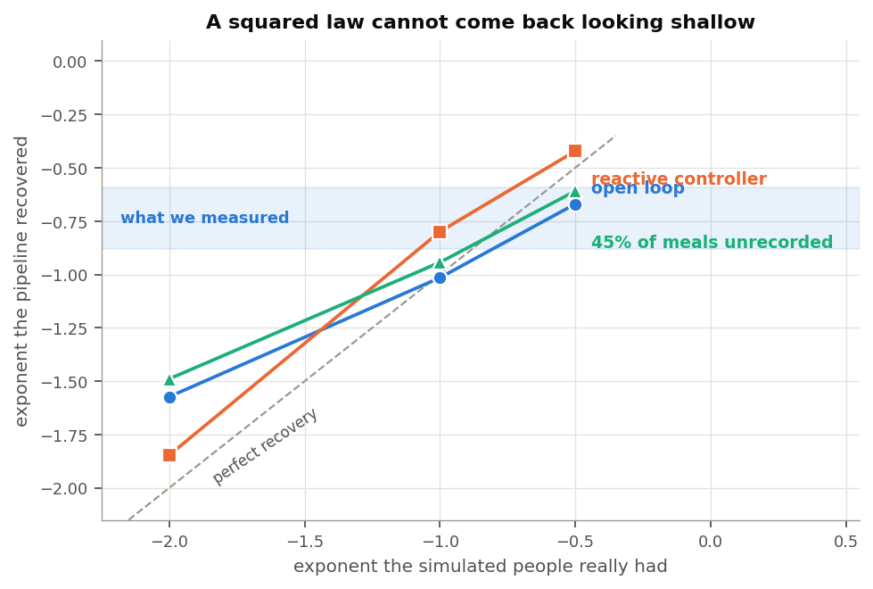
Recovery of a known relationship
Built in | Came back
-0.50 | -0.67
-1.00 | -1.02
-2.00 | -1.57
The middle row returns almost exactly. The shallow one comes back a little steep, at -0.67 [-0.75, -0.58], and the squared one flattens. The bottom row decides it: a squared law returns between -1.49 and -1.85 under every condition I tried, including one where nearly half of all meals went unrecorded. The measurements ran between -0.65 and -0.88. A squared law cannot look like that.
(Corrected 10 November 2026. The simulator had been writing its unrecorded meals into the carbohydrate record, so that condition hid none of them. With the meals hidden, the squared law returns -1.49 [-1.60, -1.38] where this section said -1.56. The first row of the table said -0.50; the committed run has always returned -0.67.)

What this does not settle
It supplies no number to set. The method shrinks the sensitivities it measures, so only the shape of the relationship comes through, not a constant.
It covers overnight fasting. The four hours after a meal appear here only well enough to show sensitivity turning negative. Working out what a meal really does across those hours would put the carbohydrate absorption model itself under examination, which is different work and probably more useful.
It says nothing about sensitivity that moves with the day rather than with TDD. Exercise, illness and a change in diet all move it over hours and days. None of that appears here, and none of it is being argued against.
The cohorts running automated systems make weak evidence alone. In the Control-IQ studies the share of people with a positive sensitivity sits near a coin toss, and below one for the youngest. They back a direction rather than establishing it.
Two faults in the underlying data needed repair. Extended bolus durations arrive in milliseconds for three of the six studies and in seconds for the other two, so a one hour square wave reads as a thousand hours. The database also returns timestamps at microsecond resolution, which divided every basal total by a thousand until I checked the rebuild against the database’s own sums. Anyone working from these archives will meet both.

Where the two equations stand
v1’s TDD term holds up, and holds up best in the ground it came from: it describes what people run their pumps at to within a few per cent. Against the glucose response it looks a touch steep, with support running between the square root and v1.
Its glucose term points the wrong way, as does v2’s. Both make insulin most effective near target where the measurement makes it least effective. The term stays small enough to cost little.
v2’s squared TDD term finds no support here. What people run contradicts it, what glucose does contradicts it, it never beat the alternatives for anyone, and the simulation says a squared law could not have looked like anything I measured. It behaves worst in children and at low TDD, where a correction that comes out far too small does the most harm.
The scope of that conclusion is narrow. It describes what a large and varied group of people did. It says nothing about anyone’s intent or competence, it covers overnight fasting in archives collected for other purposes, and the equations under examination moved the discussion to where this work could begin. Another route into the same question would be welcome.
Anyone wanting a TDD term will find support here for something between about -0.65 and -1.0, applied to a person’s own level rather than used to set it. But a plain static 1800 rule out-predicted every dynamic version tested, so the question I am left with is not which exponent to use. It is whether sensitivity is the right place for this adjustment at all, when the clearest unfinished business is what a meal keeps doing four hours after somebody logged it.

Methods
Windows run four hours from starts between 23:00 and 03:00. Each needs 80% sensor coverage, a starting glucose between 90 and 300 mg/dL, and either six hours clear of logged carbohydrate or, where nothing is logged, four hours clear of a bolus large against that person’s own TDD. Screening looks only backwards, never at what glucose did next. Dropping the nights where glucose rose removes the nights insulin worked least well and inflates the result.
Insulin action comes from convolving the delivery record with an insulin model. Loop subjects use the models LoopKit ships, taken from its source rather than approximated. The rest use the oref exponential at six hours with a 75 minute peak.
Per-person fits use ordinary least squares with a heteroskedasticity-robust standard error. Population figures pool the per-person estimates by the method of DerSimonian and Laird, matching the earlier work in this series so the two read side by side. Intervals are percentile bootstrap over people, weighted as the estimate they wrap.
The per-reading calculation looks back six hours at every reading. It takes the glucose change and the insulin action as departures from that person’s own median for that half hour of the day, and requires the excess insulin action to clear 0.3 units so the denominator is not noise.
Testing whether the axes multiply cleanly means fitting insulin action against glucose, against TDD, and against the product, then reading the third coefficient. The glucose profile is measured as a power law and, because the power law describes it poorly, by interacting insulin action with glucose band indicators, which imposes no shape.
Fitted as a power law the glucose exponent comes to +0.238, standard error 0.044. The body above does not quote it because it is unstable: a narrower glucose range moves it to about +1.0, a larger shift than the number itself. A power law cannot describe a step, so fitting one across the profile in the table averages the step into almost no slope, whose sign follows whichever range was chosen.
Both equations are implemented in inv008/dynisf.py and every v1 and v2 figure here comes from them. They follow the Boost variant of the plugin code, which differs from the stock AAPS DynamicISF plugin in two places. Stock computes 1800 / (tdd * ln(glucose / divisor + 1)) with no cap on glucose, while the Boost variant counts glucose above 210 mg/dL at a third. Stock blends the TDD as 0.33 * w8h + 0.34 * tdd7D + 0.33 * tdd1D with no branch, while the Boost variant substitutes a lower figure for the seven day term when the eight hour figure falls under 75% of it.
Repeating the overnight comparison under the stock formulas moves v1 from 36.7 to 36.6 mg/dL and v2 from 140.9 to 126.8. The ordering, the counts of who each candidate suits best, and every conclusion here are the same under either. Both sets of formulas are pinned to the plugin source by tests in inv009/tests/test_equations.py.
An earlier draft of this document, and an earlier note in this series, put the crossing point between v1 and v2 at 64 units a day. That figure is the ratio of the two leading coefficients, 115000 over 1800, and it is not the crossing point. v1 takes the logarithm of glucose over the divisor plus one and v2 takes it without the plus one, and that pair differs by a factor of two to three across the range. The crossing point therefore carries a glucose term and sits much higher: 101 units a day at 150 mg/dL, 130 at 120 mg/dL, and 194 near target. A test now covers it.
An earlier draft reported a glucose exponent of -2.67. An indexing defect caused it. The interaction term had been inserted ahead of the insulin coefficient in the design matrix while the code still read that coefficient from a fixed position, so the interaction was divided by the starting glucose term. A second implementation disagreed on the sign, which is how it surfaced. Design matrix columns now carry names and a regression test covers it.
Code sits in inv009/ in the dynamic-isf-calculations repository, with 29 tests.
psql -d oref -f inv009/ingest/sql/05_settings.sql
python3 inv009/ingest/load_settings.py
python3 -m inv009.build_cache
python3 -m inv009.entered_isf && python3 -m inv009.effective_isf
python3 -m inv009.tdd_axis && python3 -m inv009.glucose_axis
python3 -m inv009.head_to_head && python3 -m inv009.synthetic
python3 -m inv009.loop_model_infer && python3 -m inv009.ml_shap
python3 -m inv009.carb_hypothesis && python3 -m inv009.joint_surface
python3 -m inv009.pointwise_isf && python3 -m inv009.figures

Data attribution
The source of the data is the Loop Study (sponsored by the Jaeb Center for Health Research and funded by the Helmsley Charitable Trust), but the analyses, content and conclusions presented herein are solely the responsibility of the authors and have not been reviewed or approved by the study sponsor.
The source of the data is the Insulin Only Bionic Pancreas Pivotal Trial, but the analyses, content and conclusions presented herein are solely the responsibility of the authors and have not been reviewed or approved by the Bionic Pancreas Research Group or Beta Bionics.
DCLP3, DCLP5, PEDAP and REPLACE-BG are also public datasets from the Jaeb Center for Health Research, whose releases carry no attribution wording of their own. The analyses, content and conclusions here are solely mine and have not been reviewed or approved by any study sponsor.
Dates in these archives are shifted or rebased per participant, so time of day is preserved and calendar date is not. Nothing here depends on calendar date.

