Dynamic ISF, glucose and carbohydrate: a summary
  - Three findings from testing both equations against 1,684 people in seven public study archives
Tim Street
25 August 2026

What was done
Both dynamic ISF equations calculate a sensitivity factor from two inputs: how much insulin somebody has been using, and where their glucose sits. This work tested both against seven public study archives, covering about 1,700 people, ages 2 to 82, with total daily doses from 7 to 107 units. One of those archives, REPLACE-BG, ran on a pump and a sensor with no algorithm between them, and two recorded what people ate.
Sensitivity was rebuilt from delivered basal and boluses across overnight periods, then compared against what each equation calculates at the same moment. The full paper carries the method and its checks. Three findings are worth stating on their own.

One: with carbohydrate excluded, glucose barely moves sensitivity, and moves it the other way
Both equations reduce sensitivity when glucose runs high. The reasoning is familiar and reasonable: insulin is thought to work less well at higher glucose, so a correction should be larger.
Measured across overnight periods at least six hours clear of any recorded meal, sensitivity moves the other way.
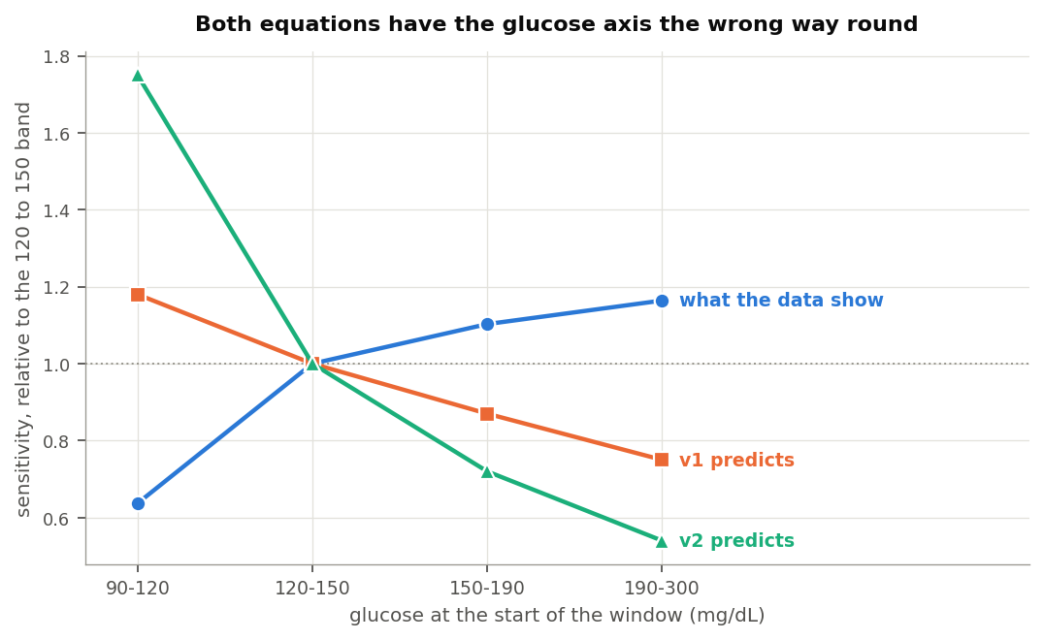
Sensitivity by glucose band against both equations
Glucose | Measured | v1 assumes | v2 assumes
90 to 120 mg/dL | 0.64 | 1.18 | 1.75
120 to 150 | 1.00 | 1.00 | 1.00
150 to 190 | 1.10 | 0.87 | 0.72
190 to 300 | 1.16 | 0.75 | 0.54
Those figures scale the 120 to 150 band to 1.00. A unit does about a third less near target than it does mid-range, then slightly more as glucose climbs. Both equations have that profile running the other way.
The near-target end explains most of it. That is where the body defends against a further fall, so a unit achieves less there for reasons that have nothing to do with high glucose resistance. Above 120 mg/dL the profile is close to flat.
The movement is also small. Out of sample, six candidate glucose shapes including both equations’ own landed within 0.05 mg/dL of each other at predicting the overnight fall, and a flat sensitivity ranked first. The threshold set before running the comparison was an improvement of half a milligram per decilitre. Nothing reached a tenth of that.
Three separate methods return the same reversal, including one that computes a sensitivity at every glucose reading and fits no curve to anything.
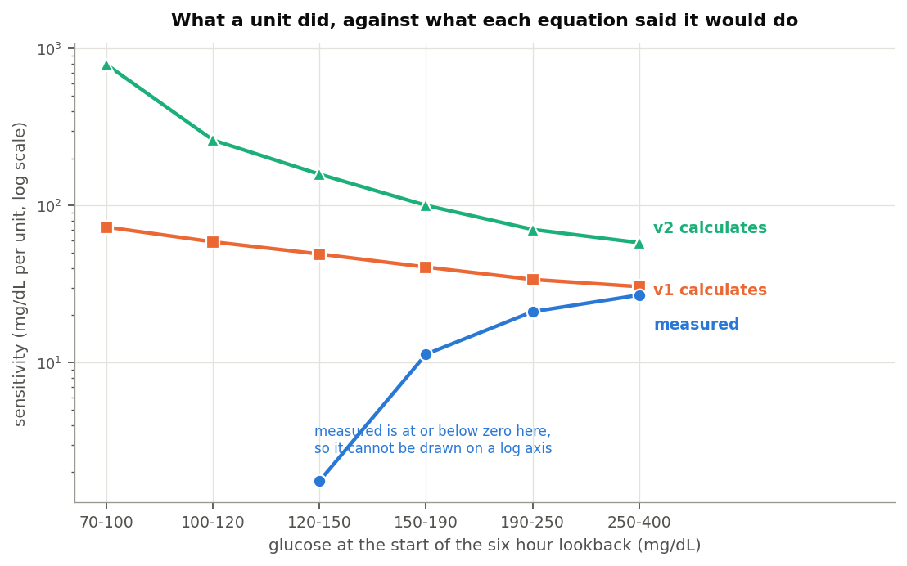
Measured sensitivity against both equations at the same reading

Two: the original picture may have been shaped by carbohydrate
The effect these equations encode is visible in data. It is just not visible once meals are excluded.
Within four hours of a meal somebody logged, measured sensitivity comes out at -1.62 mg/dL per unit.
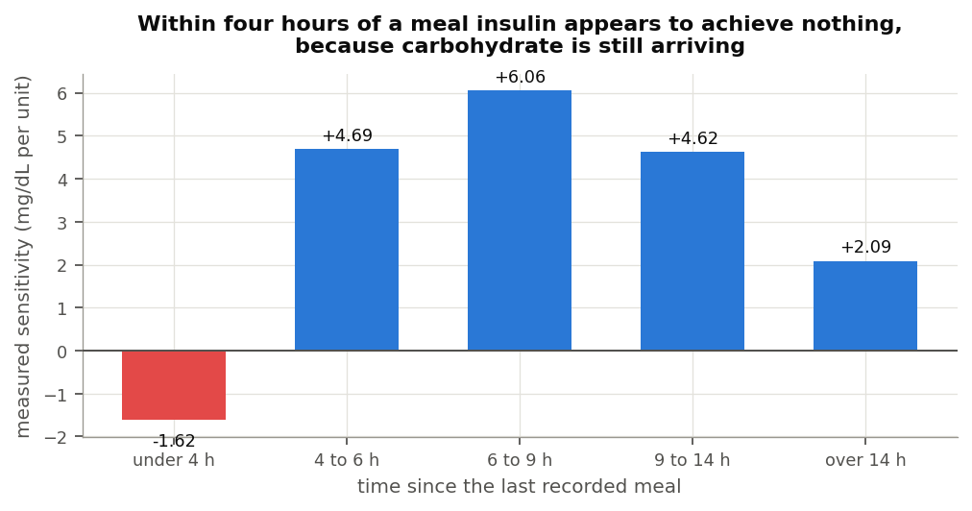
Measured sensitivity by time since the last meal
Nothing has a negative sensitivity. The number says glucose rose while insulin acted, which is what happens when carbohydrate keeps arriving after the absorption model has finished counting it. By six to nine hours out, the same people measure 6.06.
That matters for how the glucose term looks in any dataset that has not excluded meals. The apparent glucose effect tracks distance from the last meal closely.
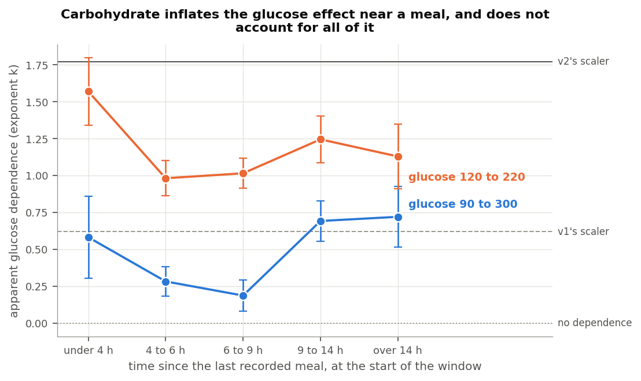
Apparent glucose dependence by time since the last meal
Time since the last recorded meal | Apparent glucose dependence
Under 4 hours | +0.610
4 to 6 hours | +0.308
6 to 9 hours | +0.207
Each band is measured from different periods, and the decline is steady. Close to a meal the effect is roughly three times its size in clean fasting.
Somebody evaluating dynamic ISF on periods that included the hours after eating would therefore see much of what these equations encode. They would see sensitivity apparently falling as glucose rose, because glucose was high and insulin looked weak for a reason nobody had accounted for. This is offered as a plausible account of how the original picture formed rather than as a reconstruction of it. What can be said from these archives is that the effect is around three times larger where uncounted carbohydrate is present.

Three: where the equation helps, it may be offsetting a different model’s error
There is a reading of this that is more sympathetic to dynamic ISF than the first two findings suggest, and it deserves stating.
Carbohydrate absorption models in these systems are approximations, and the measurement above shows one specific way they fall short: they stop counting before the carbohydrate stops arriving. During that tail, glucose runs high and more insulin is genuinely needed than the system’s own accounting calls for.
A glucose-driven sensitivity term delivers more insulin when glucose is high. Overnight and away from food, this analysis finds that adjustment pointing the wrong way. In the hours after a meal, it delivers extra insulin at exactly the times uncounted carbohydrate is arriving.
So for people whose meals are frequently under-counted, whether through unannounced eating or through absorption running longer than the model allows, the two errors work in opposite directions and can offset. The equation would be compensating for the carbohydrate model rather than describing insulin sensitivity, and it would still produce a better outcome for that person.
The evidence here supports the mechanism at the population level: the apparent glucose effect is three times larger near meals than away from them. A per-person version of the same test, asking whether people with deeper carbohydrate tails show stronger glucose dependence, did not reach significance once terms shared between the two measurements were removed. The mechanism is consistent with what these archives show, and the individual case is not established by them.

What this does not say
It does not say the total daily dose half of these equations is wrong. That relationship is real, survives holding recent carbohydrate constant, and appears in a model given no functional form to fit. Its exponent measures between about -0.65 and -0.84, against the -1 that v1 assumes and the -2 that v2 assumes.
It does not cover the hours after a meal as a dosing problem. Those hours appear here only well enough to show sensitivity turning negative. Working out what a meal really does across them would put the carbohydrate absorption model itself under examination, which is different work.
It does not measure sensitivity that moves with the day rather than with the dose. Exercise, illness and a change in diet all move it over hours and days, and none of that is measured here.
It gives no number to set. The method shrinks the sensitivities it measures, so only the shape of the relationship comes through.

Where that leaves things
The total daily dose term in v1 holds up well and matches what people already run their pumps at. The squared version in v2 finds no support in these archives, and its errors are largest for children and for anyone on a small daily total.
The glucose term in both points the wrong way once meals are excluded, though it is small enough to cost little either way, and it may be doing useful work for some people by standing in for carbohydrate the system has not fully counted.
The people who built these equations were working from the same rule of thumb most pump settings come from, and that rule survives this analysis in good shape. The more interesting question these findings raise is not which sensitivity exponent to use. It is what a meal is still doing four hours after somebody logged it, and whether that is better addressed where it happens.
Full analysis, methods and code: Dynamic-ISF-6-Public-Datasets-2026-08-25 and the dynamic-isf-calculations repository.

Data attribution
The source of the data is the Loop Study (sponsored by the Jaeb Center for Health Research and funded by the Helmsley Charitable Trust), but the analyses, content and conclusions presented herein are solely the responsibility of the authors and have not been reviewed or approved by the study sponsor.
The source of the data is the Insulin Only Bionic Pancreas Pivotal Trial, but the analyses, content and conclusions presented herein are solely the responsibility of the authors and have not been reviewed or approved by the Bionic Pancreas Research Group or Beta Bionics.
DCLP3, DCLP5, PEDAP and REPLACE-BG are also public datasets from the Jaeb Center for Health Research, whose releases carry no attribution wording of their own. The analyses, content and conclusions here are solely mine and have not been reviewed or approved by any study sponsor.

