A paid application standardises what large language models read about insulin pump settings and leaves what they decide to chance: reproducibility of an automated insulin delivery settings review across eleven models
Tim Street, Diabettech Ltd, London, United Kingdom

Abstract
Background. A paid Android application prepares a user’s AndroidAPS data and four prompts for any large language model, checks the returned JSON and presents it as a settings review; what a user receives has not been measured.
Methods. The application’s package and prompts were replayed verbatim in fresh conversations against eleven models at default sampling, 50 conversations per model (20 for two), on one adult’s 14-day record. Responses were judged by a validator reconstructed from, and checked against, the application’s behaviour. Outcomes were whether quoted figures were in the record, agreement on 23 settings within and between models, and what the check accepted, with Wilson 95 per cent intervals over conversations.
Results. The models quoted the record accurately, with 97.0 to 100 per cent of cited figures present in it. Three models lowered the maximum insulin on board limit in 79 to 98 per cent of conversations, proposing 17 to 18 distinct value pairs; four never changed it. One model proposed sensitivity factors from 30 to 180 mg/dL per unit against a current 56. Acceptance at first paste ranged from 34 per cent (22.4 to 47.8) to 100 per cent, and up to 17 of 20 accepted responses broke rules the prompts state but the check does not enforce.
Conclusions. A sensitivity factor three times the current value and a meal step marked completed on a record with no meals both passed the application’s check. The record was read consistently and the advice was not: which settings a user is told to change depended more on the model opened than on the data, and the user is given no means of telling which answer they have. The design supports no claim about outcomes.
Keywords: artificial intelligence; automated insulin delivery; AndroidAPS; large language models; reproducibility; type 1 diabetes
Abbreviations: AID, automated insulin delivery; CGM, continuous glucose monitoring; DIA, duration of insulin action; IOB, insulin on board; ISF, insulin sensitivity factor; JSON, JavaScript Object Notation; LLM, large language model.

Introduction
A person who runs an open-source automated insulin delivery (AID) system such as AndroidAPS sets their own basal rates, carbohydrate ratios, insulin sensitivity factors, duration of insulin action and glucose targets, and the limits that bound what the algorithm may deliver [1]. Reviewing those settings against a fortnight of glucose data is skilled work, and since general-purpose large language models (LLMs) learned to read an exported file, some users have asked them to do it between clinic appointments [2, 3]. By August 2026 an Android application had made the practice a product. TuneMyBG [4] describes itself as “AI ready Nightscout data for safer AAPS tuning” and as “a tool for organizing data, preparing prompts, and helping users think through possible profile improvements”. It builds a JSON package from the user’s Nightscout instance and AndroidAPS profile, with a decision inventory of 23 settings, and supplies four prompts. The user opens a new conversation in whichever LLM they prefer, attaches the package with the first prompt, sends the other three in turn and pastes the final response, which must be one strict JSON object, back into the application. The application checks it, returns the user to the conversation with a repair prompt if it fails, and otherwise renders a primary profile recommendation, a decision for every setting, a meal strategy and a list of recommendations; a subscription costs £4.49 a month, and no model is recommended.
The product rests on the promise that a model given a well-structured record will derive a review from it, and on the assumption that checking the review’s form is enough to stand behind its content. Earlier work bears on the promise: general-purpose models answer diabetes questions fluently and sometimes wrongly [5], and their carbohydrate estimates from photographs vary from query to query, with median within-image coefficients of variation of 2.4 to 11.0 per cent [6, 7, 8]. Asked to propose pump settings from a week of raw CGM and pump data, five models anchored on textbook values unless told the user’s current settings, and 30 to 70 per cent of the glucose readings they cited were not in the data; the authors concluded that a deployment would need two safeguards, the user’s settings as context and programmatic checking of what the model cites [9]. The Diabetes Technology Network UK has advised that any suggested change to a pump setting must be checked for plausibility before it is acted on [10]. TuneMyBG supplies the first safeguard, since the package carries the current profile, and its check is a form of the second; what happens to the review once both are in place has not been measured.
This study replicated the application’s workflow as closely as the providers’ interfaces allow, against eleven models, on one real record, and asked three questions in order: whether the models read the record correctly, whether they agreed about what to change, and what the application’s check made of the difference. The product’s regulatory position is taken up in a companion commentary.

Methods

Materials
The package and the four prompts were copied verbatim from the application (package version 10, template “general_audit”). The application’s source is not available, so its repair prompt and acceptance behaviour were established by pasting 25 real model outputs, chosen to cover every failure shape observed, into the result screen and recording what it did. The application’s synthetic demonstration package (time in range 99.7 per cent, no glucose below 70 mg/dL, 3.9 mmol/L) served as a control. The study package was generated by the application from the author’s own Nightscout instance and AndroidAPS profile: 14 days, 3,995 CGM entries with 98.7 per cent coverage, mean glucose 121.6 mg/dL, time in range 86.0 per cent, time below 70 mg/dL (3.9 mmol/L [11]; glucose is given in mg/dL throughout, with mmol/L where a threshold is defined) 5.1 per cent, coefficient of variation 32.6 per cent, 655 insulin entries totalling 275.95 units, and no carbohydrate entries, since the author does not log meals. The profile had a single sensitivity factor of 56 mg/dL per unit, overnight targets of 90 mg/dL, a duration of insulin action of 10 hours, a maximum basal of 12 U/h and a maximum IOB of 25 U. Time below 70 mg/dL peaks at 18.5 per cent in the hour after midnight and has fallen to low single figures by 04:00 with the same basal segment running, which under a 10-hour duration of insulin action is more consistent with the tail of evening insulin than with the overnight basal or target; that reading is the author’s and is offered as interpretation. One record was used by design: the question is whether the same input yields the same review, and holding the input fixed while the conversation is repeated attributes all observed variation to the model and the application rather than to differences between records. A study of whether the advice is correct would need many records and a reference standard, and is a different study.

Replication of the workflow
Each conversation was started afresh, with the package attached as a text document to the first prompt and the remaining prompts sent in turn after each response completed. No sampling parameters were set, so each provider’s default applied, as it does for a user of the consumer chat interfaces, none of which exposes temperature. Eleven models were run on 21 and 22 August 2026: Gemini 3.6 Flash, Gemini 3.1 Pro Preview and Gemini 3.5 Flash-Lite (Google); GPT-5.6-sol and GPT-5.4-mini at the medium reasoning setting (OpenAI); Claude Opus 5, Claude Sonnet 5 and Claude Haiku 4.5 (Anthropic); DeepSeek V4 Pro; Grok 4.6 (xAI); and Llama 4 Maverick (Meta), the last three through OpenRouter. Fifty conversations were run per model, except Opus and Sonnet at 20 because of cost, and the served model identifier was recorded for every turn (Supplementary Table S1). Conversations ran through the providers’ programming interfaces, the only way to run them at this scale, so the results describe the models rather than any chat product.

The application’s check and the repair loop
Testing against the application reduced its acceptance rules to a short list, beginning with the three conditions for which it issues a repair prompt: decision rows missing from or absent in the inventory, a current value not copied exactly, and a primary recommendation focus outside the five allowed words. It stops without a prompt when the paste is not valid JSON or a required string field is absent. It accepts everything else, including missing sections, invalid status, confidence and priority words, and extra keys. The validator built from these observations reproduces the application’s verdict on all 23 informative test pastes (Supplementary Table S2), and it, rather than the application, judged the study’s responses. Where a first response needed repair, the repair prompt was sent once in the same conversation and the corrected response judged again, and each conversation was classified as accepted at first paste, accepted after repair, rejected with no prompt offered, or still rejected after repair; rules stated in the prompts but not enforced were recorded separately.

Outcome measures
Whether the models read the record was measured by checking every figure with a unit quoted in an accepted response against the numbers in the package, and by recording whether each response recognised the absence of carbohydrate data and how it scored the meal strategy step. Whether the models agreed was measured, for each of the 23 settings, by the proportion of accepted conversations proposing a change and the values proposed; by a stability index, the mean over settings of the proportion of conversations agreeing with the modal decision; and by the primary recommendation’s focus. What the check made of it was measured by the acceptance classes and the proportion of accepted responses breaking an unenforced rule. Proportions carry Wilson 95 per cent intervals with the conversation as the unit. The within-model results rest on 20 to 50 conversations per model and are solid; the between-model comparison is provisional, since the models are versioned services that change; the reasons offered for the differences are interpretation. All analyses were specified before the runs except the carbohydrate-handling examination, the citation check and the reading of the overnight rationales for whether they attributed the lows to earlier insulin or to the setting itself, which were added after inspection of the outputs. The harness, validator, analysis code, prompts, all transcripts and outputs, and the package with identifiers removed are in the study repository.

Results

What the models read
On the control package all 50 Gemini 3.6 Flash conversations kept every setting unchanged, so the remainder concerns the study record. The models quoted the record accurately (post hoc analysis): of the figures with a unit in accepted responses, 97.0 per cent (Opus) to 100 per cent (GPT-5.4-mini, Llama) were present in the package, the remainder being thresholds or simple derived quantities. Every model recognised that no carbohydrates had been logged in at least 72 per cent of conversations (post hoc analysis), and all read the daytime glucose pattern as unannounced meals. No model but Llama changed a carbohydrate ratio (2 of 46 conversations); elsewhere the models left the ratios and said they could not be tested without meal data. The three models that acted on the safety limits cited the same arithmetic, a 25 U ceiling against roughly 19.7 U of insulin a day, and both branches of the fork described below cited the same figure, 18.5 per cent of readings below 70 mg/dL at 01:00.

What the models concluded
Table 2 sets the models side by side. Gemini 3.6 Flash, Gemini 3.1 Pro and Opus lowered the IOB limit in 98, 90 and 79 per cent of conversations; GPT-5.6-sol, GPT-5.4-mini, Sonnet and Grok never did; DeepSeek and Llama did so in 44 and 39 per cent, Llama to 15 or 20 U where the others chose 3 to 10 U. The overnight target was raised by the Gemini models in 78 to 90 per cent of conversations, by GPT-5.6-sol in 36 per cent and by Grok in 20 per cent. The primary recommendation was headed “target” by Flash, Pro, GPT-5.6-sol and Grok in most conversations, “basal” by GPT-5.4-mini, Flash-Lite, Llama and Opus, and “ISF” by DeepSeek in 17 of 50. Four models changed nothing in most conversations: GPT-5.4-mini in 46 of 48, Sonnet in 19 of 20, Grok in 40 of 50 and Flash-Lite in 39 of 49.
Within a model the direction of a change was usually consistent and the number was not (Figure 2). Gemini 3.6 Flash lowered the IOB limit in 49 of 50 conversations (98 per cent, 89.5 to 99.6) and the basal limit in 48, proposing 18 distinct pairs of values: IOB from 4 to 15 U with 7 U the commonest (27 of 49), maximum basal from 2.5 to 4 U/h with 3.5 U/h the commonest (19 of 48). Gemini 3.1 Pro lowered the IOB limit in 45 of 50 (90 per cent, 78.6 to 95.7), to between 3 and 10 U, with 17 distinct pairs; Opus in 15 of 19 (79 per cent, 56.7 to 91.5), to between 6 and 10 U. Stability indices ranged from 0.915 (DeepSeek) and 0.926 (Haiku) to 0.998 (GPT-5.4-mini and Sonnet); an index of 1 would mean every conversation made the same decision on every setting, so for the least stable model roughly one setting decision in twelve departed from the modal answer, and the highest indices belonged to the models that changed nothing.
The primary recommendation also forked within a model: Gemini 3.6 Flash raised the two overnight targets from 90 to 100 mg/dL (5.0 to 5.6 mmol/L) in 39 of 50 conversations (78 per cent, 64.8 to 87.2) and headed the result with “target”; in the other 11 it left the targets alone, cut the midnight basal from 0.6 to 0.5 U/h and headed the result with “basal”. Llama changed the midnight basal in 27 of 49 accepted conversations, raising it to 0.65 U/h in 19 and lowering it to 0.55 U/h in the rest, on data whose overnight hours carried the highest time below range of the period. DeepSeek changed the sensitivity factor in 20 of 50 (40 per cent, 27.6 to 53.8), proposing 14 distinct values from 30 to 180 mg/dL per unit against a current 56, so that some conversations roughly doubled the strength of a correction and others cut it by two thirds; it also shortened the 10-hour duration of insulin action in eight conversations, to between 5 and 8 hours.
The overnight lows themselves were read three ways (Table 3; post hoc analysis). Opus and Sonnet traced them to earlier insulin in 19 of 19 and 19 of 20 conversations, one Opus rationale putting it that the low band “is better explained by an insulin tail than by the target, since it self-resolves by local 04:00 under the same target”, and neither model changed the overnight target or basal in any conversation. Gemini 3.1 Pro traced the lows to “massive late insulin stacking from evening UAMs” in 40 of 50 conversations and still raised the target in 45, 36 of them while naming the stacking, as a buffer against it; Gemini 3.6 Flash named the earlier insulin in 21 of 50 and changed the target or basal in 44. Llama changed the midnight basal in 25 of 46 conversations with no causal attribution of any kind, most of its rationales consisting of the sentence “No strong evidence to change”.
The meal strategy step, which had no meal data to work from, was marked completed by Flash-Lite, Llama and Haiku in 49 of 49, 45 of 46 and 20 of 20 conversations, and partial or blocked by the other models.

What the check caught
Table 1 gives the acceptance classes with intervals. Four models were accepted at first paste in every conversation and three in 90 per cent or more. Opus produced output that was not valid JSON in nine of 20 conversations (45 per cent, 25.8 to 65.8), typically one closing brace omitted after the meal strategy section, and Flash-Lite in 11 of 50 (22 per cent, 12.8 to 35.2); the application offers no way forward from that state. Llama recovered through the repair prompt in 25 of 50 conversations, its errors being the ones the application repairs, whereas Haiku was still rejected after the repair prompt in 27 of 50 (54 per cent, 40.3 to 67.2), most often for a free-text phrase in the focus field repeated when corrected.
Nothing in the preceding section was caught: the check accepted all 18 safety-limit pairs, both branches of the Flash fork, both directions of the Llama basal change, all 14 DeepSeek sensitivity factors and every meal step marked completed on a record with no meals. Among accepted responses the proportion breaking a rule the prompts state but the check does not enforce ranged from none (GPT-5.6-sol) to 25 of 48 (GPT-5.4-mini) and 17 of 20 (Haiku), the commonest breaches being confidence words outside the allowed set, such as “medium-high” or “partial”, a missing issues section, and extra keys, all of which reach the result screen.

Discussion
On this record the review a user received depended more on which model they opened than on the data, and the application could not tell the difference. The models agreed about the record: the figures they quoted were almost all in it, each model noted the absent carbohydrate entries in most of its conversations, and the three that lowered the safety limits did so from the same sum, but they did not agree about what followed: four models left every setting alone, three lowered the limits, one proposed sensitivity factors that ranged over a factor of six, and one raised a basal rate that another lowered. Within a single model the direction held and the number did not, so a second conversation on the same package would often have given a different pair of safety limits and, for a fifth of Gemini 3.6 Flash users, a different headline setting. The overnight lows show the difference at its clearest: the same figure led two models to leave the overnight settings alone because earlier insulin explained it, two to raise the target as a cushion against that same insulin, and one to change the basal without offering a cause, and only the first of these acts on what the record shows. Each answer was internally coherent and presented in the same form, so nothing on the screen tells the user which they have been given.
This is a different failure from the two described for models given raw five-minute data, where settings anchored on training priors and the cited readings were unreliable [9]. Here the package carried the current profile and the check enforced the copying of current values, the two safeguards that paper proposed, and the anchoring and the misquotation largely disappeared: the models read the record and argued from it, and what they argued was not stable. With good evidence the models generate several plausible conclusions and the sampling decides which is shown. A structured package appears to fix what the model reads and to leave untouched what it decides, and the product sells the decision.
The application’s check is a check of form, enforcing the identity of the decision table, the copying of current values and one enumerated field. It does not inspect a proposed value, a status, a confidence word or the content of a recommendation, so a meal step marked completed on a record with no meals appears as the model wrote it, and a sensitivity factor of 180 mg/dL per unit passes as readily as one of 56. The prompts contain rules against most of this, but they are instructions to the model rather than checks, and the cheaper models broke them in a quarter to four fifths of accepted responses.
None of this can be cured by a temperature setting, since the chat interfaces expose none and provider-side non-determinism persists at temperature zero [12]. A design that took the variation seriously would run the analysis several times and show the spread, and would validate and pin one model rather than accept any. The advice that every suggested change be checked for plausibility before it is acted on [10] assumes a user who can recognise which of several plausible answers they have been handed, and the application’s screen gives them no means of doing so. Whether the application is a medical device is considered in the companion commentary.
The record came from one adult who does not log carbohydrates, so a profile with different problems might be treated differently. Conversations ran through the providers’ interfaces rather than the chat products most users will use. The validator reproduces the application’s behaviour on 23 informative tests but could differ on cases not tested, and one repair round was allowed, as the application offers one prompt at a time. The models are versioned services, and the between-model comparison is a snapshot of two days in August 2026. The study measured consistency, not correctness: there is no reference answer for these settings and no counterfactual glucose trajectory for any proposed change, so what is reported is what the models produced, not what would have happened had a user acted on it. The safety concern is therefore epistemic rather than a claim that any particular answer was wrong. Some of the answers may well have been right; the user is not told that they differ, is given nothing with which to tell a right one from a wrong one, and is sold each as the review of their data. Sample sizes for Opus and Sonnet were 20, and their intervals are correspondingly wide.

Conclusion
Eleven models quoted one glucose record accurately and returned reviews that differed in substance between models and in detail within them, and the application that sells the review accepted all of them. A single review from such a product is one sample from a distribution whose shape the user is not shown. A developer who sells one answer should first measure the spread and disclose it, and a user who receives one should treat it as a hypothesis rather than a finding.

Declarations
Funding. No funding was received. Model usage for the study, $158.42 plus £19.73, was paid for by the author.
Conflicting interests. The author runs Diabettech Ltd, is a committee member of the Diabetes Technology Network UK and wrote its statement on large language models, and is the author of the two SSRN preprints cited. He has no relationship with the developer of the application studied and paid for its subscription.
Ethical approval. The glucose and pump data analysed are the author’s own, exported from his Nightscout instance and AndroidAPS profile; no other person’s data were used. The study analysed model outputs; no change was made to any treatment and no institutional review board reviewed the work.
Data availability. The prompts, the harness, the validator, the analysis code, every transcript and model output, and the package with identifiers removed are published in the study repository. The package is the author’s own health data and is released with his consent.

References
- AndroidAPS documentation. https://androidaps.readthedocs.io. Accessed 21 August 2026.
- Street T. In conversation with: factual questions for large language models. Diabettech. 21 June 2025. https://www.diabettech.com/ai/in-conversation-with-factual-questions-for-large-language-models/
- Street T. ChatGPT “Health” conversations and a Boost AndroidAPS case study. Diabettech. 8 January 2026.
- Kowalczyk A. TuneMyBG. Google Play. Version 1.0.5, updated 20 August 2026. https://play.google.com/store/apps/details?id=com.adamkowalczyk.tunemybg
- Sng GLY, Tung JYM, Lim DYZ, Bee YM. Potential and pitfalls of ChatGPT and natural-language artificial intelligence models for diabetes education. Diabetes Care. 2023;46:e103-5.
- Goncalves S, Coelho C, Pretre L, et al. Chat, Gemini and Claude at the dinner table: assessing general-purpose AI tools for carbohydrate counting in type 1 diabetes. Diabetes Res Clin Pract. 2025;113031. https://doi.org/10.1016/j.diabres.2025.113031
- Joubert M, Dreves B, Arnould T, et al. Comparative accuracy of smartphone apps and a generative AI tool for carbohydrate counting: an independent bicentric study. Diabetes Obes Metab. 2026. https://doi.org/10.1111/dom.70396
- Street T. Reproducibility and accuracy of large language model vision APIs for carbohydrate estimation from food photographs: a four-model batch comparison with implications for automated insulin dosing. SSRN preprint. 2026. https://doi.org/10.2139/ssrn.6577780
- Street T. Frontier LLMs require explicit clinical context to avoid training-data anchoring for insulin pump settings: a pre-registered exploratory study. SSRN preprint. 2026. https://doi.org/10.2139/ssrn.6619638. Pre-registration: OSF, 10.17605/OSF.IO/Q4UX9.
- Diabetes Technology Network UK. DTN-UK statement on large language models. Association of British Clinical Diabetologists. January 2026. https://abcd.care/dtn/resource/current/dtn-uk-statement-large-language-models
- International Hypoglycaemia Study Group. Glucose concentrations of less than 3.0 mmol/L (54 mg/dL) should be reported in clinical trials: a joint position statement of the American Diabetes Association and the European Association for the Study of Diabetes. Diabetologia. 2017;60:3-6. https://doi.org/10.1007/s00125-016-4146-6
- Understanding and mitigating numerical sources of nondeterminism in LLM inference. arXiv 2506.09501. 2025.

Tables
Table 1. Acceptance of the final response by the application, by model: conversations; accepted at first paste, with Wilson 95 per cent interval; accepted after the repair prompt; rejected with no prompt offered (invalid JSON or a required field absent); still rejected after repair; accepted responses breaking a rule the prompts state but the application does not check; stability index.
Model | n | Accepted first paste, n (per cent; 95 per cent interval) | After repair | No prompt offered | Still rejected | Accepted but breaking a prompt rule | Stability index
Gemini 3.6 Flash | 50 | 50 (100; 92.9 to 100) | 0 | 0 | 0 | 4 of 50 | 0.951
Gemini 3.1 Pro | 50 | 50 (100; 92.9 to 100) | 0 | 0 | 0 | 3 of 50 | 0.983
Gemini 3.5 Flash-Lite | 50 | 38 (76; 62.6 to 85.7) | 1 | 11 | 0 | 8 of 49 | 0.987
GPT-5.6-sol | 50 | 50 (100; 92.9 to 100) | 0 | 0 | 0 | 0 of 50 | 0.983
GPT-5.4-mini | 50 | 48 (96; 86.5 to 98.9) | 0 | 1 | 1 | 25 of 48 | 0.998
Claude Opus 5 | 20 | 10 (50; 29.9 to 70.1) | 1 | 9 | 0 | 5 of 19 | 0.970
Claude Sonnet 5 | 20 | 18 (90; 69.9 to 97.2) | 1 | 1 | 0 | 2 of 20 | 0.998
Claude Haiku 4.5 | 50 | 17 (34; 22.4 to 47.8) | 3 | 3 | 27 | 17 of 20 | 0.926
DeepSeek V4 Pro | 50 | 45 (90; 78.6 to 95.7) | 3 | 2 | 0 | 14 of 50 | 0.915
Grok 4.6 | 50 | 50 (100; 92.9 to 100) | 0 | 0 | 0 | 1 of 50 | 0.986
Llama 4 Maverick | 50 | 19 (38; 25.9 to 51.8) | 25 | 2 | 4 | 5 of 46 | 0.952
Table 2. Settings any model changed in more than 10 per cent of accepted conversations. Each cell gives the percentage of accepted conversations proposing a change, with the range of suggested values in parentheses; 0 means no conversation proposed a change. Current values: maximum IOB 25 U; maximum basal 12 U/h; target at 00:00 90 mg/dL; basal at 00:00 0.6 U/h; ISF 56 mg/dL per unit; dynamic ISF factor 70 per cent; DIA 10 h. AndroidAPS code defaults: maximum IOB 3 U, maximum basal 1 U/h, dynamic ISF factor 100 per cent; profile rows have no code default.
Model | Max IOB (U) | Max basal (U/h) | Target 00:00 (mg/dL) | Basal 00:00 (U/h) | ISF (mg/dL per unit) | Dynamic ISF factor (per cent) | DIA (h)
Gemini 3.6 Flash | 98 (4 to 15) | 96 (2.5 to 4) | 78 (100) | 22 (0.5) | 0 | 26 (50) | 0
Gemini 3.1 Pro | 90 (3 to 10) | 82 (2.5 to 4) | 90 (100 to 110) | 2 (0.5) | 0 | 0 | 0
Gemini 3.5 Flash-Lite | 16 (6 to 15) | 0 | 2 (95) | 10 (0.5) | 0 | 0 | 0
GPT-5.6-sol | 0 | 0 | 36 (100) | 0 | 0 | 0 | 0
GPT-5.4-mini | 0 | 0 | 0 | 4 (0.55) | 0 | 0 | 0
Claude Opus 5 | 79 (6 to 10) | 11 (4 to 5) | 0 | 0 | 0 | 32 (55 to 60) | 0
Claude Sonnet 5 | 0 | 0 | 0 | 0 | 0 | 0 | 0
Claude Haiku 4.5 | 6 (8 to 20) | 0 | 4 (95 to 100) | 14 (0.5 to 0.55) | 14 (40 to 110) | 6 (50 to 85) | 12 (5.5 to 8)
DeepSeek V4 Pro | 44 (2 to 12) | 18 (2 to 4) | 2 (100) | 44 (0.5 to 0.55) | 40 (30 to 180) | 18 (0 to 100) | 16 (5 to 8)
Grok 4.6 | 0 | 0 | 20 (100) | 0 | 0 | 0 | 0
Llama 4 Maverick | 39 (15 to 20) | 2 (10) | 0 | 55 (0.55 to 0.65) | 8 (50 to 55) | 0 | 0
Table 3. How the accepted conversations read the overnight lows: attribution to earlier insulin (the tail of evening dosing, stacking, carry-over or residual IOB) or to the target or basal itself, against whether the conversation changed the target at 00:00 or 23:00 or the basal at 00:00. A conversation may attribute to both. Wilson 95 per cent intervals in brackets.
Model | n | Attributes lows to earlier insulin | Attributes lows to target or basal | Changed overnight target or basal | Changed despite attributing to earlier insulin | Changed with no causal attribution
Gemini 3.6 Flash | 50 | 21 (42; 29 to 56) | 45 (90; 79 to 96) | 44 (88; 76 to 94) | 16 | 3
Gemini 3.1 Pro | 50 | 40 (80; 67 to 89) | 42 (84; 71 to 92) | 45 (90; 79 to 96) | 36 | 2
Gemini 3.5 Flash-Lite | 49 | 4 (8; 3 to 19) | 24 (49; 36 to 62) | 6 (12; 6 to 24) | 0 | 2
GPT-5.6-sol | 50 | 35 (70; 56 to 81) | 47 (94; 84 to 98) | 18 (36; 24 to 50) | 9 | 1
GPT-5.4-mini | 48 | 14 (29; 18 to 43) | 35 (73; 59 to 83) | 2 (4; 1 to 14) | 0 | 0
Claude Opus 5 | 19 | 19 (100; 83 to 100) | 19 (100; 83 to 100) | 0 (0; 0 to 17) | 0 | 0
Claude Sonnet 5 | 20 | 19 (95; 76 to 99) | 15 (75; 53 to 89) | 0 (0; 0 to 16) | 0 | 0
Claude Haiku 4.5 | 20 | 15 (75; 53 to 89) | 19 (95; 76 to 99) | 3 (15; 5 to 36) | 1 | 0
DeepSeek V4 Pro | 50 | 26 (52; 39 to 65) | 49 (98; 90 to 100) | 22 (44; 31 to 58) | 6 | 1
Grok 4.6 | 50 | 34 (68; 54 to 79) | 42 (84; 71 to 92) | 10 (20; 11 to 33) | 6 | 0
Llama 4 Maverick | 46 | 0 (0; 0 to 8) | 5 (11; 5 to 23) | 25 (54; 40 to 68) | 0 | 20

Figures
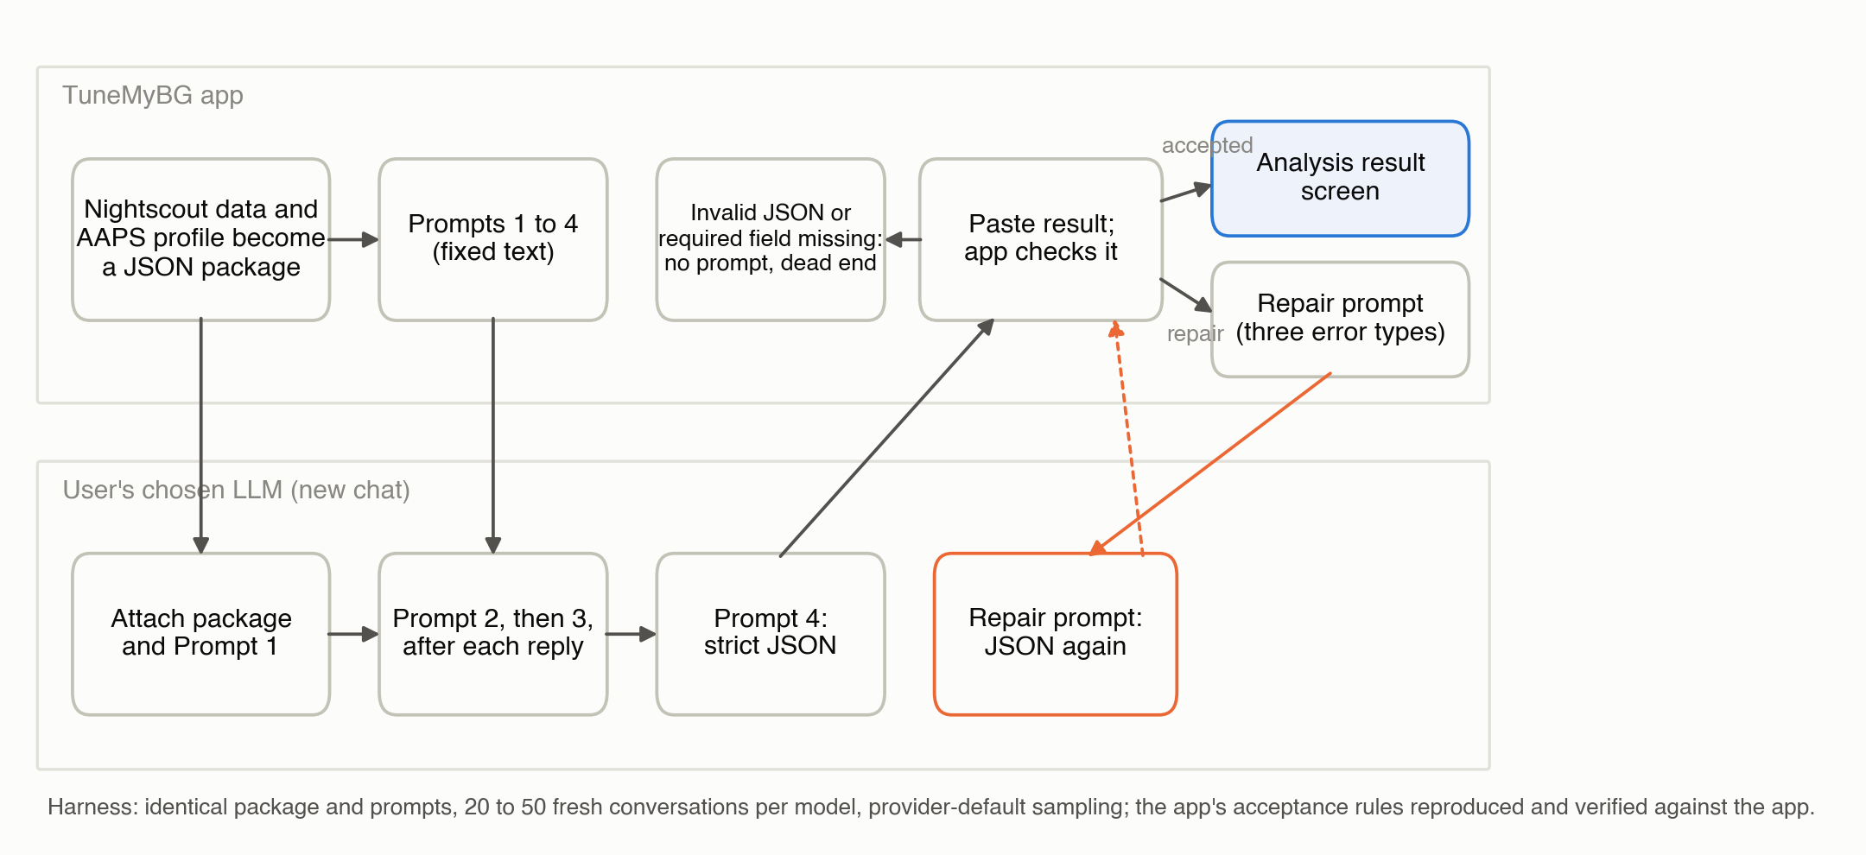
Figure 1
Figure 1. The application’s workflow as replicated: the package and four prompts go to a new conversation in the user’s chosen model; the fourth response is pasted back; the application accepts it, issues a repair prompt for three error types, or stops without a prompt when the paste is not valid JSON or a required field is absent.
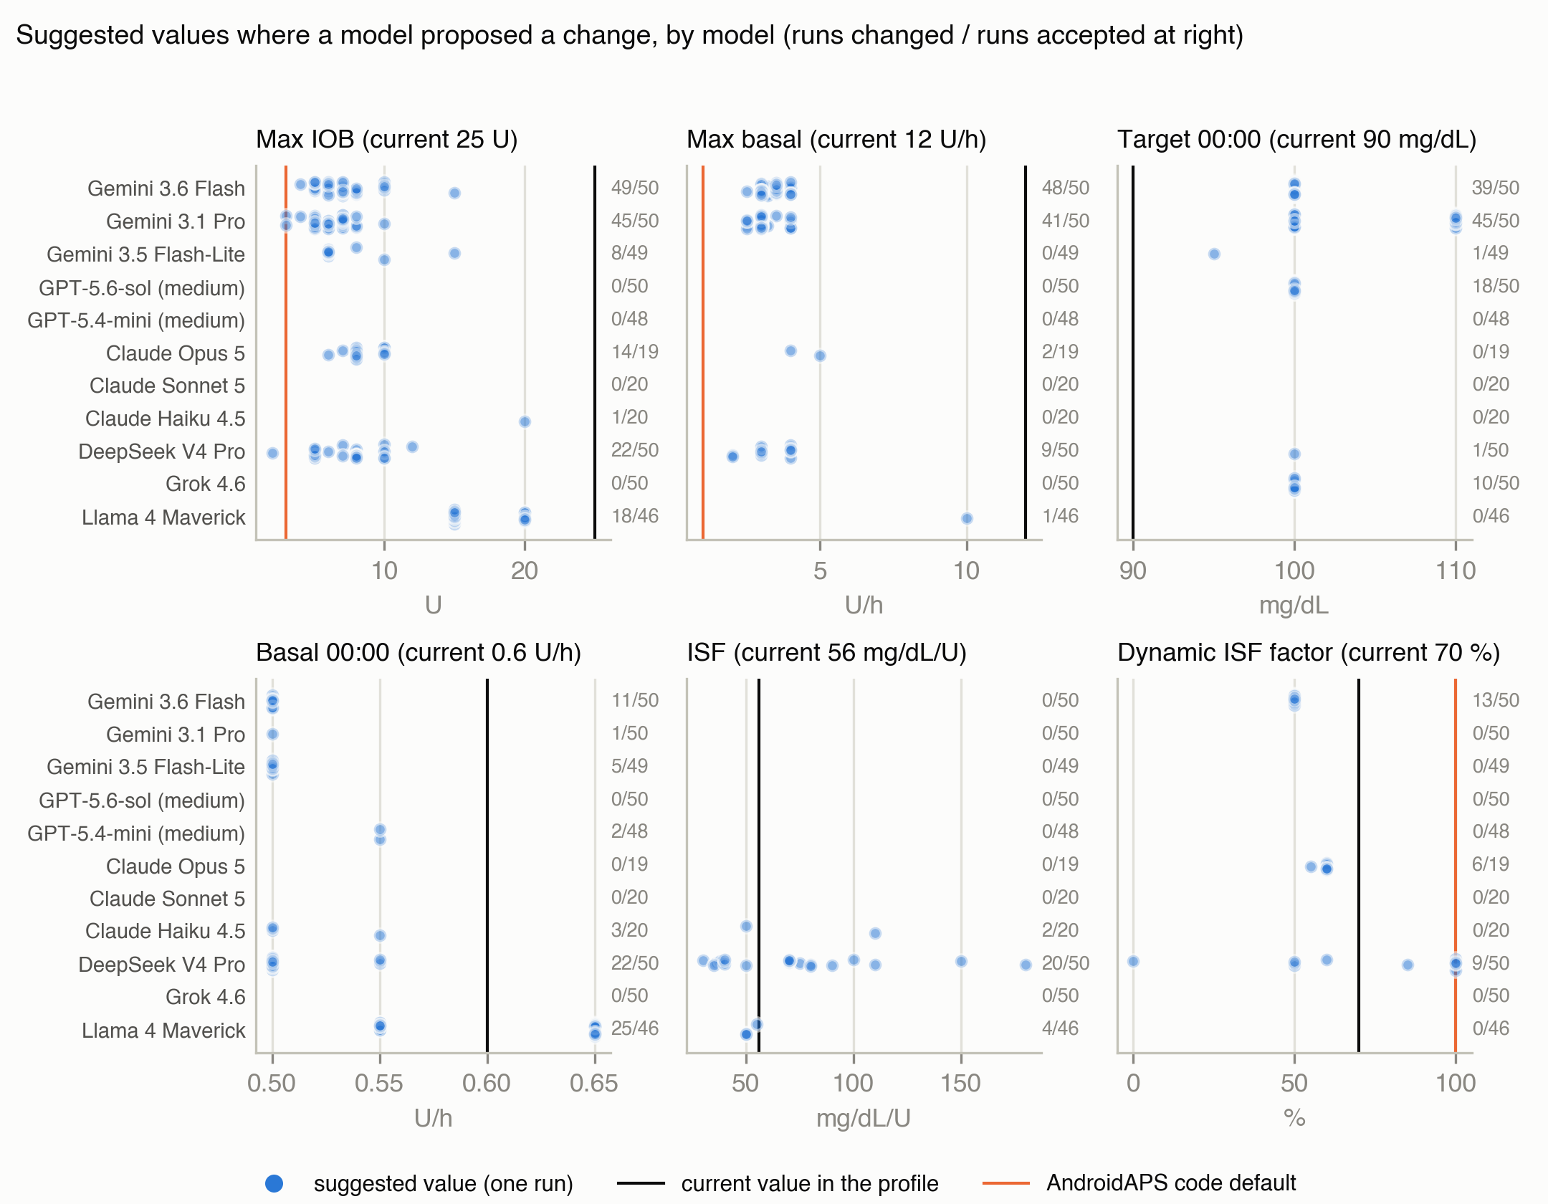
Figure 2
Figure 2. Suggested values in every accepted conversation that proposed a change, by model, for six settings, against the current value and the AndroidAPS code default; the count at the right of each row is conversations that changed the setting over conversations accepted.

