REPORT ON THE OWASPBWA

Student Name
Oluwatimilehin Oluwagbemi

Reg. No
2025/GRC/10712

24th September, 2025

Course Title
GRC 103 – Risk Assessment and Management Techniques

To: CISO & Application Development Management
From: GRC Audit Team
Date: 23rd September, 2025
Subject: Critical OWASP Top 10 Findings in Legacy Web Applications.
Executive Summary:
The OWASP Broken Web Applications (BWA) virtual lab was tested in the context of governance, risk, and compliance (GRC). This assessment is a summary of the results. The goal was to check the security of the vulnerable web apps that were already in use, find the most important or important issues, connect the found flaws to common control frameworks like OWASP Top 10, PCI DSS, NIST CSF and relevant regulatory requirements, and then make suggestions for how to fix the problems.
An assessment of the OWASPBWA server revealed multiple severe web application vulnerabilities that align with the OWASP Top 10 such as SQL Injection, Broken Access Control, Cryptographic Failures and Identification Failures. These findings indicate a systemic failure in our Secure Development Lifecycle (SDLC) and pose a direct threat to customer and company data.
Key Findings & Risks:
- Critical Risk – Data Breach Vector: Several applications were found to be vulnerable to SQL Injection (A03:2021). This could allow an attacker to steal, modify or delete the entire application database.
- Critical Risk – Broken Access Controls (A01:2021): Administrative interfaces were accessible without proper authentication, allowing any user to gain privileged access to application functions and data.
- High Risk – Lack of Encryption (A02:2021): User credentials were observed being transmitted without encryption, making them susceptible to interception.
Recommended Actions:
- Immediate Mitigation: isolate the affected systems from any network reachable by untrusted users.
- Remediation: The development team must prioritize fixing these vulnerabilities using OWASP proactive controls and cheat sheets.
- Process Improvement: Mandate formal security training for developers focused on the OWASP Top 10. Integrate SAST/DAST tools (like Burp Suite) into the CI/CD pipeline.
- Penetration Testing: Commission a full third-party penetration test before any similar applications is delayed in production.
Phase 1 – Discovery and Reconnaissance
Step 1: Target Discovery
The owaspbwa which serves as the target was powered on, I ran the ‘ifconfig’ command to get the IP address that will be pinged on Kali Linux which is the attack machine. The command returns the IP address ‘192.18.1.4’ which was pinged on kali using the command ‘ping -c 4 192.168.1.4’ and it returned a response which showed that the target is alive.
Step 2: Service Enumeration
This step involves the identification of the type of services running on the server, and the open ports on the server. The task was carried out using the command ‘ nmap -sV -sC -O -p- -oA initial_scan 192.168.1.4’
The command generated a report of the open ports on the server. The ports opened are:
- 22 – SSH running tcp, the version is 5.31p1 Debian 3ubuntu4, this poses a risk of backdoor, the ssh-hostkey is also exposed with the type of service such as DSA and RSA, this poses a compliance violation.
- 80, 8080 – HTTP running tcp is open with potentially risky methods such as TRACE, the server is running an outdated version of Apache 2.2.14, this can be exploited to compromise the server.
- 139 & 445 – NETBIOS-SSN running tcp is open, the server is running Samba smbd 3.X – 4.X which is an outdated version, this poses a compliance violation.
- 143 – IMAP
- 443, 8081– HTTPS running tcp is open with potentially risky methods such as TRACE, the server is running an outdated version of Apache 2.2.14, this can be exploited to compromise the server.
Nmap full scan report: https://drive.google.com/file/d/194UmG-N6rsNlUvi3Yda5s-uZ0iz_sSCN/view?usp=sharing
Step 3: Application Discovery
The target was further explored to find vulnerable applications running on the server, to achieve this, I opened the target IP address on Firefox browser; http://192.168.1.4, and I saw a directory listing available applications such as WordPress, WebGoat, Hackxnor, DVWA, BodgeIt Store and many more. Find the screenshot of the directory listing below:
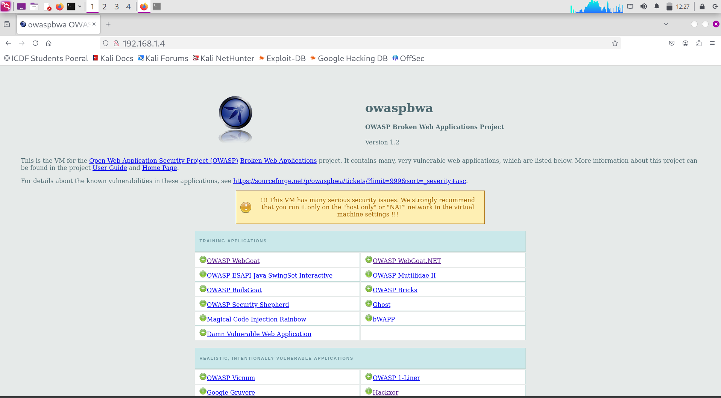
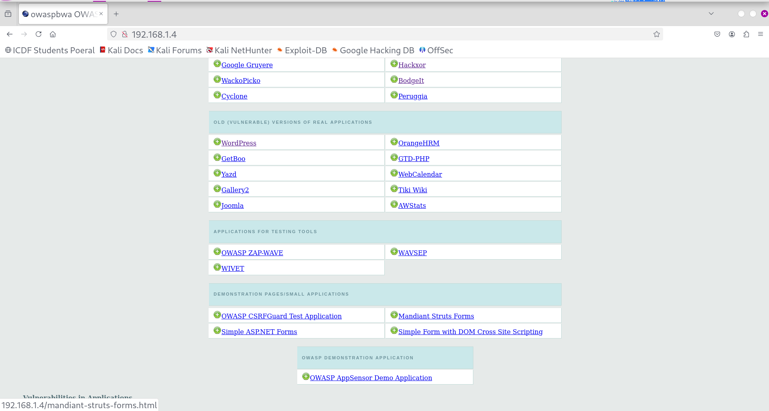

Phase 2: Tool Configuration & Automated Scanning
Step 4: Configuring Burp Suite Professional
To set up my environment to route traffic through Burp, I launched my Burp Suite Professional, navigate to my Firefox browser, installed foxyproxy an adds-on that enables traffic interception. Then I set up my foxy proxy using the proxy settings in Burp Suite Professional ‘Proxy: 127.0.0.1, Port: 8080’.
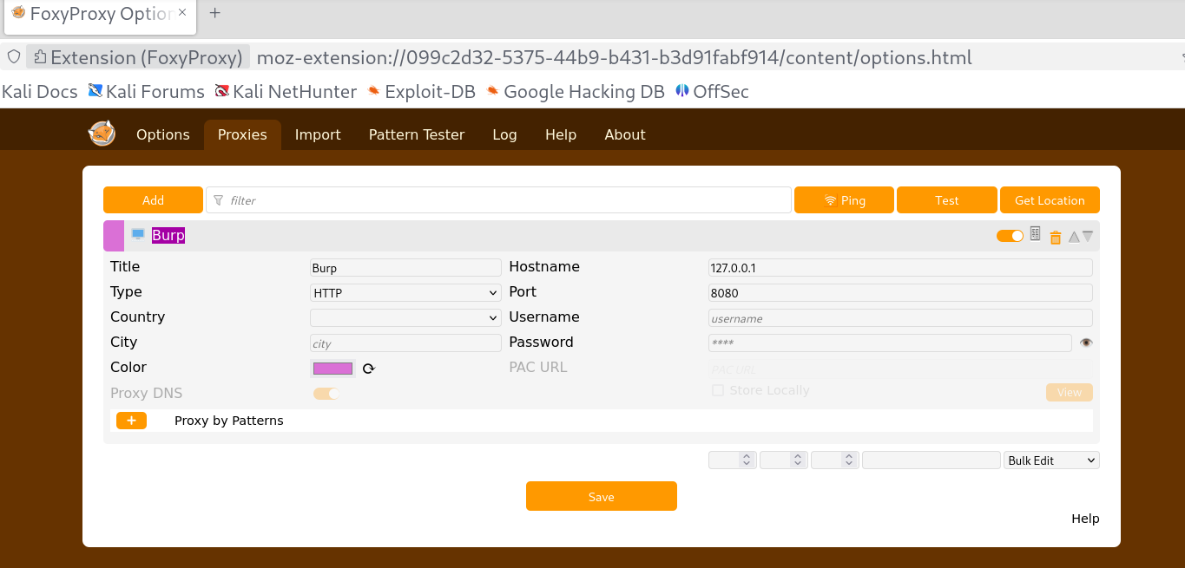
In order to route traffic from my browser to the Burp Suite, it is essential to turn on intercept which is a feature on the proxy tab.
Then I browsed to http://192.168.1.4, forwarded the request to populate the Site map
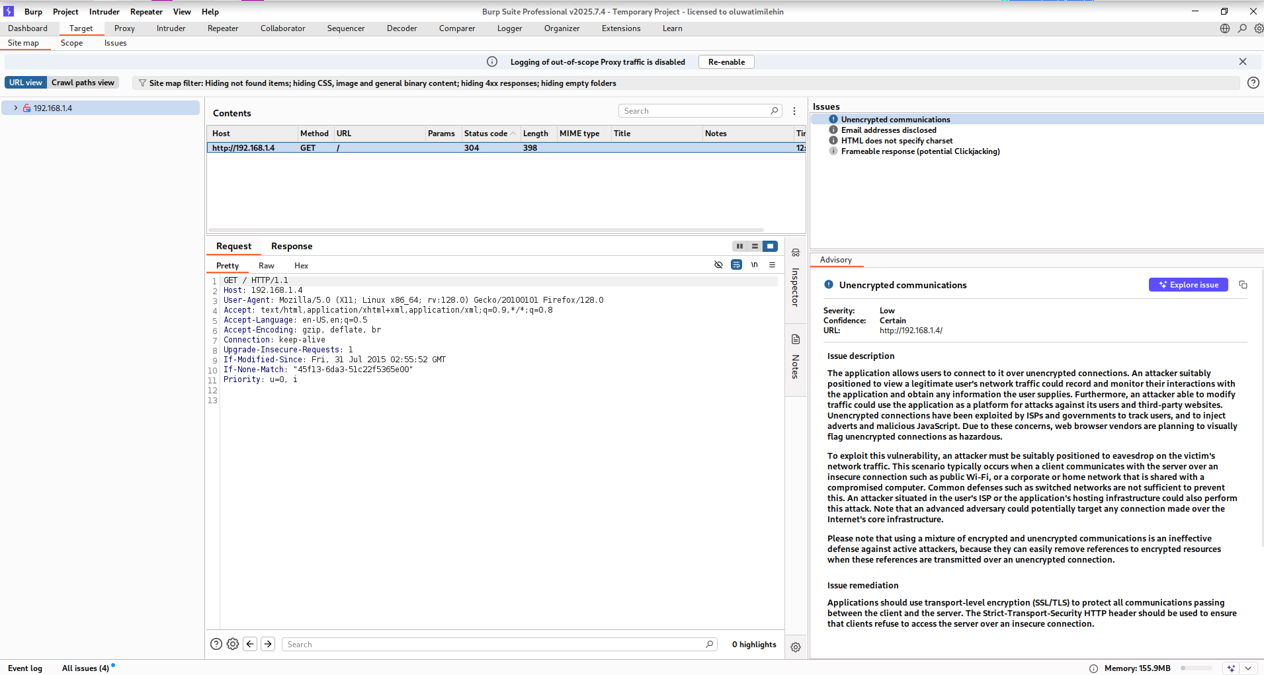
Step 5: Automated Passive & Active Scanning
After populating the site map, I right clicked on the folder and selected scan to scan the website for vulnerabilities.
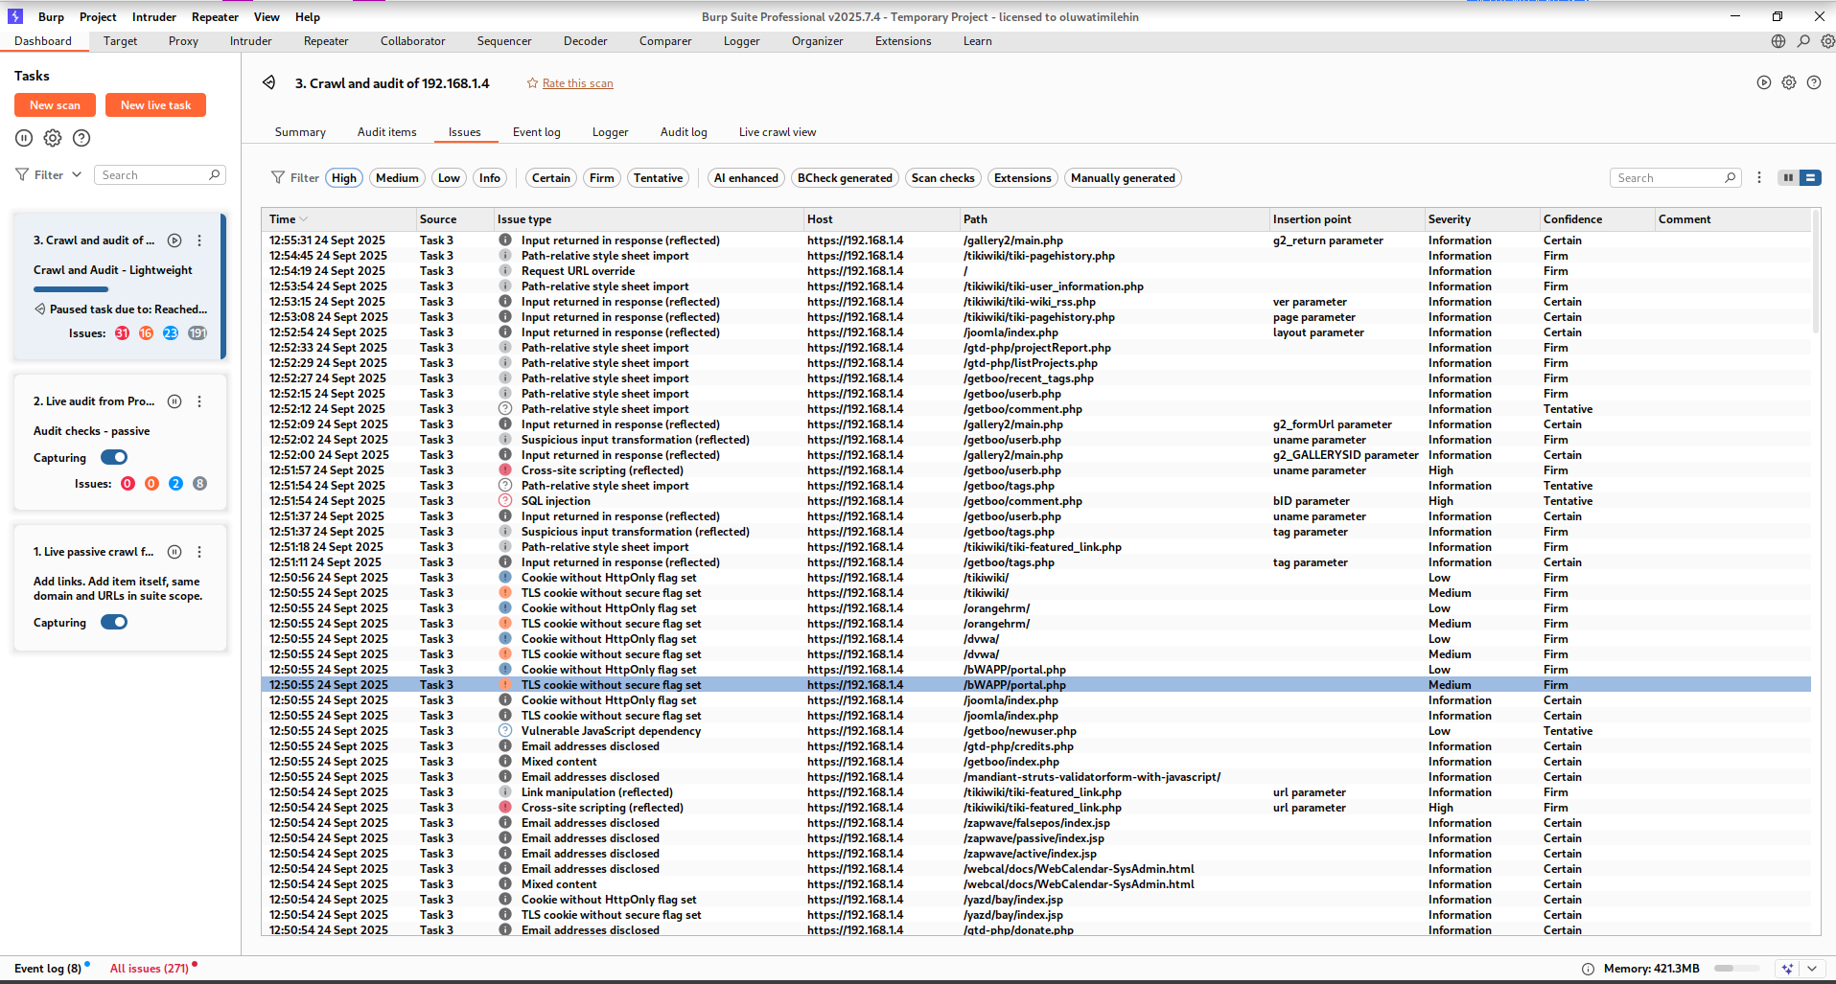
https://drive.google.com/file/d/1pvlaBZtvouqkdqBEond7KtOZmSv2j5Z8/view?usp=sharing
https://drive.google.com/file/d/1o0J45RD2oKQuJzIFu9WJNsBEQt0fEzdk/view?usp=sharing

Step 6: Testing for A01:2021-Broken Access Control (BodgeIt Store)
Using BodgeIt Store to test for broken access control, which is a critical failure in authorization policies, directly violating the principle of least privilege, I tried to access an administrative page directly using the url http://192.168.1.4/bodgeit/admin.jsp and i was able to access the admin page of the web site, this is a critical risk violating PCI DSS 7.2.1, because unauthorized person can have access to credentials of everyone that has logged in to that website.
A01:2021-Broken Access Control doesn't follow PCI DSS 7.2.1, which says that access control systems should use least privilege and need-to-know. The found flaws allow for increased privileges and unauthorized access to data, showing a lack of compliance.
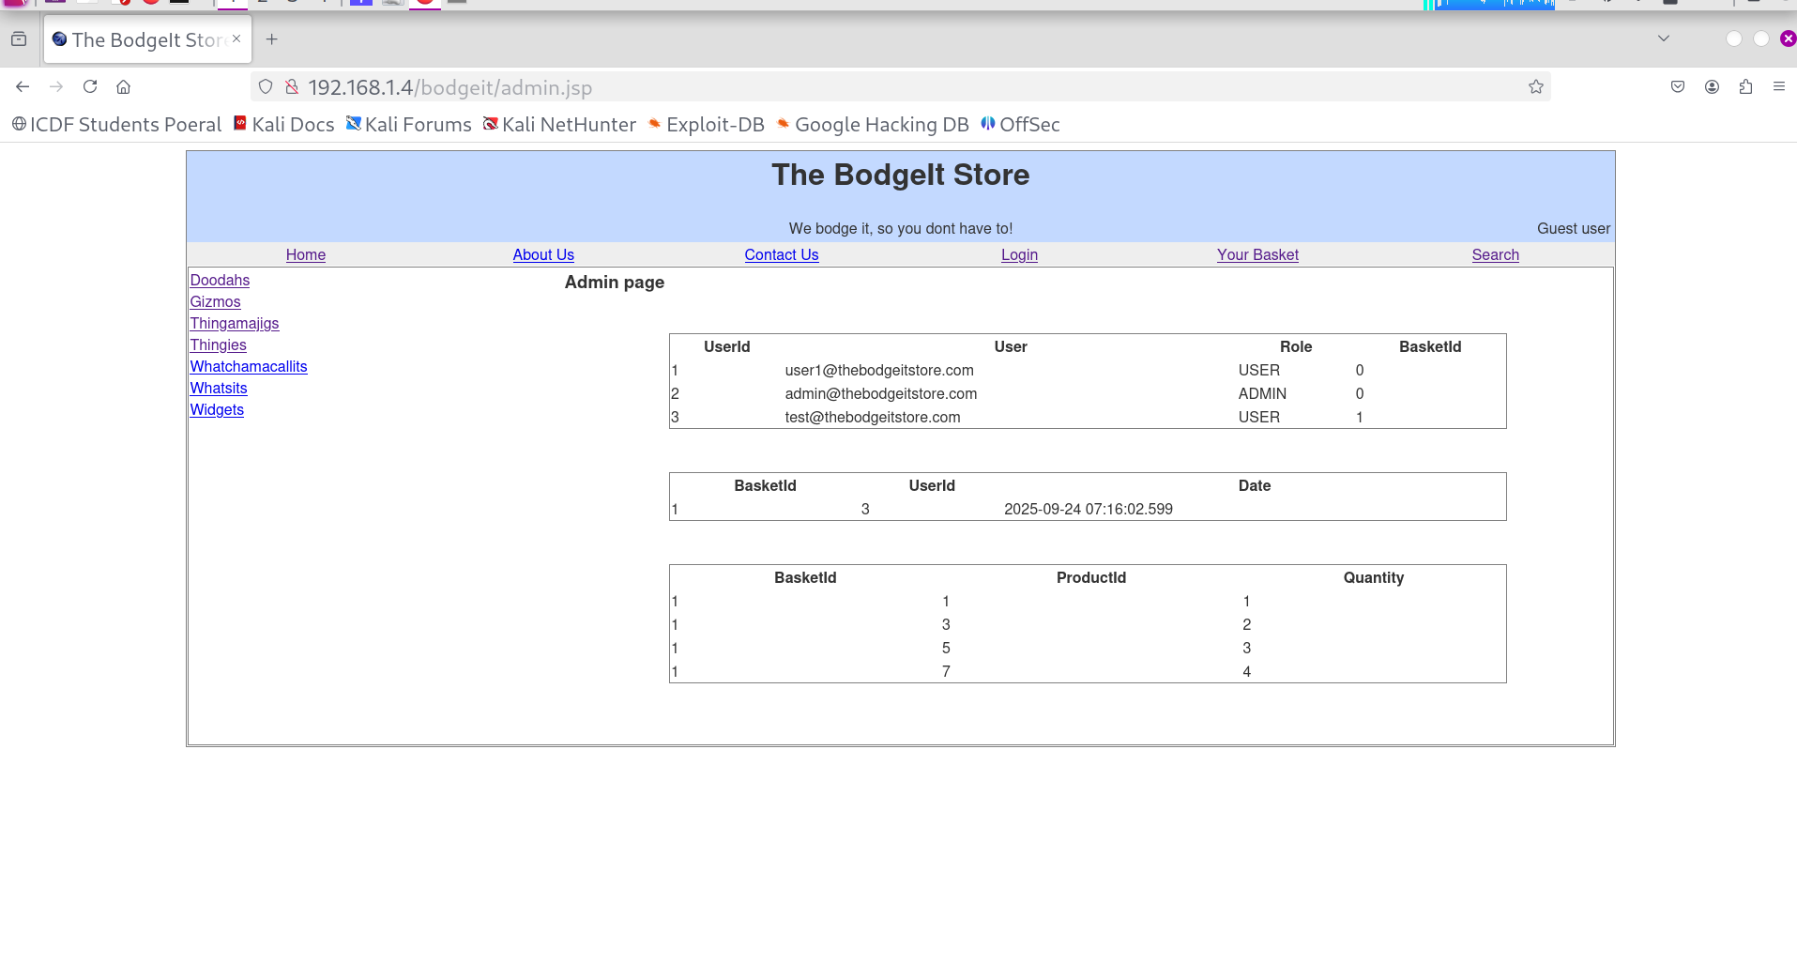
Step 7: Testing for A02:2021-Cryptographic Failures (WebGoat)
WebGoat application was used to test for cryptographic failure on the server, which means the transmitting of passwords in cleartext, which is a severe violation of every data protection standards including GDPR and PCI DSS, which poses risk of information disclosure.
The application (WebGoat) was used to test for this vulnerability, and the result showed that it is vulnerable, I used Burp Suite to intercept the traffic of the operation carried out on WebGoat which is randomly inputting password and username to check for this vulnerability, turning on the intercept, from the proxy tab, I clicked on the HTTP history tab to get the information captured by Burp Suite, then looked for the POST request that contained a password, from the raw request, the password returned is a plaintext.
PCI DSS Requirement 4.1 says if there is need to send sensitive data over an open network, it must be pass through strong encryption technique. A02:2021-Cryptographic Failures map directly to this need. Cardholder data can be stolen because weak or missing encryption mechanisms are known to be used. This is a breach of compliance.

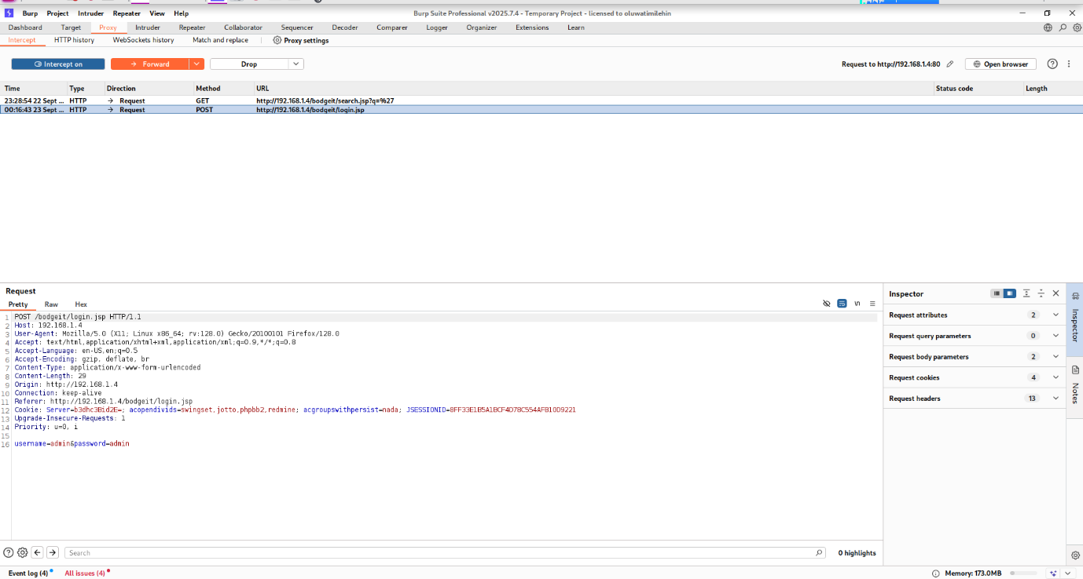
Step 8: Testing for A03:2021-Injection (BodgeIt Store Search)
To test for SQL Injection, the BodgeIt Store application was used and the results indicate that the application is vulnerable to SQL Injection which is a classic high-impact vulnerablity, which can lead to full data breach as attackers can inject malicious code, this violates data integrity and confidentiality policies.
The process started by turning on intercept in Burp, while on the WebGoat Application, I navigated to the search bar and inputted the codes used to test for SQL Injection, the codes used are: ‘, ‘ OR ‘1’=’1 and ‘ UNION SELECT 1,2,3,4,5,6 which returned items using the Repeater in Burp Suite. The HTTP response was OK code 200, no error was returned for each code. This proved that the site is vulnerable to SQL Injection.
A03:2021-Injection and PCI DSS 6.5.1 both addresses injection vulnerabilities. PCI DSS 6.5.1 says that custom applications must find and fix injection flaws like SQL injection. It's against the rules not to fix these issues, and someone could get to your data without proper authorization/permission.

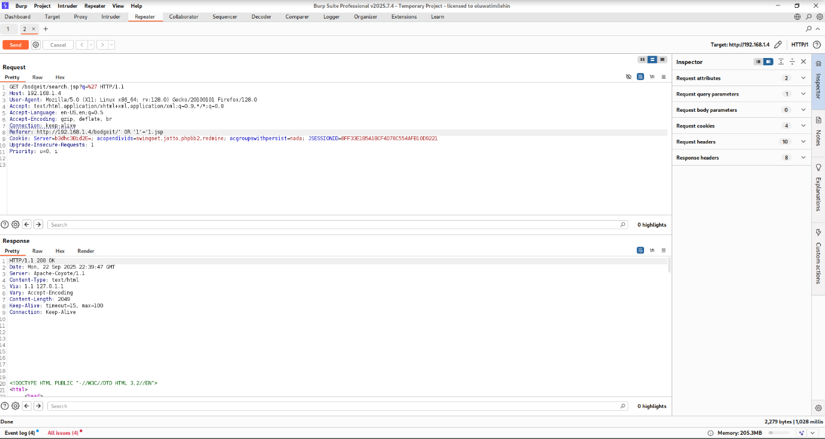
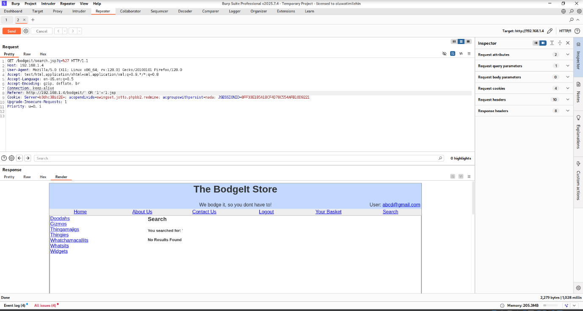
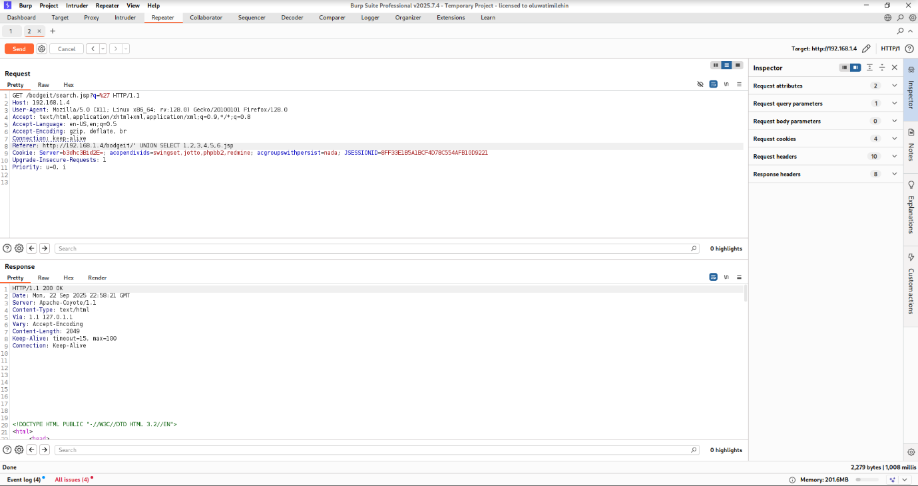
Step 9: Testing for A07:2021-Identification and Authentication Failures (BodgeIt Login)
To test for weak authentication mechanisms using Burp Suite Intruder, I navigated to the login page tried out weak credentials such as admin:admin and test:test, turned on the intercept and clear all payloads and setting a new one for the password parameter. I added list of payloads such as password, admin, 123456, letmein, password123 to check for a response with a different length or status code which might indicate a successful login.
A07:2021-Identification Failures results in problems with identifying and authenticating people. This is non-compliant to NIST CSF PR.AC-1, which says that identities and credentials should be safely issued, checked, and managed. It has been found that using default credentials and weak authentication controls goes against PR.AC-1 and lets people in who aren't supposed to be there.

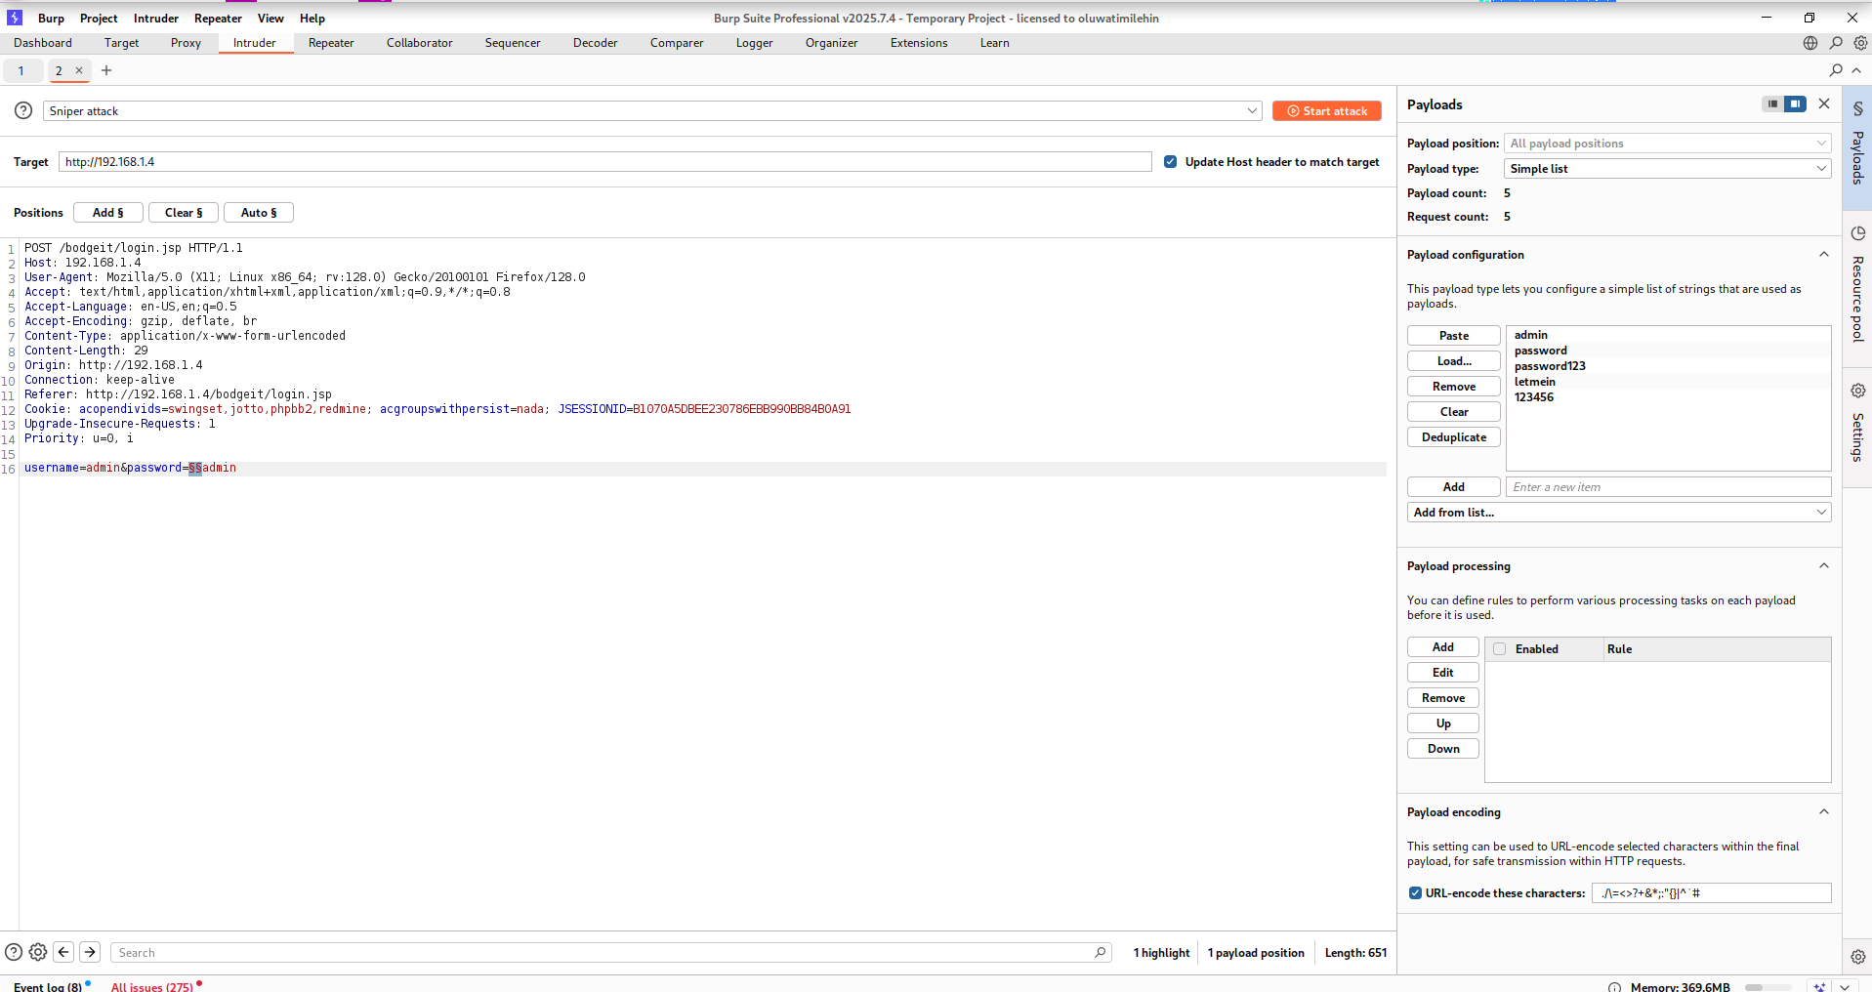
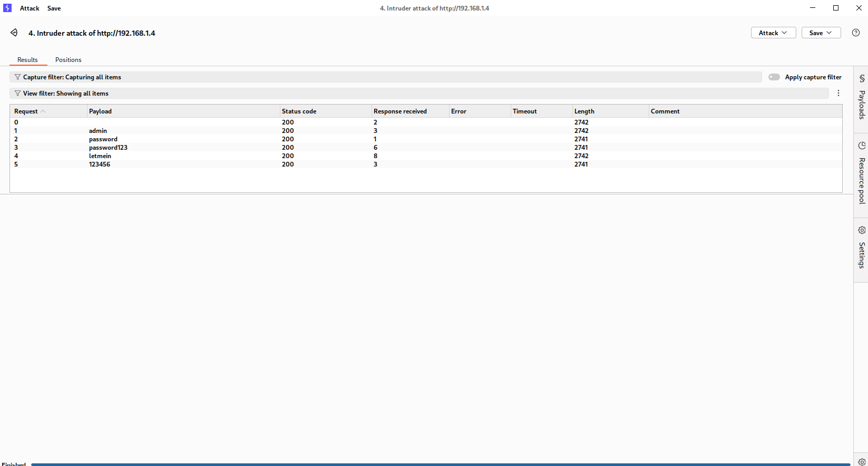
Phase 4: Analysis and Reporting
Step 10: Triage and Risk Assessment
OWASP Top 10 Category | Vulnerability Example | Affected Application | Inherent Risk (L,M,H) | Compliance Violation | Business Impact
A01: Broken Access Control | Unprotected Admin Page | BodgeIt Store | H | PCI DSS 7.2.1 | Unauthorized data access, privilege escalation
A02: Cryptographic Failures | Cleartext Password Transmission | WebGoat | H | PCI DSS 4.1 | Credential theft, account takeover
A03: Injection | SQL Injection in Search | BodgeIt Store | H | PCI DSS 6.5.1 | Full Database compromise, data loss
A07: Identification Failures | Weak Password Policy | BodgeIt Store | M/H | NIST CSF PR.AC -1 | Unauthorized access, initial breach vector.

