**Content:**

**Summary**

**Introduction to study:**

Topography of the region (DEM, SLOPE, ASPECT, RIVERS, BORDERS, CITIES, POPULATION)

Air temperature average

Precipitation average

Landcover development

Geology

Glaciers

Stream flow conditions

**Data & Methodology:**

DB (Monthly temperature, precipitation rates, streamflow (FDC) and surface runoff coefficient) temperature extrapolation, average estimation of snow ratio for MS Pskem or MS Oigaing based on historic observations.

Google Earth Engine (Java AP, Python)

Arc (ESRI (high resolution imagery with metadata))

**Accuracy:**

DB assesment

Evaluation of MODIS, Landsat 5/8 (spatial, temporal and radiometric)

**Results:**

Air temperature (lapses: variance, std)

Extrapolate daily temperature for Oigaing by keeping variance

Correlation of precipitation

Landcover change

1. Correlation of summer average NDVI  (histogram) - Streamflow
2. Correlation of fall/winter NDSI (histogram) - Streamflow
3. Glaciers (Error matrix) with high resolution imagery (Quality assessment)
4. Streamflow behaviour (table, FDC, ratiio of inputs)

**Conclusion**

**References**

**Summary.**

River watersheds are widely studied around the world. However, there are some regions that are restricted for studies due to security precautions or political preferences. This work is aimed to reveal physical properties of a Pskem watershed. It is one of the major tributaries of river Syr-Darya a source of water for Aral Sea. Waters from this river serve as supply for capital city of Uzbekistan, Tashkent, as well they serve for irrigation needs downstream. In this work first time, a hydrologic model to estimate streamflow on monthly step is implemented along with attempt to reveal factors affecting streamflow conditions. In the study region there is no data available for public that would be sufficient for streamflow modelling for daily basis as landcover, soil characteristics and daily precipitation. However, available data from satellites (Landsat 5, Landsat 8, MODIS) and Data Bases allow to evaluate affect of temperature, vegetation, and landcover changes over the past few decades. The Pskem watershed average elevation exceeds 2000 m.a.s.l and basin Is subdivided into 4 parts, namely Oigaing, Maydantal, Charalma which merge into Pskem river. 1) For each watershed temperature, precipitation and monthly/daily streamflow trends analyzed and reported; 2) Streamflow modelling at Pskem gage station is based on segmentation of streamflow on daily and monthly timestep, and with consideration of watershed characteristics; 4) Daily streamflow measurements at these watersheds were available for several years from 2010 to 2015 and were a reference data for model calibration and analysis;

The data was analyzed with state of art public platform of Google Earth Engine for GIS analysis and a free statistical software as R. The result of study of landcover change revealed decrease in the area of glaciation. The area of glaciers changed significantly between mid 90th of 20 centuries and nowadays leaving only 1/3 of previous surface glaciation. Study revealed that there is no signs of significant decrease in the streamflow conditions. Precipitation shows decreasing trends leaving with the fact that steady streamflow is result of increased intensity and meltwater contribution from glaciers. Hence, decrease of glaciation over the next two decades will affect streamflow by decreasing skewness of the hydrograph during the summer and eventually will lead to decrease of overall average streamflow.

**Introduction.** The Pskem river watershed is located in the Northern part of Tien Shan ridge (***Fig. 1:1,2***) and is the main source of water supply for Uzbekistan, Tashkent region. The Pskem river is one of the major tributaries of Chirchik river that forms after Pskem and Chatkal rivers merge. The Chirchik river flows into Syr’Darya river and the whole watershed is one of the main sources of the water for Syr’Darya river that flows about 500 km through the territory of Uzbekistan into Kazakhstan and is a water source for the upper part of the Aral sea.

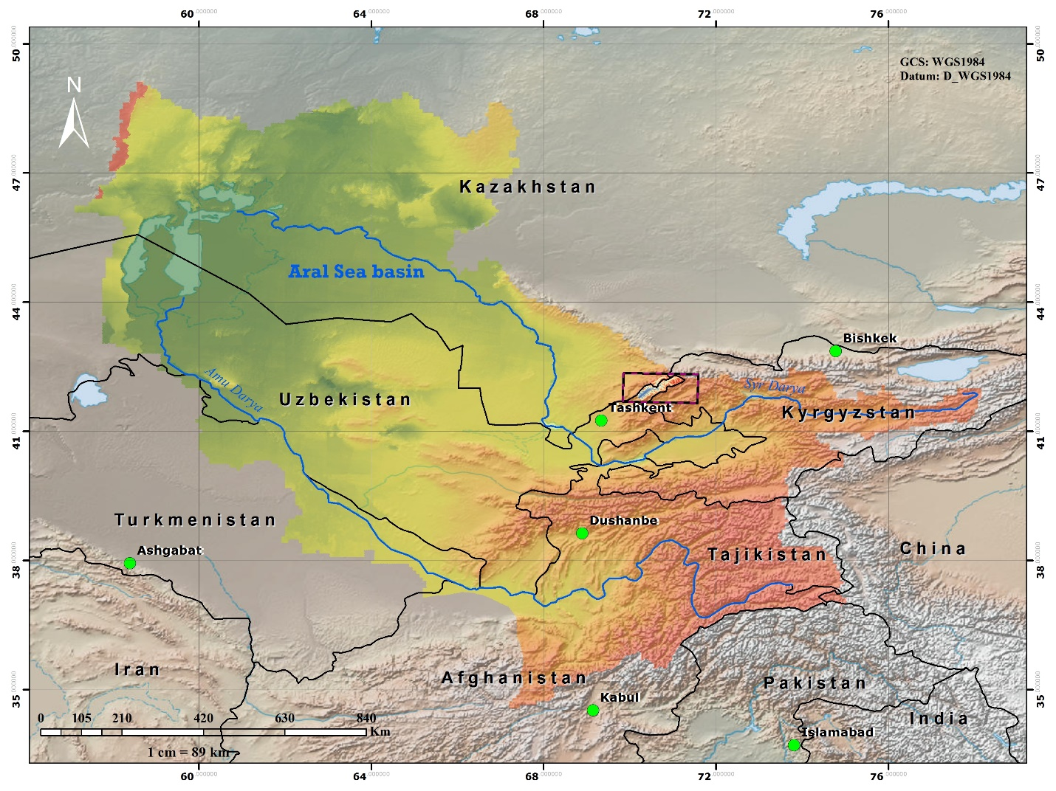

Figure 1 Aral sea basin, extend to Pskem river basin

Relief of the watershed is highly variable, and mainly located at the mountainous ridges. The area of the watershed total is 2540 km2. Oigaing river watershed is the biggest with the area of *****, Maydantal is ****. The smallest watershed is Charalma river **** and lowest part of Pskem basin is ***** Figure 2.

The highest point of the watershed is 4830 meters above the sea level (m.a.s.l). (Appendix figure – 1 ). The flank orientation of the watershed is almost equal. (Pie chart), (Appendix figure – 2). Length of the river Pskem, Oigaing, Maydantal ??***

The climate of the region is mainly continental, and that over the last 50 years, the relief of the watershed has significantly changed, due to degradation of glaciers (***Table 1***).

Table 1 Changes in the area of glaciation in regions

|  |  |  |  |
| --- | --- | --- | --- |
| ***Glacier data*** | ***Surkhandarya*** | ***Tashkent*** | ***Kashkadarya*** |
| *Glaciation, number/area 1960s [km2]* (Schetinnikov, 1976) | 158/52.1 | 251/121.2 | 58/20.3 |
| *Glaciation, number/area 1980s [km2]* (Glazirin and Glazirina, 2012) | 65/15.5 | 260/106.1 | 65/15.5 |
| *Change in glacier area between 1960s-2010 s, %* (Semakova et al., 2015) | -40 | -23 | -49 |
| *Glaciation, number/area 2015[km2]* (Semakova et al., 2015) | 202/31.5 | 309/93.5 | 76/10.2 |

It is important to note that significant research have been completed that revealed changes in the landscape reflecting on increasing number and area of mountain lakes (Petrov et al., 2017) and decreasing number and area of glaciers (Semakova et al., 2015).

It is important to note there is a lack of research conducted that study the effect of these changes on vegetation in the region. At the same time, the field of remote sensing has been rapidly developing over the last decades and purpose of this study is to provide examples of available online data sources for scientists in developing countries.

|  |  |  |  |  |
| --- | --- | --- | --- | --- |
| Monthly temperature and precipitation data | Monthly flow data | Daily flow data | Name of tile | Area of watershed |
|  |  | 2013  2014  2015 | AP_15822_FBS_F0830_RT1.dem.tif  AP_07945_FBD_F0830_RT1.dem.tif  AP_08193_FBD_F0820_RT2.dem.tif  AP_08193_FBD_F0830_RT1.dem.tif  AP_15822_FBS_F0820_RT1.dem.tif | 2540 km2 |
|  |  |  |  |  |

Pskem watershed delineation and flow modelling

41° 47' 0" North, 70° 13' 0" Mullala coordinates

**Data.**

The climate data from previous observations is available from 2 data sources: 1) National Climatic Data Center ([NOAA](https://www.ncdc.noaa.gov/cdo-web/)) which provides a worldwide collection of observed precipitation and daily temperatures; 2) Climate data for Central Asia available online from National Snow & Ice Data Center ([NSIDC](http://nsidc.org/data/docs/noaa/g02174_central_asia_data/)) in the form of a database for the periods of observations from 1873 to 2003 for 298 hydro-meteorological stations across the region (Williams, 2008).

Both of databases are partly filled, however, NSIDC contains more accurate and reliable historic observations in form of an excel spreadsheet with missing data noted, while the first database contains recent daily observations but is missing historic data before 1990. For the Pskem watershed, average monthly values of air temperature were generalized for the periods of observation that conjugate available data for precipitation measurements from both data sets. The author had attempted to relate changes in temperature and observed changes in precipitation as they are main factors that impact the local water balance of the watershed.

Precipitation data for the meteorological station (MS) Oigaing at Pskem river watershed was recorded up to 2015, while for MS Pskem there were no observations. Therefore, linear regression was employed and the average sum of the annual precipitation at the MS Pskem were estimated.

There was also a lack of studies of available information on the changes in landscape and vegetation in the watershed. To assess these changes the author employed Geographic Information Systems and remote sensing techniques that allow the derivation of Normalized Difference Vegetation Index (NDVI) values which are a measure of the density of vegetation. For this purpose results of NDVI values from MODIS satellites were analyzed from 2000 to 2017. At the same time to reveal trends of correlation between temperature and landscape, Landsat 5 and Landsat 8 NDVI values were also analyzed for the summer of 1993 and 2015. Source of the data was United States Geologic Survey (USGS) online portal <https://earthexplorer.usgs.gov/>.

Spectral bands and resolution of satellite images were used to compute the NDVI values that are indicated in (***Table 2***).

Table 2. Sattelite images characteristics.

|  |  |  |  |  |
| --- | --- | --- | --- | --- |
| Satellite | Spectral band | Wavelength (mm) | Spatial resolution (m) | Patch/Row |
| Landsat – 5 | Band 3,4 | 0.63 – 0.69, 0.76 – 0.90 | 30 | 165/31 |
| Landsat – 8 | Band 4,5 | 0.64 - 0.67, 0.85 - 0.88 | 30 | 165/31 |

**Methodology.**

The average monthly temperatures were linearly interpolated between Oigaing and Pskem hydrologic stations to obtain environmental lapse rate (ELR). While the temperature lapse rate is the measure how air temperature changes over it rise in the atmosphere:

Change in temperature/Change in elevation=𝜕T/𝜕H=𝜆=Lapse rate [5]

While actual ELR is an *actual* measured decrease in temperature with height above the ground.

Usually, ELR assumed to be λ ≈ 6.5 C°/1000m.

For this work lapse rate was a function of changes in elevation and temperature as a ratio of 1000.

(𝜕Tup - 𝜕Tdow)*∆H/1000= 𝜆 [6]

Where ∆H – 895 m.a.s.l. is the difference of the elevation between hydrologic stations of Oigaing (2151 m.a.s.l.) and Pskem (1254 m.a.s.l.)

*𝜕Tup* – Air temperature at hydrologic station upstream

*𝜕Tdow* – Air temperature at hydrologic station downstream

One might assume that changes in the temperature downstream will not affect changes in the temperature upstream. This could be revealed by comparison lapse rates in two different seasons across two different periods. If the average monthly temperatures downstream would not affect temperatures upstream and there will be no correlation, therefore that would reflect in the absolute difference of the air temperatures, hence environmental lapse rate would decrease, else remain constant or increase. For both hydrologic stations data were available from the same original input. Average monthly temperatures were available for both hydrologic stations for the period between 1965 to 1998. As in the study authors attempted to correlate changes in air temperatures with changes in the measured river flow at a watershed. For each month, average temperatures were calculated across 33 water years period, and then the seasonal average temperature was calculated as the arithmetic means of average monthly temperatures during the different seasons of the year. For both stations, the absolute difference in the elevations and in temperatures was used to interpolate values of temperatures with corresponding adiabatic lapse rates for each season.

For the watershed area defined, we can select DEM and use raster calculator with an equation to find temperatures at all elevations of DEM.

(H'-DEM)/1000*𝜆+T [7]

H’ is a constant elevation of hydrologic station 1254 m.a.s.l.

The estimate of potential runoff based on the simple assumption of water balance in the watershed as Q = P – E0. Where P is the average precipitation and E0 is the potential evaporation.

A Hamon’s model developed to estimate potential evapotranspiration (E0) from the surface have been employed which is a hybrid of the temperature-based model to estimate E0 and surface runoff. The simplest assumption is that difference between the average amount of precipitation and potential evapotranspiration values would estimate river flow Q = P – E0. While P is measured at the station, E0 could be estimated as a function of N, the number of hours of daylight on the day (i) which is average monthly values; es, saturated vapor pressure which is a function of air temperature. At a given temperature, saturated vapor pressure:

es=0.6108*exp (17.27*T/(237.3+T)) [1]

The final equation expressed as:

Eo = 0.021 N2 es/(T + 273) [2]

The performance of the model was assessed by the coefficient of determination R2 and Bias. The average residual (bottom of the last row) is often referred to as the Bias of the predicted change in volume:

[3]

where:

For many estimators, we want our bias to be as close to zero as possible. Another classic model performance metric is the coefficient of determination R2.

[4]

where: *=mean of observed values*

The closer the R2 is to 1, the better the model fit. A perfect model fit will have a R2 = 1.0.

Results.

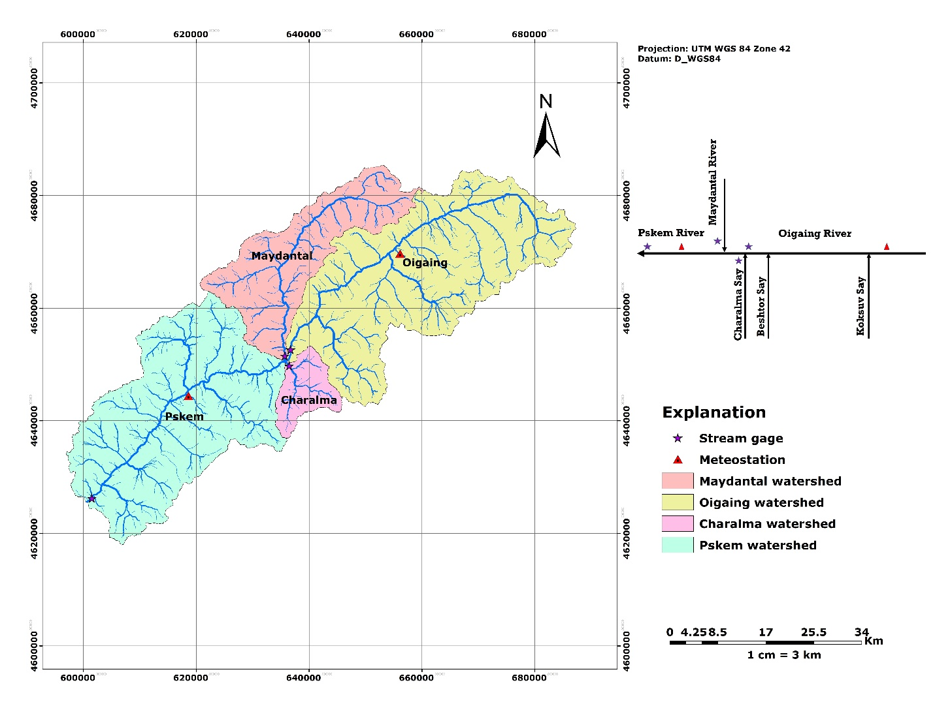Q(P)=Q(O)+Q(M)+Q(Ch)+a

1. Discharge at river Pskem assumed to be equal to the sum of flows from tributaries as Oigaing (1005) km2, Maydantal (450) km2 and Charalma (105) km2 plus remaining region with no glaciation. The amount of flow from the surface of the watershed is represented as runoff coefficient (C)

C= Q(P)-(Q(O)+Q(M)+Q(Ch))/(A(P)-A(Q+M+Ch))

Where C – runoff mm/s, Q(P) discharge at Pskem gage station (cms), Q(O) discharge at Oigaing stream gage station, Q(M) discharge at Maydantal stream gage station, Q(Ch) discharge at Charalma stream gage station, A(P) – total area of watershed, A – area of watersheds.

C/(F(P)-(F(O)+F(M)+F(Ch)) = q

1. Coefficient (C) we can determine amount of water flowing from the watershed with area of 982 km2, which includes precipitation and groundwater for each day without evapotranspirated moisture. One of the limitations of this approach is that we assume evapotranspiration is uniform along the watershed, that means that model does not account for topography and changes in the temperature with elevation.
2. Limitations: The lapse rate variations between Oigaing and Pskem MS depict high correlation of temperature trends. However, existence of the lapse rates defines different amount of potential evapotranspiration that would reflect in different amount of accumulation and distribution of precipitation following topography.

Data.

Daily streamflow measurements for at 4 gage stations were available. As mentioned before, Pskem watershed with the area of 2540 km2 consist of 3 main tributaries, these are Oigaing (1005 km2), Maydantal (450 km2) and Charalma (105 km2). For each of them limited daily streamflow were also available (Figure – x).

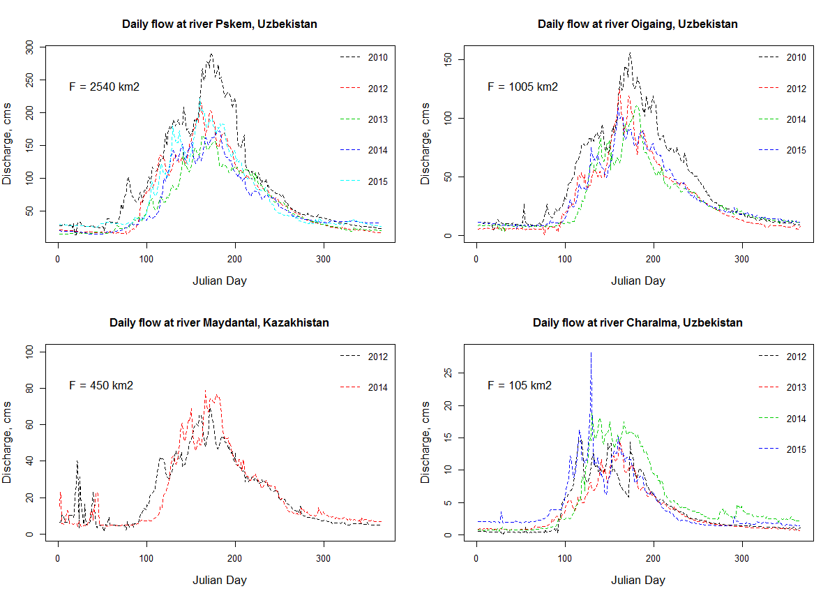

The input from these 3 major tributaries consist 98 and 99 % of the streamflow respectively. Hence, it is important to notice that area of 980 km2 below the merging of rivers contribute only about 2% of the annual flow.

|  |  |  |  |  |
| --- | --- | --- | --- | --- |
| Parameters | Charalma | Oigaing | Maydantal | Pskem * |
| Area, F (km2) | 105 | 1005 | 450 | 2540 |
| Length, L (km) | 15 | 72 | 43 | 119 |
| Years | 4 | 4 | 2 | 5 |
|  |  |  |  |  |
| MAF (cms) | 4.30 | 34.93 | 21.51 | 70.04 |
| MAF/F (L/s/km2) | 40.98 | 34.75 | 47.80 | 27.57 |
| Q50 (cms) | 2.38 | 20.70 | 11.70 | 41.1 |
| Q90 (cms) | 0.78 | 7.69 | 4.83 | 18.47 |
| Q95 (cms) | 0.53 | 5.92 | 4.50 | 16.8 |
| Q90/Q50 | 0.32 | 0.37 | 0.41 | 0.45 |
| MAF on FDC (%) | 32% | 37% | 39% | 38% |
| Q1.5 (cms) | 5.23 | 43.23 | 26.58 | 87.22 |
| Q2 (cms) | 2.67 | 22.92 | 14.41 | 51.51 |
| Q1.5/Q2 | 0.51 | 0.53 | 0.54 | 0.58 |
| Q2/MAF | 1.21 | 1.23 | 1.23 | 1.24 |

**MAF – mean annual streamflow; MAF/F – mean annual flow from the one square of surface area; Q50, Q90, Q95 – 50th, 90th and 95th percentiles of streamflow respectively that exceeds 50, 90 and 95 percentile on FDC respectively; Q90/Q50 – baseflow index; MAF on FDC – mean annual flow on flow duration curve; Q1.5, Q2 – One and a half and two year low flows from log type II distribution; Q1.5/Q2 , Q2/MAF – ratio of one and a half year over two year low flow, and ratio of two year low flow over mean annual flow;**

**\*There is an autocorrelation between flows at Pskem river and three other watersheds, as they are major tributaries for Pskem river located downstream.**

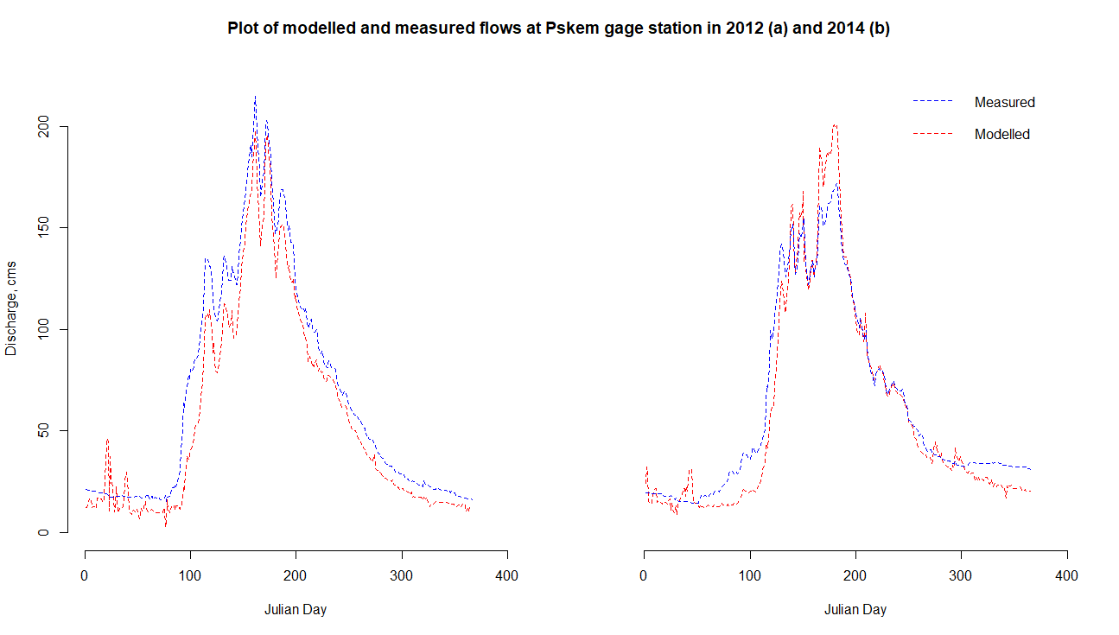

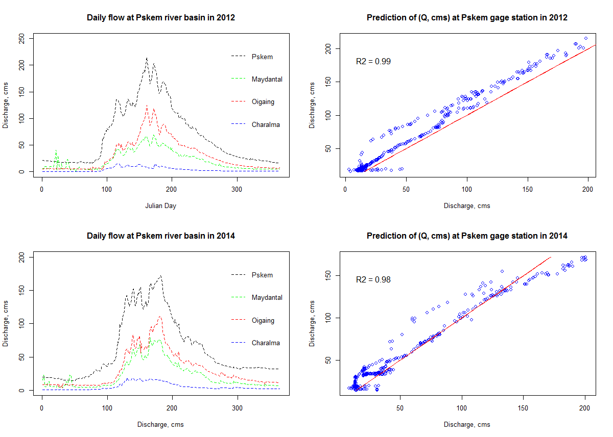

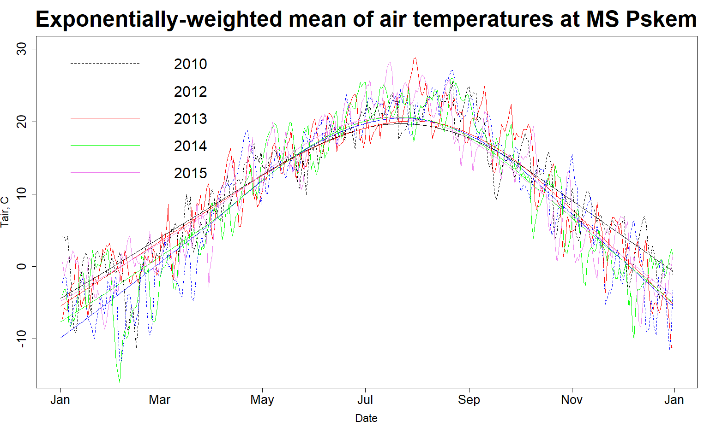

Lapse rate variations

Appendix.