CONCEPT PAPER
Measuring What the Data Can Actually Say
A provenance-first design for national environmental data infrastructure, demonstrated on the river basins and districts of Uzbekistan
Author | Affiliation | Correspondence
Draft for conference submission — September 2026

Abstract
Environmental data platforms in developing economies are usually judged by how many datasets they contain. That is the wrong measure. A platform can hold a hundred layers and still be unable to say whether a number it reports is an observation or an interpolation, whether it describes the place it claims to, or whether it is current. This paper proposes an alternative design principle: the description of a measurement should constrain what the system is allowed to store, rather than merely annotate it afterwards. Three rules follow. Analytical grain is derived from each source’s own resolution rather than chosen once for the whole system. Quality and currency are stored fields, not documentation. And the semantic layer is validated continuously, so that an invalid state is refused rather than described. We implement this on the 3,981 level-12 river basins and 199 districts of Uzbekistan, integrating nine atmospheric, three land and nine hydrological data products into a single validated graph of 908 entities and 3,822 typed assertions. The design surfaced six defects that conventional integration would have carried silently into analysis, including a 1.41 standard deviation discontinuity in a reanalysis record, a forecast product whose skill differs by a factor of three between two variables commonly reported together, and a widely used gridded temperature product that is 87% interpolation over the study country. We argue that surfacing such defects is the primary value of an environmental ontology, and that platforms which cannot surface them should not be trusted for policy.
Keywords: environmental data infrastructure · data provenance · hydrological units · Earth observation · forecast verification · Central Asia

1. The problem is not scarcity
The conventional diagnosis of environmental data in Central Asia is scarcity: too few stations, too little history, too much held privately. The diagnosis is not wrong, but it has become a distraction. Global Earth observation now supplies daily atmospheric composition, five-day forecasts, four decades of gridded temperature and precipitation, and annual land cover at ten metres — freely, for any country that can process it. The binding constraint has moved. It is no longer whether data exists. It is whether an institution can state, of any particular number it is about to act on, where it came from, what it actually measures, how good it is, and when it was last true.
This distinction matters because the failure mode has changed with it. A missing dataset announces itself. A dataset that is present, plausible and quietly wrong does not. A basin statistic derived from a grid coarser than the basin will return a number for every basin, and neighbouring basins will silently share one value. A climatological baseline drawn across a change of observing system will produce anomalies that are artefacts of the handover. A forecast product will report a value at every lead time whether or not it has skill at that lead time. None of these failures produce an error. All of them produce a number, and a number is what gets used.
Our position is that an environmental data platform earns trust not by the breadth of what it holds but by its capacity to refuse. This paper sets out a design in which the semantic description of a measurement is a constraint on storage rather than a description of it, and reports what that design exposed when applied to a national system.
Box 1. Four failures that produce a number rather than an error
• Grain mismatch. A statistic computed for a unit smaller than the source grid cell. Every unit receives a value; adjacent units receive the same one.
• Record inhomogeneity. A baseline spanning a change of observing system, so that anomalies measured against it encode the handover rather than the climate.
• Derived-product substitution. Using a disaggregated daily series where the source is computed at a coarser step, giving apparent daily detail that is an artefact of the disaggregation.
• Frame substitution. Reporting a national average over one spatial partition when the policy question concerns another, where the two give materially different answers.

2. Three rules
The design rests on three rules. Each is stated as a constraint the system enforces, not as guidance the analyst is expected to follow.

2.1 Grain is derived, not chosen
Most platforms select an analytical unit once — a district, a catchment, a grid — and compute every variable on it. This is administratively convenient and physically indefensible. A unit smaller than the source pixel cannot hold an independent value; it borrows one. We therefore derive the analytical unit per product, from that product’s own resolution, and refuse any pairing that falls below a floor of roughly two grid cells per unit.
In the demonstrator this produces three different hydrological levels for what a conventional design would treat as one class of variable. Coarse reanalysis and forecast products are read at Pfafstetter level 6 or 7; five-kilometre precipitation and temperature at level 12. The cost is that cross-product comparison requires an explicit aggregation step through the basin hierarchy. The benefit is that no stored value is a borrowed one.
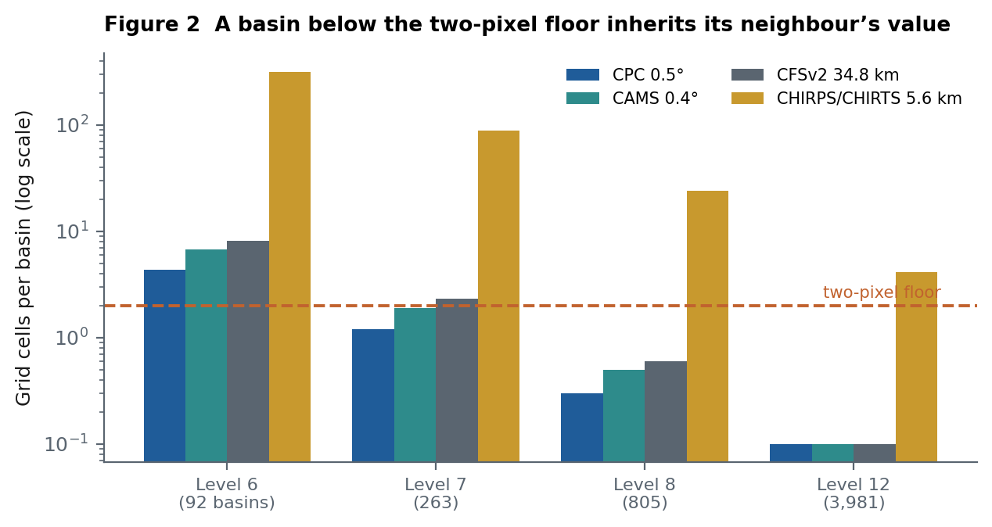
Figure 2. Grid cells per basin, by hydrological level and product
Source: Authors’ calculation from BasinATLAS v1.0 sub-basin areas and the native resolution of each product as reported by Google Earth Engine. Logarithmic scale. Levels below the dashed floor cannot carry an independent value for that product.

2.2 Quality and currency are fields, not documentation
Every stored measurement carries an explicit quality state and every stored table carries its coverage and the command that would refresh it. This is a modest-sounding requirement with sharp consequences. It forces a distinction that documentation habitually blurs: between a value that is absent, a value that is present but implausible, a value obtained by a fallback method, and a value that is simply good. In the demonstrator these are four distinct states, and analysis that consumes the tables filters on them rather than trusting them.
Currency receives the same treatment. A table records the period it covers and the period its upstream source can supply; the difference between them is computed rather than asserted. A closed record — a product that has stopped being updated — is a distinct state from one that has fallen behind, because the remedy differs.

2.3 The semantic layer is validated, not documented
The relationship between a dataset, the property it measures, the agent that produced it, the licence it carries and the spatial frame it is reduced onto is expressed as a typed graph with a schema, and that schema is enforced on every build. A measurement whose predicate does not admit its subject type is rejected. A table naming a dataset that does not exist is rejected. The purpose is not tidiness. It is that a system which cannot be invalid can be reasoned over — by a person, and later by a model.
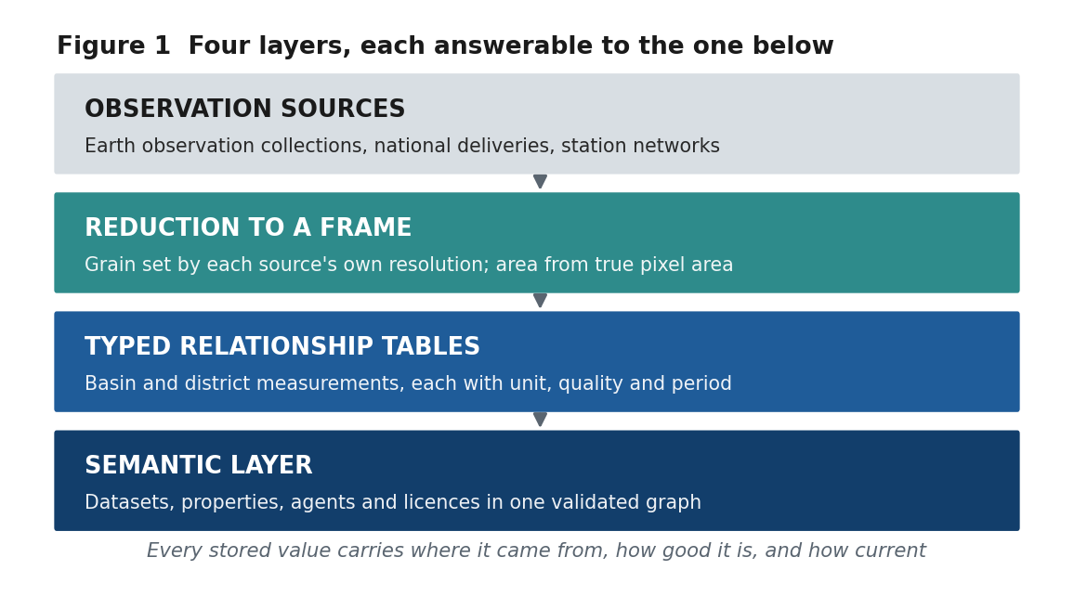
Figure 1. The four layers of the proposed design
Source: Authors. Each layer constrains the one above it: a measurement that cannot be typed by the semantic layer cannot enter a relationship table.

3. Demonstrator: the basins and districts of Uzbekistan
Uzbekistan is a useful test because its water is largely not its own. The Amu Darya and Syr Darya rise in Tajikistan, Kyrgyzstan and Afghanistan; the country sits at the downstream end of a basin it does not control, and its agriculture is almost entirely irrigated. Any environmental data system for such a country must be explicit about what lies outside its own boundary, because most of the causal chain does.
The reference frame is BasinATLAS level-12 sub-basins — 3,981 units averaging 127 km² — joined to 14 provinces and 199 districts by an area-weighted overlay computed on an equal-area projection. The overlay is complete: every square kilometre of the administrative geography is attributed to a basin, and 3,979 of 3,981 basins carry a province.
Layer | Units | Content
Semantic graph | 908 entities · 3,822 assertions | 186 datasets, 509 distributions, 190 stations, 15 agents
Controlled vocabulary | 103 properties · 28 predicates | Seven themes; every measurement typed to a property
Relationship tables | 23 tables | Basin, district and reach measurements with unit, quality, period
Domains | 24 datasets | Atmosphere 9 · Water 9 · Land 3 · Reference 3
Basin–admin overlay | 10,383 links | 4,374 province and 6,009 district links; 100% area coverage
Source: Authors’ implementation. Counts are as generated and schema-validated at the time of writing.

Twelve source products are integrated, spanning atmospheric composition and forecasts, reanalysis, gauge-blended precipitation and temperature, annual land cover, cumulative human modification, and the hydrological topology itself. The point of the exercise was not integration for its own sake. It was to see what the three rules would refuse.

4. What the design surfaced
Six defects emerged that a conventional pipeline would have carried into analysis without comment. We report them not as curiosities but as evidence for the central claim: these are the ordinary condition of integrated environmental data, and a platform that cannot surface them is not neutral about them.

4.1 A reanalysis record that is not homogeneous
The coupled reanalysis product supplying soil moisture, precipitation and radiation is fed by one system to 2010 and its operational successor from 2011. Across that handover, 25 cm soil moisture over the country steps up by 1.41 standard deviations of the pre-2011 spread — larger than most of the interannual variability the record is used to study. A climatological baseline spanning the boundary would render every year after 2011 anomalously wet and every year before it anomalously dry. The standard 1991–2020 normal period straddles it exactly.
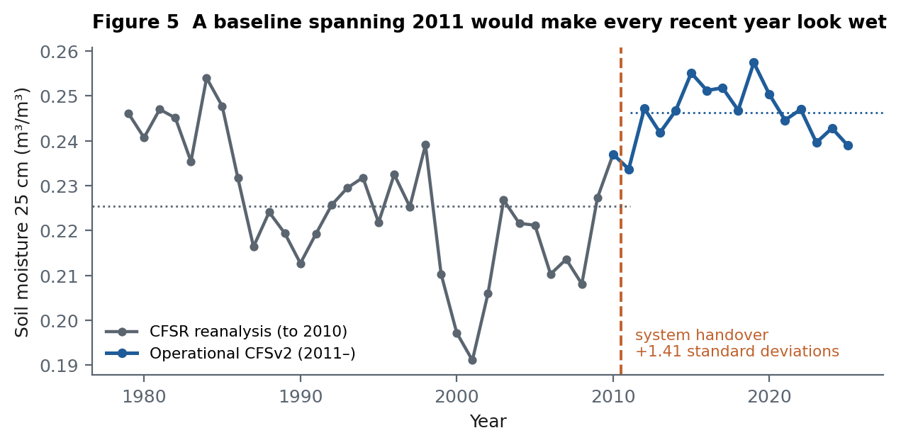
Figure 5. Annual mean soil moisture at 25 cm over Uzbekistan, 1979–2025
Source: Authors’ calculation from NOAA CFSv2 6-hourly harmonized data via Google Earth Engine, area mean over the national bounding box. Dotted lines show the pre- and post-handover means.

4.2 Forecast skill that differs by variable, not by product
Atmospheric composition forecasts are habitually reported as a single product with a single lead-time horizon. Verifying them against their own analysis at a point in Tashkent, over 2024–2026 and above the 95th percentile, shows two quite different systems inside one product. Dust optical depth is detected in three of four episodes at 24 hours and two of three at 120. Surface particulate matter is a coin flip at 24 hours and detects one episode in five by 96 hours, by which point nearly three quarters of its alarms are false.
The gap is physical rather than statistical. Dust optical depth is a transported column governed by synoptic weather, which is predictable for days. Surface particulate concentration adds local emission and depends on boundary-layer mixing, which is not. The operational consequence is direct: the same product supports a dust advisory at three to five days and does not support a general air quality warning at one.
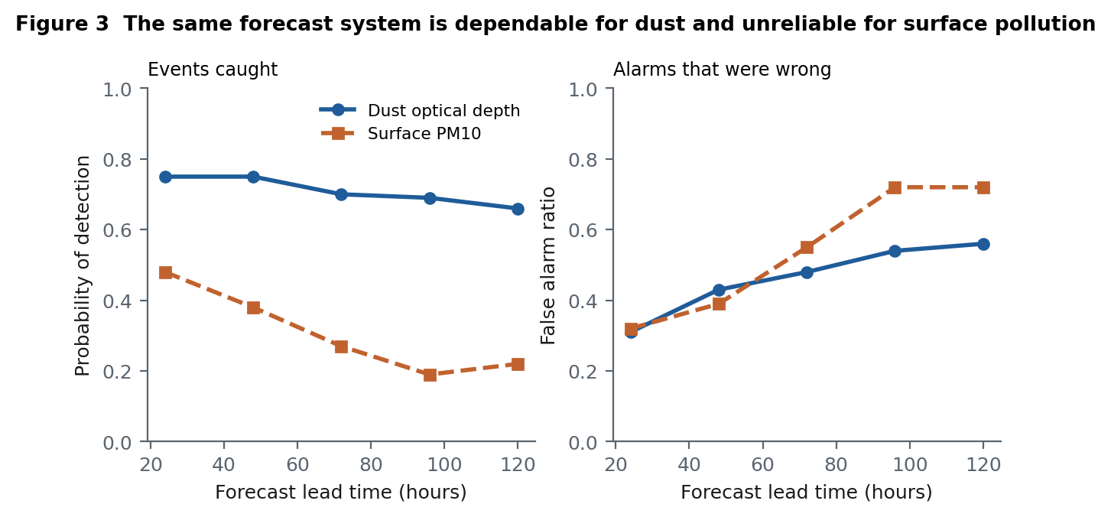
Figure 3. Event detection skill by forecast lead time, Tashkent, 2024–2026
Source: Authors’ verification of ECMWF CAMS near-real-time forecasts against the same system’s zero-hour analysis. An event is a value at or above the 95th percentile of the analysis record. Note that this compares forecast to analysis, not to independent ground observation.

4.3 A gridded product that is mostly interpolation
A long, current, gauge-based temperature analysis is an attractive reference for a data-poor country. The product used here carries, unusually, the number of stations informing each cell. Over Uzbekistan that averages 0.13 stations per cell per day, and 51% of basin-months see none at all. The product is not wrong; it is interpolation from distant reports, and it looks exactly as authoritative as a dense network would. Without the station-count band, nothing in the values themselves would reveal this.
This has a direct investment implication. The map of where interpolation dominates is a map of where a ground station would add the most information, and it can be produced from the data already held.

4.4 The frame changes the answer
Cumulative human modification, reduced over the same country in the same year, averages 0.33 when computed over river basins and 0.61 when computed over districts. Neither is wrong. Districts are drawn around settlement; basins include the desert between it. A platform that reports one national figure without naming its partition is reporting an artefact of an administrative choice.

4.5 Derived products presented as observations
The precipitation product is computed at pentadal and monthly steps; its daily series is a disaggregation. Summed over a month the two agree to within 0.00% in every month tested across fifteen years, confirming the daily series carries no independent information at that scale. The consequence is that within-pentad daily variation is an artefact of the disaggregation algorithm, and any analysis reading it as rainfall on a particular day is reading the algorithm.

4.6 A traced catchment that stops at the border
Tracing upstream from an outlet on the Amu Darya returns 11% of the catchment that hydrological reference data attributes to that point. The remainder rises outside the national boundary, where the clipped reference stops. A watershed tool that reported the traced area as the catchment would understate it roughly ninefold. The system therefore reports the traced area against the independently known upstream area, and states the coverage explicitly.
Box 2. Why these six are the point, not the exception
Each defect is invisible in the values themselves. Each produces a plausible number. Each would survive peer review of the analysis built on it, because the analysis would be correct given its inputs.
They were surfaced not by expertise applied case by case but by three structural rules applied uniformly: derive the grain, store the quality, validate the description. That is the claim this paper makes for the design.

5. What it enables
The rules are restrictive by design, and restriction has to buy something. It buys questions that span the frames without losing their footing.

5.1 Irrigated land, measured where policy acts
Urgench district in Khorezm is 492 km² of intensively irrigated land in the lower Amu Darya. Between 2017 and 2025 it lost 15.9 km² of cropland — 4.9% of its farmland — while built area grew by 13.3 km². The two figures are close enough, and the classes adjacent enough, to describe a single process: settlement expanding onto irrigated fields. Because the measurement is stored per district and per year with its own quality state, the same question can be asked of all 199 districts and answered consistently.
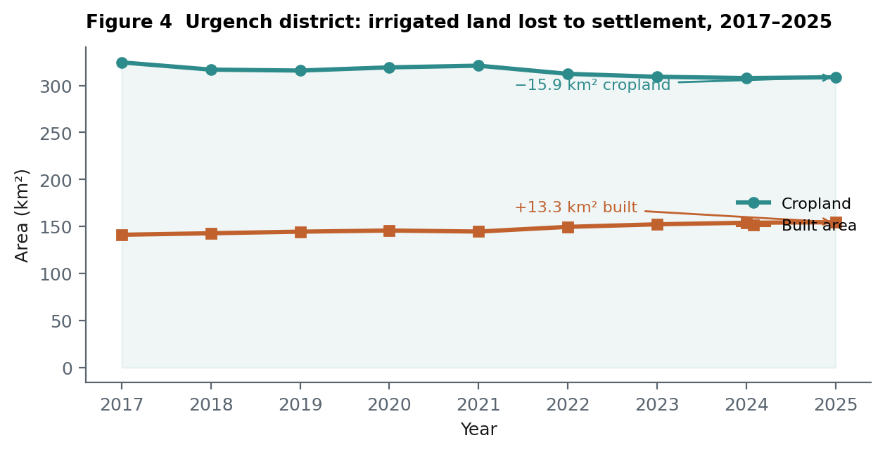
Figure 4. Cropland and built area, Urgench district, 2017–2025
Source: Authors’ calculation from Impact Observatory / Esri 10 m annual land cover via Google Earth Engine. Areas from true pixel area rather than pixel count, computed server-side per district.

5.2 Upstream attribution for water administration
Because basins and districts are joined by a measured area overlay rather than a nominal lookup, a catchment traced upstream of any river reach can be attributed to the provinces and districts that feed it, weighted by the area each genuinely contributes. Tracing from a reach in the lower Amu Darya returns 132 basins across three provinces — Karakalpakstan 46.5%, Bukhara 45.7%, Khorezm 7.9%. That is the form in which a water allocation question is actually posed.

5.3 A foundation that a model can stand on
The eventual intent is a service in which selecting a feature on a map returns not a value but the network of relationships around it, and a language or learning model reasons over that network. The three rules are what make this tractable. A model that consumes a table where quality is a field can weight accordingly; one that consumes a table where quality lives in a PDF cannot. A model asked which districts drain to a point can answer from a measured overlay; it cannot answer from a nominal one. We regard the modelling layer as the last step of this programme rather than the first, for the plain reason that a model trained on silently borrowed values will reproduce them confidently.

6. Limitations
Three limitations bear directly on the claims above and are stated rather than deferred.
First, forecast verification here compares a forecast to its own analysis. The analysis is a model state constrained by assimilated satellite retrievals, not an independent measurement, so agreement demonstrates internal consistency rather than accuracy. Independent verification requires surface monitors or sun-photometer sites, of which the study country has very few — which is itself a finding.
Second, the transboundary gap is a constraint on the science, not only on the data. Because the hydrological reference is clipped to the national boundary, upstream tracing is truncated at the border and all eight place concepts in the vocabulary with no data attached are transboundary ones. Extending the reference to the Aral Sea basin would close both gaps at once and requires no new licence.
Third, the demonstrator is one country and one institutional context. The three rules are general, but the specific grain assignments, the two-pixel floor and the choice of hydrological frame reflect Uzbekistan’s geography and the resolution of currently available products. Both would need re-deriving elsewhere, which is precisely the point of deriving rather than choosing them.

7. Research and implementation agenda
 | Step | What it resolves
1 | Extend the hydrological reference to the Aral Sea basin | Closes the 89% truncation in upstream tracing and the eight empty transboundary place concepts
2 | Map the internal model onto DCAT, SOSA/SSN and GeoSPARQL | Makes the graph interoperable with national and multilateral catalogues rather than bespoke
3 | Add SHACL constraints over the assertion graph | Moves validation from a build script into a portable, publishable contract
4 | Target ground monitoring using the interpolation map | Directs station investment to cells where gridded products carry least observation
5 | Independent verification against surface monitors | Replaces forecast-versus-analysis with forecast-versus-measurement
6 | Introduce the modelling layer over the validated tables | Only once quality and grain are enforced, so that learned relationships are not artefacts
Source: Authors. Ordered by dependency: each step assumes the ones above it.

8. Conclusion
The value of an environmental data platform is usually argued from what it contains. We have argued it from what it refuses. A design in which grain is derived from the source, quality and currency are stored fields, and the semantic layer is continuously validated will hold fewer numbers than a permissive one, and will decline to answer questions the permissive system answers readily. That is the benefit rather than the cost. In the demonstrator, the rules surfaced six defects — a reanalysis discontinuity larger than the signal, a forecast product whose skill varies threefold between variables reported together, a temperature grid that is 87% interpolation, a national statistic that changes by nearly a factor of two with the choice of partition, a daily series that is a disaggregation, and a catchment trace covering a ninth of its catchment. None would have announced itself. All would have entered analysis as fact.
For institutions financing environmental management in data-scarce economies, the practical implication is that the first investment is not another dataset. It is the capacity to say what the existing ones can and cannot support — and to have that capacity enforced by the system rather than entrusted to the diligence of whoever is next to use it.

References
Lehner, B., and G. Grill. 2013. Global River Hydrography and Network Routing: Baseline Data and New Approaches to Study the World’s Large River Systems. Hydrological Processes 27(15): 2171–2186.
Linke, S., B. Lehner, C. Ouellet Dallaire, et al. 2019. Global Hydro-Environmental Sub-Basin and River Reach Characteristics at High Spatial Resolution. Scientific Data 6: 283.
Funk, C., P. Peterson, M. Landsfeld, et al. 2015. The Climate Hazards Infrared Precipitation with Stations. Scientific Data 2: 150066.
Verdin, A., C. Funk, P. Peterson, et al. 2020. Development and Validation of the CHIRTS-daily Quasi-Global High-Resolution Daily Temperature Data Set. Scientific Data 7: 303.
Saha, S., S. Moorthi, X. Wu, et al. 2014. The NCEP Climate Forecast System Version 2. Journal of Climate 27(6): 2185–2208.
Inness, A., M. Ades, A. Agustí-Panareda, et al. 2019. The CAMS Reanalysis of Atmospheric Composition. Atmospheric Chemistry and Physics 19(6): 3515–3556.
Kennedy, C. M., J. R. Oakleaf, D. M. Theobald, et al. 2019. Managing the Middle: A Shared Data Model for Global Human Modification. Global Change Biology 25(3): 811–826.
Karra, K., C. Kontgis, Z. Statman-Weil, et al. 2021. Global Land Use/Land Cover with Sentinel-2 and Deep Learning. IEEE International Geoscience and Remote Sensing Symposium.
Gorelick, N., M. Hancher, M. Dixon, et al. 2017. Google Earth Engine: Planetary-Scale Geospatial Analysis for Everyone. Remote Sensing of Environment 202: 18–27.
W3C. 2024. Data Catalog Vocabulary (DCAT) — Version 3. W3C Recommendation.

