A business event occurs as part of a business process. Examples of business processes include sales (individual order or sale of a product), finance (a payment) or a marketing business process (clicks on an ad).
Dimension – things that a business cares about, e.g. time, customers, products, locations
Hierarchy – different levels of a dimension, e.g. for the Time dimension (day, week, month, quarter)
- Hierarchies are stored as attributes of dimensional tables
- Hierarchies help with slicing and dicing the data
- Choosing a hierarchy level = choosing a level of granularity
Fact – the numeric measurement of the business event. Facts are stored in fact tables. Each row in the table is a fact
- Fact table’s PK is composite, consisting of the dimensions’ FKs
The dimensional model is an ERD modelling the relationship between the Fact and its dimensions.
- Also known as a star schema
- The snowflake schema expands the star schema, such that each level of a hierarchy is modelled as its own table

Activity: Wimmera Wines
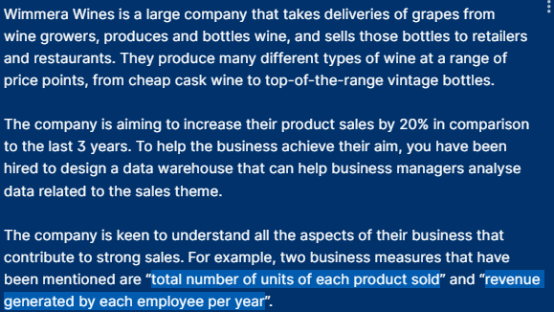
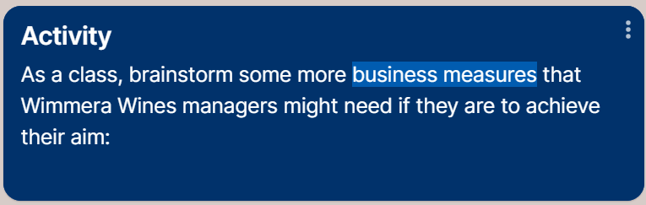
Examples of questions that we can ask
- Sales by wine type and colour
- Volume of sales by customer location (state, city, postcode) against season
- Top 50 products in sales revenue
Four-step dimensional design process
- Select and explain the business process: sales
- Declare the grain and justify your choice: yearly transactional – this is not likely the kind of business that has a high volume of day-to-day sales, so transactional granularity should be manageable
- Identify and explain dimensions: Time, Product, Customer, Employee
- Identify and explain the facts: quantity sold, revenue, profit (Product.RetailPrice – Product.CostPrice), discount factor
Neven’s answer


