Question 1. How many surgeries did each patient have? Your results should show patient id, patient names as first and last name separated by space, and number of surgeries ordered by the total number of surgeries in descending order. Note, patients who did not have surgeries must not be listed.
SELECT
'1729171' AS StuID,
p.patient_id AS pID,
CONCAT(p.f_name, ' ', p.l_name) AS pName,
COUNT(*) AS sCount
FROM patients9171 p
INNER JOIN surgeryrecord9171 sr ON p.patient_id = sr.patient_id
GROUP BY pID
ORDER BY sCount DESC;
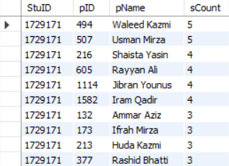
734 rows returned

Question 2. We need a list of doctors, showing for each doctor the total amount of payments for the doctor’s appointments with patients. The list should also include doctors who did not have any appointments. Your results should show doctor IDs, doctor names as first and last names separated by space, and total amounts, ordered by the totals from highest to lowest.
SELECT
'1729171' AS StuID,
d.doct_id AS dID,
CONCAT(d.f_name, ' ', d.l_name) AS dName,
IFNULL(SUM(a.payment_amount), 0) AS dTotalAmountEarned
FROM doctor9171 AS d
LEFT JOIN appointment9171 a ON d.doct_id = a.doct_id
GROUP BY dID
ORDER BY dTotalAmountEarned DESC;
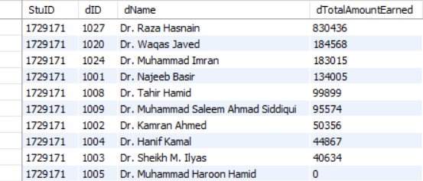
400 rows returned

Question 3. Produce a report showing number of shifts only with doctors on duty (no nurses or helpers), number of shifts with only nurses on duty (no doctors or helpers) and number of shifts with only helpers on duty (no doctors or nurses). Your report should use the following format and headings (actual staff numbers are removed):
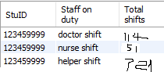
SELECT
'1729171' AS StuID,
'doctor shift' AS `Staff on duty`,
SUM(doct_id IS NOT NULL AND nurse_id IS NULL AND helper_id IS NULL) AS `Total shifts`
FROM staffshift9171
UNION ALL
SELECT
'1729171' AS StuID,
'nurse shift' AS `Staff on duty`,
SUM(doct_id IS NULL AND nurse_id IS NOT NULL AND helper_id IS NULL) AS `Total shifts`
FROM staffshift9171
UNION ALL
SELECT
'1729171' AS StuID,
'helper shift' AS `Staff on duty`,
SUM(doct_id IS NULL AND nurse_id IS NULL AND helper_id IS NOT NULL) AS `Total shifts`
FROM staffshift9171;
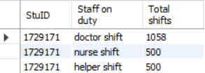
3 rows returned
Question 4. List all patients who have more than one cancelled appointment. You list should show patient id, last name and first name, gender and how many appointments this patient cancelled. Order the results by patients last name.
SELECT
'1729171' AS StuID,
p.patient_id AS pID,
p.l_name AS lName,
p.f_name AS fName,
p.gender,
a.appointment_status AS aStatus,
COUNT(*) AS numCancelledAppts
FROM patients9171 AS p
LEFT JOIN appointment9171 a ON p.patient_id = a.patient_id
WHERE a.appointment_status = 'Cancelled'
GROUP BY p.patient_id
HAVING COUNT(*) > 1
ORDER BY lName;
1 row returned

Question 5. List all helpers who have not been allocated to any staff shifts. Your list should show department id and name where the helper works, helper id and helper full name as first and last names separated by space. The results should be sorted by department id and within each department alphabetically by helper full name.
SELECT
'1729171' AS StuID,
d.dept_id AS deptID,
d.dept_name AS deptName,
h.helper_id AS hID,
CONCAT(h.f_name, ' ', h.l_name) AS hName
FROM helpers9171 h
LEFT JOIN staffshift9171 ss ON h.helper_id = ss.helper_id
LEFT JOIN department9171 d ON h.dept_id = d.dept_id
WHERE ss.shift_id IS NULL
ORDER BY deptID, hName;
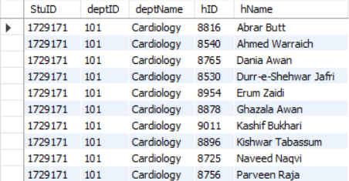
600 rows returned

Question 6. How much money came through as payments in total and in each calendar year using each mode of payment. Your results should show full total in the first row and then rows with details: calendar year, mode of payment and money received ordered by year and mode of payment (similar to below but showing total values in the last column). Your output should look similar to the one below.
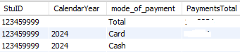
SELECT
'1729171' AS StuID,
YEAR(appointment_date) AS calendarYear,
mode_of_payment AS modeOfPayment,
SUM(payment_amount) AS paymentsTotal,
1 AS rowType,
YEAR(appointment_date) AS sortYear
FROM appointment9171
GROUP BY YEAR(appointment_date), mode_of_payment
UNION ALL
SELECT
'1729171' AS StuID,
'' AS calendarYear,
'Total' AS modeOfPayment,
SUM(payment_amount) AS paymentsTotal,
0 AS rowType,
YEAR(appointment_date) AS sortYear
FROM appointment9171
GROUP BY YEAR(appointment_date)
ORDER BY sortYear ASC, rowType ASC, modeOfPayment ASC;
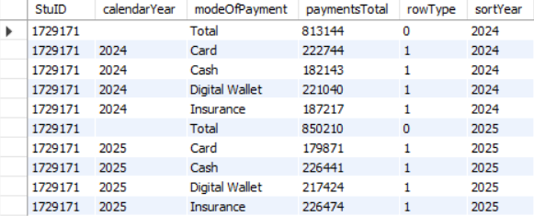
10 rows returned

Question 7. List the number of surgeries performed by each surgeon in each calendar year. Your list should display years when surgeries were performed, then surgeons’ id and last name and the number of performed surgeries.
SELECT
'1729171' AS StuID,
d.doct_id AS sID,
d.l_name AS sLastName,
IFNULL(YEAR(sr.surgery_date), '') AS yearOfSurgery,
IFNULL(COUNT(surgery_id), 0) AS numSurgeries
FROM doctor9171 d
LEFT JOIN surgeryrecord9171 sr
ON d.doct_id = sr.surgeon_id
GROUP BY IFNULL(YEAR(sr.surgery_date), ''), d.doct_id;
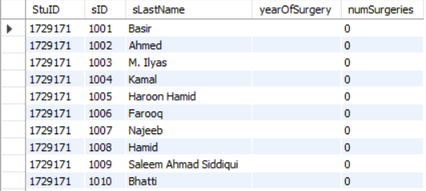
509 rows returned

Question 8. For each letter of the alphabet – A, B, C etc. – display the number of patients whose last name begins with that letter. Order your output alphabetically. If a letter doesn't have any corresponding patients, you can simply omit it from the listing. Hint: you can use the LEFT(string, n) function to find the first letter of a string. For example, the first two lines of your output would look like this:
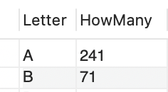
SELECT
'1729171' AS StuID,
LEFT(p.l_name, 1) AS Letter,
COUNT(*) AS HowMany
FROM patients9171 p
GROUP BY Letter
ORDER BY Letter;
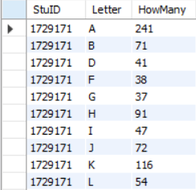
19 rows returned

Question 9. Which patient (or patients if more than one) has had the highest number of appointments? (That is, more appointments than all the other patients.) If there is a tie for first place, list all the patients who tied. Your results should show the patient(s)’ ID, first and last name in the format “last comma space first” (e.g. Lee, June), and the number of appointments they had. Hint: you will need to use ALL (see additional explanation https://www.w3schools.com/sql/sql_all.asp).
SELECT
'1729171' AS StuID,
p.patient_id AS pID,
CONCAT(l_name, ', ', f_name) AS pName,
COUNT(*) AS numAppts
FROM patients9171 p
INNER JOIN appointment9171 a
ON p.patient_id = a.patient_id
GROUP BY p.patient_id
HAVING COUNT(*) >= ALL(
SELECT COUNT(*)
FROM appointment9171 a2
GROUP BY a2.patient_id
);
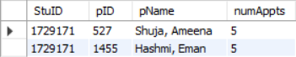
2 rows returned

Question 10a. Add yourself as a patient. You do not need to provide your real DOB, phone and address, any fictitious data is acceptable, as long as it is saved in the table. Use your student ID as patient ID. Provide a screenshot of the message generated by Workbench that a record was added.
INSERT INTO patients9171
VALUES(1729171, 'Timothy', 'Wong', 'M', '1999-12-25', '0467897622', '1 Park Road, Carlton VIC 3010, Australia');

Question 10b. Add an appointment for yourself with Dr. Sonia Ali on any date in October 2026; use any reason you want for the appointment. The appointment status should be as “scheduled” and in person without payment details. This task needs to be done as a simple transaction where you need to determine doctor’s ID first and only after that you can save appointment details.
Note, to find out the last appointment number use MAX(appointment_Id). This task needs to be done as a transaction.
Provide a screenshot of the status of executing the transaction. Make sure you include all status rows relevant to the transaction.
START TRANSACTION;
-- Step 1. Find Dr. Sonia Ali's ID
SET @DrSoniaAliID = (
SELECT doct_id AS `Dr. Sonia Ali's ID`
FROM doctor9171
WHERE l_name = 'Ali' AND f_name = 'Dr. Sonia'
);
-- Step 2. Find the last appointment number
SET @LastApptNum = (
SELECT MAX(appointment_id) AS `Last appointment number`
FROM appointment9171
);
-- Step 3. Schedule an appointment
INSERT INTO appointment9171(appointment_id, patient_id, doct_id, appointment_date, appointment_status)
VALUES(@LastApptNum + 1, 1729171, @DrSoniaAliID, '2026-10-15', 'Scheduled');
COMMIT;

Question 10c. Create an SQL statement showing your id and name as a patient and your appointment details including appointment id, doctor’s id and full name (last and first separated by comma and space), date, mode of the appointment and status of the appointment.
SELECT
'1729171' AS StuID,
p.patient_id AS pID,
CONCAT(p.l_name, ', ', p.f_name) AS pName,
appointment_id AS apptID,
d.doct_id AS dID,
CONCAT(d.l_name, ', ', d.f_name) AS dName,
appointment_date AS apptDate,
mode_of_appointment AS apptMode,
mode_of_payment AS paymentMode,
appointment_status AS apptStatus
FROM patients9171 p
LEFT JOIN appointment9171 a ON p.patient_id = a.patient_id
LEFT JOIN doctor9171 d ON d.doct_id = a.doct_id
WHERE p.patient_id = 1729171;
1 row returned

Question 11a. Write the SQL DDL to create a view that counts number of wards in each department. Your list should include department ID, department name and number of wards.
CREATE VIEW WardCount AS
SELECT
d.dept_id AS deptID,
d.dept_name AS deptName,
COUNT(*) AS numWards
FROM department9171 d
LEFT JOIN ward9171 w ON d.dept_id = w.dept_id
GROUP BY d.dept_id;
In addition to the code, you need to provide 2 screenshots:
- the list of tables and views from the left pane of Workbench showing your created view
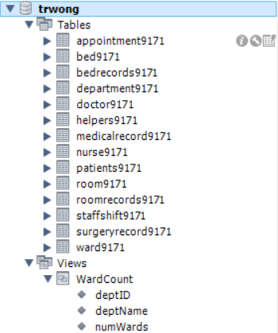
- the results of running SELECT from your View (we recommend explicitly showing the SELECT statement used to create the View).
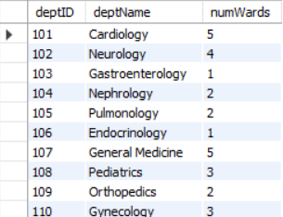
31 rows returned
Question 11b. Using the View you created in Task 11a, list the departments with the highest number of wards. Your results need to display department id, department name and the corresponding number of wards. You must include your student ID in task b.
SELECT
'1729171' AS StuID,
WardCount.*
FROM WardCount
WHERE numWards = (
SELECT MAX(numWards)
FROM WardCount
);
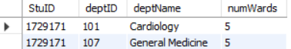
2 rows returned

