<https://www.behance.net/gallery/146078831/Developer-website-Portfolio-Freelancer-website?tracking_source=search_projects%7Cportfolio%20website>

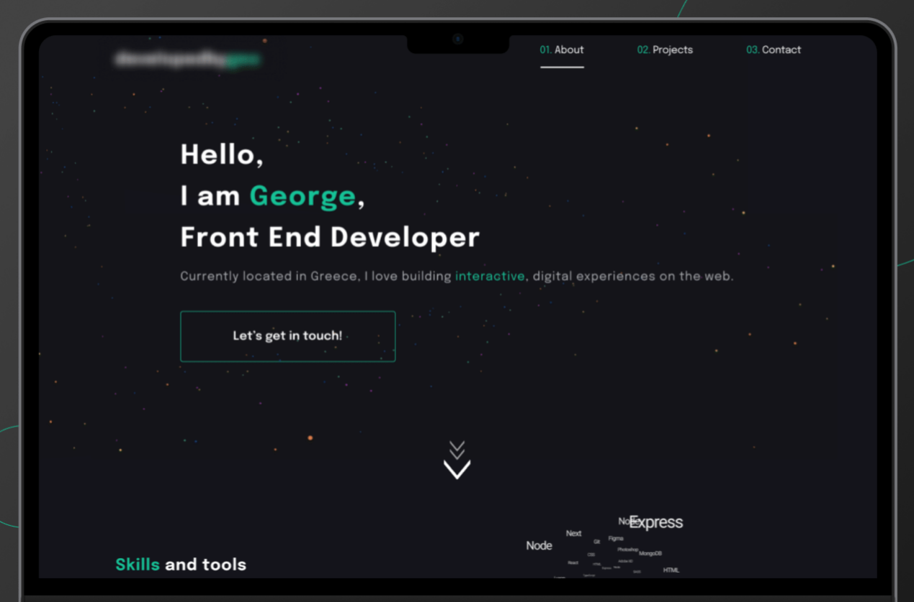

https://alvarotrigo.com/blog/web-developer-portfolio-examples/

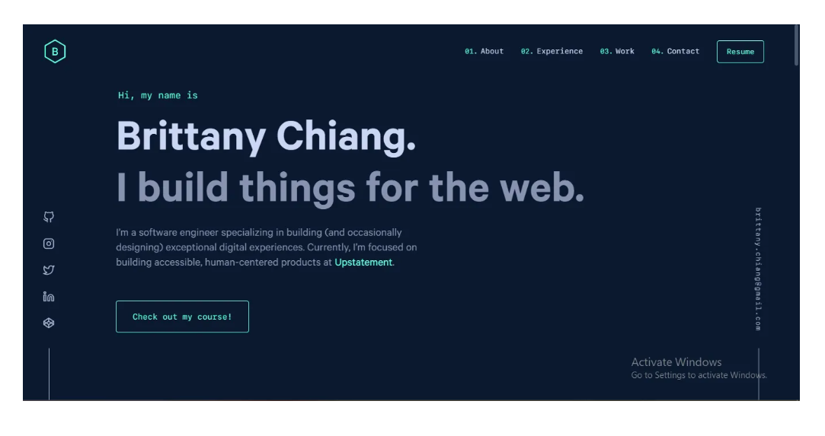

[https://alvarotrigo.com/blog/web-developer-portfolio-examples/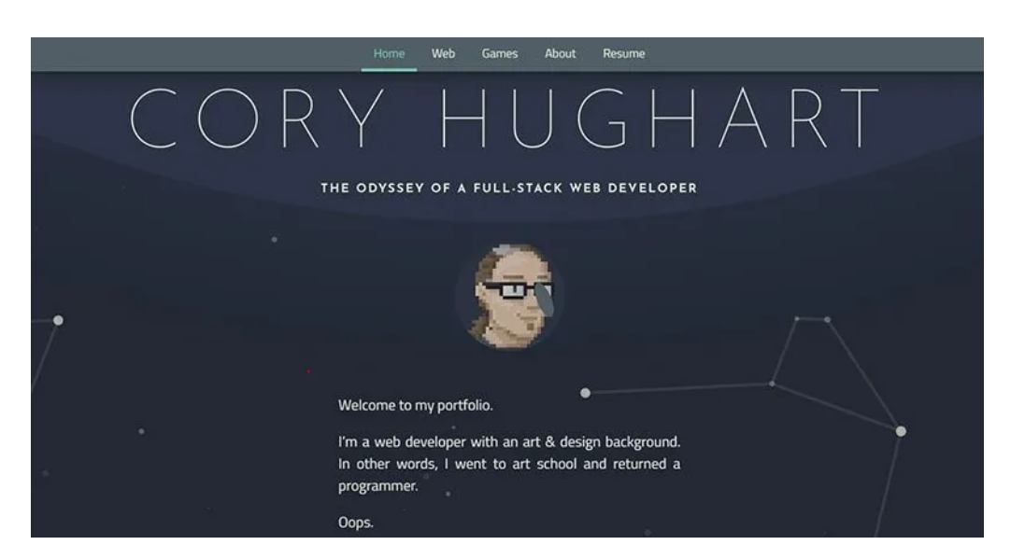](https://alvarotrigo.com/blog/web-developer-portfolio-examples/)

<http://preview.themeforest.net/item/sam-bailey-personal-cvresume-wordpress-theme/full_screen_preview/31873028?_ga=2.78905364.1843793174.1661651961-964060779.1660215673>

