**Notes**

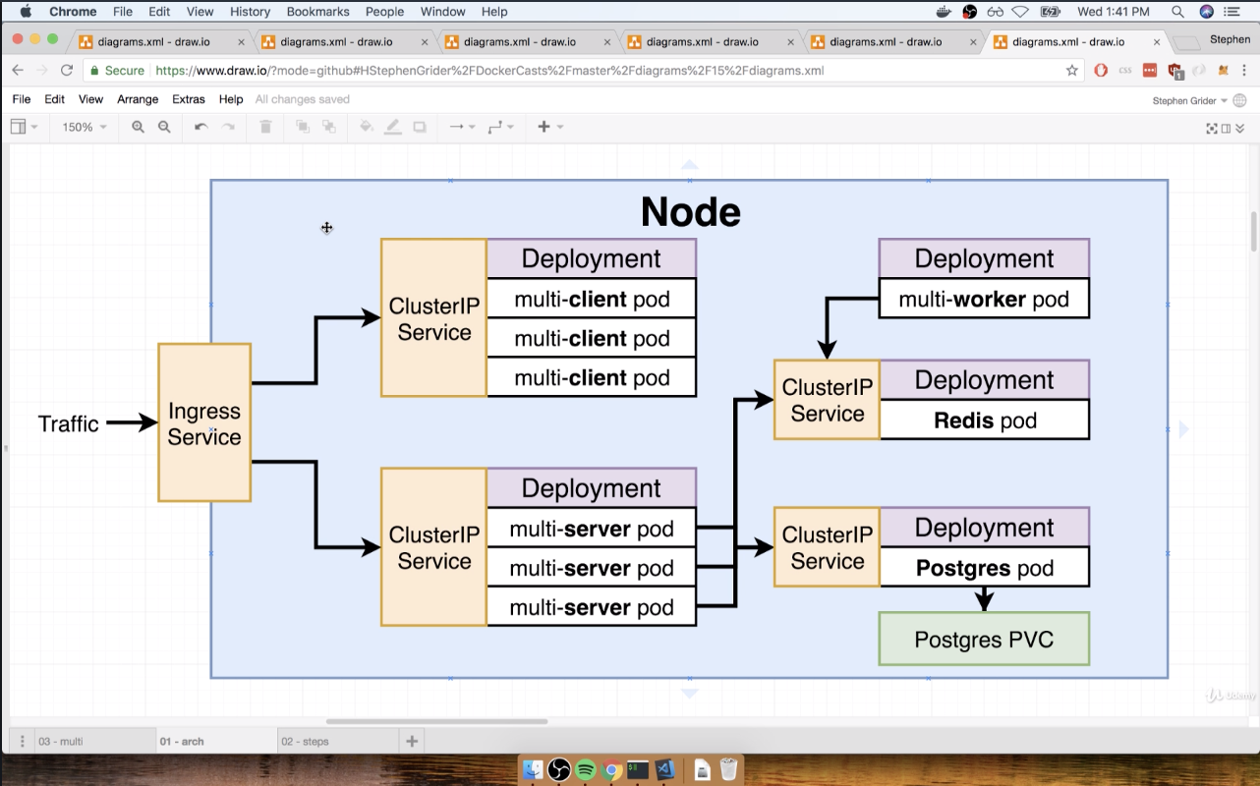

1. We need to create config files for each of these configs
2. For routing, we will not be using nginx server, we will be using the Ingress service

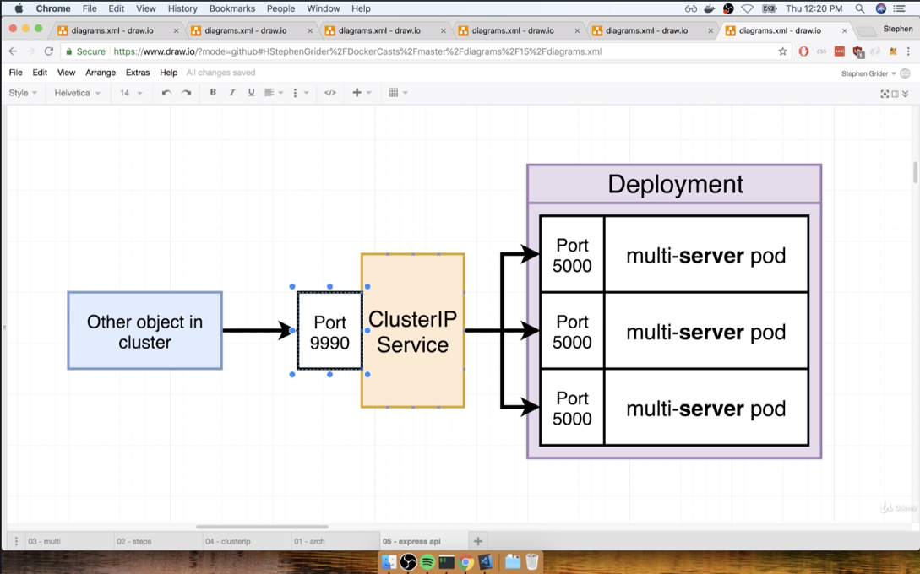

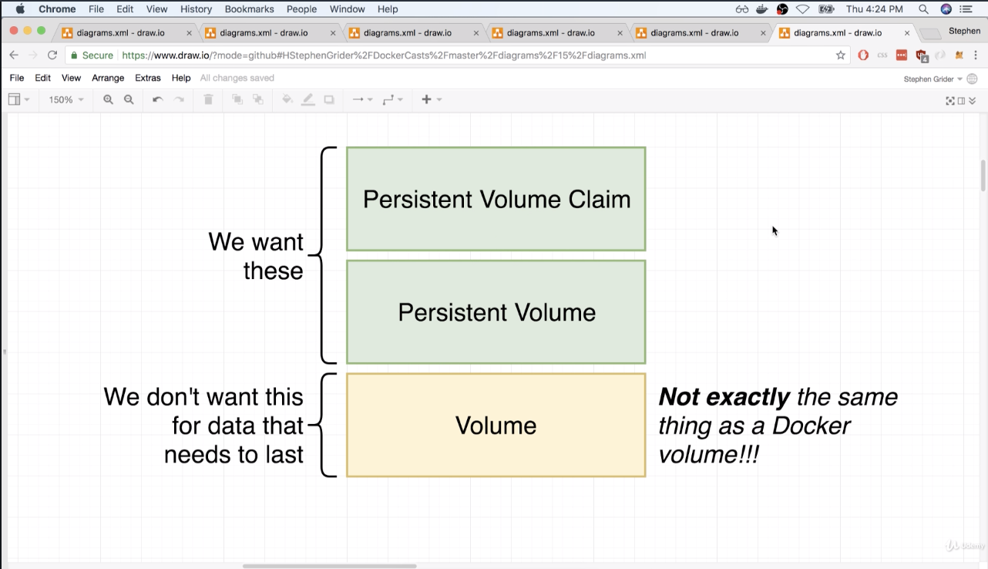

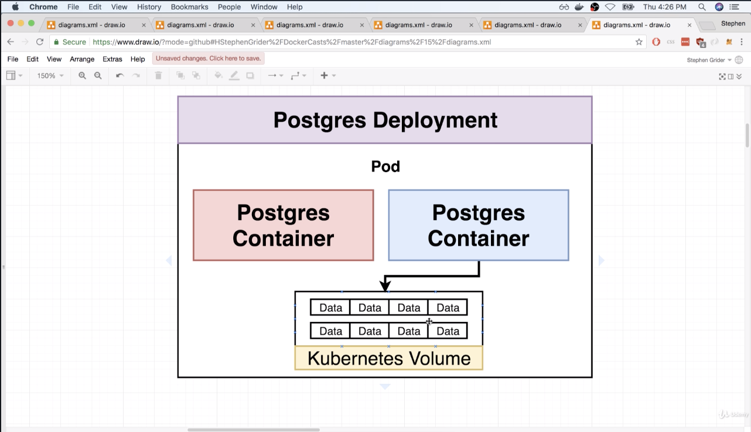

* If Contianer dies, the volume is ok but if the pod itself crashes, the data is lost completely since the Kubernetes volume exists ONLY within the pod

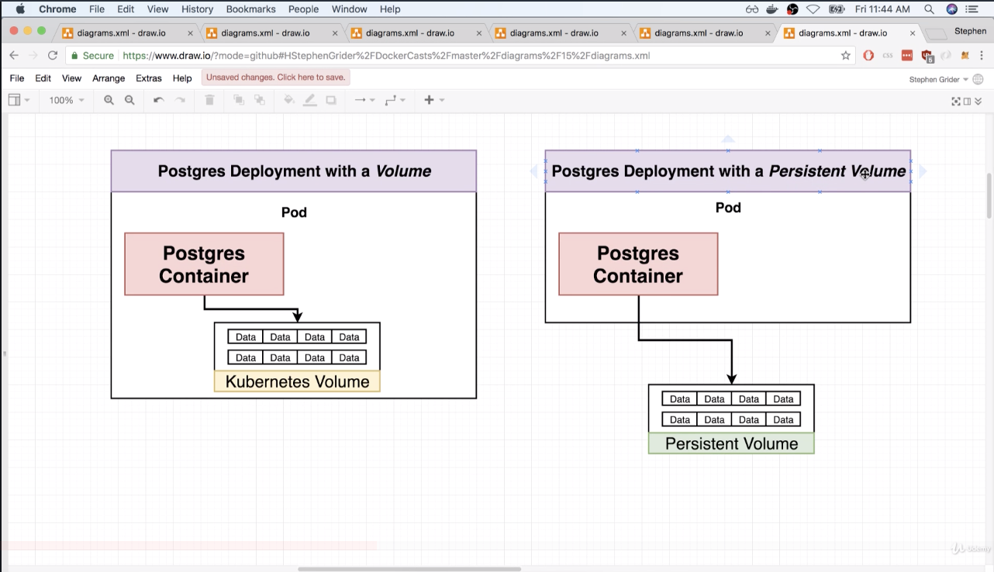

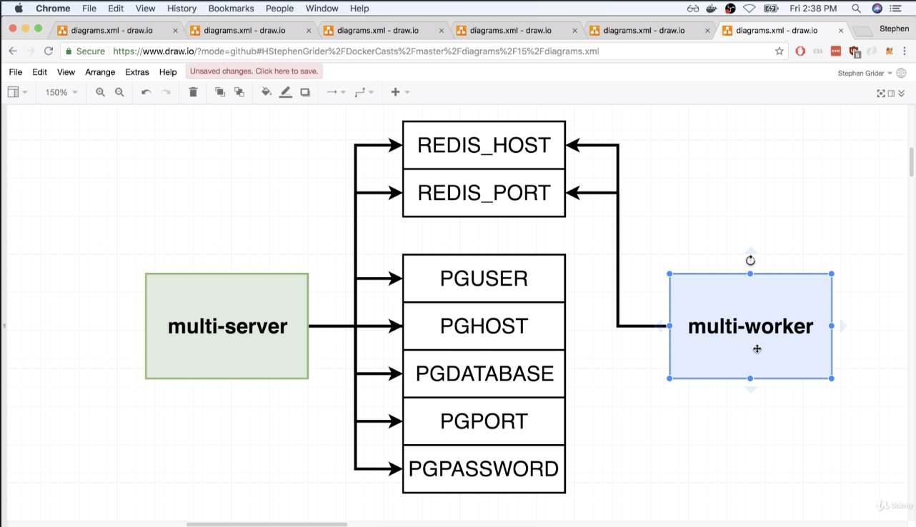

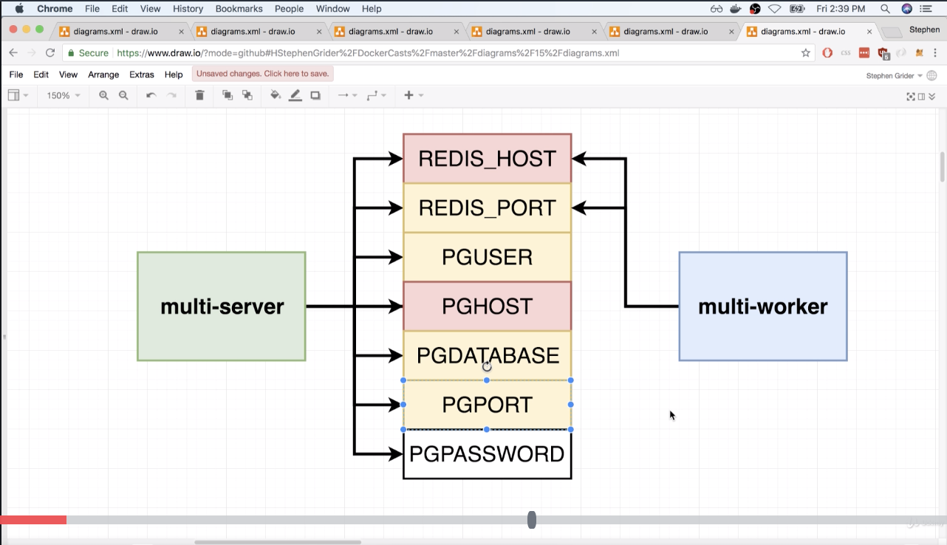Yellow – Constant values

Red – Constant values but will tell how to connect

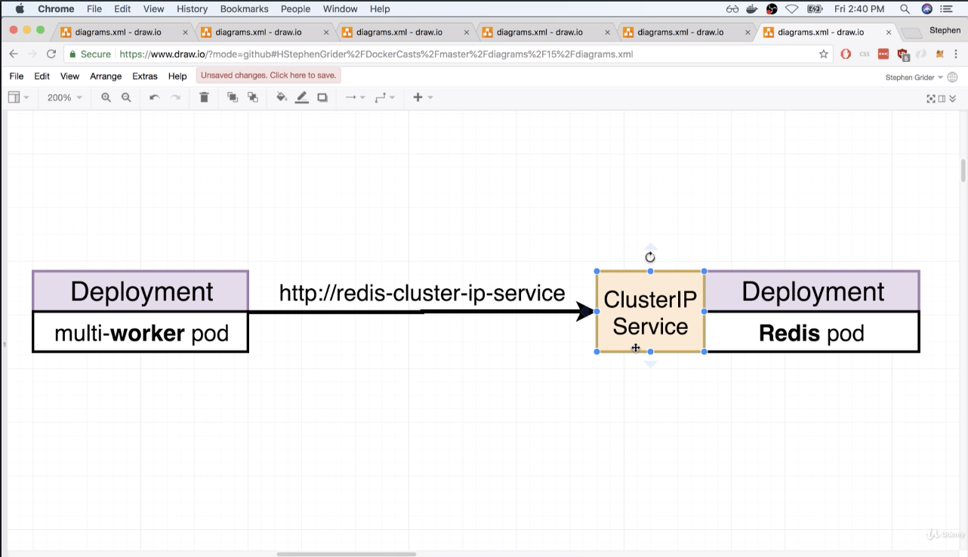

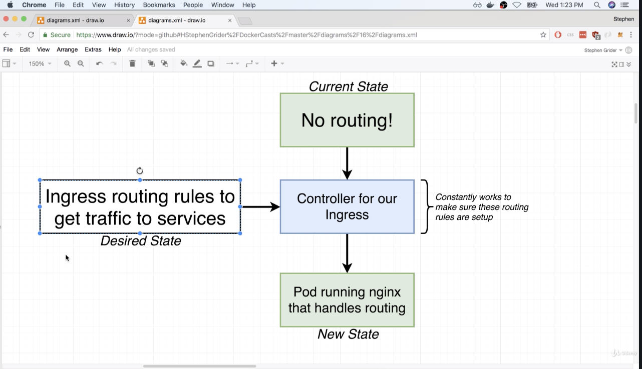

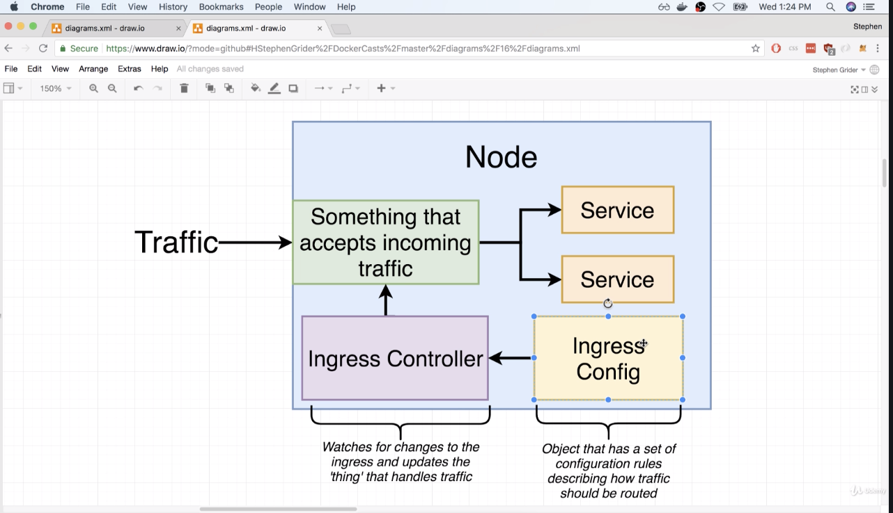

How to Launch ?

1. Execute minikube ip
2. Type in ip on browser (No PORT needed)