Task 1_1
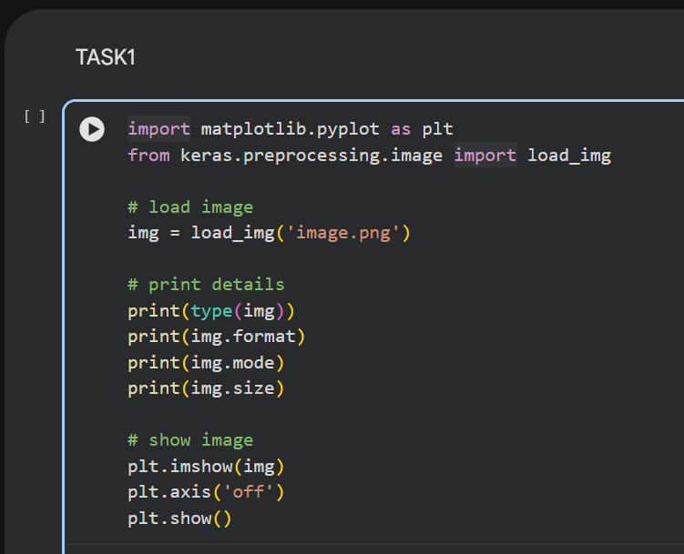
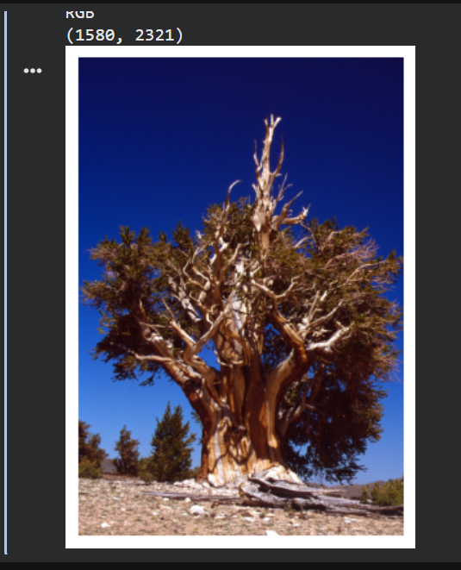
In this task, I loaded and displayed an image using Keras and Matplotlib in Google Colab. The image was successfully visualized, which helped me understand how images can be processed and displayed in Python.

Task 1_2
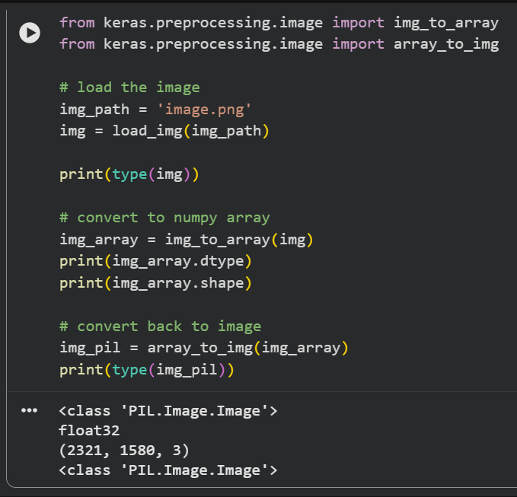
In this task, I converted the image into a NumPy array and examined its data type and shape. I also converted the array back into an image, which helped me understand how images can be represented and reconstructed in Python.

Task 1_3
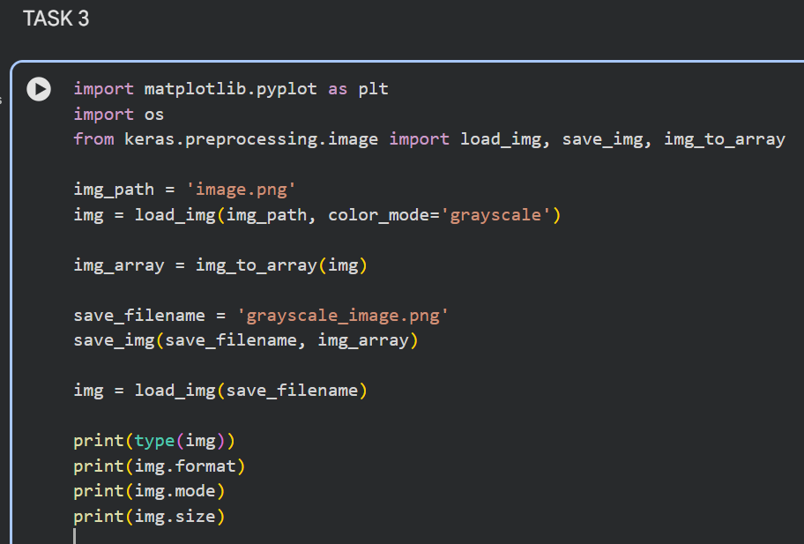
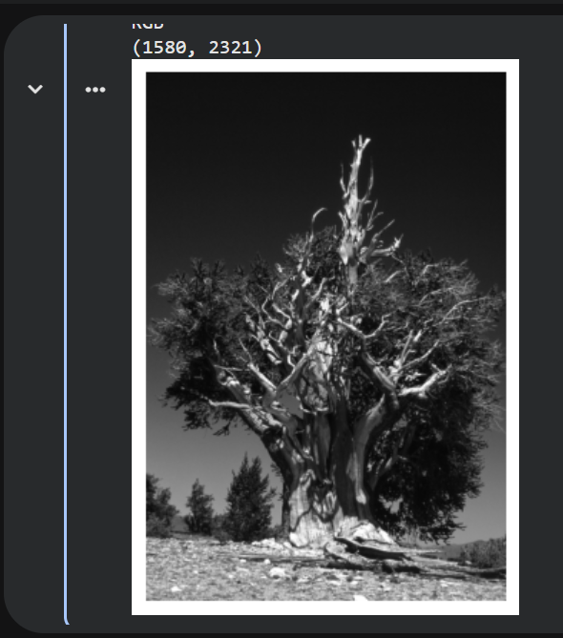
In this task, I converted the image to grayscale, saved it, reloaded it, and displayed it. This helped me understand how to process and store images using Keras and Matplotlib.

Task 1_4
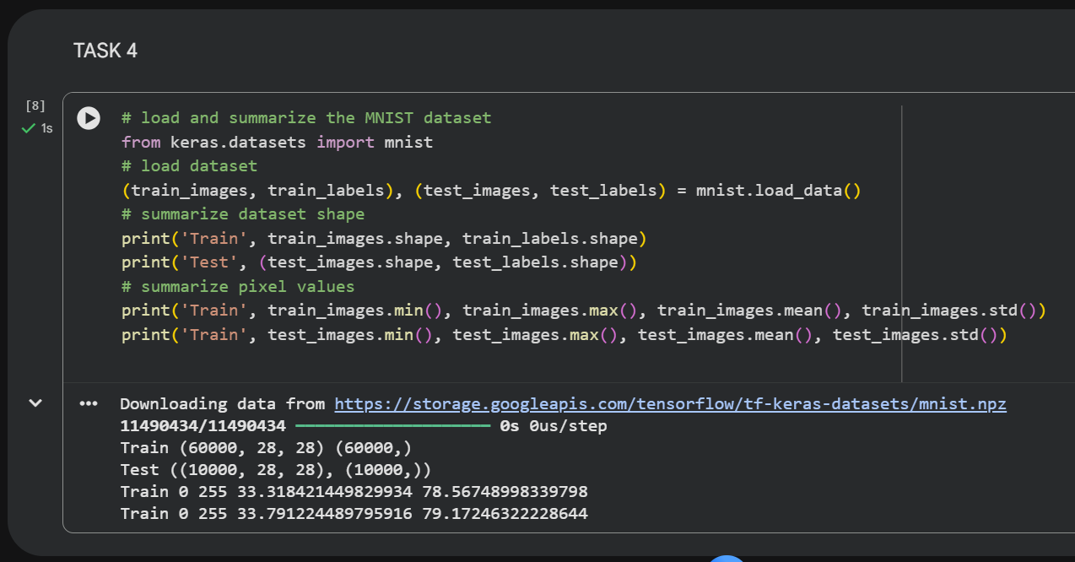
In this task, I loaded the MNIST dataset using Keras and examined its structure. I printed the shape of the training and testing data, as well as the pixel value statistics. This helped me understand how image datasets are structured and analyzed in machine learning.

Task 1_5
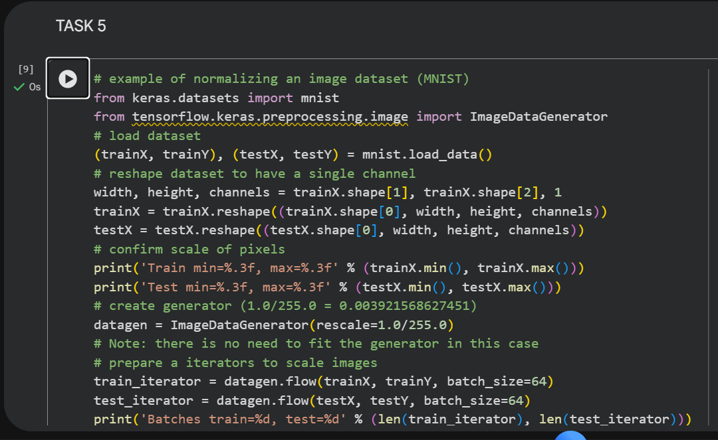
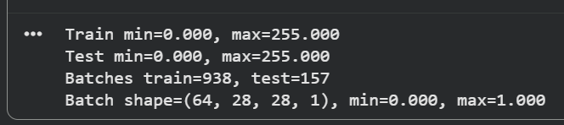
In this task, I normalized the MNIST dataset by scaling the pixel values from 0–255 to 0–1. This helps improve model performance and makes the data easier to process. Normalization is an important preprocessing step in machine learning.

Task 1_6
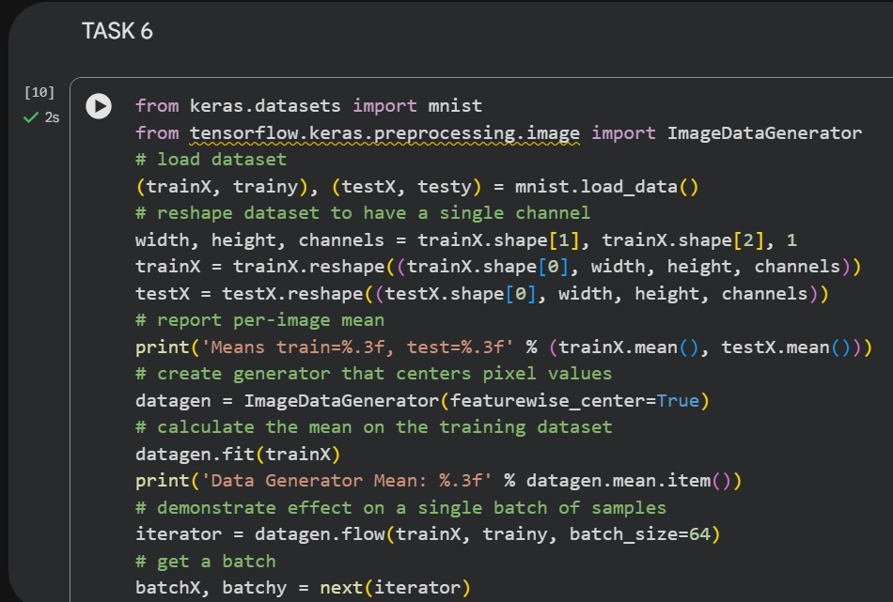
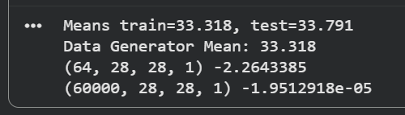
In this task, I centered the MNIST dataset by subtracting the mean value from the images. This helps to shift the data so that it is centered around zero, which improves the performance of machine learning models. Centering reduces bias in the dataset and makes training more stable.
Task 1_7
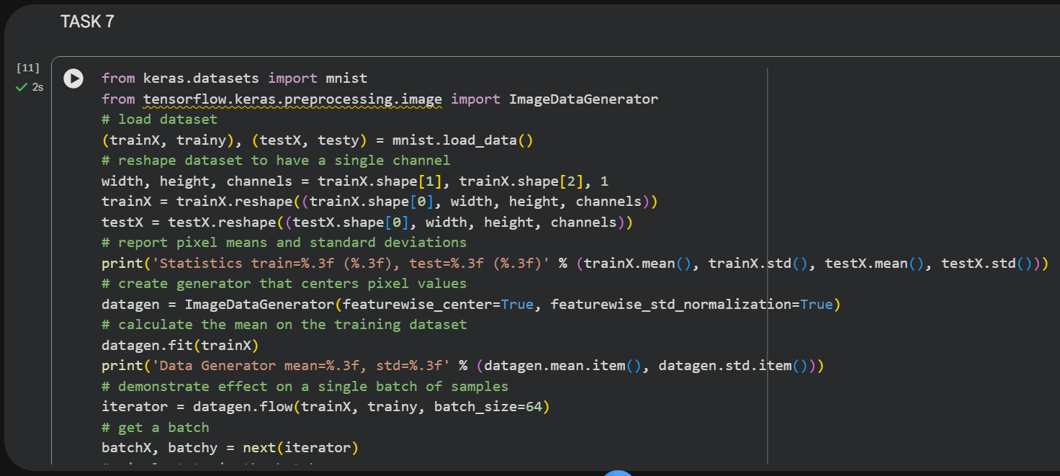
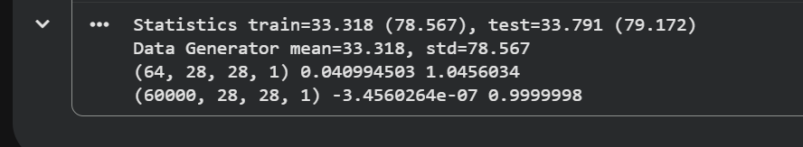
In this task, I standardized the MNIST dataset by subtracting the mean and dividing by the standard deviation. This ensures that the data has a mean close to zero and a standard deviation close to one, which helps improve model performance.

