About this guide

This guide assumes you already have the communication book application installed and running, with a symbol library loaded. If you need assistance with this please refer to the project wiki at http://communication-book.wikispaces.com/

This guide is aimed at people who wish to make use of the application and those helping them. It is intended to show you how to make the existing features of the application work, where to get help, and how to customise the application to your needs.

User Guide

Introducing the interface
Here is what the application looks like when it is first opened. You may have a different set of pictures and category names showing as the application can load different “symbol libraries”:

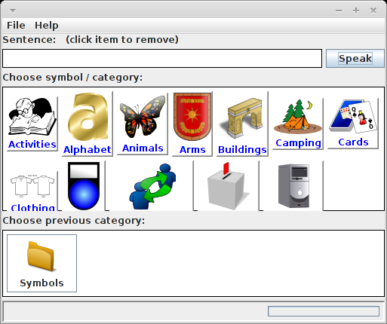

Constructing a sentence

As a simple demonstration, I will construct the sentence “Gardening is cool” using the default bundled symbol library.
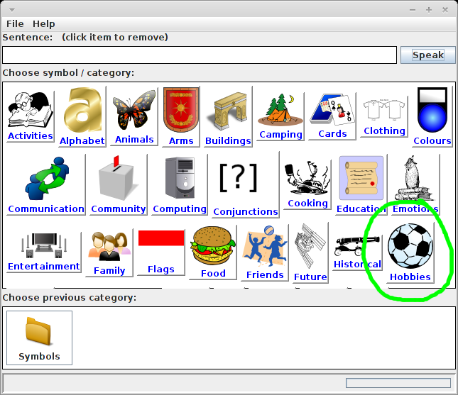
- Click the “Hobbies” category in the “symbol / category” panel:
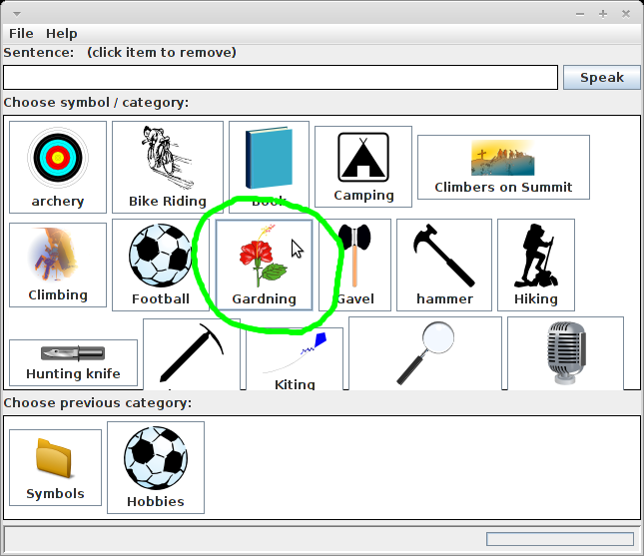
- Add the word “Gardening” to your sentence by clicking the hobby symbol “Gardening” in the symbol / category panel:
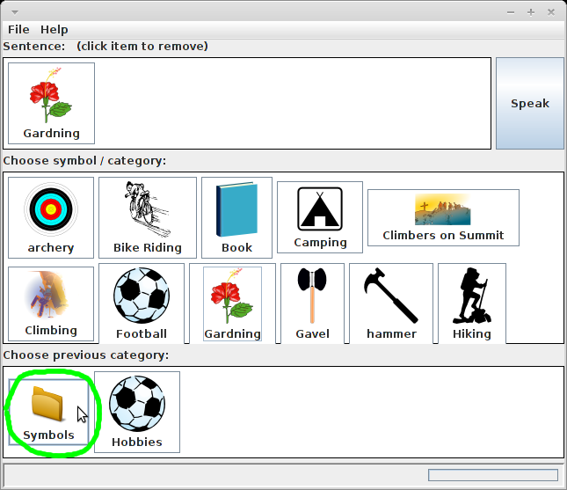
- Now we need to return to the list of categories we saw when we first started the application in order to go into a different category. To do this, click the first button in the “previous category” panel, this may be named differently depending on the library that is loaded:
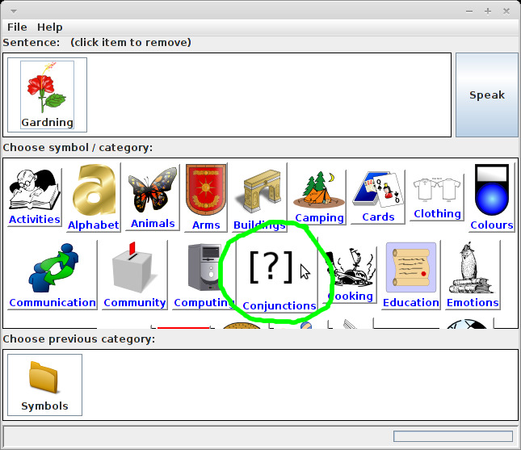
- Now click the “Conjunctions” category in order to find “Is”:
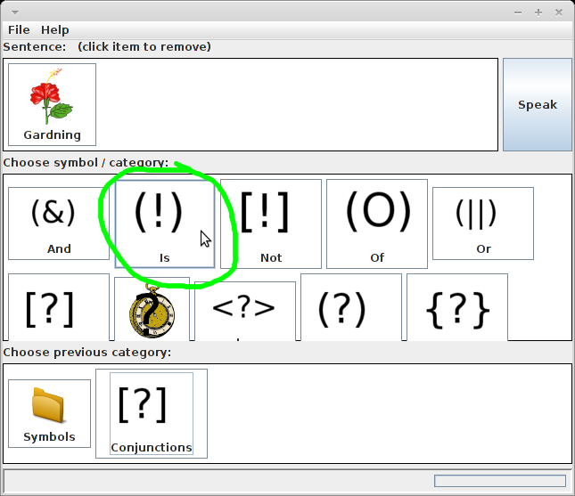
- Now add “Is” to your sentence by clicking on the symbol/word:
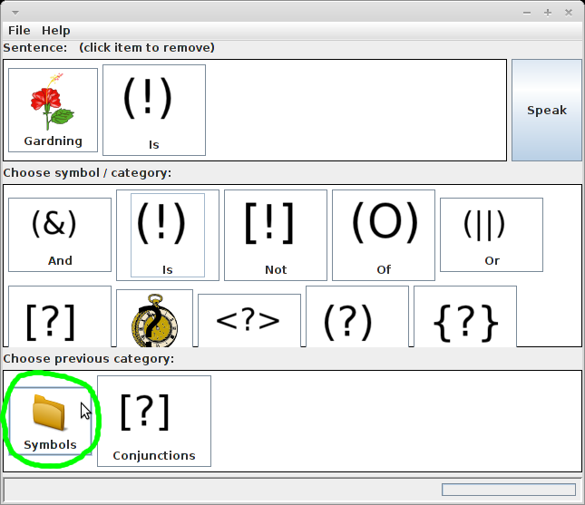
- Once again return to the top of the library by clicking the first button in the “previous category” panel:
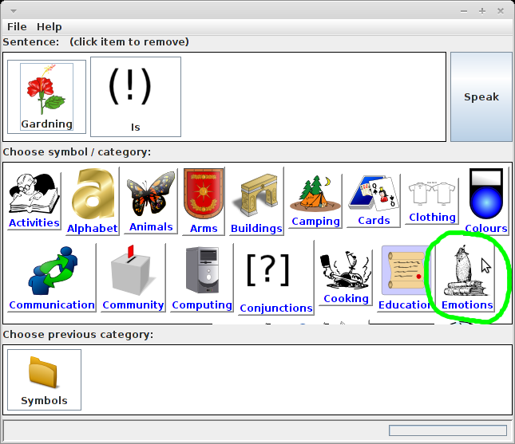
- Click the “Emotions” category:
- Now click the symbol “Cool” to add the last word to the sentence:
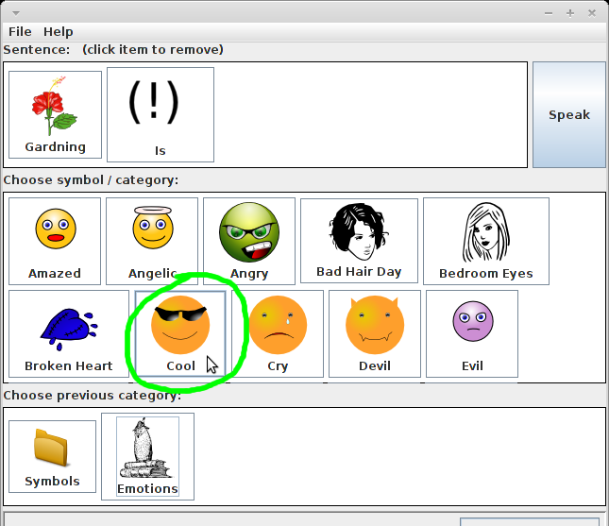

Your sentence is now complete.

Hint: If you can't find exactly the word you after, try a similar sounding word, and people will likely understand your meaning.

Hearing your sentence
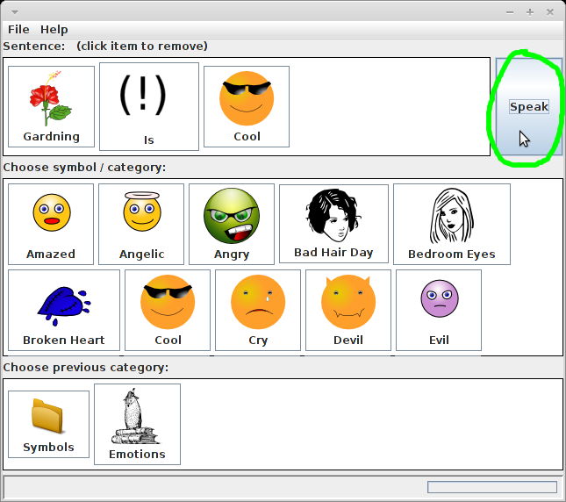
To hear your sentence spoken click the “Speak” button:

Removing a word from your sentence
Click the word you wish to remove:
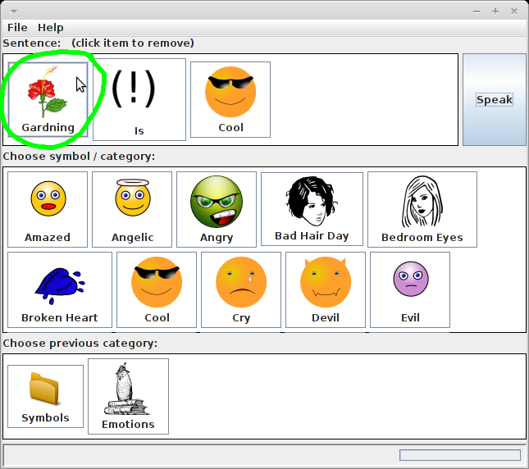
If you wish to clear the whole sentence then repeat for each word.

Getting help
If you need help or wish to contribute, then please join the mailing list at https://launchpad.net/~communication-book-community and send an email to the list. You are also encouraged to join this mailing list if you are just interested in this project, as this is where announcements and discussions will take place. There is a public record (https://lists.launchpad.net/communication-book-community/) of messages sent to this mailing list. The email address for this mailing list is communication-book-community@lists.launchpad.net

If you have found a problem with the computer program or have a feature request, you can add an entry to the blueprint or bug lists for the project.

- Blueprints: https://blueprints.launchpad.net/communication
- Bugs: https://bugs.launchpad.net/communication

Project information and background
The Communication Book project was started in Nov 2011 by John D Morton with the aim of providing a computer program to aid those with aphasia (https://en.wikipedia.org/wiki/Aphasia) in their communication with others.

Specifically this project is aimed at those who are unable to think of the words they wish to say, but who are able to select a symbol on a computer screen. The ambition is to provide a piece of software which allows you to construct a sentence through the selection of visual symbols, and then have the computer speak the sentence for you.

The program has been made freely available, and additionally the program and its source code (which you would need should you wish to alter the program) are licensed under the GNU Public License version 3 (http://www.gnu.org/licenses/gpl.html) which ensures that you have the rights to continue the project, to make any changes you wish (with the help of a programmer if needed), and to redistrubute your own versions for the good of the community at large.

Advanced usage

Customising a symbol library
The application has been designed to load different libraries, and for the libraries to be modifiable by anyone with a basic knowledge of computers.
The symbol library is a simple folder of named images. Folders represent categories, and image files represent the symbols displayed in the application:

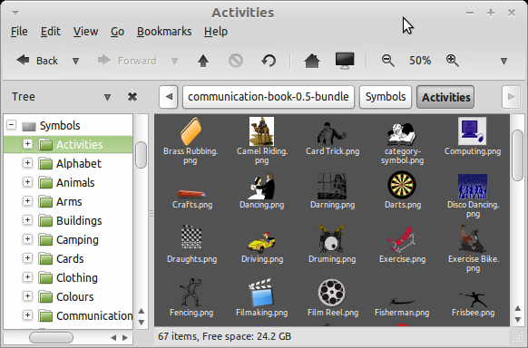
You can create your own image libraries by following this convention and the application will load them. Go ahead, give it a try!

You can give a category a picture by adding a specially named image file “category-symbol.png” to the category folder, and the application will use this file as the picture for the category, and will not show it within the category:

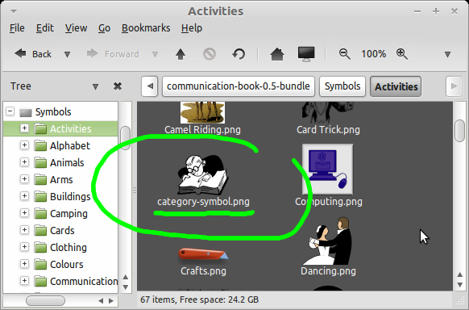

Loading different symbol libraries
If you are running the bundle, you will find within that a folder called “Symbols”, this is the default symbol library, and the supplied .bat file will load this library by default. You can however create as many variations of these libraries as you wish. You can either load these libraries with File > Load ...
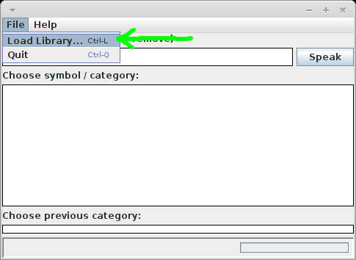
… or you can alter the .bat file (which is just a text file) to open an different library:
By default, the .bat (windows batch file) file contains the following:
java -jar communication-book.jar -l Symbols
where “Symbols” is the directory of the symbol library to be loaded when the application starts. For example:
java -jar communication-book.jar -l "C:\My Symbol Library"
As such you could create several batch files for loading different favourite symbol libraries.

About this document
This document is part of the communication book project and as such is licensed for user / modification / reproduct and redistribution under the GPL v3 license.

