The Communication Book program
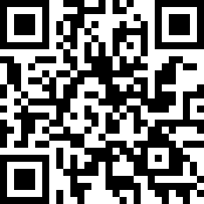http://is.gd/commsbook
More information and downloads:
http://communication-book.wikispaces.com/

The Communication Book project was started in Nov 2011 by John D Morton with the aim of providing a computer program to aid those with aphasia in their communication with others.

Specifically this project is aimed at those who are unable to think of the words they wish to say, but who are able to select a symbol on a computer screen. The ambition is to provide a piece of software which allows you to construct a sentence through the selection of visual symbols, and then have the computer speak the sentence for you.

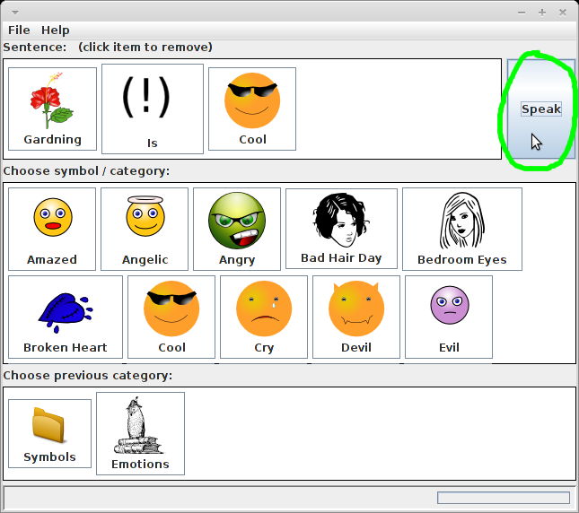A sentence ready to speak

The program has been made freely available, and additionally the program and its source code (which you would need should you wish to alter the program) are licensed under the GNU Public License version 3 (http://www.gnu.org/licenses/gpl.html) which ensures that you have the rights to continue the project, to make any changes you wish (with the help of a programmer if needed), and to redistrubute your own versions for the good of the community at large.

About this document
This document is part of the communication book project and as such is licensed for user / modification / reproduct and redistribution under the GPL v3 license.

