Assignment 1
Due, Sunday, February 20, 2022 for 100% credit
Monday, February 21, 2022 for 90% credit
Tuesday, February 22, 2022 for 80% credit
Wednesday, February 23, 2022 for 70% credit

Scenario
You have started your own business and lease or rent a physical space. You need to develop a website to advertise and potentially provide online services. The website will be developed in stages. Each assignment represents an upgrade to your website.

References
- Basic web document structure is specified in code example 2_HTMLBasicPage.html.
- Block level and inline HTML elements are specified in code example 5_HTMLTags.html.
- HTML attributes are identified in any of the code examples in addition to 6_1_HTMLAttributes.html and 6_2_HTMLGlobalAttributes.html.

Assignment 1
- Create a website with three pages
  - Home page
  - Products or Services page
  - About us/Contact us page
  - Inline elements: the site must include a minimum of 10 of the 28 possible inline elements
  - Block-level elements, the site must include a minimum of 10 of the 29 possible block-level elements
  - At least half of your included HTML elements must use attributes.
- Each page should include the following
  - <!doctype html> declaration using HTML5
  - Navigation for the entire website with functioning links (<link>, <nav>)
  - <head> section that implements the <title> element
  - <body> section

- The website should include relevant information such as
  - Block level tag elements describing the Website (heading, paragraph, blockquote, div, address, etc…)
  - The company’s name, address, city, state, zip, phone number(s), fax number, point of contact, hours of operation (pseudo information is okay)
  - Display a list (<ul>, <ol>, or <dl>) of the services or products your company offers
  - Images of products or services offered (<img>)
  - A video
  - Inline elements (image, bold, italics, etc…)

- Comments as necessary; recommend commenting the different pages and section of the website also include author name and date developed

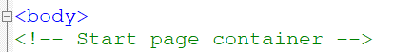
Figure 1Comment is in green font

- The directory structure of the website must be in good form:
  - Parent folder of the website has the index.html file only, see figure 2
  - An html folder for all other pages of the site, see figure 2
  - An images folder for all images, see figure 2
  - Pathing must be relative not absolute, see figure 3

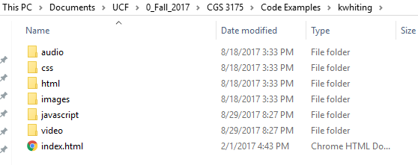
Figure 2 Parent directory is kwhiting
Figure 3 Pathing is relative to where file index.html exists

- The website pages must validate using the W3C Markup Validation Service at URL https://validator.w3.org/. I recommend using the second tab option, Validate by File Upload. Validate means the following:
  - No warnings
  - No errors

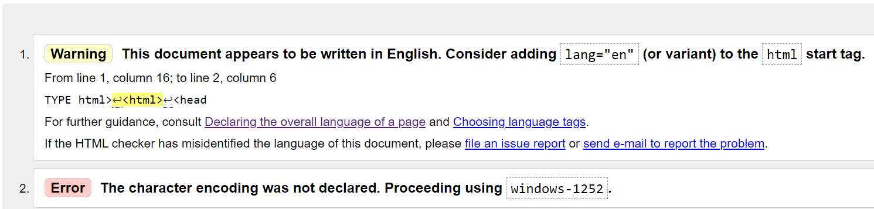
Figure 4 Has warnings or errors

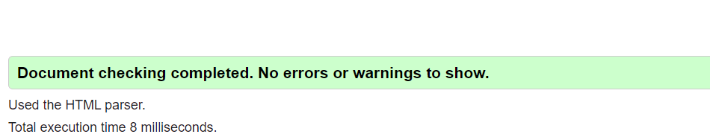
Figure 5 Does not have warnings or errors

- Submit the assignment in a compressed format (e.g. .zip, .tgz, .tar, etc…) that includes all resources (i.e. compress at the parent directory level)

