CEED
CEGUI Unified Editor

Requirements
Operating system:
- UNIX with X11
- Windows XP and newer
- MacOS X (I won't test and support this officially since I don't have the necessary hardware!)
Hardware:
- Graphics card capable of running CEGUI (accelerated OpenGL)

Dependencies
- Python 2.6
- Qt 4.7 – handles all UI
- PySide – python bindings for Qt
- CEGUI 0.8
- PyCEGUI 0.8 – python bindings for CEGUI

Main interface
This interface hosts all the tabbed editors and provides some functionality that is shared by all the editors. It consist of an interface surrounding the application.

Feature highlights
- Create a new project from scratch (the project will have a base folder and no files in it)
- Close the project (also closes all files opened right now)
- Add new files to the project (creates the file, by default passes base folder as the parent folder)
- Add existing files to the project (choose existing file(s) to add to the project, by default starts in the base folder)
- Remove existing files in the project (with an option to delete the file on the disk)
- Tab based file editing (one tab per opened file)
- Ability to open/close each tab
- Ability to close all tabs
- Save all opened files (all files opened in the tabs are saved to disk)
- Ability to view CEGUI log of the embedded CEGUI
- Integrated Exception message box (+more robustness than CELE2)
- Undo/Redo system reusable by all the integrated editors. Undo/Redo is per file.
- Manual XML edit for files (switch from Visual to XML)

The overall look
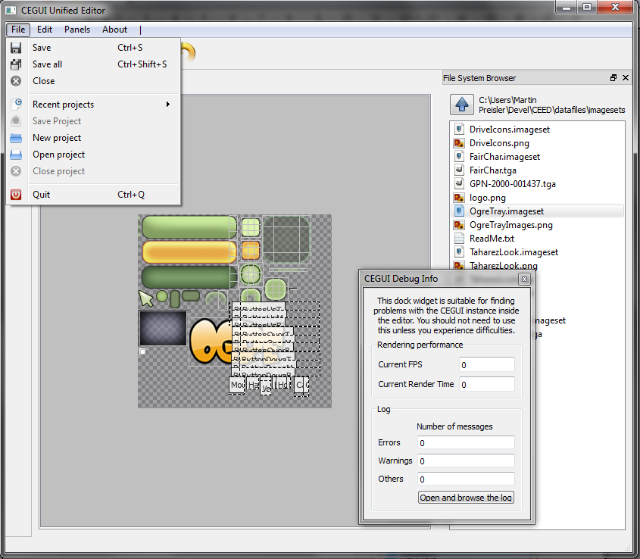
The whole interface consists of the centre part providing tabs, each tab is one opened file. User can close any tab. Reordering of the tabs is also possible.
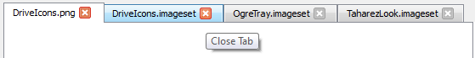
Surrounding this centre part are dock widgets and toolbars.

Project manager
Allows user to manage a project (project is a set of related files), browse through files, open any file for editing, add new or existing files to the project and remove files from the project.
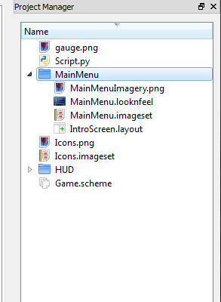
Most of the project managing takes place in the 'Project Manager' dock widget.
The dock widgets lists all files currently in the project and allows user to edit/view them by double clicking them.
Right clicking brings up a context menu with the ability to add files to the project or remove currently selected files from the project.
The main reason for project management is to have CEGUI resource path settings shared for all the files in the project. The project files are designed to be committed to a repository and used on different computers for as robust and trouble-free workflow as possible, so all paths are relative to the project file (even though you may see absolute paths in the editor itself, they get converted to relative paths in the end).

Session data
While the project file is designed to be shared in a repository by all team members working on the project, session data file is designed to be used only on the computer it was first created on. It resides next to the project file and it's name is projectfilename.session.
The session file contains info about locked and hidden images in the imagesets, locked widgets in various layouts.
Session data for all project files are kept in one session file.

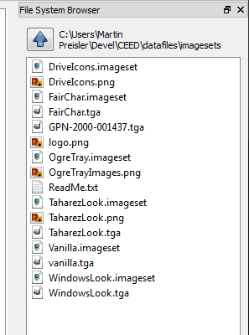
File system browser
In addition to the project manager, CEED allows you to browse filesystem and simply open files for quick editing. Please note that this will only work for some file types (it can't work for schemes and layouts because CEGUI paths aren't set if project isn't loaded).
This is again realised through a dock widget that hosts the functionality. It has a very simplistic interface, displaying current path, allowing the user to go one level up the hierarchy and simply listing files and folder in the current path.

Double clicking a file opens it for editing.

Undo & Redo functionality
Since most tabbed editors allow undo and redo, the main interface allows you to perform these actions via shared means in the top toolbar.
Undo & Redo are per-file, so whenever you switch tabs, the undo stack gets changed. If you for example do changes to file A, then switch to file B, do some changes and keep pressing Undo, only changes to file B gets undone, you have to switch to A again and undo there.
Selections aren't undoable as they don't count as undo actions. Switching editing mode is an undoable action though as the changes of XML code don't make sense in visual code (even though just switching to XML mode doesn't change the file at all).
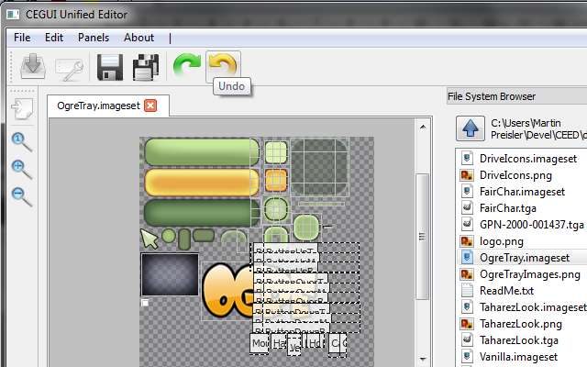

Editing modes
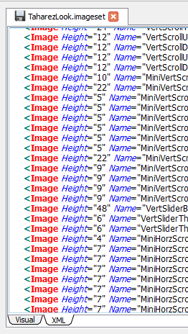
For some file types (mostly .imageset and .layout), it makes sense to edit in both visual mode (WYSIWYG more or less) as well as XML (editing plain text XML code). Undo and redo is transparent between mode switching as mode switching counts as an undo action.
You can switch modes by clicking on the bottom tab pane.
All files are by default opened in Visual mode and XML is regarded as a clutch mechanism, a tool to make tedious mass changes or work around problems with Visual mode.

API
The whole code is divided into folders where the root folder provides basic reusable functionality (project management, undo view, tab management, …) and the editors themselves providing editing facilities for various files.

TabbedEditor
A base class for editors hosted in a tab.
There are 3 phases that need to happen before a tabbed editor shows up to the user:
- Construction of the class
- Initialisation
  - all the supporting widgets get created
  - the file is loaded and processed
- Activation
  - this puts the tabbed editor 'on stage'

The destruction works in the exact opposite order.

Variants of the TabbedEditor
To avoid repeating code (DRY principle), there are 2 very important classes that add functionality to TabbedEditor that you want to inherit if applicable to avoid reinventing.

UndoStackTabbedEditor
You are using the Qt's UndoStack. This connects all the necessary calls.

MixedModeTabbedEditor
Useful when you want multiple editing modes. Please note that you must be using UndoStack in this situation as switching modes is an undo action!

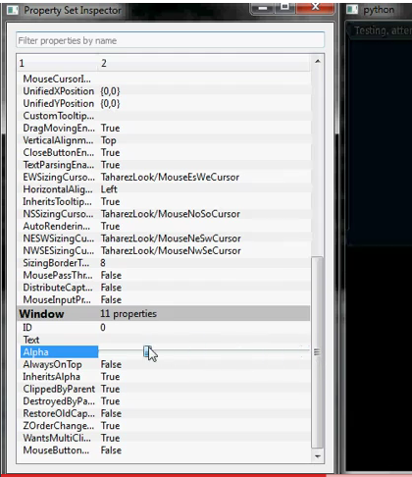
Property editing
A lot of CEGUI classes provide basic introspection via property strings. CEED has a set of classes to reuse when you want to edit properties of widgets or any other classes that inherit from PropertySet.
PropertyInspector inspects invidividual properties
PropertySetInspector uses PropertyInspector to inspect all properties in a PropertySet

XML editing
Lot of CEGUI files are XML so when you want to add XML edit modes for them, the API provides a reusable class that offers rudimentary XML 'syntax' highlighting (colouring the tags).

Font editing
Subject to change, .font file format will be changing and hasn't been established for 0.8 yet!
Files with the font extension describe fonts used within CEGUI. Fonts can be loaded (and rasterised) from TTF files or loaded directly from pixmaps. Doesn't contain any actual character editing. Only used to reference existing TTF files and pixmaps for CEGUI.

The output
TTF .font file usually looks like this:
<Font Name="DejaVuSans-10" Filename="DejaVuSans.ttf" Type="FreeType" Size="10" NativeHorzRes="800" NativeVertRes="600" AutoScaled="true"/>
The exact XML definition: http://cegui.org.uk/docs/current/xml_imageset.html
(Subject to change in 0.8!)

Feature highlights
- Automatically create a font definition file from a TTF file on the disk
- Edit the fonts settings (Size, Native Resolution, Auto scaling enabled/disabled) – this will affect the entire project!
- Removing fonts (with option to delete the TTF or pixmap file from the disk) will optionally search for references to this font in the project files and warn the user about that with option to mass replace that font with something else (OPTIONAL FEATURE)
- Preview the font by writing text (the font will be rendered by CEGUI)

Imageset editing
Imageset is practically a texture atlas, a technique used to put many smaller images on one texture to drastically speed up rendering (texture switching is still a very expensive operation, even on today's hardware).
Each imageset has a name, underlying image (what to load the texture from), knows whether it's autoscaled and its native resolution if it is so and a set of 'images'. By 'image' I basically mean rectangle selection of the underlying image in artist's eyes. Each of these 'images' has position (x, y), width, height and offset (x, y). Offset allows you to move the virtual 'pivot point' of the image, which is useful for crosshairs for example (because by default the 'pivot point' is top left).
Most of the code of this tabbed editor is pure Qt, apart from loading the image it doesn't use PyCEGUI at all.

The output
.imageset files usually look like this:
<Imageset AutoScaled="true" Imagefile="UnderlyingImage.png" Name="ImagesetName" NativeHorzRes="800" NativeVertRes="600">
<Image Height="1" Name="FirstImage" Width="8" XPos="201" YPos="98" />
<Image Height="46" Name="SecondImage" Width="62" XPos="2" YPos="127" />
</Imageset>
The exact XML definition: http://cegui.org.uk/docs/current/xml_imageset.html
(Please note that the definition is 0.7 at the moment, whilst the target version is 0.8, imageset file format is unlikely to change though)

Feature highlights
- Create a new imageset from a set of image files (automatically creates a texture and puts all the images on it with as much efficiency as possible)
- Create/Delete image rectangles from the image
- Affect X/YOffset values of each image rectangle (a cross hair that will mark the centre of the image)
- Zoom in/out
- Lock image rectangle (prevents accidental editing)
- Hide image rectangle (it's finished and doesn't need any further editing)
- Save locks and hides to the XML for reuse but purge them for production use (optional)

Working with an existing imageset
Opening existing imageset for editing doesn't require you to have a project opened - the underlying image is sought after in the same directory the .imageset file resides in in that case. If a project file is opened, the appropriate resource directory is used to search for the files instead.
Upon opening the imageset, a dock widget containing basic imageset properties (all editable), list of images shows up. The centre part of the editor shows the underlying image and rectangles describing geometry of the images.
Image rectangles can be selected (including multiple selection). Selection works in both the image list and the centre part (rubber band selection). Both selections are synchronised.
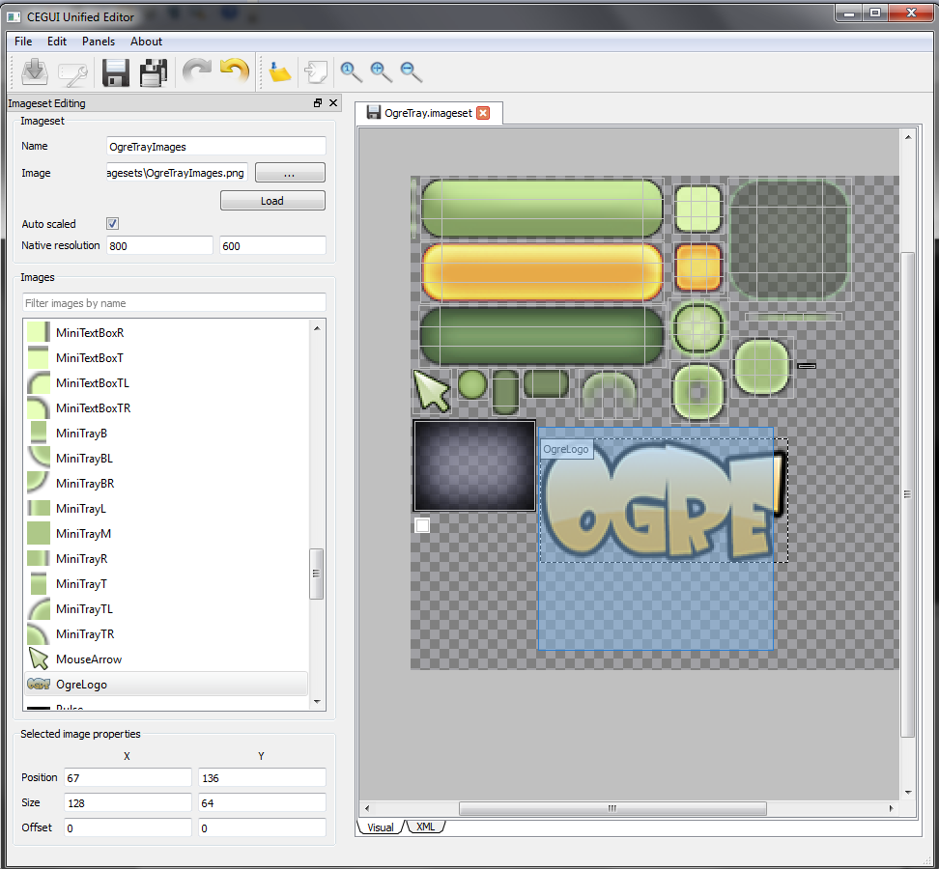
When selected, you can move the images by dragging (including multiple selection) or using keyboard (WSAD scheme moves the images one pixel in each of the directions, pressing CTRL moves them 10 pixels in each of the directions). You can also resize the images by pressing SHIFT and one of the WSAD keys, this moves just the bottom right 'vertex' of the image rectangle.
You can delete a selection of images by selecting and pressing DELETE (this is of course undoable).
Resizing with a mouse and creating new images is yet to be specified

Layout editing
The word layout has 2 meanings in the CEGUI world so I will first disambiguate it. The first meaning is a hierarchy of widgets (the layout describes the way widgets are laid out). The other meaning is a widget able to lay out its child widgets during runtime (more precisely called Layout Container). I will use the word 'layout' with the first meaning in the rest of this document unless stated otherwise.
Each layout starts with the root widget (and can only have exactly one root widget, if you need more root widgets, just put them into DefaultWidget and use the DefaultWidget as the root widget). When loading the layout you always get this root widget back.
Widgets always have a name that must be unique in the context of it's parent.
When I say widget 'Parent/Child/SubChild' I mean a widget that is a child of the 'Child' widget and 'Child' widget is a child of 'Parent' widget. I will call this notation the 'widget path'.
This tabbed editor will use PyCEGUI a lot to avoid reinventing widget rendering. The whole central part will be rendered by CEGUI into a QGLWidget (encapsulating OpenGL inside Qt).

The Output
.layout files usually look like this:
<GUILayout>
<Window Name="root" Type="DefaultWindow">
… properties
</Window>
</GUILayout>
The exact specification - http://www.cegui.org.uk/docs/current/xml_layout.html

Custom widgets
The editor loads all schemes in the project so standard widgets get registered if you have them in your scheme.
The scheme will be able to load a custom widget set module. The custom widget set module is able to add widget factories so you can even add custom made widgets and have the editor edit them.
(Subject to change in 0.8!)

Feature highlights
- Save, load a layout file
- Add a new widget
- Delete widget (option to delete all children too or attach them to widget's parent)
- Hierarchy view and organisation including ability to move widgets in the tree
- Select a widget
- View and modify properties of the currently selected widget
- Multiple widget selection and mass property modification (optional)
- Move selected widget
- Rotate selected widget
- Import layout into layout
- Export a subtree of the layout
- Rename a widget in the layout (including a refactor option to rename all child widgets)
- Export layout to C++ (optional, could be used as a last step optimisation)
- XML editing mode

Animation editing
Animations are composed of Affectors and can work on any PropertySet based class (Widget, MouseCursor, …). Each Affector affects exactly one property. Affector has keyframes where each keyframe has value and a progression (if the 'time' should accelerate towards it, decelerate or be linear).

The output
Animations can be defined via multiple ways, there is a animation XML file format that can define 1 or more animations. - Exact XML specification: http://www.cegui.org.uk/docs/current/xml_animation.html
Animations can also be defined in a .looknfeel file (the syntax is exactly the same)

Feature highlights
- Create new animation within the animation xml
- Delete existing animation frmo the animation xml
- Choose preview widget based on predefined options, or choose completely custom preview widget
- Enable/Disable auto keyframe creation
- Change duration of the animation
- Add Affector (one affector interpolates one property only)
- Destroy Affector
- Move current timeline position (timeline is shared between affectors, keyframes are on different lines)
- Create a new keyframe on current timeline position
- Destroy existing keyframe
- Change progression of every keyframe (linear, quadratic, …)

Scheme editing
Scheme is a file that ties everything together. It is in scheme where you choose what to load and how to map widgets to their renderers and looknfeels.
This editor will basically allow you to add, remove and reorder steps in the scheme loading.

The output
The exact XML specification - http://www.cegui.org.uk/docs/current/xml_scheme.html

Feature highlights
- View widget mappings
- Add a widget mapping
- Remove a widget mapping
- Instantiate and preview each individual mapped widget
- Add Imageset and Font files (integration with the project management, allows you to select existing Imageset file from the project)
- Remove existing Imageset/Font files (optionally delete files from disk)

