**Overview:**  
  
 The following visualization is based on a set of e-sports earnings data from 1998-2020. This data can be found at <https://www.kaggle.com/datasets/jackdaoud/esports-earnings-for-players-teams-by-game>. Overall the goal of this visualization is to show which countries have made the most money from the most popular e-sports games. In order to distill this data down into a concise visualization the data required some preprocessing, aggregation, and ranking. Some of these tasks were done up front, while other were borne from the iterative process of review and evaluation. Note that all outputs are available from the links at the end of this document.

**Quick Low-Fi Prototypes:**

After initial massaging of the data to serve the high level goal of showing earnings by Country and Game, I started applying visualization types to find which made the most sense for what I wanted to show. These can be seen below:

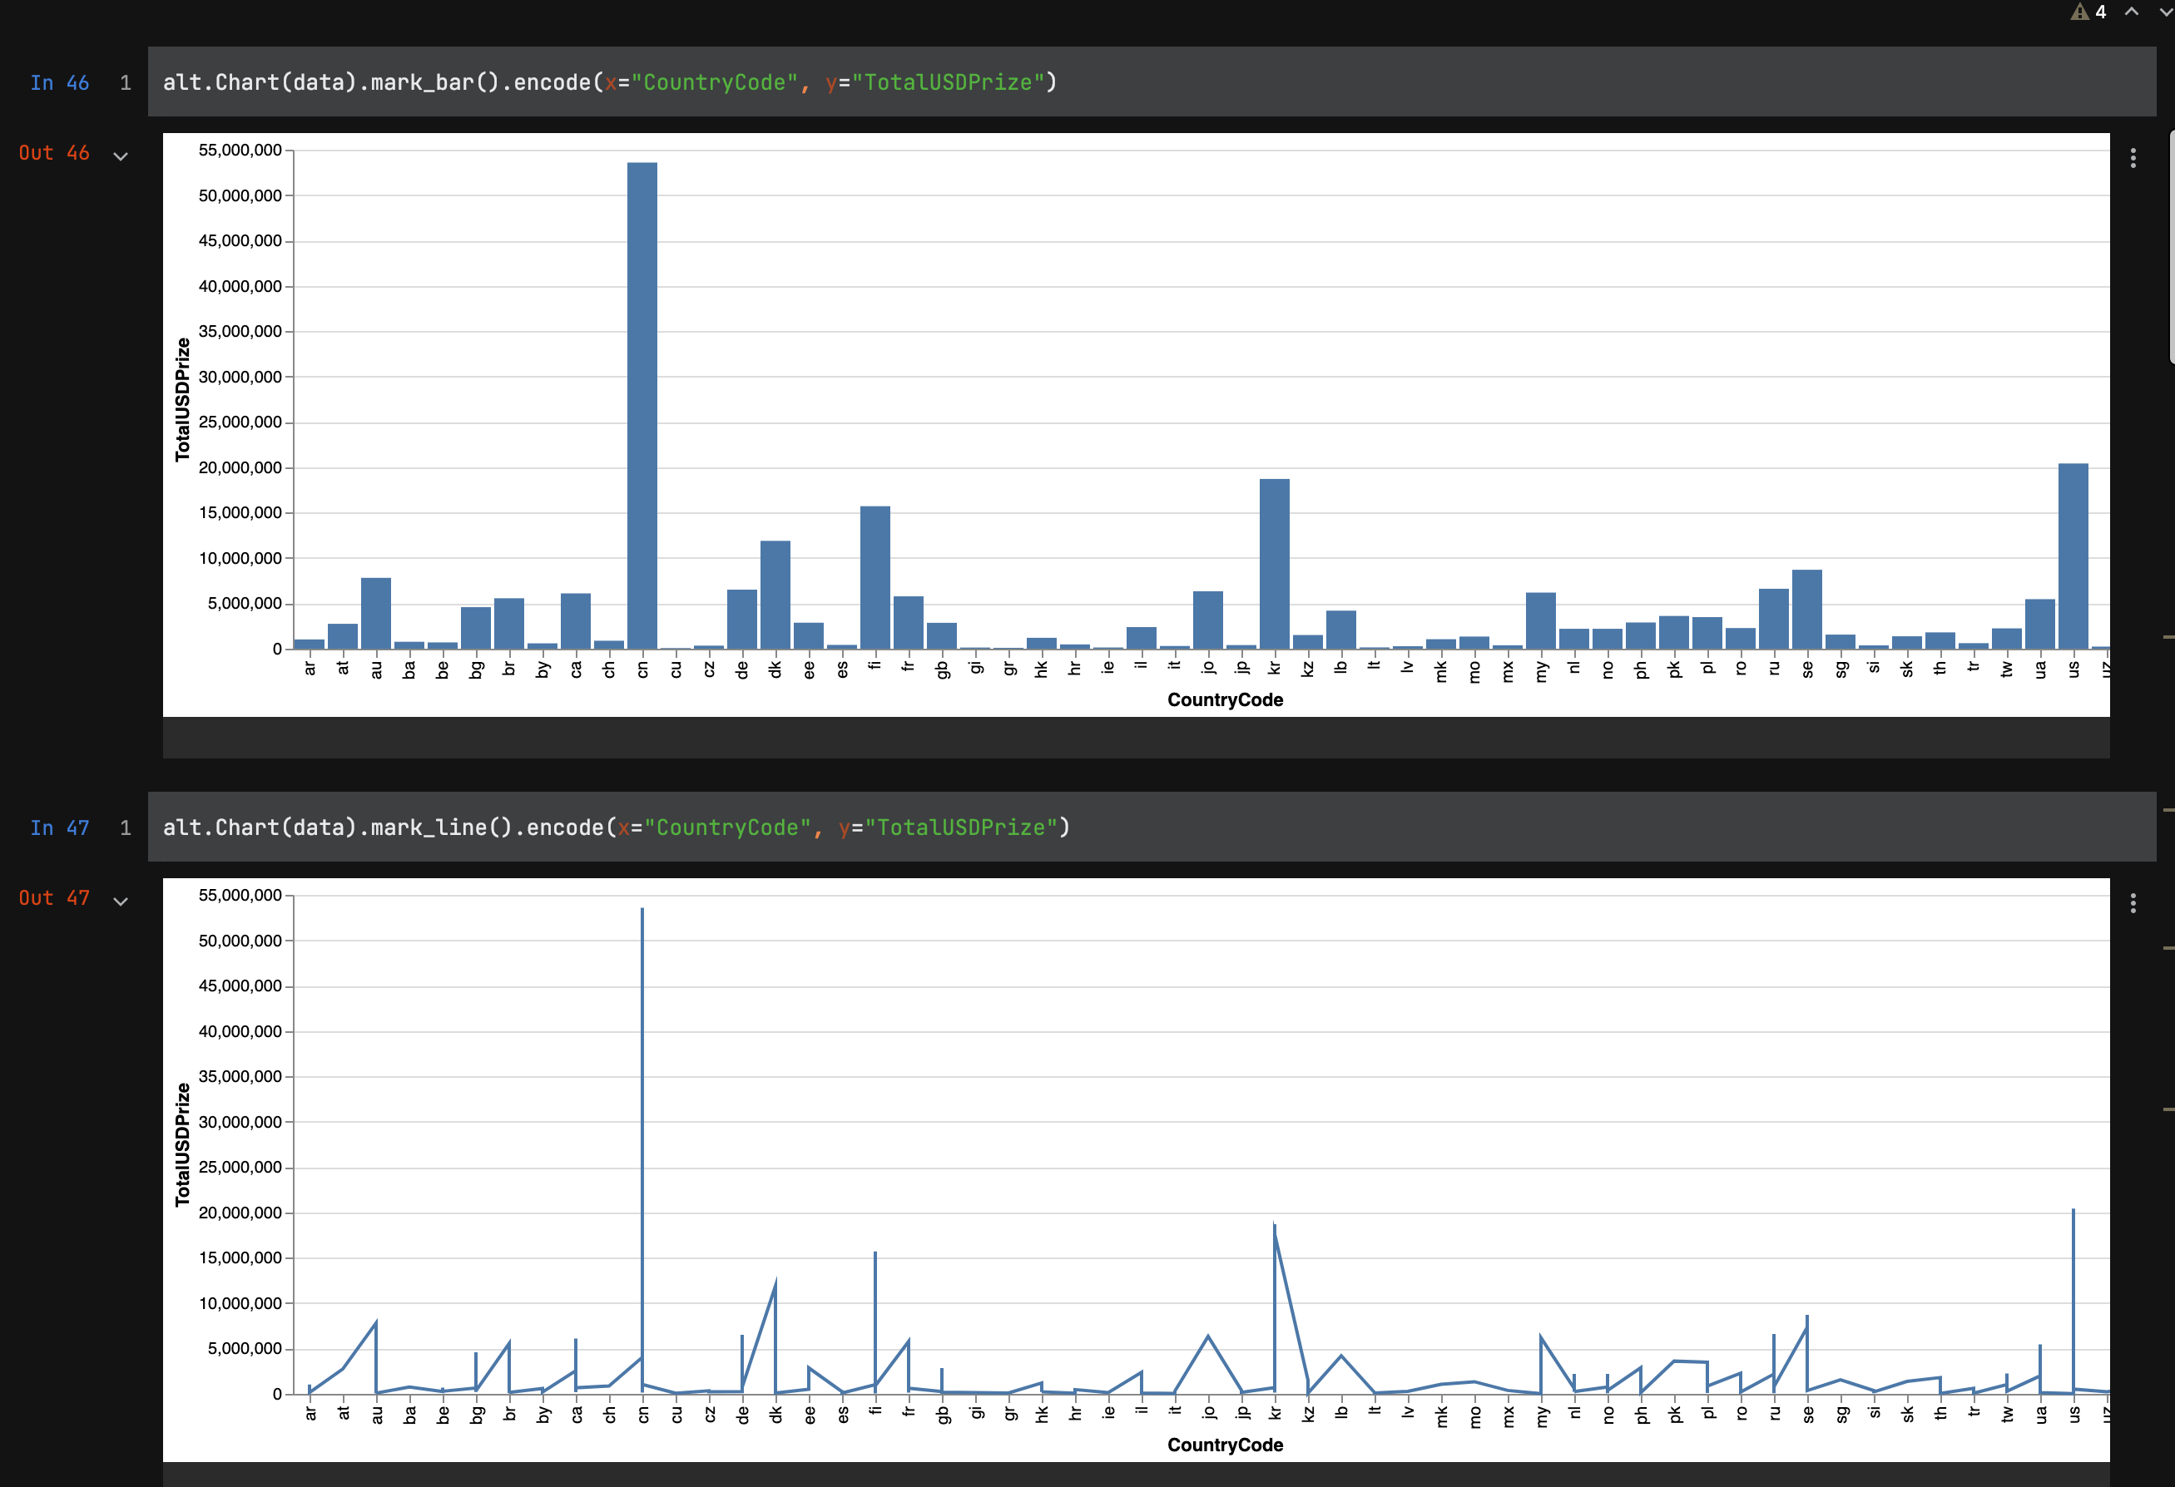

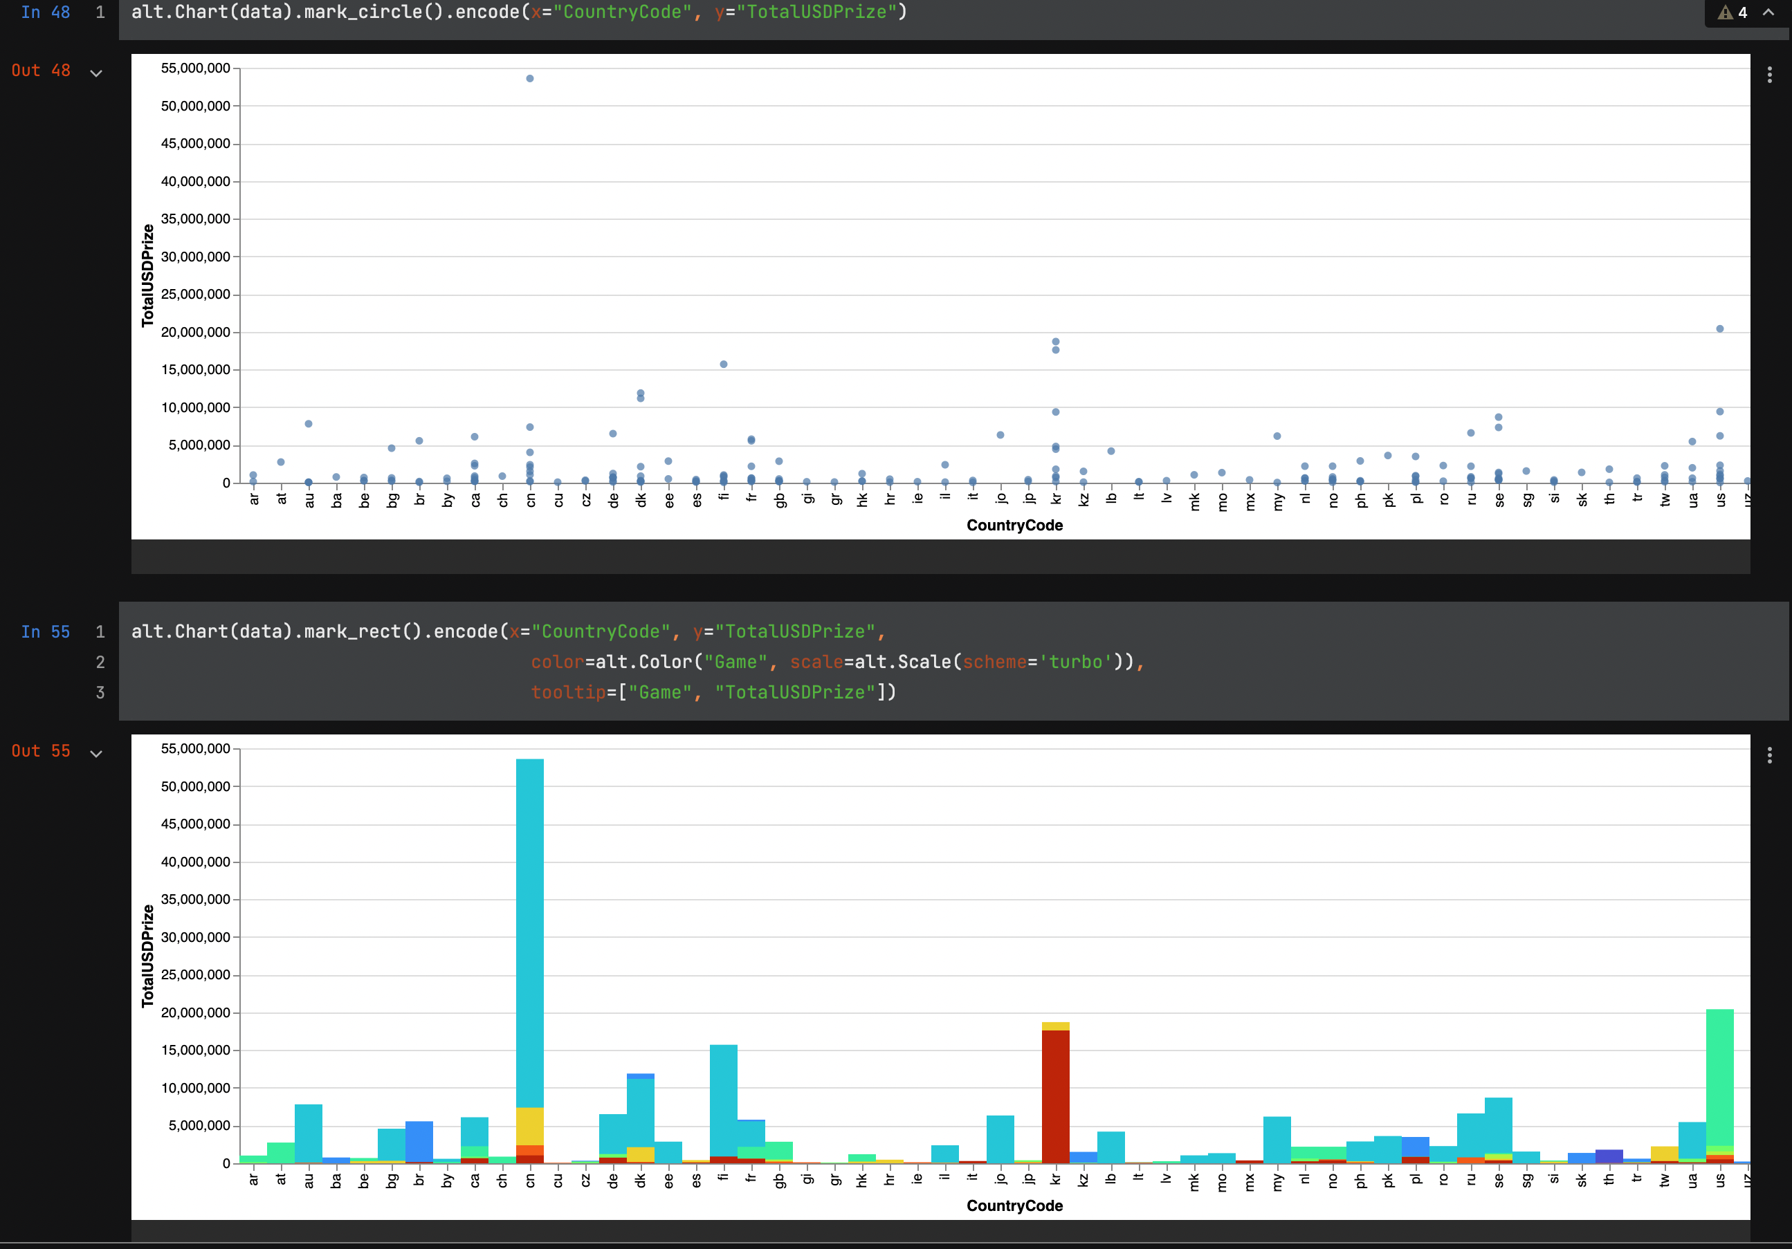

From these four prototypes, I decided that the circle made the most sense. Bar graphs seemed too plain, line graph was nonsensical, and the data didn’t seem to fit the attempted heat map, looking more like a rainbow colored bar graph. Once this was determined I put together the first iteration.

**Iterative Evaluation:**

The first iteration that was presented for evaluation is represented by the HTML file “review_iteration_1.html”. I asked a family member to view the visualization and give feedback after providing minimal context to what the data was about. Thankfully they were able to figure out what I was trying to represent, but they stated that there was too much noise. A large portion of the countries included in the file had very little earnings compared to others. With this information I moved onto the second iteration.

For this next iteration I reduced the dataset too only the Top 20 countries. I originally tried Top 10, but the visualization seemed a little to small. This iteration is represented by “review_iteration_2.html”. After implementing this change, I asked one of my coworkers to take a look at the visualization. His reaction was much more positive, liking that the top earning countries and games were represented, but there was some constructive feedback as well. He expressed that it would be cool to see only the games that he cared about, or at least have them easier to find on the graph. With this knowledge I moved on to the final iteration.  
  
 This last iteration implemented an interactive legend to highlight the selected game. This was done by making the selection more salient by increasing transparency of the non-selected values. This can be seen by opening “review_iteration_final.html”. After making this change I had both previous reviewers take a final look at this iteration along with the previous two. Both agreed that this was the best iteration so far. Thus I selected it as the final.

**Findings and Thoughts:**

Overall I feel the iterative process was instrumental in making sense of this data set at glance. While even the prototypes were able to point out that China made the most money from e-sports, the more advanced visualizations point out that the game that made them the money was Dota 2, and you could compare money made by game in each country. Looking back on the process one thing I would have like to have done differently is try to move this information to a map visualization. Being geographic in nature this I feel this data could look really good on an interactive map. Also replacing the legend images with game icon could be a nice touch.

**Source Code and Images:**

Notebook:  
https://github.com/timber-apparition/msds-projects/blob/279520ef8a28544d9deb26d121ec268165fa4886/dtsa-5304/fund_vis_proj.ipynb

Lo-Fi Images:

https://github.com/timber-apparition/msds-projects/blob/279520ef8a28544d9deb26d121ec268165fa4886/dtsa-5304/lo-fi_iteration_1.png

https://github.com/timber-apparition/msds-projects/blob/279520ef8a28544d9deb26d121ec268165fa4886/dtsa-5304/lo-fi_iteration_2.png

Iterations:

https://github.com/timber-apparition/msds-projects/blob/279520ef8a28544d9deb26d121ec268165fa4886/dtsa-5304/review_iteration_1.html

https://github.com/timber-apparition/msds-projects/blob/279520ef8a28544d9deb26d121ec268165fa4886/dtsa-5304/review_iteration_2.html

https://github.com/timber-apparition/msds-projects/blob/279520ef8a28544d9deb26d121ec268165fa4886/dtsa-5304/review_iteration_final.html