**Project #2 for MSDS 6372-4023**

**Repeated Measures Analysis on Interferons**

**Submitted by:**

Ed Johnson

Kevin Okiah

Timothy McWilliams

**{edgarj, kokiah, tmcwilliams}@smu.edu**

**July 13, 2017**

**Contents**

Problem Description 1

Dataset 1

Concerns and Limitations 2

Exploratory Data Analysis 3

Testing Repeated Measures Assumptions 4

Analysis Procedure and Interpretation of Results 7

Conclusion 8

Reference 8

Appendix 9

## **Problem Description**

Common side effects of interferons (that may occur with all interferons) include flu-like symptoms following each injection such as: chills, fever, headache, muscle aches, and other pains. These side effects vary from mild to severe and occur in up to half of all patients. The symptoms tend to diminish with repeated injections. Interferons are a family of naturally-occurring proteins that are made and secreted by cells of the immune system (for example, white blood cells, natural killer cells, fibroblasts, and epithelial cells). Three classes of interferons have been identified: alpha, beta, and gamma. [1]

Commercially available interferons come from the human body and manufactured using recombinant DNA technology. Interferons modulate the response of the immune system to viruses, bacteria, cancer, and other foreign substances that invade the body. Interferons do not directly kill viral or cancerous cells; they boost the immune system response and reduce the growth of cancer cells by regulating the action of several genes that control the secretion of numerous cellular proteins that affect growth. [2]

This paper analyses 1 gene expression variable (IFITM3) from about 40,000 genes that a researcher has asked us to analyze.  The study consisted of about 17 to 20 healthy adults. Observations were recorded at a baseline value for all subjects (hour 0), then all the subjects were given the flu virus.  Then more observations were taken at additional time points hour 5, hour 12, etc.  At the end of the study, each subject was identified as being symptomatic (showing symptoms) versus asymptomatic (not showing symptoms).  So, we have two key variables time-point and symptomatic/asymptomatic groups. The researcher would like to know the following questions:

1. Are there any differences between symptomatic and asymptomatic groups?
2. Does it depend on what time point you look at?
3. Within each of the two groups, are there any changes over time compared to the baseline?
4. Does age/gender have any role in how the data behaves over time?

The following sections will: describe the dataset; address issues and concerns with the dataset; and then discuss our approach and methods to analyze the data with respect to these questions of interest; and conclude with a statement regarding our findings.

## **Dataset**

The researchers repeatedly measured the IFITM3 levels of 17 subjects, Male and Female; with and without flu-like symptoms 15 times over a 108-hour period. This report analyzes IFITM3 Gene expression data provided to us courtesy of Dr. Turner. Interferon-induced transmembrane protein 3 (IFITM3) is a protein that in humans is encoded by the IFITM3 gene. IFITM3 plays a critical role in the immune system's defense against Swine Flu, where heightened levels of IFITM3 keep viral levels low, and the removal of IFITM3 allows the virus to multiply unchecked [3]. The data used in this study was collected from 17 healthy adults whose IFITM3 gene levels were measured at time 0 (used as the control test) before the Interferon was administered and repeated measures of their level of IFITM3 gene carried out at different hours following interferon treatment. Individuals were characterized as either being Symptomatic “Symp” or Asymptomatic “Asymp”. Other than Symptomatic classification of an individual listed under “characteristics_ch1.3” column, this dataset has the following key attributes:

|  |  |
| --- | --- |
| Feature Name | Description of feature |
| Subject | identifies an individual |
| Hours | the number of hours from the initial measurement of IFTIM3 |
| Gender | classifies a subject as either male or female |
| Age | the age of a Subject |
| SYM or characteristics_ch1.3 | identifies whether or not the subject had flu-like symptoms. |
| IFITM3 | the measure of IFITM3 gene present after several hours:  6 hours from initial, then  again after: 7, 8 and 9 hours repeated four times, and  ending on 7 for a total of 108 hours |

Table 1: Key data attributes for this analysis.

We use these attributes to build up a model for the analysis of variance of the IFITM3 levels across the individual groups symptomatic versus asymptomatic.

## **Concerns and Limitations**

Since this study is an observational study we caution the reader against generalizing the results to the larger population. The IFITM3 measures for the same individual are dependent whereas the measures of different individuals are independent. Even though the individuals are identified as being healthy at time 0, we must worry about “latency effect” where an individual already had a flu virus though benign (not detected at time 0). The effect of administering the interferon on such an individual would be compounded and reflected on subsequent IFITM3 measurement post interferon treatment. Besides, “carry- over effects” could potentially be present as well as the individuals may have taken a flu vaccine recently hence their immune system strengthened before participating in this study. Carry-over and latency effects could positively or negatively influence the mean IFITM3 measurement away from the true mean IFITM3 level.

## **Exploratory Data Analysis**

Figure 1 shows a clear upward trend with respect to the number of hours for the Symptomatic group while the Asymptomatic group exhibits more stable variance. The panel scatter plot displays the IFITM3 levels for each hour the observations were taken by symptoms. The left scatter plot, Asymptomatic, shows IFITM3 levels mainly under 13 for all hours that the observations were taken. The right scatter plot, Symptomatic, shows a positive correlation between IFITM3 levels and the hours the observations were taken. Box plots over time on Figure 2 further contrast the IFITM3 levels over hours for the four-day period subjects were treated with the interferon.

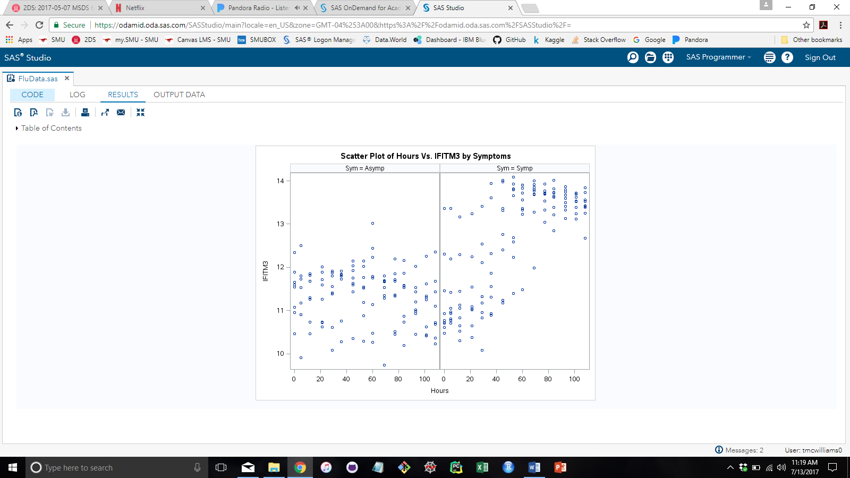

Figure 1

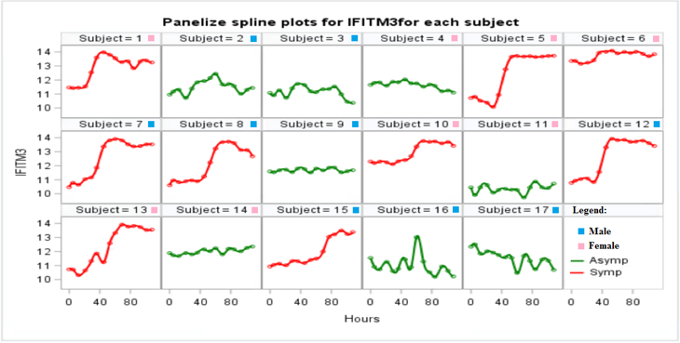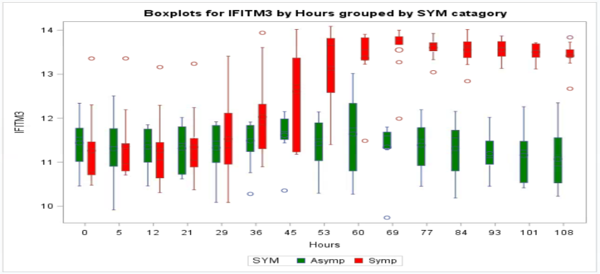

Figure 3

Figure 2

From Figure 3, it is evident that Symptomatic subjects show uniform variance across the time periods apart from subject 6. Subject 6 displayed elevated IFITM3 levels from time 0 indicating potential exposure to the flu virus pre-study. Sometime after hour 40 marks a key turning point on when the effects of the flu virus begins. Symptomatic subjects experience elevated levels in the IFITM3 measures at this time.

We also note that apart from subject 16, asymptomatic subjects show constant variance as a group across the time periods. Subject 16 is interesting in the sense that sometime after hour 40, there is a spike in IFITM3 levels signaling potential for flu-like symptoms, but those levels rapidly decrease. If this subject had been exposed to flu vaccine before the study, we could claim their immune system fought off the effects of the flu from interferon treatment, thus the decrease in IFITM3 after treatment.

Table 2 below charts summary statistics for IFITM3 levels with respect to Hours. It is interesting to note that the Symptomatic group is not linearly separable from the Asymptomatic group as we saw in the lower left quadrant of Figure 1. We will investigate the IFITM3 levels with respect to Hours in more detail later. For now, we simply want to draw a distinction between the mean levels of IFITM3 versus Hours; and highlight hours 29 through 45 as being a critical period of interest for the SYMP group.



## Table 2: Summary statistics for IFITM3 levels by Hours

## 

## **Repeated Measures: Assumptions and Analysis**

The repeated measures techniques that we use on this dataset require that the residuals form a random cloud about the x-axis for assuming normality. Additionally, we check to see if our data has a constant variance. We do this by testing for symmetry in the data. The following residual plots of the IFITM3 levels tells us how well the data conforms to the normality conditions and the constant variance assumptions.

Figure 4

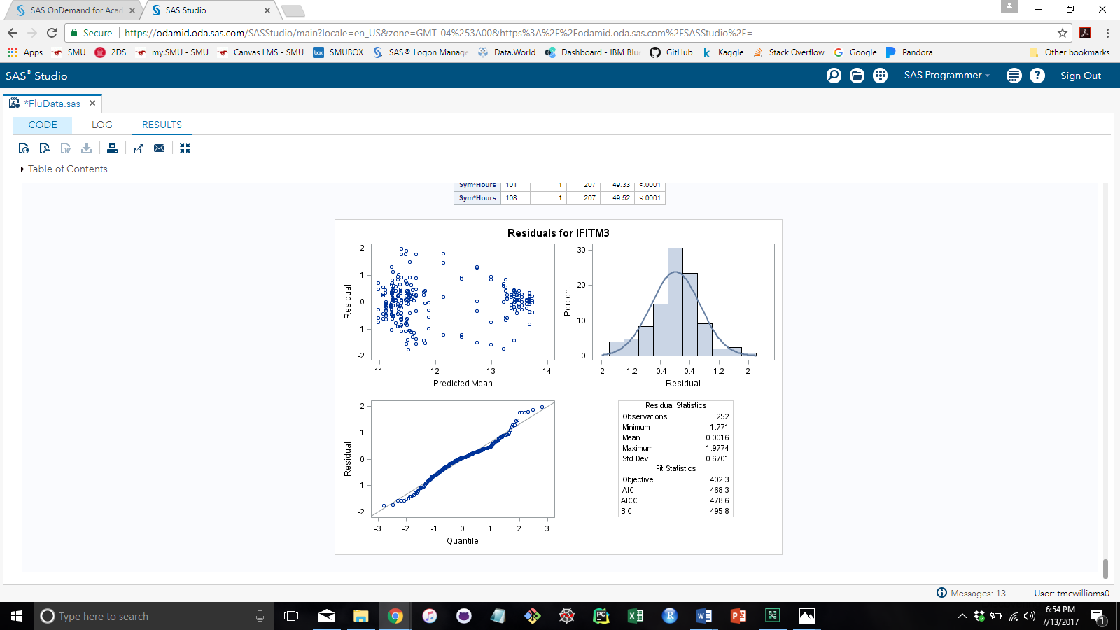

Figure 4

Figure 4 displays the assumptions for the repeated measures analysis. The top left scatter plot assesses the constant variance assumption. There are a few areas of clustering, however overall this plot shows that there is no evidence that the constant variance assumption is not met. The histogram and Q-Q plot assesses the normality assumption. Both the plots show no evidence that the normality assumption is not met. Therefore, we can proceed with the analysis.

Table 3 shows for each gender a big distance between a female whom is asymptomatic and a male whom is asymptomatic, which we generated using a discriminate procedure in SAS. We also notice varying distance among the symptomatic female and male with respect to their ages, shown in Table 4. These large distances suggest that there may exist a more detailed model to describe the effects of gender and age on IFITM3 levels.

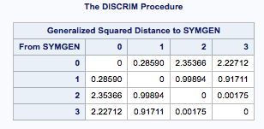

Table 3

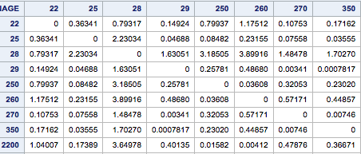

Table 4

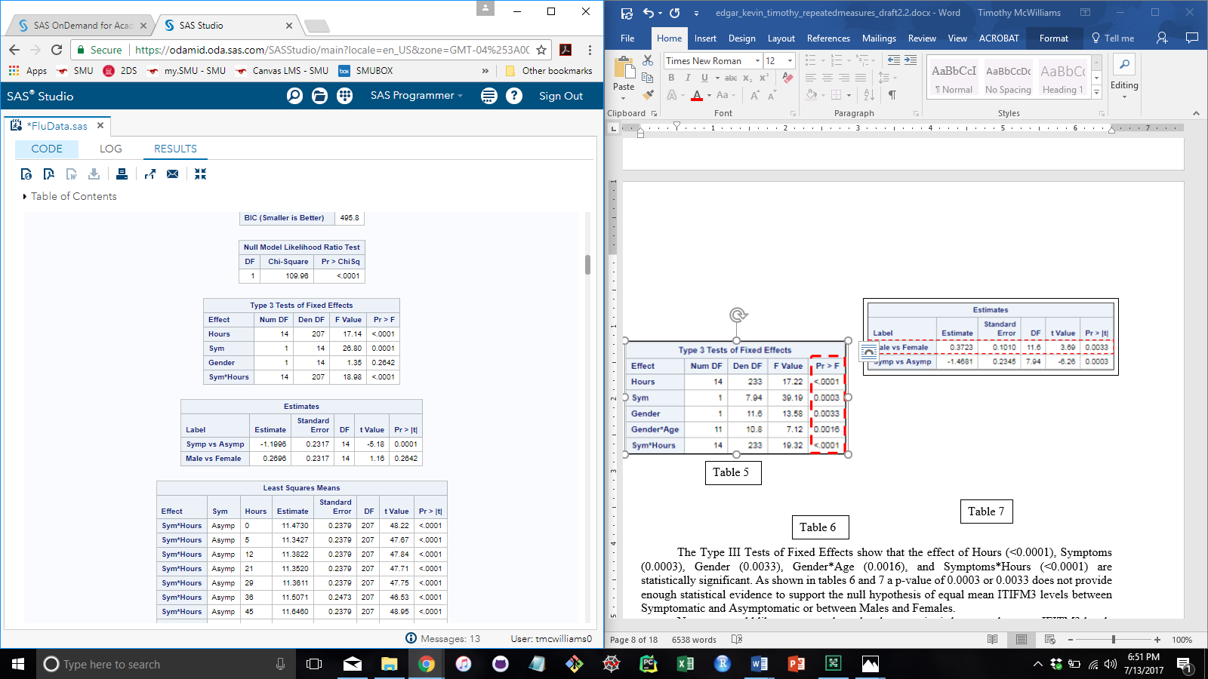

Figure 5

The Type III Tests of Fixed Effects show that the effect of Hours (<0.0001), Symptoms (0.0001), Gender (0.2642), and Symptoms*Hours (<0.0001) are statistically significant. As shown in the Estimates table in figure 5 a p-value of 0.0001 or 0.2642 does not provide enough statistical evidence to support the null hypothesis of equal mean ITIFM3 levels between Symptomatic and Asymptomatic or between Males and Females.

Next, we would like to assess where the change point is between the mean IFITM3 levels for symptomatic and the mean IFITM3 levels for asymptomatic subjects at the different hour intervals in which the measurements were taken. To do this we have to assess the means for symptomatic and asymptomatic subjects for the 0hour and compare that to the means of symptomatic and asymptomatic subjects for all other hours.

This requires a separate model from the one used previously in this report. Since this is a separate model the assumptions need to be addressed before we continue. Figure 6 displays the residuals which show no evidence against normality nor constant variance. The Type III Tests of Fixed Effects, Table 8, show that the effect of Hours (<0.0001), Sym (0.0002), and Sym*Hours (<0.0001) are statistically significant.

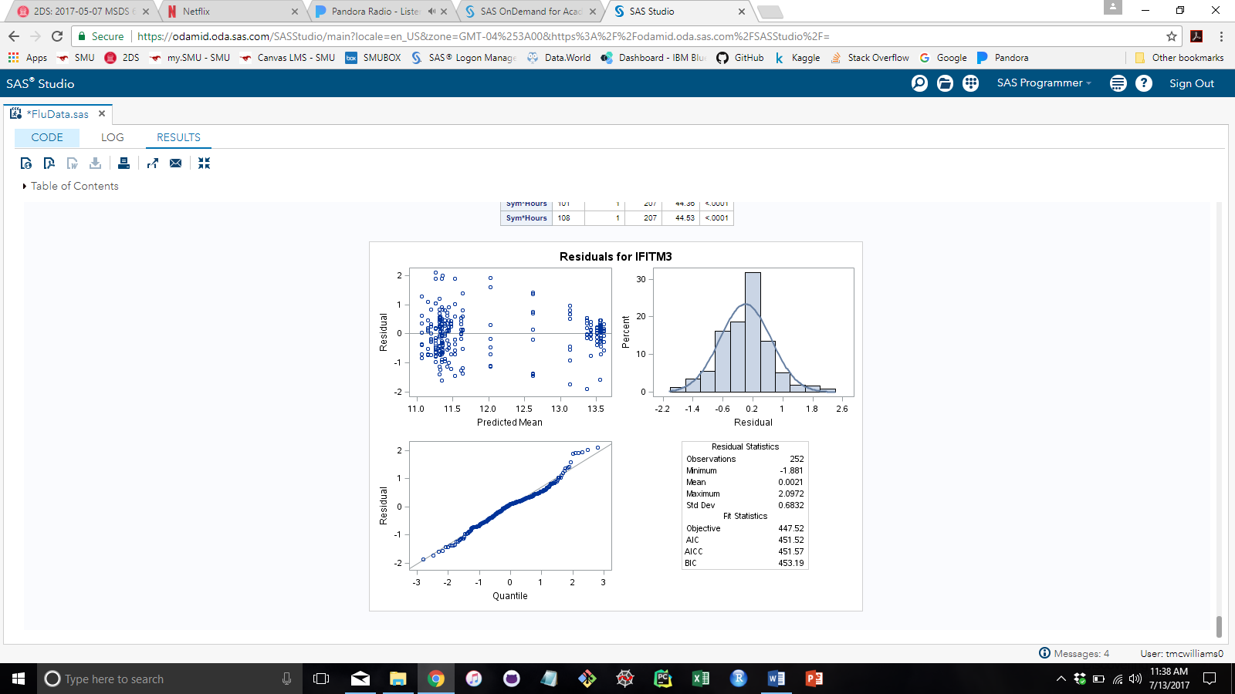

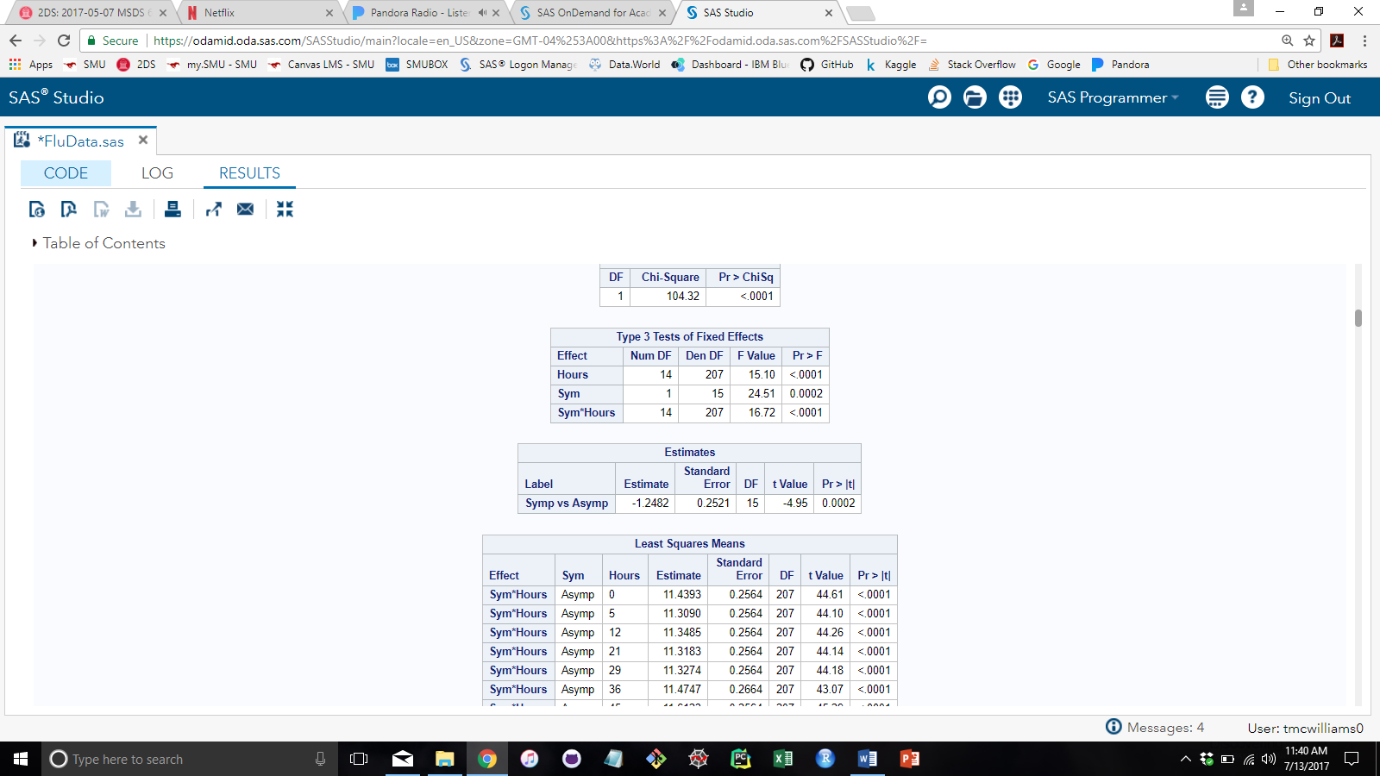

Table 8

Figure 6

Table 9 displays the Tests of Effect Slices. This table specifies effects by which to partition interaction LSMEANS effects. This can produce what are known as tests of simple effects. For example, suppose that the interaction A*B is significant, and you want to test the effect of A for each level of B. This is what we are doing here. The interaction term Sym*Hours is significant, and we want to test the effect of Symptoms for each level of Hours.

At this point, hour 36, the adjusted p-values show evidence of not being statistically significant (p-value < 0.05). This tells us that for the mean IFITM3 levels up to and including hour 36 are the same. Then suddenly at hour 45 and beyond the mean IFITM3 levels are not the same. This change point is highlighted with a red dotted box. Both of the breaking points can be visually assessed by referring to Figure 2.

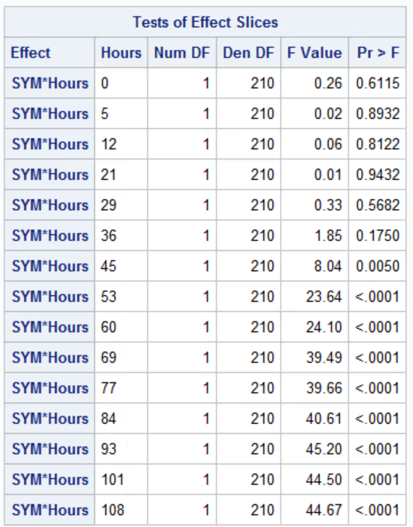

Table 9

## **Analysis Procedure and Interpretation of Results**

From our exploratory data analysis, we explored a few charts, each suggesting a significant shift in the structure of the data over time and/or age. We test for a single change point in the IFITM3 levels with respect to Hours using a mixed procedure in SAS. Tests of Effect Slices, output Table 7, complements our mean gradient table from the summary statistics of the SAS univariate procedure, output Table 2. We note a statistically significant break point at the 36th hour for the symptomatic group compared to the asymptomatic group.

We see from the side-by-side scatterplot of Figure 1 that the asymptomatic group keeps a constant variance, while the symptomatic group ventures away from the IFITM3 level of the control time, hour zero. We setup a mixed procedure comparing the mean IFITM3 levels between two sets of times: from the control time to each of the other times; and the times after the other time to the last time at 108 Hours. We look at the p-value of each until we notice a significant difference in the means of the two-time periods. The first significant departure signals the change point of interest at hour 36, Table 7. This tells us that the symptomatic subjects have the same mean IFITM3 levels as the asymptomatic subjects up to and including hour 36. After hour 36 the mean IFITM3 levels for symptomatic subjects increased, but the mean IFITM3 levels for asymptomatic subjects stayed constant throughout the test period. The method allows us to detect the change points within symptomatic groups not seen in the asymptomatic groups (especially useful for subject 16).

Using an auto regressive procedure would weigh the IFITM3 levels less and less the further back in time the data goes from the current time point. This does not necessarily address our problem subject, 16. SAS also provides a MCMC procedure, which takes a number of parameters to get correct, but looks promising to provide a more accurate estimate of change points. For now, we have left the exact change point as future work; and simply provide an estimated change point about the 36th hour. The change point for the female group may differ from the male group as the SAS discriminate procedure suggests. The change point may also differ based on age.

## **Conclusion**

In conclusion, in this research, we were tasked with addressing if there exists a difference between symptomatic and asymptomatic groups; ascertain if the difference depends on what time point you look at; check within each of the two groups, if any changes over time compared to the baseline and gauge, if age and/or gender have any role in how the data behaves over time. We found that after 36 hours Subjects started displaying an increase in IFITM3 levels, which would manifest in the form of flu-like symptoms for half of the patients. Only one Subject showed an unusual spike in the IFITM3 levels, which did not persist long enough to characterize as flu-like. Statistically significant results (p=0.0033, p=0.0003) from the repeated measures Type III Tests of Fixed Effects analysis indicates there is a difference in the means between symptomatic and asymptomatic groups and male and female respectively. We also honed in on a change point estimate about hour 36 for the symptomatic group; and did not find any statistical difference in the asymptomatic group. We recommend looking further into the symptomatic group to see if the change points differ with respect to age and or gender. The SAS code provides an encoded feature for these additional levels of interest.

## **References**

1. <http://www.medicinenet.com/interferon/page2.htm>
2. <http://www.medicinenet.com/interferon/article.htm>
3. IFITM3 - <https://en.wikipedia.org/wiki/IFITM3>
4. Analysis of repeated measurement data in the clinical trials by Vineeta Singh, Rakesh Kumar Rana, and Richa Singhal : <https://www.ncbi.nlm.nih.gov/pmc/articles/PMC3737450/>

## **Appendix**

**SAS CODE:**

**data fluVirus;**

**Input Columnname $ Subject Hours Gender $ Age SYM $ IFITM3;**

**datalines;**

**;**

**run;**

**proc sort data=fluvirus out=fluAgeSort;**

**by Age Subject Hours;**

**run;**

**data fluCenter;**

**set fluAgeSort;**

**keep Subject Hours Gender Sex GS SYMGENAGE Age _Z CAR_Z SYMGEN SYM SYM2 SymColor SS IFITM3 I_3 center;**

**Sex = Gender ;**

**SYM2 = SYM ;**

**I_3 = IFITM3 ;**

**if Subject not = (Subject-1) then center=IFITM3;**

**if Subject=Subject+1 then center=center+IFITM3;**

**if Subject<Subject+1 then center=center/15;**

**if SYM="Asymp" then SymColor="BLUE";**

**if SYM="Symp" then SymColor="RED";**

**if SYM="Asymp" then SS=14;**

**if SYM="Symp" then SS=7;**

**if Gender="Female" then GS=14;**

**if Gender="Male" then GS=7;**

**if SYM="Symp" and Gender="Female" then _Z=4;**

**if SYM="Symp" and Gender="Male" then _Z=6;**

**if SYM="Asymp" and Gender="Female" then _Z=10;**

**if SYM="Asymp" and Gender="Male" then _Z=14;**

**if SYM="Symp" and Gender="Female" then CAR_Z="*";**

**if SYM="Symp" and Gender="Male" then CAR_Z="<";**

**if SYM="Asymp" and Gender="Female" then CAR_Z="+";**

**if SYM="Asymp" and Gender="Male" then CAR_Z="^";**

**if SYM="Symp" and Gender="Female" then SYMGEN=0;**

**if SYM="Symp" and Gender="Male" then SYMGEN=1;**

**if SYM="Asymp" and Gender="Female" then SYMGEN=2;**

**if SYM="Asymp" and Gender="Male" then SYMGEN=3;**

**if SYM="Symp" and Gender="Female" then SYMGENAGE=1*Age;**

**if SYM="Symp" and Gender="Male" then SYMGENAGE=10*Age;**

**if SYM="Asymp" and Gender="Female" then SYMGENAGE=100*Age;**

**if SYM="Asymp" and Gender="Male" then SYMGENAGE=1000*Age;**

**run;**

**/* Columnname Subject Hours Gender Age SYM IFITM3 */**

**/** An attempt to merge data by subject **/**

**data flu_clean;**

**set fluCenter;**

**keep Subject Gender SYM _Z IFITM3**

**G_1 GS_1 A_1 S_1 SS_1 M_1 SZ_1 CAR_1 I3_1 C_1**

**G_2 GS_2 A_2 S_2 SS_2 M_2 SZ_2 CAR_2 I3_2 C_2**

**G_3 GS_3 A_3 S_3 SS_3 M_3 SZ_3 CAR_3 I3_3 C_3**

**G_4 GS_4 A_4 S_4 SS_4 M_4 SZ_4 CAR_4 I3_4 C_4**

**G_5 GS_5 A_5 S_5 SS_5 M_5 SZ_5 CAR_5 I3_5 C_5**

**G_6 GS_6 A_6 S_6 SS_6 M_6 SZ_6 CAR_6 I3_6 C_6**

**G_7 GS_7 A_7 S_7 SS_7 M_7 SZ_7 CAR_7 I3_7 C_7**

**G_8 GS_8 A_8 S_8 SS_8 M_8 SZ_8 CAR_8 I3_8 C_8**

**G_9 GS_9 A_9 S_9 SS_9 M_9 SZ_9 CAR_9 I3_9 C_9**

**G_10 GS_10 A_10 S_10 SS_10 M_10 SZ_10 CAR_10 I3_10 C_10**

**G_11 GS_11 A_11 S_11 SS_11 M_11 SZ_11 CAR_11 I3_11 C_11**

**G_12 GS_12 A_12 S_12 SS_12 M_12 SZ_12 CAR_12 I3_12 C_12**

**G_13 GS_13 A_13 S_13 SS_13 M_13 SZ_13 CAR_13 I3_13 C_13**

**G_14 GS_14 A_14 S_14 SS_14 M_14 SZ_14 CAR_14 I3_14 C_14**

**G_15 GS_15 A_15 S_15 SS_15 M_15 SZ_15 CAR_15 I3_15 C_15**

**G_16 GS_16 A_16 S_16 SS_16 M_16 SZ_16 CAR_16 I3_16 C_16**

**G_17 GS_17 A_17 S_17 SS_17 M_17 SZ_17 CAR_17 I3_17 C_17;**

**merge fluCenter(where=(Subject=1)**

**rename=(Sex=G_1) rename=(GS=GS_1) rename=(Age=A_1) rename=(_Z=SZ_1) rename=(CAR_Z=CAR_1) rename=(SYM2=S_1) rename=(SS=SS_1) rename=(center=M_1) rename=(SymColor=C_1) rename=(I_3=I3_1))**

**fluCenter(where=(Subject=2)**

**rename=(Sex=G_2) rename=(GS=GS_2) rename=(Age=A_2) rename=(_Z=SZ_2) rename=(CAR_Z=CAR_2) rename=(SYM2=S_2) rename=(SS=SS_2) rename=(center=M_2) rename=(SymColor=C_2) rename=(I_3=I3_2))**

**fluCenter(where=(Subject=3)**

**rename=(Sex=G_3) rename=(GS=GS_3) rename=(Age=A_3) rename=(_Z=SZ_3) rename=(CAR_Z=CAR_3) rename=(SYM2=S_3) rename=(SS=SS_3) rename=(center=M_3) rename=(SymColor=C_3) rename=(I_3=I3_3))**

**fluCenter(where=(Subject=4)**

**rename=(Sex=G_4) rename=(GS=GS_4) rename=(Age=A_4) rename=(_Z=SZ_4) rename=(CAR_Z=CAR_4) rename=(SYM2=S_4) rename=(SS=SS_4) rename=(center=M_4) rename=(SymColor=C_4) rename=(I_3=I3_4))**

**fluCenter(where=(Subject=5)**

**rename=(Sex=G_5) rename=(GS=GS_5) rename=(Age=A_5) rename=(_Z=SZ_5) rename=(CAR_Z=CAR_5) rename=(SYM2=S_5) rename=(SS=SS_5) rename=(center=M_5) rename=(SymColor=C_5) rename=(I_3=I3_5))**

**fluCenter(where=(Subject=6)**

**rename=(Sex=G_6) rename=(GS=GS_6) rename=(Age=A_6) rename=(_Z=SZ_6) rename=(CAR_Z=CAR_6) rename=(SYM2=S_6) rename=(SS=SS_6) rename=(center=M_6) rename=(SymColor=C_6) rename=(I_3=I3_6))**

**fluCenter(where=(Subject=7)**

**rename=(Sex=G_7) rename=(GS=GS_7) rename=(Age=A_7) rename=(_Z=SZ_7) rename=(CAR_Z=CAR_7) rename=(SYM2=S_7) rename=(SS=SS_7) rename=(center=M_7) rename=(SymColor=C_7) rename=(I_3=I3_7))**

**fluCenter(where=(Subject=8)**

**rename=(Sex=G_8) rename=(GS=GS_8) rename=(Age=A_8) rename=(_Z=SZ_8) rename=(CAR_Z=CAR_8) rename=(SYM2=S_8) rename=(SS=SS_8) rename=(center=M_8) rename=(SymColor=C_8) rename=(I_3=I3_8))**

**fluCenter(where=(Subject=9)**

**rename=(Sex=G_9) rename=(GS=GS_9) rename=(Age=A_9) rename=(_Z=SZ_9) rename=(CAR_Z=CAR_9) rename=(SYM2=S_9) rename=(SS=SS_9) rename=(center=M_9) rename=(SymColor=C_9) rename=(I_3=I3_9))**

**fluCenter(where=(Subject=10)**

**rename=(Sex=G_10) rename=(GS=GS_10) rename=(Age=A_10) rename=(_Z=SZ_10) rename=(CAR_Z=CAR_10) rename=(SYM2=S_10) rename=(SS=SS_10) rename=(center=M_10) rename=(SymColor=C_10) rename=(I_3=I3_10))**

**fluCenter(where=(Subject=11)**

**rename=(Sex=G_11) rename=(GS=GS_11) rename=(Age=A_11) rename=(_Z=SZ_11) rename=(CAR_Z=CAR_11) rename=(SYM2=S_11) rename=(SS=SS_11) rename=(center=M_11) rename=(SymColor=C_11) rename=(I_3=I3_11))**

**fluCenter(where=(Subject=12)**

**rename=(Sex=G_12) rename=(GS=GS_12) rename=(Age=A_12) rename=(_Z=SZ_12) rename=(CAR_Z=CAR_12) rename=(SYM2=S_12) rename=(SS=SS_12) rename=(center=M_12) rename=(SymColor=C_12) rename=(I_3=I3_12))**

**fluCenter(where=(Subject=13)**

**rename=(Sex=G_13) rename=(GS=GS_13) rename=(Age=A_13) rename=(_Z=SZ_13) rename=(CAR_Z=CAR_13) rename=(SYM2=S_13) rename=(SS=SS_13) rename=(center=M_13) rename=(SymColor=C_13) rename=(I_3=I3_13))**

**fluCenter(where=(Subject=14)**

**rename=(Sex=G_14) rename=(GS=GS_14) rename=(Age=A_14) rename=(_Z=SZ_14) rename=(CAR_Z=CAR_14) rename=(SYM2=S_14) rename=(SS=SS_14) rename=(center=M_14) rename=(SymColor=C_14) rename=(I_3=I3_14))**

**fluCenter(where=(Subject=15)**

**rename=(Sex=G_15) rename=(GS=GS_15) rename=(Age=A_15) rename=(_Z=SZ_15) rename=(CAR_Z=CAR_15) rename=(SYM2=S_15) rename=(SS=SS_15) rename=(center=M_15) rename=(SymColor=C_15) rename=(I_3=I3_15))**

**fluCenter(where=(Subject=16)**

**rename=(Sex=G_16) rename=(GS=GS_16) rename=(Age=A_16) rename=(_Z=SZ_16) rename=(CAR_Z=CAR_16) rename=(SYM2=S_16) rename=(SS=SS_16) rename=(center=M_16) rename=(SymColor=C_16) rename=(I_3=I3_16))**

**fluCenter(where=(Subject=17)**

**rename=(Sex=G_17) rename=(GS=GS_17) rename=(Age=A_17) rename=(_Z=SZ_17) rename=(CAR_Z=CAR_17) rename=(SYM2=S_17) rename=(SS=SS_17) rename=(center=M_17) rename=(SymColor=C_17) rename=(I_3=I3_17));**

**run;**

**proc sgplot Data=flu_clean noautolegend;**

**Title "Flu Virus Age Versus Mean IFTIM3";**

**xaxis label="Age";**

**yaxis label="the rise in IFTIM3 levels after 108 hours";**

**scatter x=A_1 y=M_1/ MARKERCHAR=CAR_1 colormodel=(BLUE RED) markerattrs=(size=14 symbol=CircleFilled);**

**scatter x=A_2 y=M_2/ MARKERCHAR=CAR_2 colormodel=(BLUE RED) markerattrs=(size=14 symbol=CircleFilled);**

**scatter x=A_3 y=M_3/ MARKERCHAR=CAR_3 colormodel=(BLUE RED) markerattrs=(size=14 symbol=CircleFilled);**

**scatter x=A_4 y=M_4/ MARKERCHAR=CAR_4 colormodel=(BLUE RED) markerattrs=(size=14 symbol=CircleFilled);**

**scatter x=A_5 y=M_5/ MARKERCHAR=CAR_5 colormodel=(BLUE RED) markerattrs=(size=14 symbol=CircleFilled);**

**scatter x=A_6 y=M_6/ MARKERCHAR=CAR_6 colormodel=(BLUE RED) markerattrs=(size=14 symbol=CircleFilled);**

**scatter x=A_7 y=M_7/ MARKERCHAR=CAR_7 colormodel=(BLUE RED) markerattrs=(size=14 symbol=CircleFilled);**

**scatter x=A_8 y=M_8/ MARKERCHAR=CAR_8 colormodel=(BLUE RED) markerattrs=(size=14 symbol=CircleFilled);**

**scatter x=A_9 y=M_9/ MARKERCHAR=CAR_9 colormodel=(BLUE RED) markerattrs=(size=14 symbol=CircleFilled);**

**scatter x=A_10 y=M_10/ MARKERCHAR=CAR_10 colormodel=(BLUE RED) markerattrs=(size=14 symbol=CircleFilled);**

**scatter x=A_11 y=M_11/ MARKERCHAR=CAR_11 colormodel=(BLUE RED) markerattrs=(size=14 symbol=CircleFilled);**

**scatter x=A_12 y=M_12/ MARKERCHAR=CAR_12 colormodel=(BLUE RED) markerattrs=(size=14 symbol=CircleFilled);**

**scatter x=A_13 y=M_13/ MARKERCHAR=CAR_13 colormodel=(BLUE RED) markerattrs=(size=14 symbol=CircleFilled);**

**scatter x=A_14 y=M_14/ MARKERCHAR=CAR_14 colormodel=(BLUE RED) markerattrs=(size=14 symbol=CircleFilled);**

**scatter x=A_15 y=M_15/ MARKERCHAR=CAR_15 colormodel=(BLUE RED) markerattrs=(size=14 symbol=CircleFilled);**

**scatter x=A_16 y=M_16/ MARKERCHAR=CAR_16 colormodel=(BLUE RED) markerattrs=(size=14 symbol=CircleFilled);**

**scatter x=A_17 y=M_17/ MARKERCHAR=CAR_17 colormodel=(BLUE RED) markerattrs=(size=14 symbol=CircleFilled);**

**run;**

**proc summary data=fluCenter nway;**

**class Subject SYM Age Gender SYMGEN CAR_Z;**

**var IFITM3;**

**output out=IFITM3Center mean=mean;**

**run;**

**proc mixed data=fluCenter;**

**class SYMGEN Hours Subject;**

**model IFITM3=SYMGEN*Hours;**

**repeated Hours/ type=CS subject=Subject;**

**lsmeans SYMGEN*Hours / slice=Hours pdiff tdiff adjust=Tukey;**

**estimate 'Control Verus The Rest' SYMGEN*Hours 3.25 3.25 3.25 3.25 1 -1 -1 -1 -1 -1 -1 -1 -1 -1 -1 -1 -1 -1 -1 /divisor=14;**

**estimate 'Left of 12 Vs. The Rest' SYMGEN*Hours 2.75 2.75 2.75 2.75 1 1 -1 -1 -1 -1 -1 -1 -1 -1 -1 -1 -1 -1 -1 /divisor=13;**

**estimate 'Left of 21 Vs. The Rest' SYMGEN*Hours 2.25 2.25 2.25 2.25 1 1 1 -1 -1 -1 -1 -1 -1 -1 -1 -1 -1 -1 -1 /divisor=12;**

**estimate 'Left of 29 Vs. The Rest' SYMGEN*Hours 1.75 1.75 1.75 1.75 1 1 1 1 -1 -1 -1 -1 -1 -1 -1 -1 -1 -1 -1 /divisor=11;**

**estimate 'Left of 36 Vs. The Rest' SYMGEN*Hours 1.25 1.25 1.25 1.25 1 1 1 1 1 -1 -1 -1 -1 -1 -1 -1 -1 -1 -1 /divisor=10;**

**estimate 'Left of 45 Vs. The Rest' SYMGEN*Hours 0.75 0.75 0.75 0.75 1 1 1 1 1 1 -1 -1 -1 -1 -1 -1 -1 -1 -1 /divisor=9;**

**estimate 'Left of 53 Vs. The Rest' SYMGEN*Hours 0.25 0.25 0.25 0.25 1 1 1 1 1 1 1 -1 -1 -1 -1 -1 -1 -1 -1 /divisor=8;**

**estimate 'Left of 60 Vs. The Rest' SYMGEN*Hours -.25 -.25 -.25 -.25 1 1 1 1 1 1 1 1 -1 -1 -1 -1 -1 -1 -1 /divisor=8;**

**estimate 'Left of 69 Vs. The Rest' SYMGEN*Hours -.75 -.75 -.75 -.75 1 1 1 1 1 1 1 1 1 -1 -1 -1 -1 -1 -1 /divisor=9;**

**estimate 'Left of 72 Vs. The Rest' SYMGEN*Hours -1.25 -1.25 -1.25 -1.25 1 1 1 1 1 1 1 1 1 1 -1 -1 -1 -1 -1 /divisor=10;**

**estimate 'Left of 84 Vs. The Rest' SYMGEN*Hours -1.75 -1.75 -1.75 -1.75 1 1 1 1 1 1 1 1 1 1 1 -1 -1 -1 -1 /divisor=11;**

**estimate 'Left of 93 Vs. The Rest' SYMGEN*Hours -2.25 -2.25 -2.25 -2.25 1 1 1 1 1 1 1 1 1 1 1 1 -1 -1 -1 /divisor=12;**

**estimate 'Left of 101 Vs. The Rest' SYMGEN*Hours -2.75 -2.75 -2.75 -2.75 1 1 1 1 1 1 1 1 1 1 1 1 1 -1 -1 /divisor=13;**

**estimate 'Left of 108 Vs. 108' SYMGEN*Hours -3.25 -3.25 -3.25 -3.25 1 1 1 1 1 1 1 1 1 1 1 1 1 1 -1 /divisor=14;**

**run;**

**proc cusum data=fluVirus;**

**xchart IFITM3*Hours /**

**mu0 = 11.100 /* Target mean for process */**

**sigma0 = 0.50 /* Known standard deviation */**

**delta = 1 /* Shift to be detected */**

**alpha = 0.10 /* Type I error probability */**

**vaxis = 8 to 205 ; /** http://support.sas.com/documentation/cdl/en/qcug/65562/HTML/default/viewer.htm#qcug_cusum_sect055.htm */**

**label IFITM3 = 'Cumulative Sum';**

**by Subject;**

**run;**

**proc shewhart data=fluVirus;**

**xschart IFITM3*Hours /**

**outtable = fluChart;**

**by Subject;**

**run;**

**proc mcmc data=fluVirus outpost=postout seed=24860 ntu=1000**

**nmc=20000;**

**ods select PostSummaries;**

**ods output PostSummaries=ds;**

**array beta[2];**

**parms alpha cp beta1 beta2;**

**parms s2;**

**prior cp ~ unif(-7, 7);**

**prior s2 ~ uniform(0, 5);**

**prior alpha beta: ~ normal(0, v = 1e6);**

**j = 1 + (hours >= cp);**

**mu = alpha + beta[j] * (hours - cp);**

**model IFITM3 ~ normal(mu, var=s2);**

**run;**

**proc autoreg data = fluVirus;**

**model IFITM3 = hours / chow = (26);**

**run;**

**proc sgplot data=IFITM3Center;**

**reg x=Age y=mean ;**

**run;**

**proc sgplot data=IFITM3Center;**

**reg x=Age y=mean / group=SYMGEN;**

**run;**

**proc sgplot data=IFITM3Center;**

**scatter x=Age y=mean / group=SYMGEN MARKERCHAR=CAR_Z;**

**lineparm x=22 y=12.1 slope=-.04545;**

**run;**

**proc discrim pool=test data=fluCenter;**

**class SYMGEN;**

**var IFITM3;**

**run;**

**proc discrim data=fluCenter;**

**class SYMGENAGE;**

**var IFITM3;**

**run;**

**/*Descriptive Statistics*/**

**PROC SORT DATA=fluVirus;**

**BY SYM;**

**RUN;**

**PROC MEANS DATA=fluVirus Min Mean Median Max Var;**

**by SYM;**

**Class Hours;**

**VAR IFITM3;**

**RUN;**

**/*specify which colors to use*/**

**data Attrs;**

**input id $ value $5. fillcolor $8.;**

**datalines;**

**SYM Asymp green**

**SYM Symp red**

**;**

**run;**

**proc print data=Attrs;**

**run;**

**/*Box Plot*/**

**title 'Boxplots for IFITM3 by Hours grouped by SYM catagory';**

**proc sgplot data=fluVirus DATTRMAP=Attrs;**

**Vbox IFITM3 / category=Hours group=SYM attrid=SYM;**

**run;**

**/*graphics for repeated Measures*/**

**\* Panel Plots IFTME3 over time;**

**title 'Panelize spline plots for IFITM3 for each subject';**

**proc sgpanel data = fluVirus;**

**styleattrs datacontrastcolors=(red green);**

**panelby Subject /columns=6 rows= 3;**

**pbspline y = IFITM3 x = Hours / group=SYM ;**

**run;**

**\*Sphaghetti plot;**

**title 'Spline plot by subject';**

**proc sgplot data = fluVirus;**

**pbspline y = IFITM3 x = Hours**

**/ group = Subject nomarkers LINEATTRS = (THICKNESS = 1);**

**run;**

**\*panel regression plots by Gender;**

**title 'IFITM3 vs Hours Regression plots by gender and SYM';**

**proc sgpanel data = fluVirus noautolegend;**

**panelby Gender SYM;**

**reg y = IFITM3 x = Hours**

**/ group = Subject nomarkers LINEATTRS = (pattern =1 Color = blue THICKNESS = 1);**

**\*add avg line;**

**reg y = IFITM3 x = Hours**

**/ group = SYM nomarkers LINEATTRS = (pattern =1 Color = red THICKNESS = 3);**

**run;**

**\*Panel regression Plots by SYM;**

**title 'IFITM3 vs Hours Regression plots by SYM';**

**proc sgpanel data = fluVirus noautolegend;**

**panelby SYM;**

**reg y = IFITM3 x = Hours**

**/ group = Subject nomarkers LINEATTRS = (pattern =1 Color = blue THICKNESS = 1);**

**\*add avg line;**

**reg y = IFITM3 x = Hours**

**/ group = SYM nomarkers LINEATTRS = (pattern =1 Color = red THICKNESS = 3);**

**run;**

**TITLE "Repeated Measures Model";**

**proc mixed data=fluVirus plots=residualpanel;**

**class SYM Subject Gender AGE Hours IFITM3;**

**model IFITM3=Hours SYM SYM*Hours;**

**repeated Hours/ type=CS subject=Subject;**

**estimate 'Symp vs Asymp' SYM 1 -1;**

**lsmeans SYM*Hours/slice=Hours adjust=Tukey;**

**run; quit;**

**proc mixed data=fluCenter plots=residualpanel;**

**class SYM Subject Gender AGE Hours IFITM3 SYMGENAGE;**

**model IFITM3=Hours SYMGENAGE SYMGENAGE*Hours;**

**repeated Hours/ type=CS subject=Subject;**

**estimate 'SYMGENAGE over HOURS' SYMGENAGE*Hours 1 -1;**

**lsmeans SYMGENAGE*Hours/slice=Hours adjust=Tukey;**

**run; quit;**

**/** (IGNORE, these plots do not add value to our analysis) Additional Scratch plots **/**

**proc sgplot data=IFITM3Center;**

**scatter x=Age y=mean / group=Gender;**

**run;**

**proc sgplot data=IFITM3Center;**

**scatter x=Age y=mean / group=SYM;**

**run;**

**/* Define the graph template */**

**proc template;**

**define statgraph scatterplot;**

**begingraph;**

**entrytitle "Average IFITM3 By Age";**

**layout overlay /**

**xaxisopts=(griddisplay=on gridattrs=(color=lightgray))**

**yaxisopts=(griddisplay=on gridattrs=(color=lightgray)**

**linearopts=(minorgrid=true minortickcount=9**

**minorgridattrs=(color=lightgray pattern=dot)));**

**scatterplot x=Age y=mean /**

**group=SYM groupdisplay=cluster**

**markerattrs=(size=14 symbol=CircleFilled);**

**endlayout;**

**endgraph;**

**end;**

**run;**

**/* Render the graph */**

**proc sgrender data=IFITM3Center template=scatterplot;**

**run;**

**/* Define the graph template */**

**proc template;**

**define statgraph scatterplot;**

**begingraph;**

**entrytitle "Average IFITM3 By Age";**

**layout overlay /**

**xaxisopts=(griddisplay=on gridattrs=(color=lightgray))**

**yaxisopts=(griddisplay=on gridattrs=(color=lightgray)**

**linearopts=(minorgrid=true minortickcount=9**

**minorgridattrs=(color=lightgray pattern=dot)));**

**scatterplot x=Age y=mean /**

**group=Gender groupdisplay=cluster**

**markerattrs=(size=14 symbol=CircleFilled);**

**endlayout;**

**endgraph;**

**end;**

**run;**

**/* Render the graph */**

**proc sgrender data=IFITM3Center template=scatterplot;**

**run;**

**/\***

**PROC GLM DATA=fluVirus PLOT=(DIAGNOSTICS RESIDUALS);**

**CLASS Subject SYM Age Gender Hours;**

**MODEL IFITM3 Hours = SYM;**

**OUTPUT OUT=ERRS R=EACT EANT;**

**MEANS IFITM3 / CLM T ALPHA=0.00833;**

**MEANS IFITM3 / CLDIFF T ALPHA=0.00833;**

**ESTIMATE 'Before CP V. After CP' Hours 1 1 1 1 1 1 -.75 -.75 -.75 -.75 -.75 -.75 -.75 -.75 / divisor=6;**

**MANOVA H=_ALL_ / PRINTE PRINTH CANONICAL;**

**RUN;**

**QUIT;**

**PROC GLM DATA=fluVirus PLOT=(DIAGNOSTICS RESIDUALS);**

**CLASS Subject;**

**MODEL ENGEFF CYCTIME = DRYRTYPE;**

**OUTPUT OUT=ERRS R=EACT EANT;**

**MEANS DRYRTYPE / CLM T ALPHA=0.00833;**

**MEANS DRYRTYPE / CLDIFF T ALPHA=0.00833;**

**ESTIMATE 'Dryer 3 vs. Dryer 1, 2 and 4' DRYRTYPE -1 -1 3 -1 / divisor=3;**

**ESTIMATE 'Dryer 4 vs. Dryer 1, 2 and 3' DRYRTYPE -1 -1 -1 3 / divisor=3;**

**ESTIMATE 'Electric vs. Gas' DRYRTYPE 1 1 -1 -1;**

**MANOVA H=_ALL_ / PRINTE PRINTH CANONICAL;**

**RUN;**

**QUIT;**

**/**This did not provide interpretable estimates *//\***

**proc mixed data=fluCenter;**

**class SYMGEN Hours Subject;**

**model IFITM3=SYMGEN*Hours;**

**repeated Hours/ type=CS subject=Subject;**

**lsmeans SYMGEN*Hours / pdiff tdiff adjust=Tukey;**

**estimate 'Hour 0 Vs. Hour 5' SYMGEN*Hours .2 .2 .2 .2 .2 -1 0 0 0 0 0 0 0 0 0 0 0 0 0;**

**estimate 'Hour 0 Vs. Hour 12' SYMGEN*Hours .2 .2 .2 .2 .2 0 -1 0 0 0 0 0 0 0 0 0 0 0 0;**

**estimate 'Hour 0 Vs. Hour 21' SYMGEN*Hours .2 .2 .2 .2 .2 0 0 -1 0 0 0 0 0 0 0 0 0 0 0;**

**estimate 'Hour 0 Vs. Hour 29' SYMGEN*Hours .2 .2 .2 .2 .2 0 0 0 -1 0 0 0 0 0 0 0 0 0 0;**

**estimate 'Hour 0 Vs. Hour 36' SYMGEN*Hours .2 .2 .2 .2 .2 0 0 0 0 -1 0 0 0 0 0 0 0 0 0;**

**estimate 'Hour 0 Vs. Hour 45' SYMGEN*Hours .2 .2 .2 .2 .2 0 0 0 0 0 -1 0 0 0 0 0 0 0 0;**

**estimate 'Hour 0 Vs. Hour 53' SYMGEN*Hours .2 .2 .2 .2 .2 0 0 0 0 0 0 -1 0 0 0 0 0 0 0;**

**estimate 'Hour 0 Vs. Hour 60' SYMGEN*Hours .2 .2 .2 .2 .2 0 0 0 0 0 0 0 -1 0 0 0 0 0 0;**

**estimate 'Hour 0 Vs. Hour 69' SYMGEN*Hours .2 .2 .2 .2 .2 0 0 0 0 0 0 0 0 -1 0 0 0 0 0;**

**estimate 'Hour 0 Vs. Hour 72' SYMGEN*Hours .2 .2 .2 .2 .2 0 0 0 0 0 0 0 0 0 -1 0 0 0 0;**

**estimate 'Hour 0 Vs. Hour 84' SYMGEN*Hours .2 .2 .2 .2 .2 0 0 0 0 0 0 0 0 0 0 -1 0 0 0;**

**estimate 'Hour 0 Vs. Hour 93' SYMGEN*Hours .2 .2 .2 .2 .2 0 0 0 0 0 0 0 0 0 0 0 -1 0 0;**

**estimate 'Hour 0 Vs. Hour 101' SYMGEN*Hours .2 .2 .2 .2 .2 0 0 0 0 0 0 0 0 0 0 0 0 -1 0;**

**estimate 'Hour 0 Vs. Hour 108' SYMGEN*Hours .2 .2 .2 .2 .2 0 0 0 0 0 0 0 0 0 0 0 0 0 -1;**

**run;**

**\*/**