BLACK PEPPER-CRUSTED STANDING RIB ROAST AU JUS
BLACK PEPPER-CRUSTED STANDING RIB ROAST AU JUS
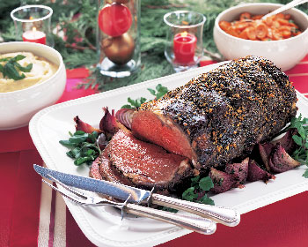
Boning the roast makes slicing the meat much easier at serving time: Have your butcher remove the backbone, or chine, from the whole rack and cut the meat off the ribs in one piece, then tie the meat back onto the bones. The roast can be served on or off the bones. To crack whole peppercorns, enclose them in a resealable plastic bag and crush slightly with a meat mallet. What to drink: A medium- to full-bodied red with peppery spice, such as Syrah (called Shiraz if it's from Australia).
INGREDIENTS:
1. 1-8 1/2-pound standing rib roast (weight with bones), top fat trimmed
2, Vegetable oil
3, 12 tablespoons (1 1/2 sticks) unsalted butter, room temperature
4. 2 tablespoons cracked or coarsely ground black pepper
5. 4 large garlic cloves, minced
6. 1/2 teaspoon salt
7. 2 1/4 cups low-salt beef broth
8. 1/2 cup dry red wine
Roasted Red Onions
9. 1 large bunch watercress

DIRECTIONS:
Place roast, fat side up, in roasting pan. Brush exposed ends of roast with vegetable oil. Sprinkle roast lightly all over with salt. Mix 8 tablespoons butter, 2 tablespoons cracked pepper, minced garlic, and 1/2 teaspoon salt in small bowl. Reserve 2 tablespoons pepper butter for sauce. Spread remaining pepper butter all over top (fat side) of roast. (Can be prepared 1 day ahead. Cover roast and reserved pepper butter separately; chill.)
Position rack in bottom third of oven and preheat to 350°F. Roast rib roast until instant-read thermometer inserted into thickest part of meat registers 125°F for medium-rare, about 2 hours 45 minutes. Transfer roast to platter and cover loosely with foil; let rest 30 minutes (temperature will rise slightly as roast stands).
Strain pan juices from roasting pan into measuring cup. Skim off any fat from top of pan juices; discard fat. Return pan juices to roasting pan; set pan over 2 burners. Add broth and wine to roasting pan and boil over high heat until liquid is reduced to 1 1/4 cups, scraping up any browned bits from bottom of pan, about 6 minutes. Whisk in reserved pepper butter and remaining 4 tablespoons plain butter. Season with more salt and pepper, if desired.
Surround roast with Roasted Red Onions. Garnish with watercress. Slice roast and serve with sauce.
Makes 8 servings.

