GEMELLI WITH SWEET ITALIAN SAUSAGE

by Zabar's Chef Andrew Regnier
Chef Andrew’s Gemelli with Sweet Italian Sausage is a relatively new recipe in the store and it’s flying off the shelves. It’s simple and classic with straightforward flavors that blend perfectly together.
In the amount of time it takes to boil a pot of water and cook the pasta the entire dish will be ready.
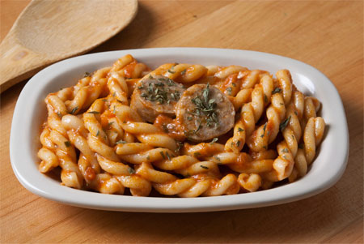
INGREDIENTS:
1. 1 ½ lbs uncooked pasta (Gemelli or fusilli)
2. 32 oz marinara sauce (if you’re using a jar pasta sauce look for a roasted garlic variety)
3. 2 tbsp grated parmesan
4. 2 tbsp fresh basil chopped
5. ½ lb sweet Italian sausage
6. 2 oz Mascarpone Cheese* (You can substitute with cream cheese, but you might need to add some sugar to the sauce, depending on how sweet your marinara sauce is.)
7. 2 tbsp salt
DIRECTIONS:
Slice the sausage and cook it in a frying pan. Set it aside.
To cook the pasta: In a large pot bring 1.5 gallons of water to a rapid boil. Add 2 tbsp salt. Add the pasta and cook following the pasta package directions until al dente. Stir the pasta every 3-4 minutes while cooking. When cooked save a bit of the pasta water to add to the sauce if it needs to be thinned. When you drain the pasta do not rinse it.
While the pasta is cooking, heat your sauce in a sauce pan. Then add cheeses, basil, sliced Italian sausage and cook until warmed and blended. Add the hot cooked pasta. Season with salt & pepper.

