**LibCrawlr Elements: Characters and Badges**

Begins in dark room where you wake up and are gradually fed clues about where you are and what’s happening. You earn information about your situation by completing tasks.

**Characters**

**Olivia**

Is from Jamaica and has red hair. She wears a man’s vintage leather pilot jacket – diesel/steam-punk.

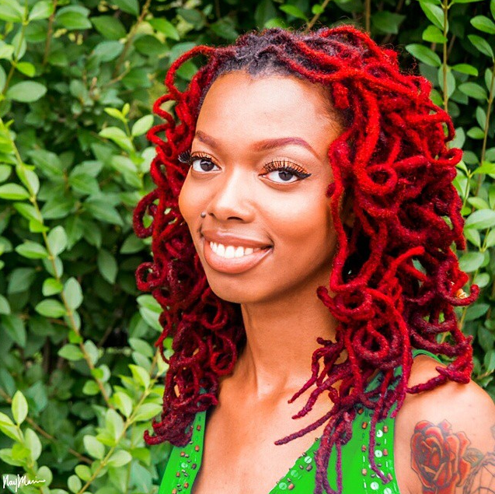 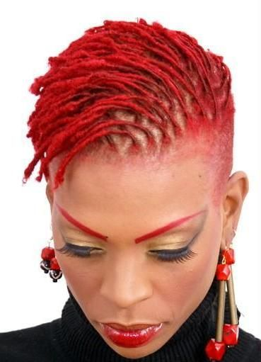

“I was dissatisfied with the philosophy of Freedom City.” “I wondered who was funding the research.” “I secretly began tutelage under Araneae.”

Characters:

**Dante’s ghost** – angry – only the face of the bust (need a better straight on photo to work with). Dante is angry because he was left in storage – lingering for years while contemporary men argued over laws. If you get an answer wrong he appears and warns you that you only have one more chance – and gives you a clue. But if you get it wrong again he gets very angry and you are sent to the third tier of hell with the lawyers that kept him in storage.

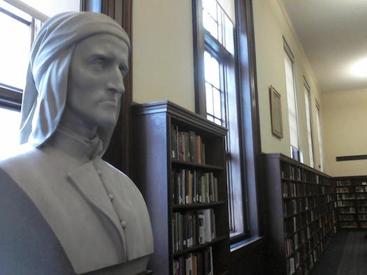

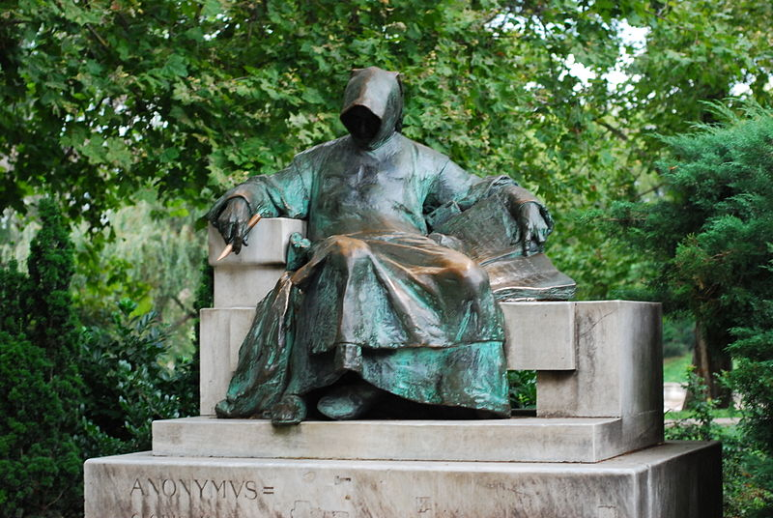

**Eliza Skinner** - Cataloger/ghost - ancient woman with gray hair in a bun, like a super old Eliza from the picture – covered in cobwebs - She’s got a secret – antique eyeglasses hang from a chain around her neck.

Eliza led you to believe that she was a prisoner of the cruel spider. However, she is the one who is in control of the innocent spider and the Robinson family, who only wish to save students from being misled into poor choices that can ruin their academic success and personal lives.

Eliza was in the magic circle. She experimented on Black Bears to put them in a controlled instant homicidal rage. Once Olivia was in her Anthropology class and a projector showed her separation from her aura. It was dark bloody red.

In the context of the past, she had legitimate authority. However now, her authority is maintained with her construction of a false story to trick students into helping her maintain power.

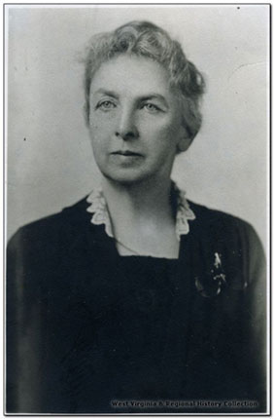 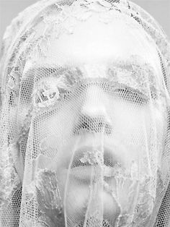  
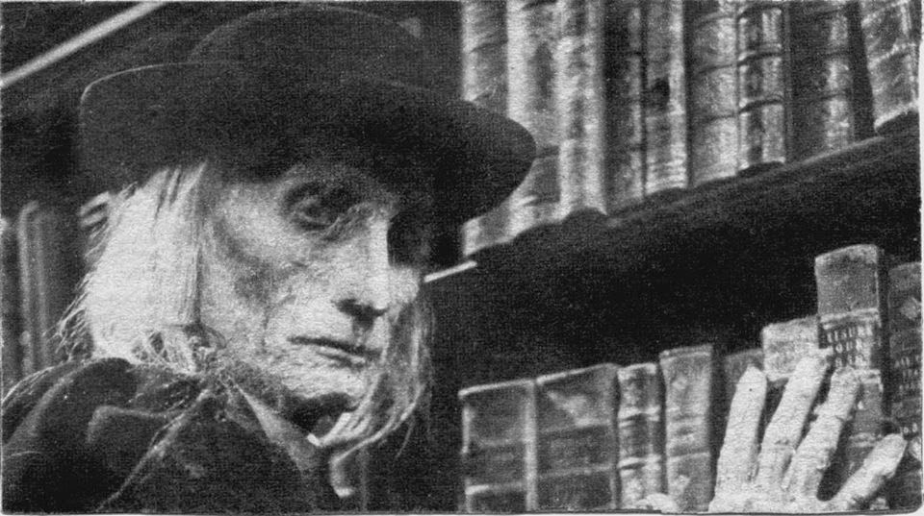

**Araneae** –large ghost spider – Eliza’s captor. Menacing to look at, but actually a good spirit that Eliza leads you to believe is bad.

[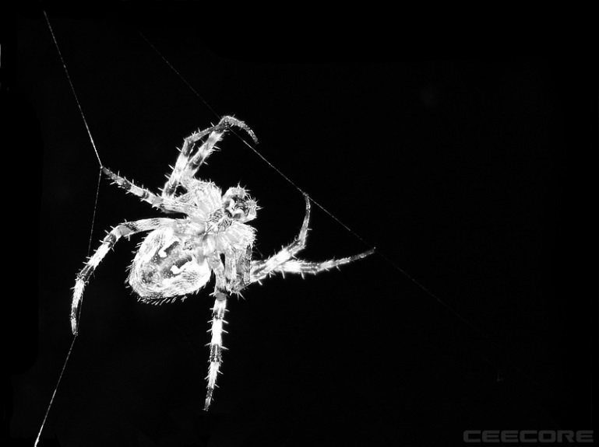 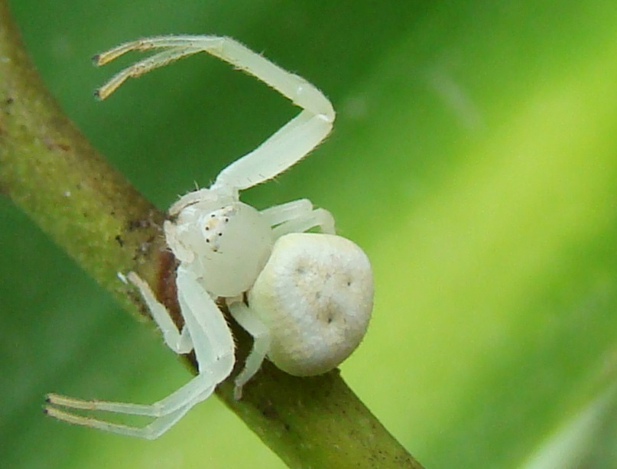 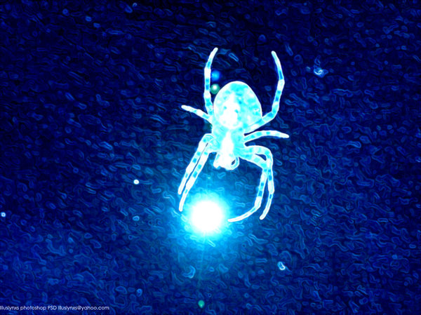](https://www.google.com/search?q=ghost+spider&espv=2&biw=1131&bih=573&source=lnms&tbm=isch&sa=X&ved=0ahUKEwj4zMTenrnMAhUBPj4KHchoBXwQ_AUIBigB)

**Raynard** - Ghost from the future - A young African American man. His grandmother is at WVU with you and after you assist her to use the library by sharing what you know, she uses her library research to create an affordable, sustainable device to purify water. This saves humanity from extinction and the spirit travels through a time portal to assist you when you most need help, and you will.

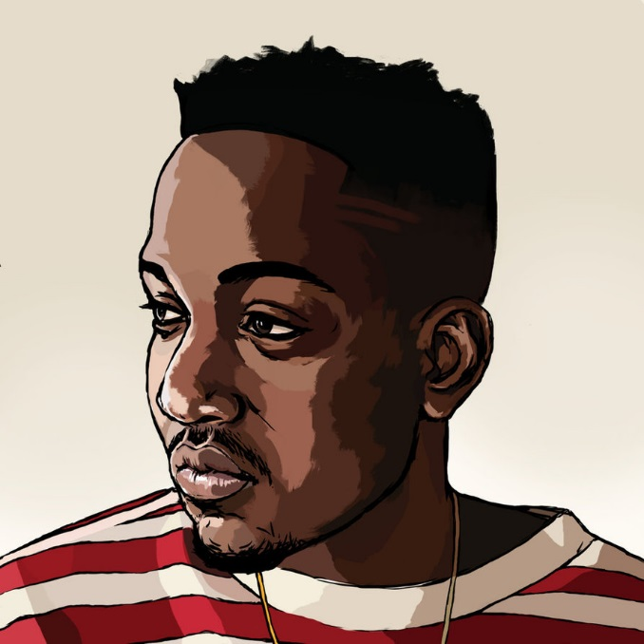

**Professor Dryasdust:**

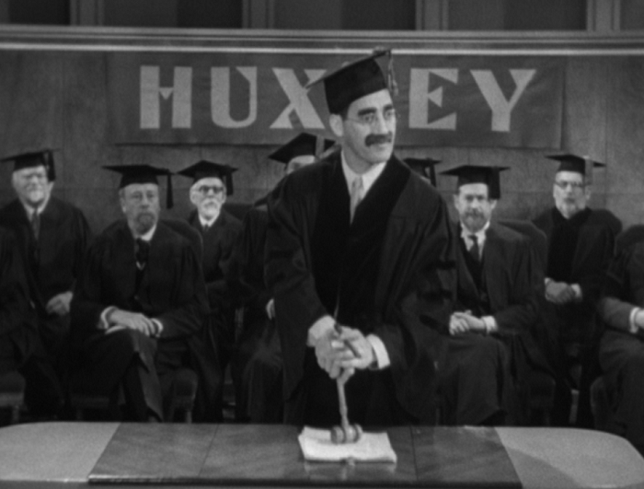

**The Robinson Family**

The Robinson Reading Room is named after them. They are a couple that met there as students. They are ghosts now but benevolent.

You can summon them to help you once if you are entirely lost or stuck on a task (one free task, pass, or answer). You are asked to pay it forward and help another student. Is there a place the students can help each other?

The Robinsons were not really evil. They were acting as if Eliza was imprisoned wrongly because she had complete psychic and astral control. They were both raised by human mothers and did not realize how dangerous trusting a human authority was. Eliza used her powers to take control of them when they were vulnerable first-year students.

**Mr. Robinson: A werewolf/lumberjack**: red flannel shirt, fall leaf camo vest, face covered in hair - hirsute with detectable beard – axe, suspenders, glowing green eyes

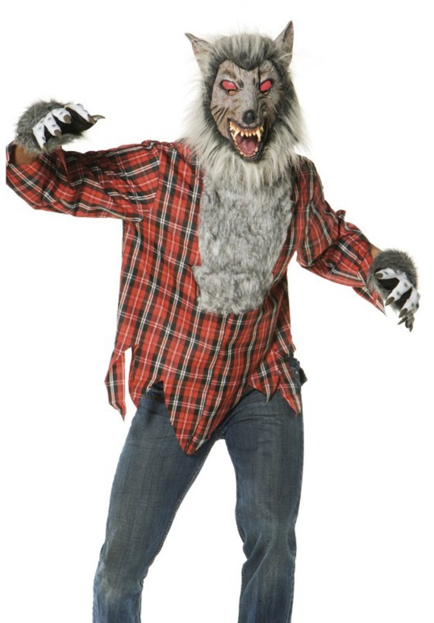 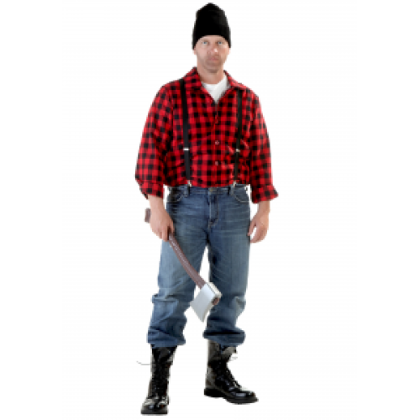

**Mrs. Robonson: A high fashion vampire**: Head scarf, skateboard, and ultra-chic skater grrrl from the streets of Dubai –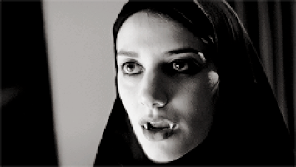  
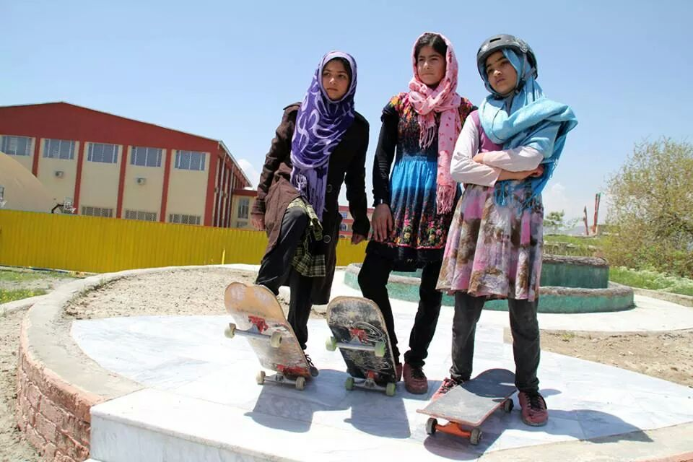  
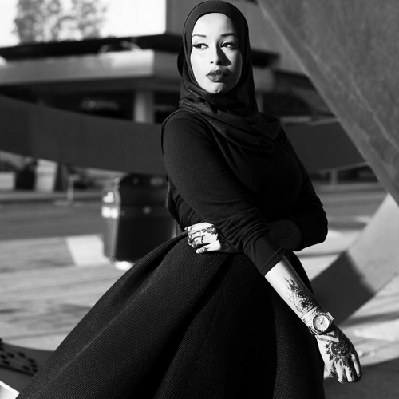

**Badges**

**System Badges**

Set up account: Reads: **Apprentice**

Update profile: Reads: **Ego**

Use a portal to proceed: Reads: **Navigator**

Help Request: Reads: **Child Mind**

Pre-assessment: Reads: **Self awareness**

Error: Reads: **Mistakes were made**

Finish: Reads: **Expert/Artisan**

**Achievement Badges**

One (I?) label: Reads: **Question everything**

Five (V?s) Reads: **Question yourself**

Ten (X?s) Reads: **Metacognition**

Twenty (XX?s) Reads: **Lifelong Learner**

**Library Badges**

Downtown = Reads: **Artisan Scholar**

Evansdale = Reads: **Magellanic Scholar**

**Question Badges**

1. **Scholar** (Social Media) (Help Request)  
   Reads: Scholarship as conversation
2. **Answers** (Set up account) (Update profile) (selfie)  
   Reads: Information Creation as a Process
3. **Adept** (Multiple choice)  
   Reads: Authority Is Constructed and Contextual
4. **Questions** (online text- copy and paste?)  
   Reads: Research as Inquiry
5. **Searching** (QR Code)  
   Reads: Searching as Strategic Exploration
6. **Truthiness** (True or False)  
   Reads: Information has value