Excel Q&A: Campaign Finance/Pivot Tables
12/31/2001

Pivot tables, also called crosstabs, are among the most useful tools for analyzing data in an Excel spreadsheet. They allow journalists to do some database-like analysis without having to learn anything about database managers.
The file xlcalifcand.xls is a list of all 153 candidates who ran for California State Assembly in the 1998 general election, along with some useful information like the amount of money they spent, whether they were an incumbent or challenger and the outcome of their election.
Your assignment is to write a wrap-up analysis of the election using these data as a foundation. Some thoughts:

1) To begin with, you might want to do a simple sort by dollars raised, highest to lowest.
2) You also might want to do a two level sort, first sorting by election district and then by dollar amount.
3) You can also calculate the average amount spent by district, but you might also want to calculate the median. Why?
4) Lastly, let’s insert a column in front of the District column and name it Rank. There are two ways to do this. One uses Excel’s auto incrementing feature, and the other uses the rank() function.

That’s about as far as we can go with this analysis. There are too many records to deal with to say how much more winners spent than losers… of if winners did indeed outspend losers, as one might suspect they would. And that’s where the pivot table comes in.

5) Create a pivot table that shows which district held the most expensive race.
6) Create a pivot table that shows average expenditures for winners and losers.
7) Now look at the chart just by incumbency.
8) Last, let’s create a table that looks at amounts raised by incumbency AND by outcome. Any surprises here? What were the odds of winning in 1998 for incumbents versus challengers?

This is just a start. There are many more advanced features available in pivot tables, some of which are discussed in other NICAR training sheets.

Excel Q&A: Answers

1) One and two level sorts:

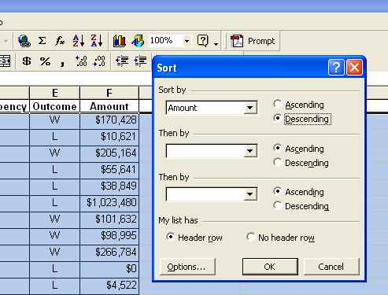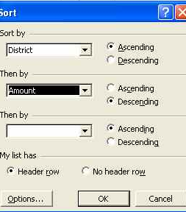

2) Use the functions average() and median(), e.g. =average(f2:f154) and =median(f2:f154)

3) Sort your table by Amount in descending order, and type the number 1 in cell A2. Type the number 2 in cell A3. Highlight both using the fat plus sign curser, then grab the handle and drag to the bottom of the sheet or simply double-click on it. The numbers should increment down the sheet from 1 to 154.
- or -
You also can use the rank() function, which some people prefer because it does not involve sorting. In cell A2 type =rank(G2,G$2:G$154), and copy the formula down to the bottom of the sheet. Excel will rank each value in relation to the range of values from G2 to G154. When using the rank function ALWAYS ANCHOR THE RANGE or things will get messed up.

4) The most expensive race (you will need to use the Rank() function after creating the pivot table, because there is no way to sort that I know of):
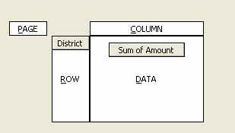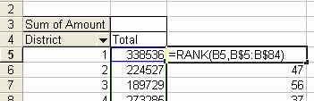

6) Average by Outcome
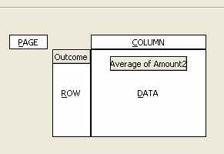

Excel Q&A: Answers

7) Average by Incumbency:
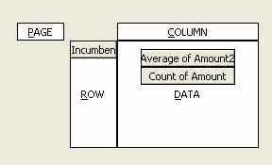

8) Average by incumbency and outcome:
I did it this way, but there is no reason you couldn’t have incumbency in the row with outcome. It would look a little messier, but it would work.

