# Assessment Brief

|  |  |
| --- | --- |
| Module Title: | Data Mining |
| Code: | B9DA103 |
| Module Leader: | Bahman Honari |
| Student code: | 10543928 |
| Student name: | Tim Browning |
| Instruction for CA 1: | The provided Dataset contains 16 variables. Response is the target variable to be predicted using the other variable, i.e. X1-X8 and Y1-Y8. X variables are the actual measurements. Y variables are the categorical form of the X variables based of the recommended cut-off points by the previous studies. Group is the variable that might moderate the predictability of response by Xs or Ys. The purpose of this study is to use “Decision Trees” to assess predictability of Response by X, Y or combination of them. As mentioned in above, this predictability might be affected by the Group variable, and therefore the analysis should be performed for all cases, as well as for each group separately to study the effect of variable Group. You would therefore need to check 9 models as follow:  Using all data, run the models Response over Xs, Response over Ys, Response over Xs and Ys.  Repeat above for data with Group=0 and Group=1, separately. |

## Model 1 - DT model - “X” for all data

### Full Decision Tree

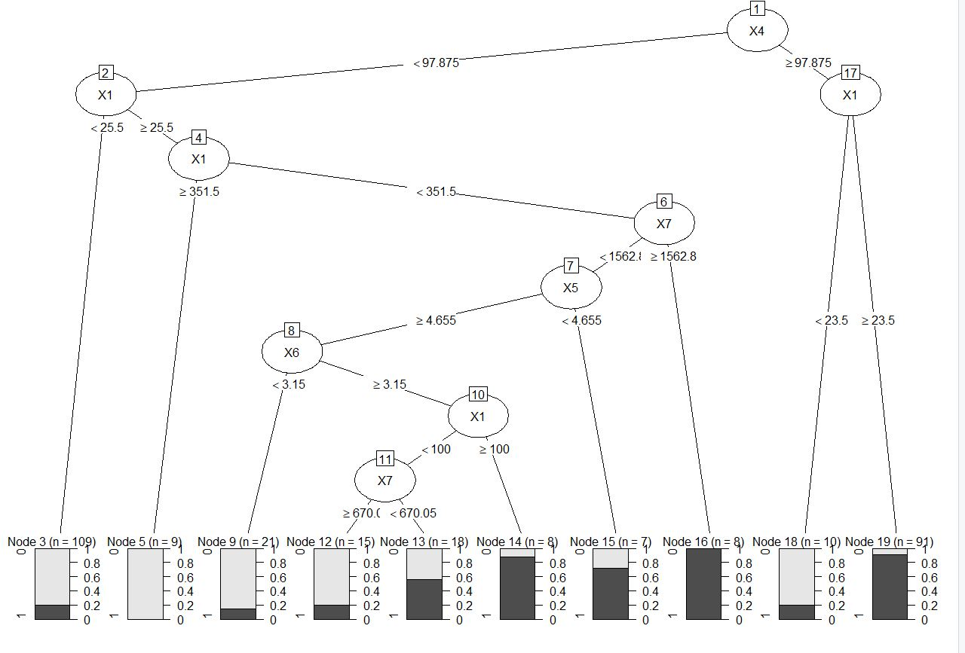

### After P­­runing the decision tree

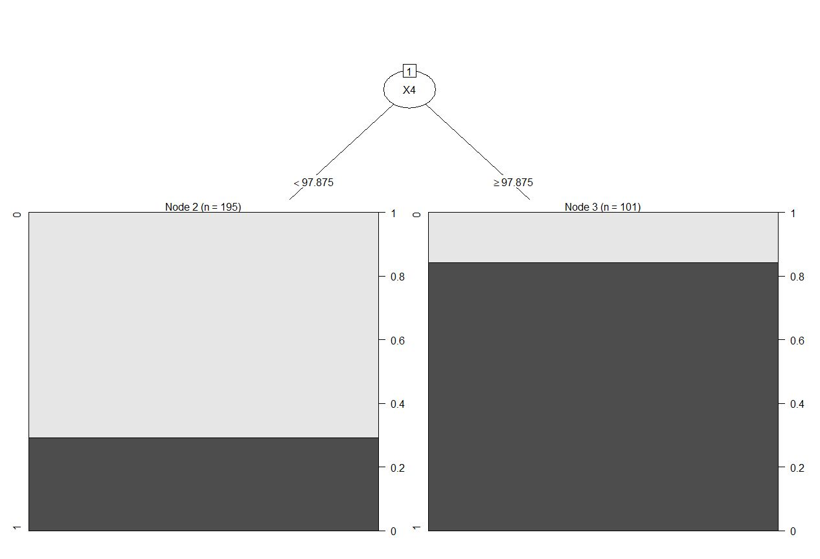

### Training model

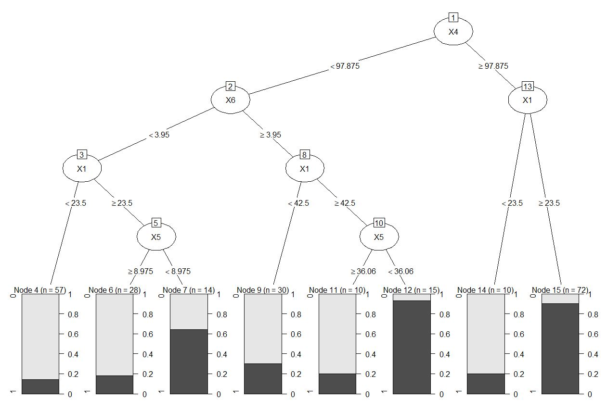

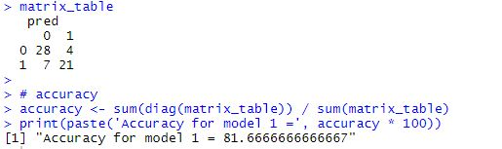

## Model 2 - DT model - “Y” for all data

### Full Decision tree

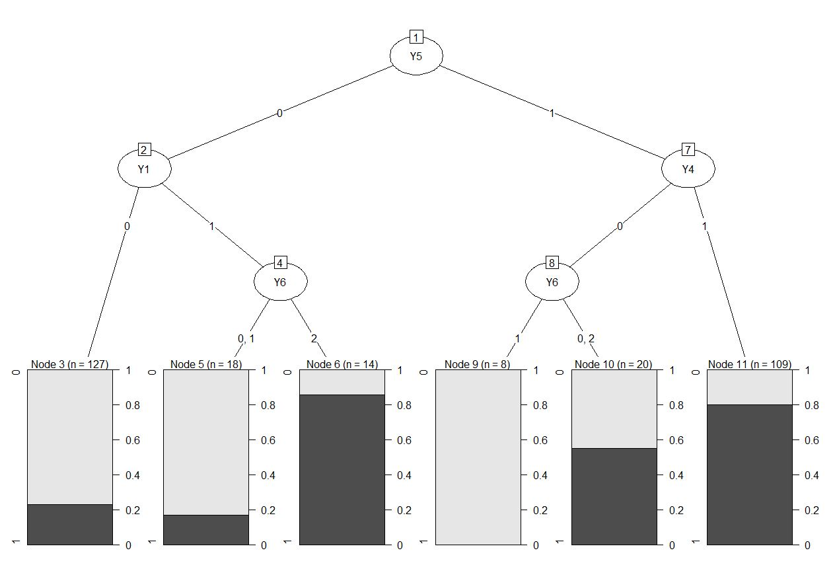

### After pruning the decision tree

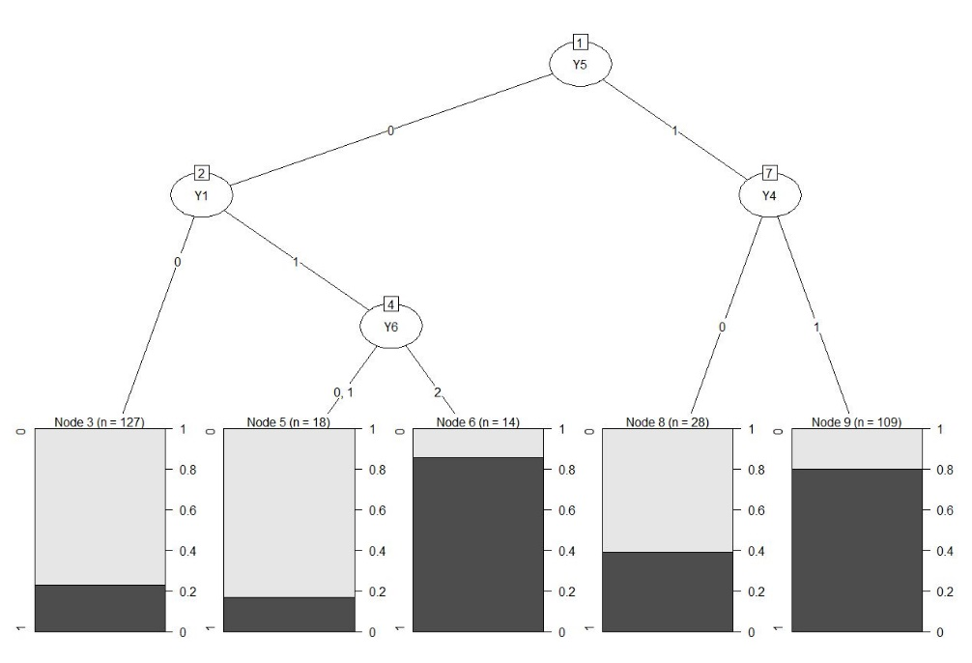

### Training model

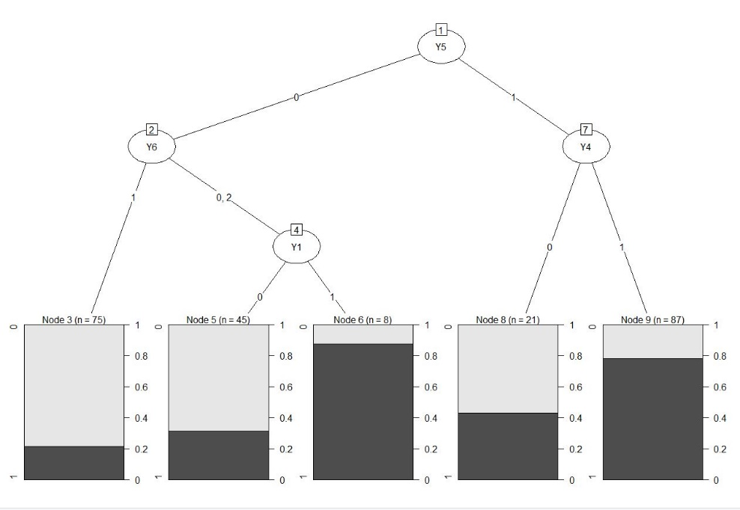

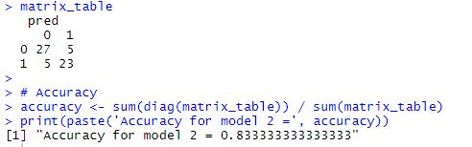

## Model 3 - DT model - “X” and “Y” for all data

### Full Decision tree

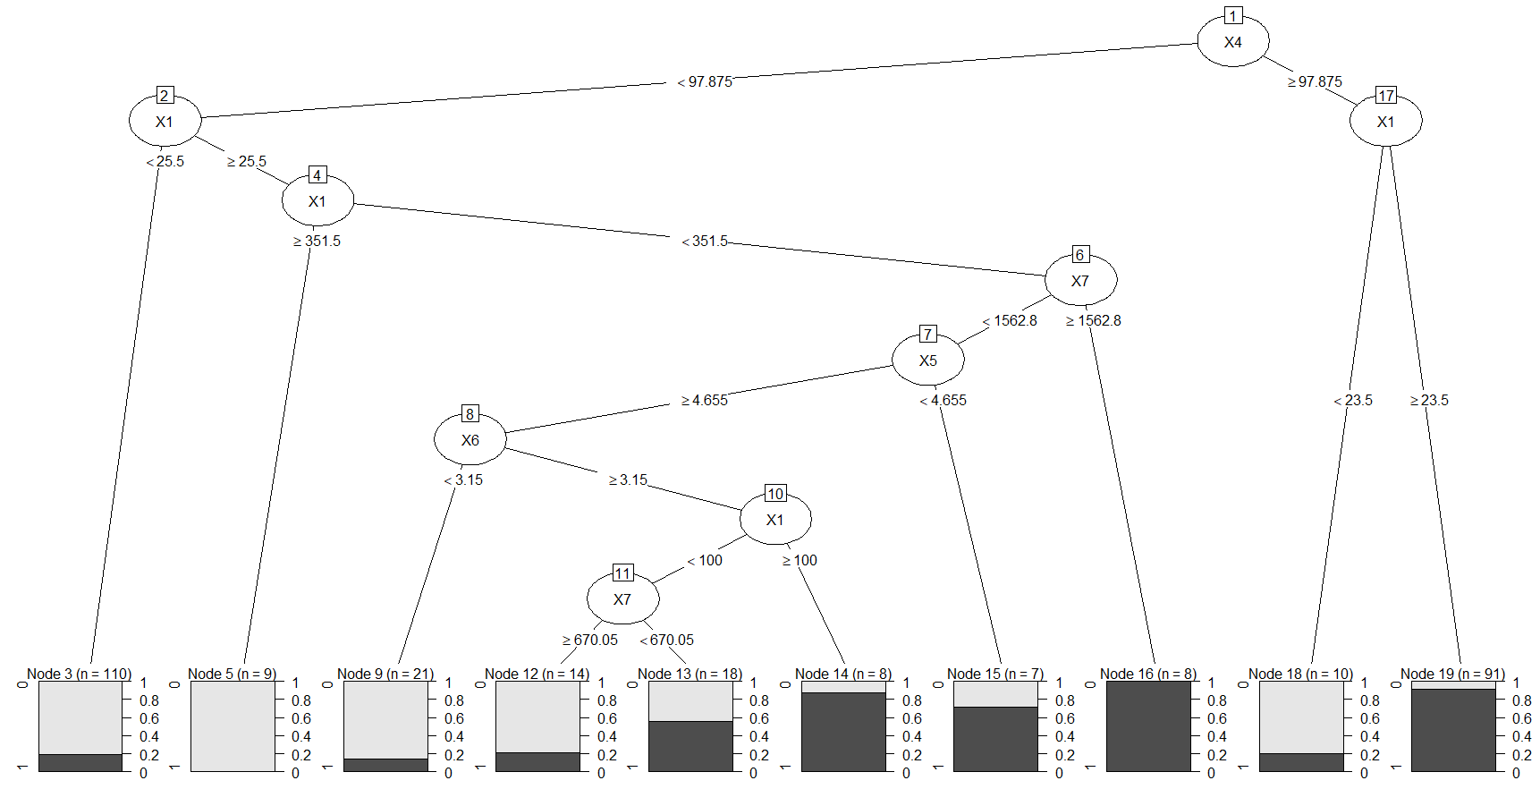

### After pruning the decision tree

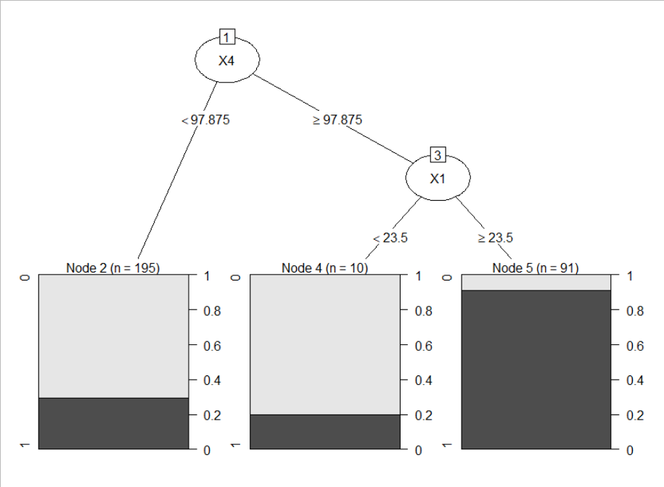

### Training model

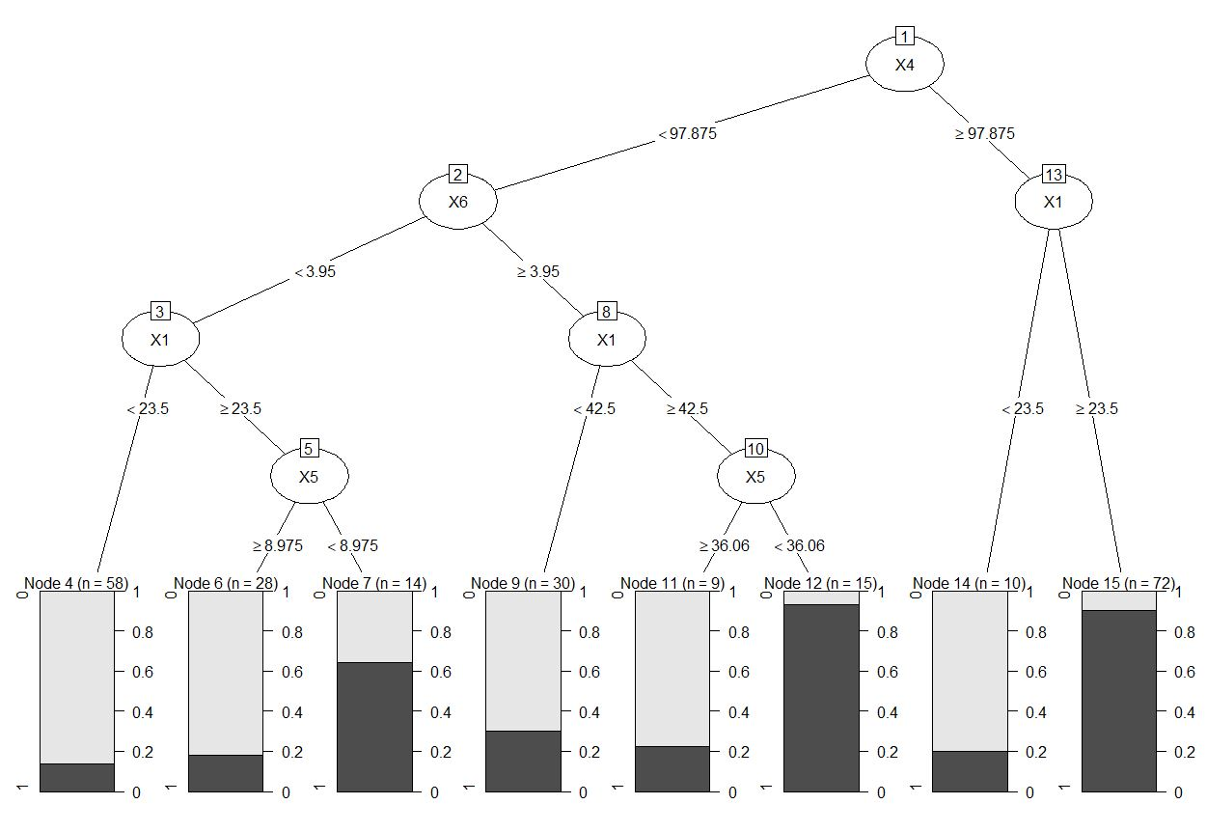

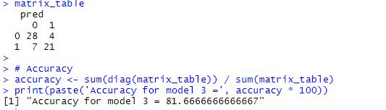

## Model 4 - DT model - “X” for Group=0

### Full Decision tree

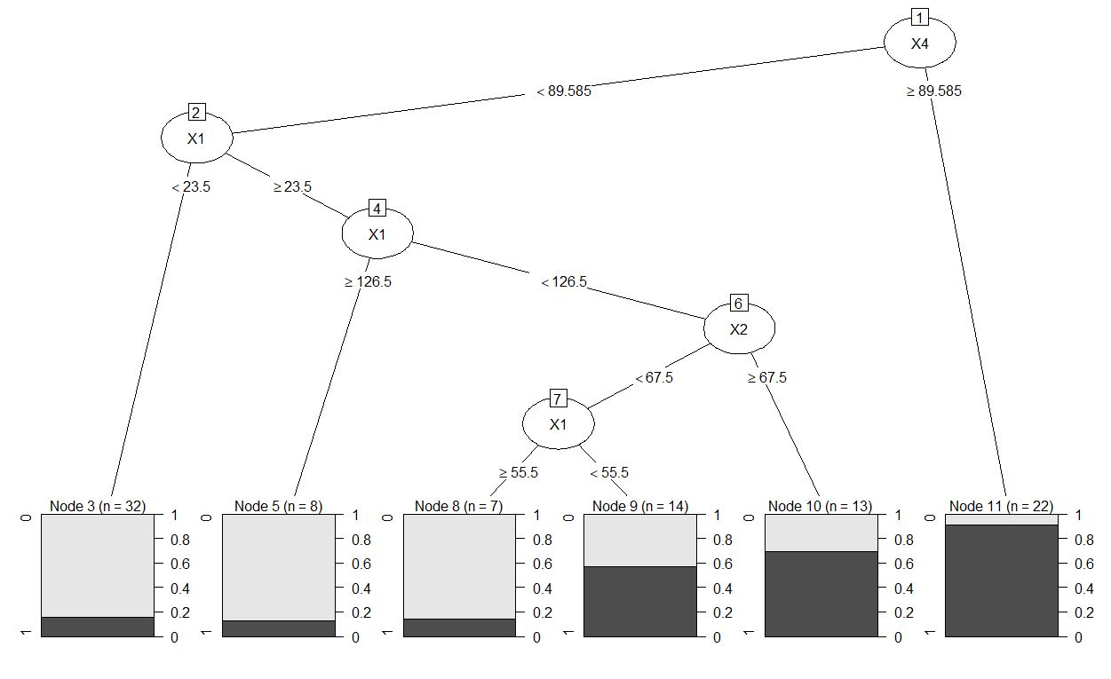

### After pruning the decision tree

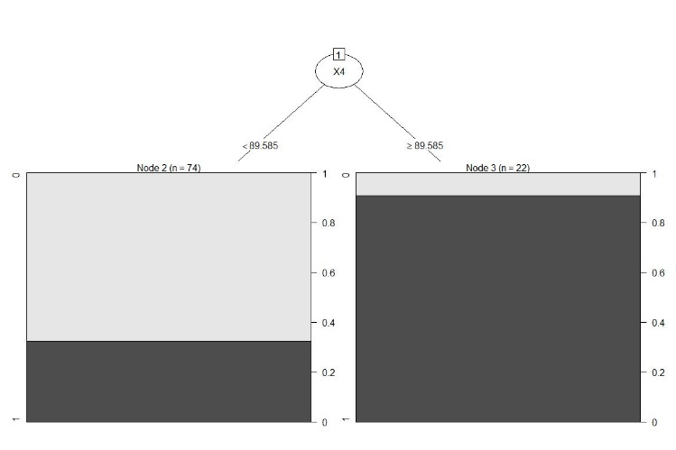

### Training model

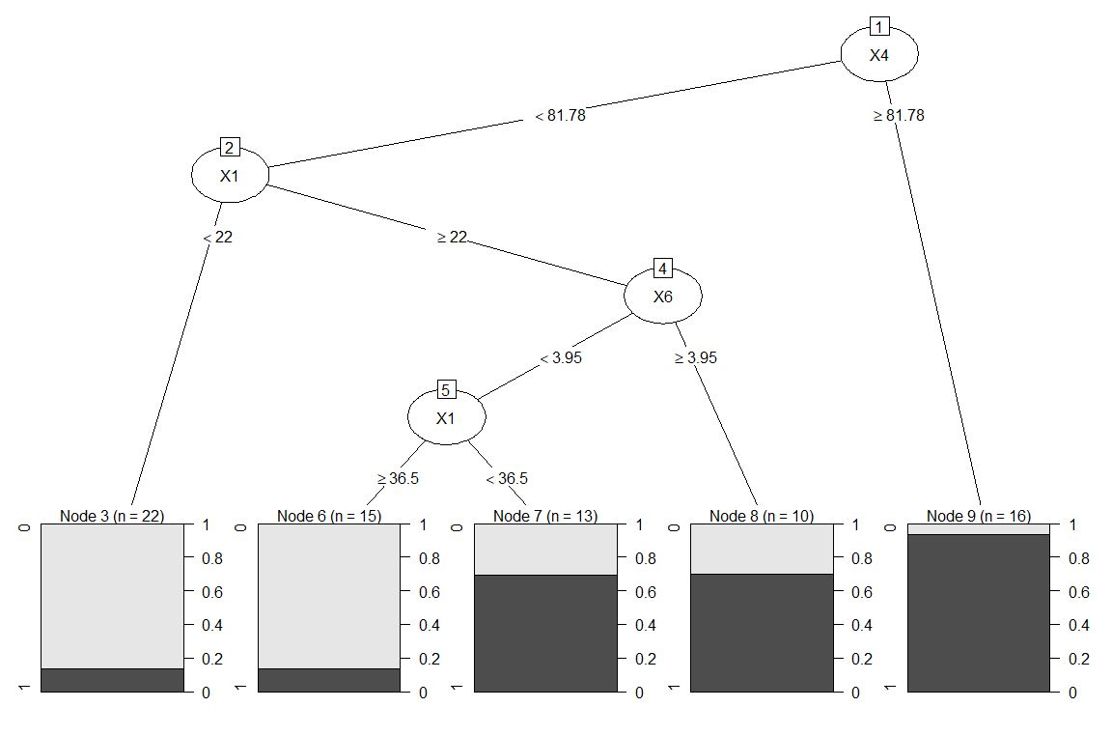

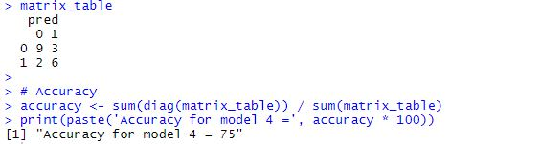

## Model 5 - DT model – “Y” for Group=0

### Full Decision tree

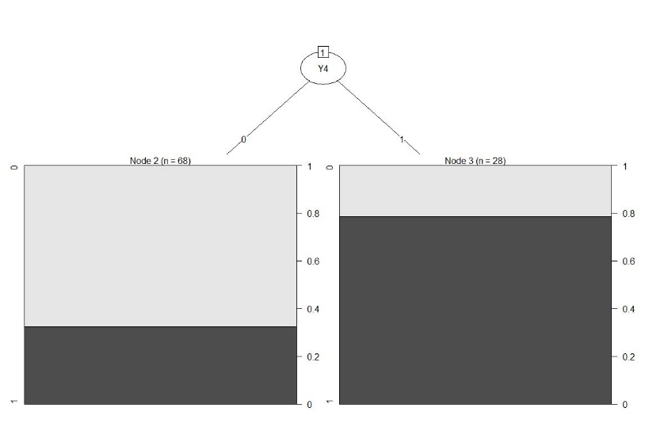

### After pruning the decision tree

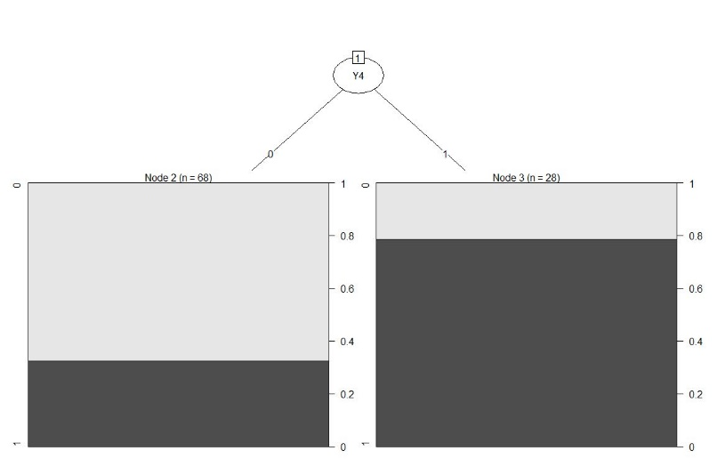

### Training model

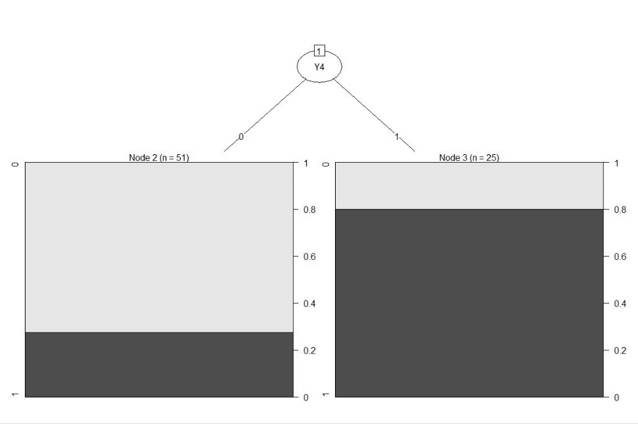

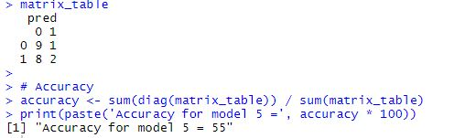

## Model 6 - DT model – “X” and “Y” for Group=0

### Full Decision tree

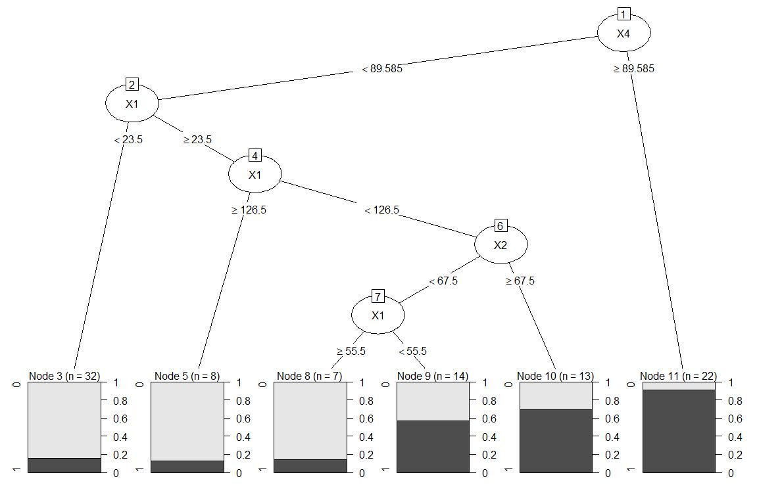

### After pruning the decision tree

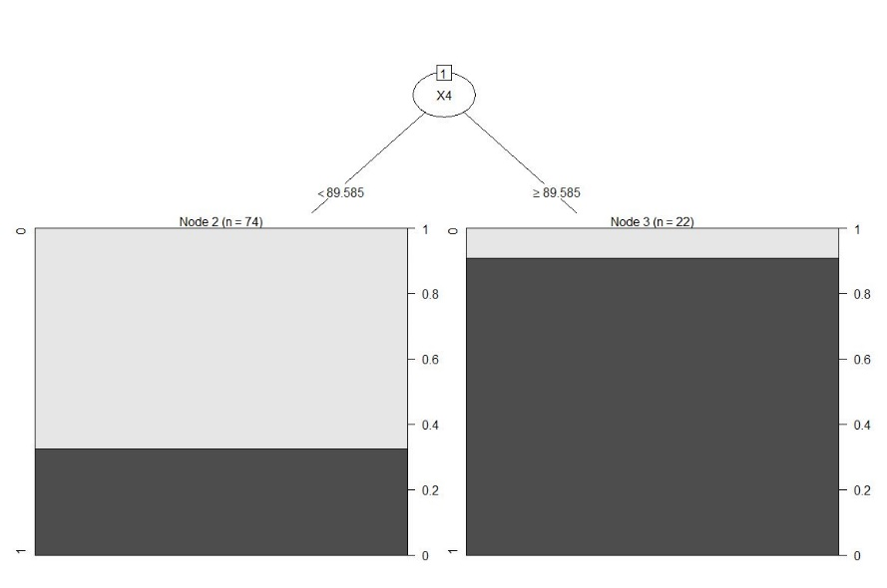

### Training model

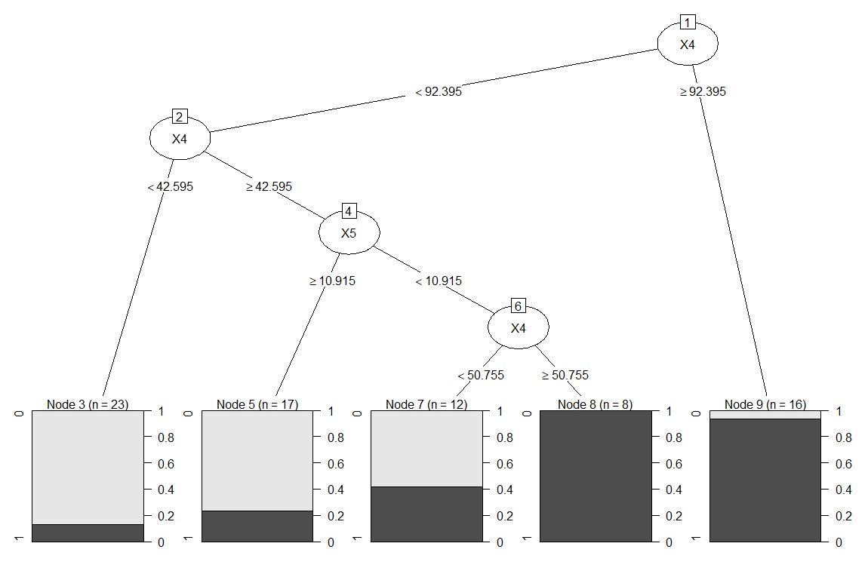

### 

## Model 7 - DT model – “X” for Group=1

### Full Decision tree

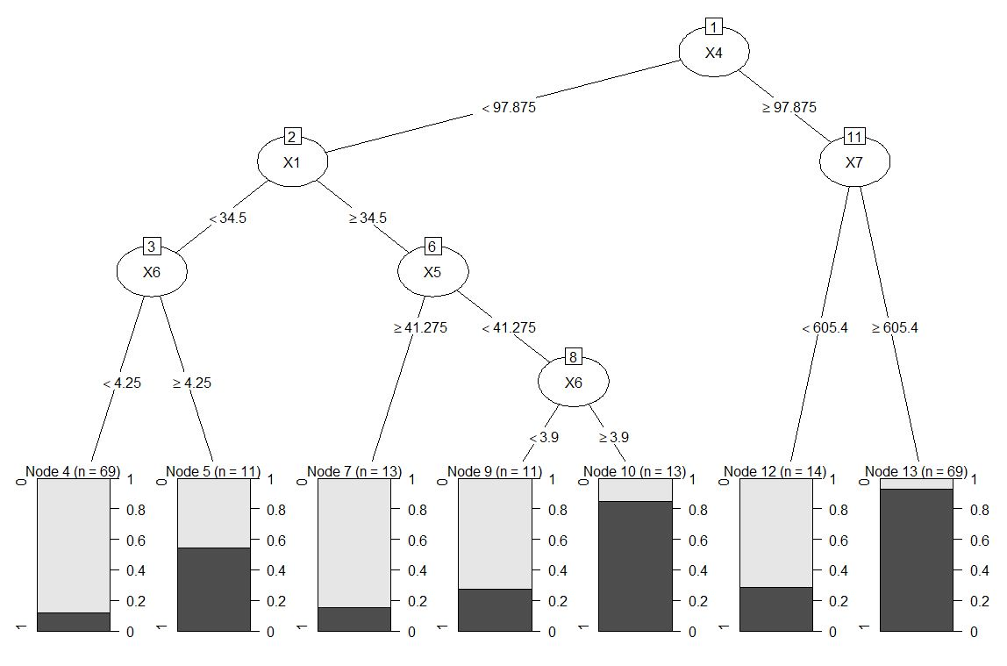

### After pruning the decision tree

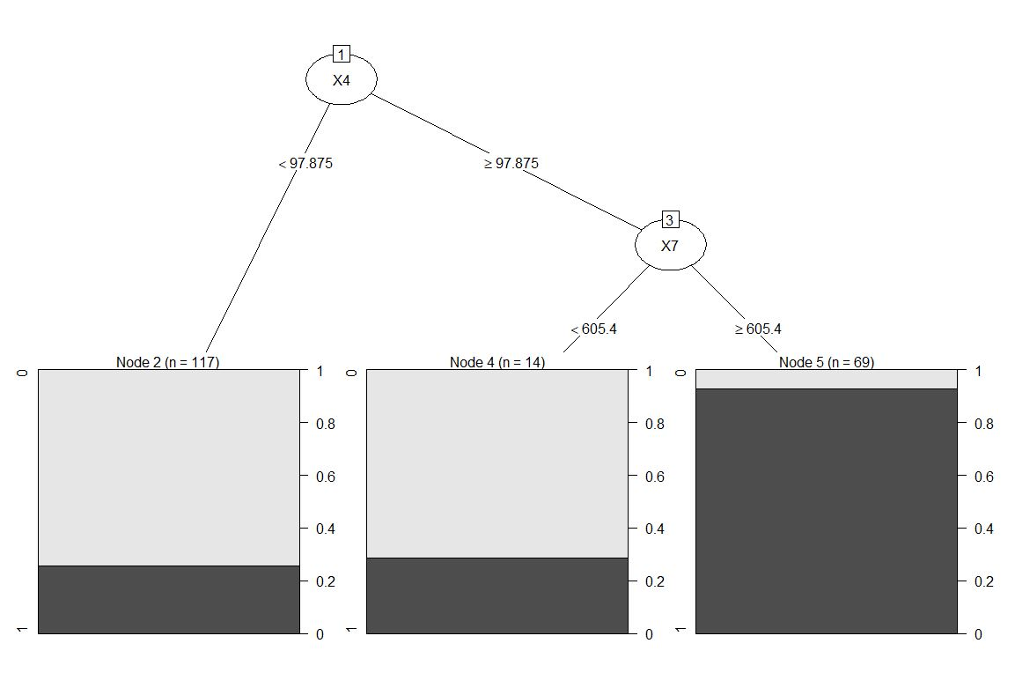

### Training model

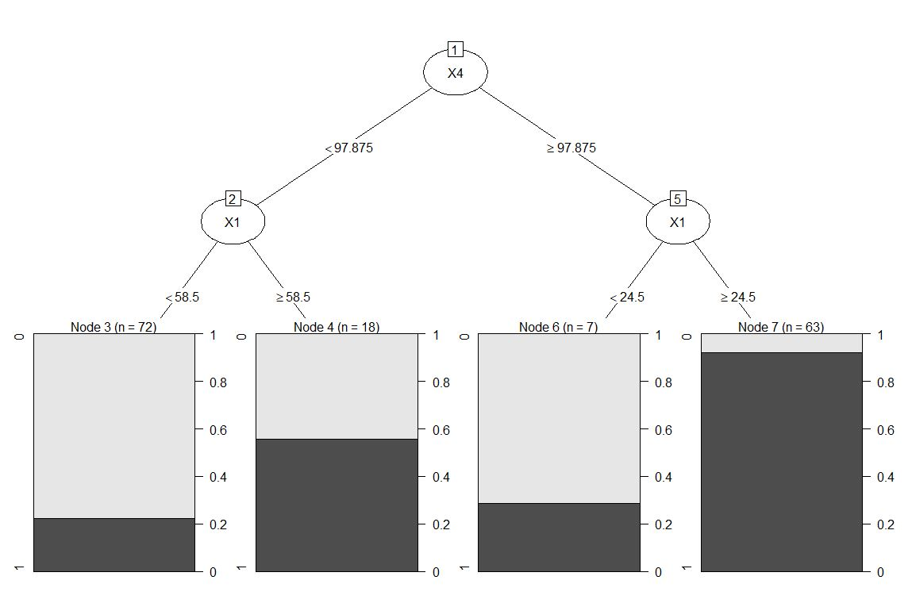

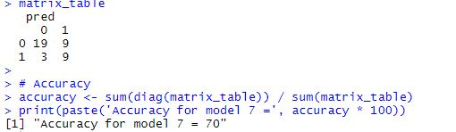

## Model 8 - DT model – “Y” for Group=1

### Full Decision tree

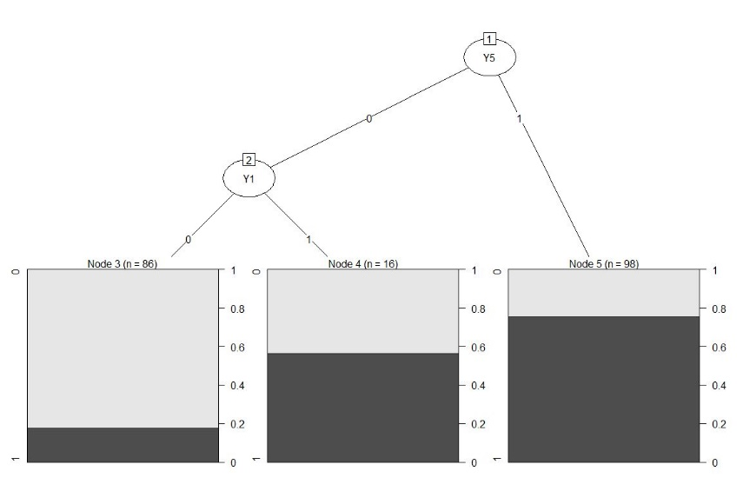

### After pruning the decision tree

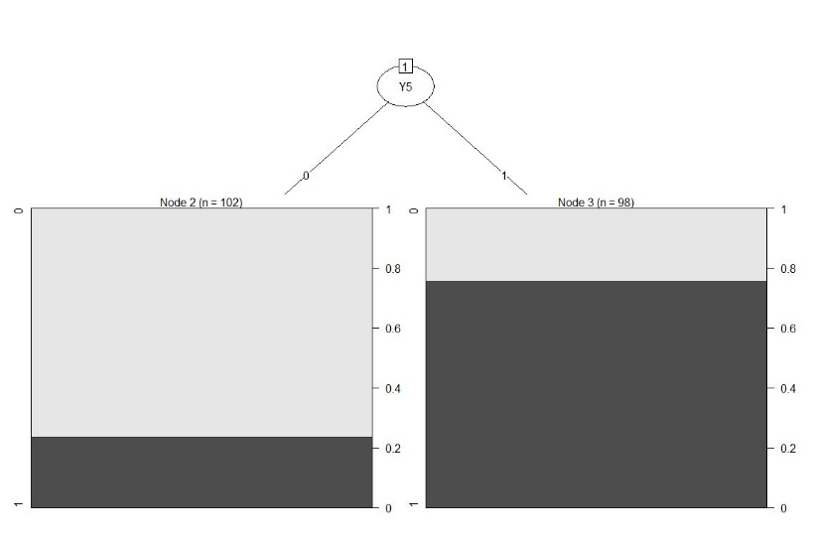

### Training model

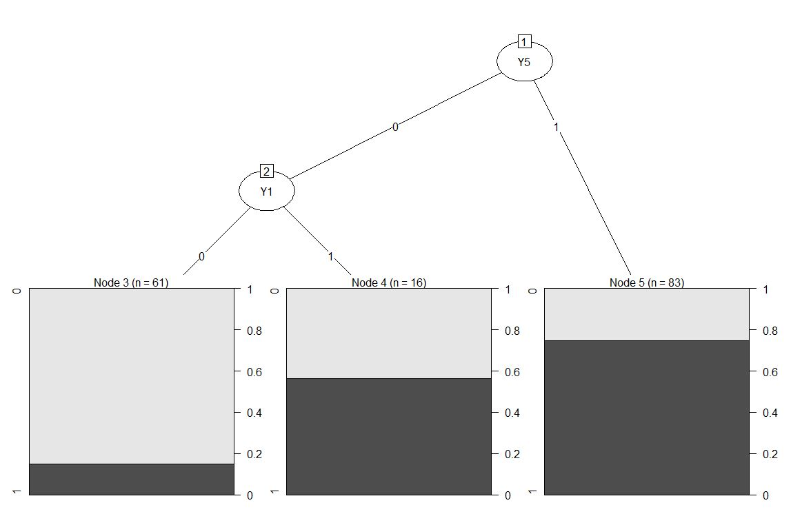

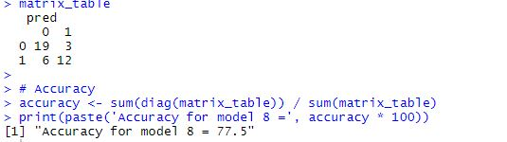

## Model 9 - DT model – “X” and “Y” for Group=1

### Full Decision tree

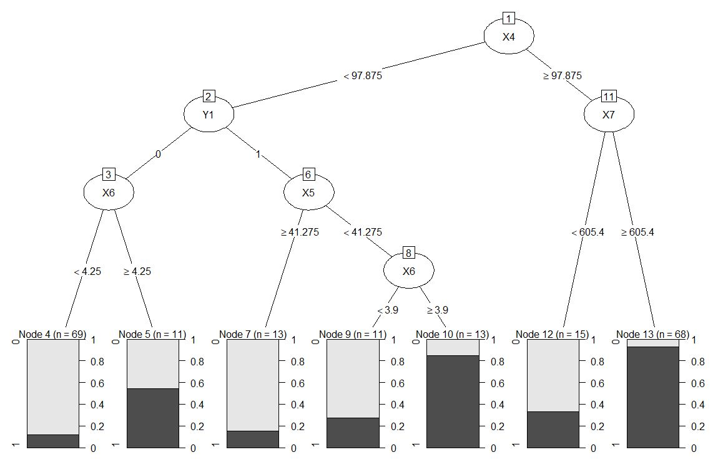

### After pruning the decision tree

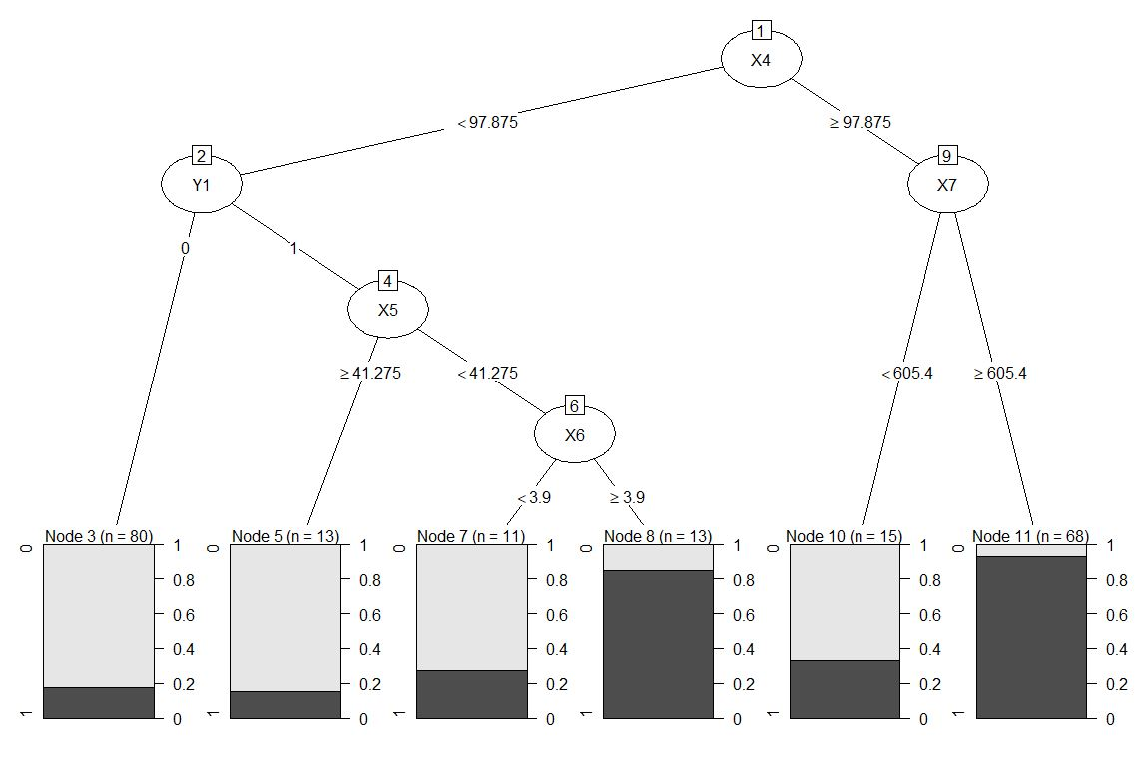

### Training model

