Design and Development of data storage solutions for analysis



By Tim Browning & Clinton Ngan

Contents

Q1) (a) Develop a proof of concept data warehouse/data mart (using dimensional modelling) capturing data from an existing data source? 3

Q1) (b) Document your reasons for selecting the subject area? 4

Q1) (C) ) identify key stakeholders? 5

## Q1) (a) Develop a proof of concept data warehouse/data mart (using dimensional modelling) capturing data from an existing data source?

1. Download AdventureWorksDW2017 from <https://docs.microsoft.com/en-us/sql/samples/adventureworks-install-configure?view=sql-server-ver15>
2. 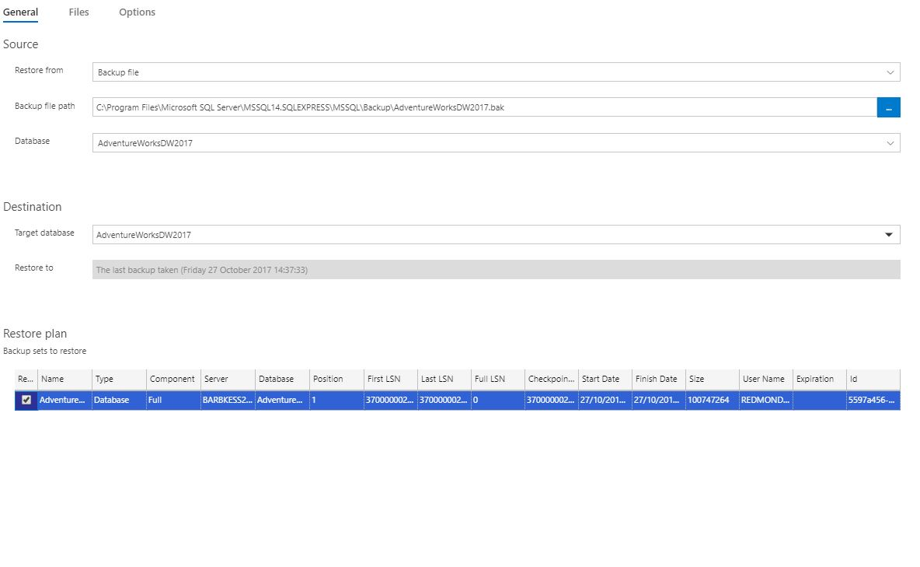Restore AdventureWorksDW2017.bak
3. 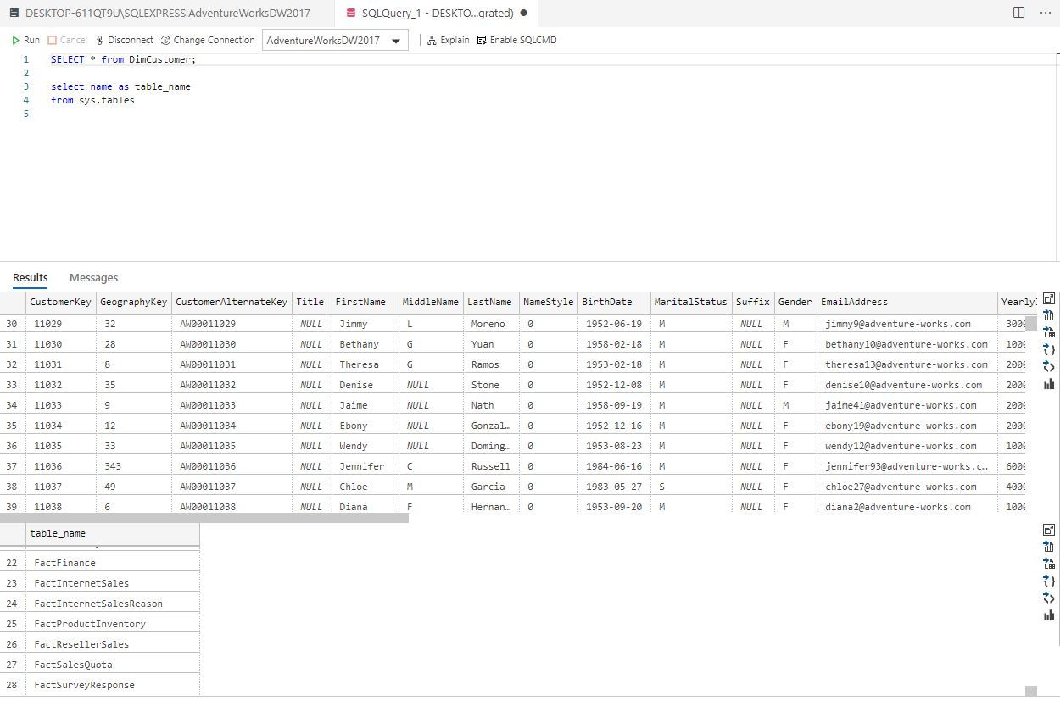Access/View tables from data warehouse

## Q1) (b) Document your reasons for selecting the subject area?

We have chosen “sales” as the subject area for the following reasons:

* Adventure Works is a sales-driven manufacturing company
* Retrieved data insights from the data warehouse can be used to increase profits
* Target Audiences/ Markets can be identified

## Q1) (C) Identify key stakeholders?

Data Producers, Data Custodians, Data consumers and Data managers

## Q1) (D) Explain the insights that a company may derive from the given data?

## Q2) (D) Develop and present a suitable schema for the data warehouse / data mart. Discuss your reasons for the design?