PKSolver Quick Start

PKSolver Environmental Specification
1. Windows XP / Vista / 7.
2. Microsoft Office 2003 / 2007 / 2010 (English Version is preferred).
3. Microsoft Excel’s “Solver Add-in” should be installed.

PKSolver Installation Package
The PKSolver add-in program is available in the supplementary materials, interested readers can download and install it for free.

Step 1.
If Solver... is not in the Tools menu, you should install Microsoft Excel’s Solver first, if Solver... has already been in the Tools menu you can go to step 3 to install PKSolver program.
1.1 Start Excel and click on Tools on the menu. Then click on Add-ins...
1.2 A box should appear with lots of checkboxes in it. If there is no checkbox for Solver Add-in, go to step 2 below.
1.3 Check the checkbox for Solver Add-in, it should look like this:
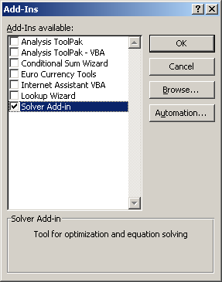
1.4 Click OK. From now on, the choice Solver... should be on the Tools menu in Excel, It should look like this:
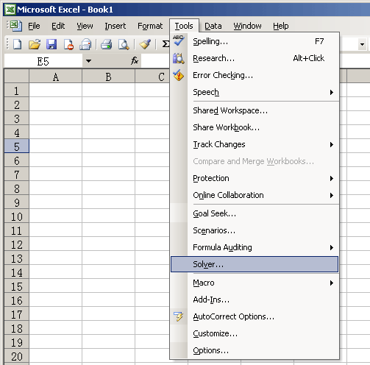
1.5 Goto step 3.

It should be noted that if the Excel’s Solver Add-in is not installed before the installation of PKSolver, a warning dialog box will appear and the calculation will be interrupted when you use the program to perform data modeling.
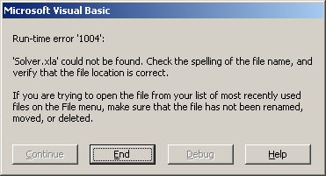
Step 2.
If Solver Add-in is not on your list of available Add-Ins, you will need your Microsoft Office CD-ROM.
2.1 Put the CD in. If the CD doesn’t run its setup program automatically, open My Computer, find setup.exe on the CD and double-click it to run it.
2.2 Check the Add or Remove Features checkbox and click Next button.
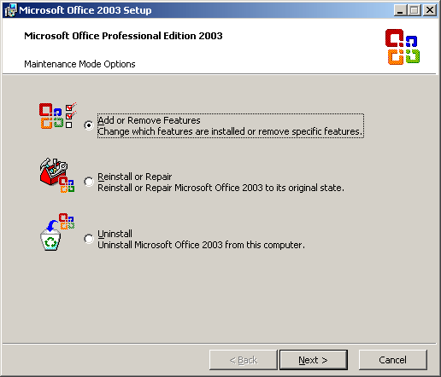
2.3 In the dialog box that then appears, check the checkbox of Choose advanced customization of the applications, click Next button.
2.4 In the graphic that then appears, click the little plus sign next to Microsoft Office Excel. This opens up the outline under that box. Click the little plus sign next to Add-ins to open that list up. Look down that list and you should find Solver.
2.5 Click on Solver and choose Run from My Computer, so that the box is white, with no yellow “1.” This picture shows how it should look when you are done.
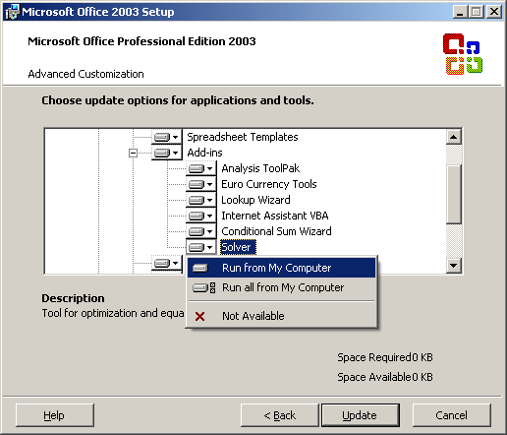
2.6 Then click Update to proceed with the installation. If your version of Office is different from mime, your screen may look different, but the procedure is near the same.
2.7 Go to step 1 above.

Step 3.
If Solver... has already been in the Tools menu, you can install PKSolver program by the following operations:
3.1 Unzip the compressed file named “PKSolver.zip” containing a file named “PKSolver.xla”.
3.2 Start Excel and click on Tools on the menu. Then click on Add-ins...
3.3 Click Browse to locate the add-in program PKSolver.xla and click OK.
3.4 Check the checkbox for PKSolver, it should look like this:
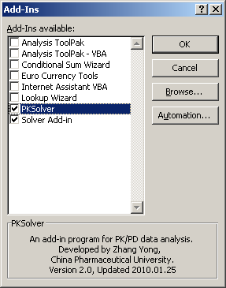
3.5 Click OK. Then a new pull-down menu PKSolver should appear on the menu bar of Excel, it should look like this:
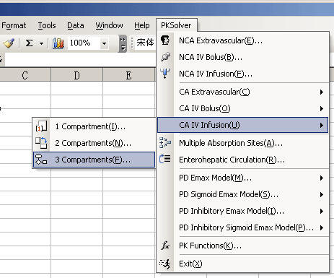
3.6 Restart Excel. From now on, you are allowed to use the PKSolver program with full functions.
3.7 If you want to uninstall the PKSolver program, please click on Tools on the menu, then click on Add-ins..., deselect the checkbox for PKSolver and click OK, and delete the PKSolvr.xla file.

Install PKSolver in Microsoft Office 2007

PKSolver Installation for Office 2007
Use steps in guide below to install PKSolver add-in program for Microsoft Office 2007:

Step 1.
If Solver is not on the Data tab, you should install Microsoft Excel’s Solver first, if Solver has already been on the Data tab you can go to step 3 to install PKSolver program.
1.1 Start Excel and click on Office button, and then click on Excel Options.
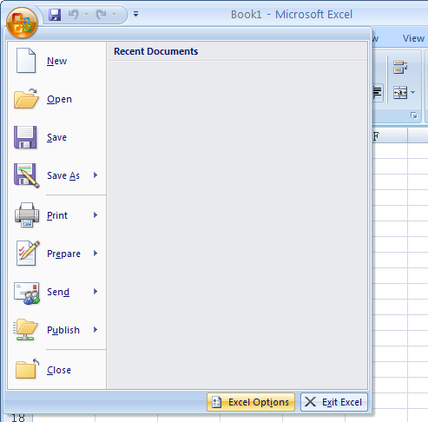
1.2 Go to the Add-Ins tab, and then in the Manage box, select Excel Add-ins, click Go.
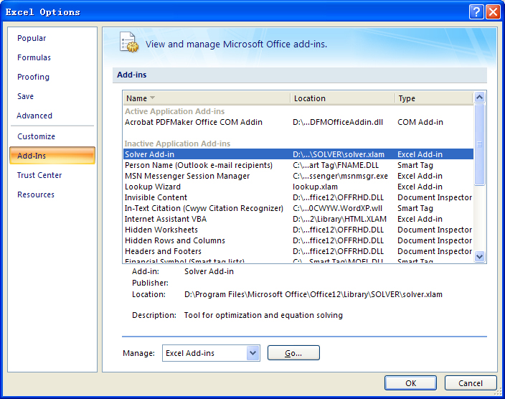
1.3 A box should appear with lots of checkboxes in it. If there is no checkbox for Solver Add-in, go to step 2 below.
1.4 Check the checkbox for Solver Add-in, it should look like this:
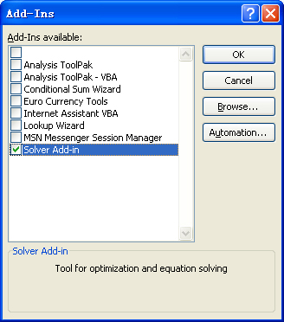
1.5 Click OK. From now on, the Solver button should be on the Data tab in Excel, It should look like this:
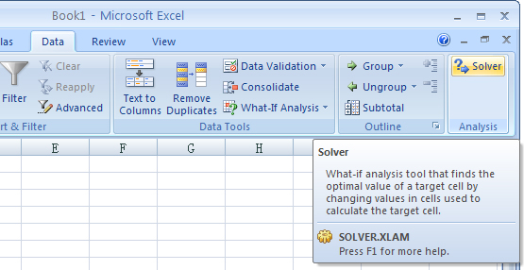
1.6 Goto step 3.

Step 2.
If Solver Add-in is not on your list of available Add-Ins, you will need your Microsoft Office CD-ROM.
2.1 Put the CD in. If the CD doesn’t run its setup program automatically, open My Computer, find setup.exe on the CD and double-click it to run it.
2.2 Check the Add or Remove Features checkbox and click Continue button.
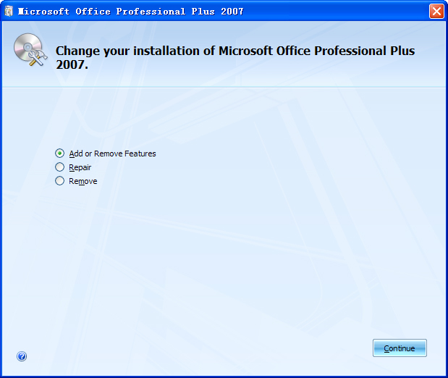
2.3 In the Installation Options tab that then appears, click the little plus sign next to Microsoft Office Excel. This opens up the outline under that box. Click the little plus sign next to Add-ins to open that list up. Look down that list and you should find Solver.
2.4 Click on Solver and choose Run from My Computer, so that the box is white, with no blue “1.” This picture shows how it should look when you are done.
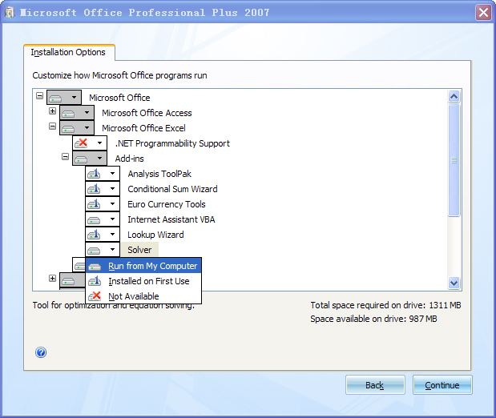
2.5 Then click Continue to proceed with the installation. If your version of Office is different from mime, your screen may look different, but the procedure is near the same.
2.6 Go to step 1 above.

Step 3.
If Solver has already been in the Data tab, you can install PKSolver program by the following operations:
3.1 Unzip the compressed file named “PKSolver.zip” containing a file named “PKSolver.xla”.
3.2 Start Excel and click on Office button, and then click on Excel Options.
3.3 Go to the Add-Ins tab, and then in the Manage box, select Excel Add-ins, click Go.
3.4 Click Browse to locate the add-in program PKSolver.xla and click OK.
3.5 Check the checkbox for PKSolver, it should look like this:
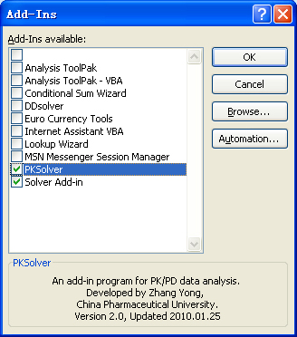
3.6 Click OK. Then a new pull-down menu PKSolver should appear on the Add-Ins tab of Excel, it should look like this:
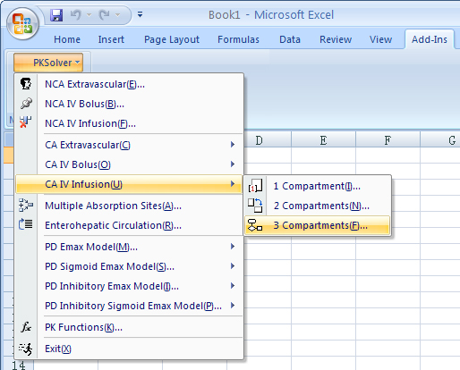
3.7 Restart Excel. From now on, you are allowed to use the PKSolver program with full functions.
3.8 If you want to uninstall the PKSolver program, start Excel and click on Office button, and then click on Excel Options. Go to the Add-Ins tab, and then in the Manage box, select Excel Add-ins, click Go, deselect the checkbox for PKSolver and click OK, and delete the PKSolvr.xla file.
Install PKSolver in Microsoft Office 2010

PKSolver Installation for Office 2010
Use steps in guide below to install PKSolver add-in program for Microsoft Office 2010:

Step 1.
If Solver is not in the Data tab, you should install Microsoft Excel’s Solver first, if Solver has already been in the Data tab you can go to step 3 to install PKSolver program.
1.1 Start Excel and click on File menu and choose Options.
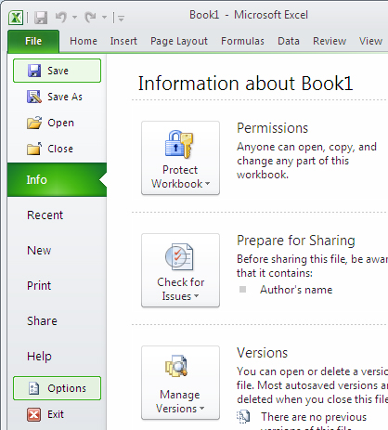
1.2 Go to the Add-Ins tab, and then in the Manage box, select Excel Add-ins, click Go.
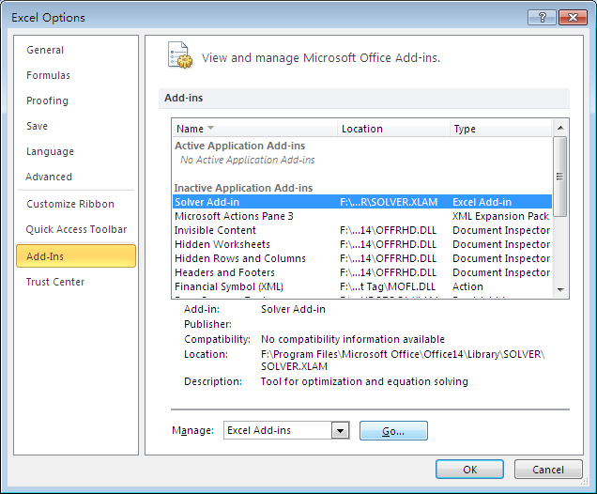
1.3 A box should appear with lots of checkboxes in it. If there is no checkbox for Solver Add-in, go to step 2 below.
1.4 Check the checkbox for Solver Add-in, it should look like this:
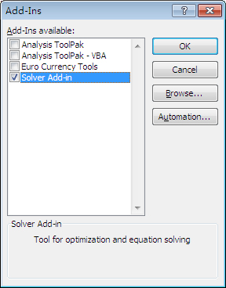
1.5 Click OK. From now on, the Solver button should be on the Data tab in Excel, It should look like this:
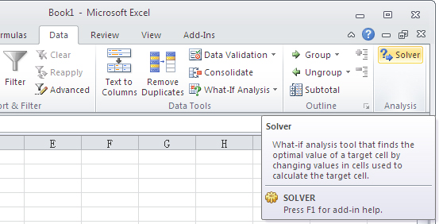
1.6 Goto step 3.

Step 2.
If Solver Add-in is not on your list of available Add-Ins, you will need your Microsoft Office CD-ROM.
2.1 Put the CD in. If the CD doesn’t run its setup program automatically, open My Computer, find setup.exe on the CD and double-click it to run it.
2.2 Check the Add or Remove Features checkbox and click Continue button.
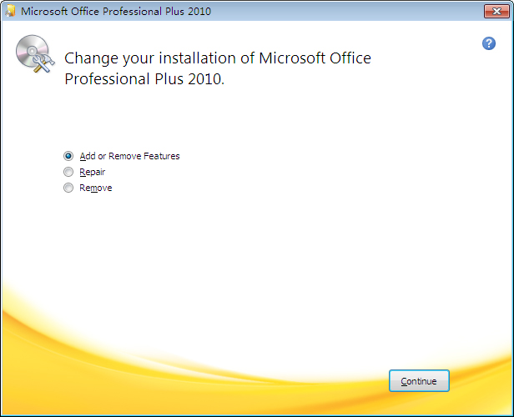
2.3 In the Installation Options tab that then appears, click the little plus sign next to Microsoft Office Excel. This opens up the outline under that box. Click the little plus sign next to Add-ins to open that list up. Look down that list and you should find Solver.
2.4 Click on Solver and choose Run from My Computer, so that the box is white, with no blue “1.” This picture shows how it should look when you are done.
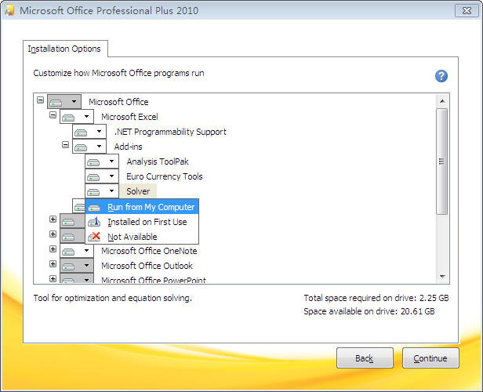
2.5 Then click Continue to proceed with the installation. If your version of Office is different from mime, your screen may look different, but the procedure is near the same.
2.6 Go to step 1 above.

Step 3.
If Solver has already been on the Data tab, you can install PKSolver program by the following operations:
3.1 Unzip the compressed file named “PKSolver.zip” containing a file named “PKSolver.xla”.
3.2 Start Excel and click on File menu and choose Options.
3.3 Go to the Add-Ins tab, and then in the Manage box, select Excel Add-ins, click Go.
3.4 Click Browse to locate the add-in program PKSolver.xla and click OK.
3.5 Check the checkbox for PKSolver, it should look like this:
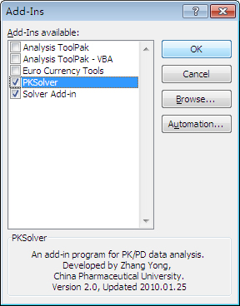
3.6 Click OK. Then a new pull-down menu PKSolver should appear on the Add-Ins tab of Excel, it should look like this:
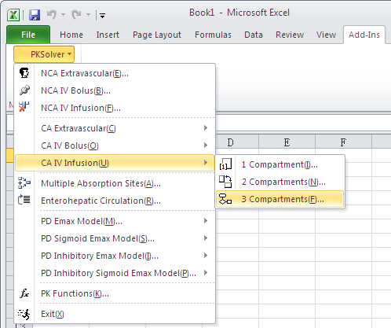
3.7 Restart Excel. From now on, you are allowed to use the PKSolver program with full functions.
3.8 If you want to uninstall the PKSolver program, start Excel and click on File menu and choose Options. Go to the Add-Ins tab, and then in the Manage box, select Excel Add-ins, click Go, deselect the checkbox for PKSolver and click OK, and delete the PKSolvr.xla file.

Questions and comments? Please do not hesitate to contact me: zhangyongcpu@163.com , I will be glad to reply you as soon as possible.

