Detecting Illicit Bitcoin Transactions under Temporal Drift
BT4012 Fraud Analytics — Competition Report · Tim Chua Siam Mgian · A0273128E
Code: https://github.com/timc5nn/BT4012

1. Introduction
The task is to predict, for each Bitcoin transaction in the test set, the probability that it is illicit (linked to scams, ransomware, darknet markets or other crime), scored by ROC-AUC. The training data has 141,772 transactions from time steps 1–35, each with 165 anonymised features and links to other transactions; only 22% are labelled, and 11.7% of those are illicit. All test transactions come from later time steps (36–49), so the model must predict a period it has never seen. Our final model, a recency-weighted XGBoost on 45 features, scores ROC-AUC 0.95483 on the public leaderboard.

2. Methodology

2.1 Data Preprocessing and Feature Engineering
Data quality. No feature has missing values; only the label is missing, for 78% of training rows. The share of illicit transactions swings between 0.4% and 36% across time steps, an early sign that patterns change over time (drift). time_step itself is never a model input, because every test value lies outside the training range.
Graph features. The graph splits into exactly 49 disconnected components, one per time step, so test transactions never connect to a labelled one. Features built from neighbours' labels would therefore be zero for every test row, so we engineered only label-free features, computed identically for training and test data:
- Degree: total degree and out-minus-in degree (consolidation vs. fan-out).
- Centrality: betweenness (estimated from 5,000 sampled sources), closeness and PageRank. PageRank replaced eigenvector centrality, which puts almost all its weight on the largest component and gives ≈ 0 to every other time step.
- Community (Louvain): size, edge density and share of internal edges of each transaction's community.
- Neighbourhood: flow ratio, mean neighbour degree and two-hop reach.
Feature selection. The anonymised features are highly redundant (147 pairs with |r| ≥ 0.9). From 176 candidates, we first grouped near-duplicates (|r| ≥ 0.9) and kept only the member most correlated with the label (78 removed), then pruned iteratively by VIF (threshold 10), each round dropping the least label-relevant feature above the threshold rather than the highest-VIF one (13 removed). This leaves 85 features (74 anonymised, 11 graph), with a maximum VIF of 7.6. Both filters used training data only.
Unlabelled rows. 78% of training transactions have no label, so we tried to turn some of them into extra training examples, hoping more data (especially more illicit examples) would help the model predict more accurately. Label propagation (k-nearest-neighbour, 7 neighbours) spreads the known labels to unlabelled transactions with similar features; we kept only confident predictions (≥ 0.9), giving pseudo-labels for 48,014 transactions. The results said otherwise: adding them lowered validation ROC-AUC from 0.997 to 0.964 (confidence ≥ 0.95) and 0.986 (≥ 0.99), and both versions scored lower on the leaderboard, likely because even confident pseudo-labels contain errors. We therefore trained only on the original 31,235 labels.

2.2 Model Development and Validation
Choice of model. We chose XGBoost (gradient-boosted decision trees) as our main model. Trees capture non-linear patterns and are unaffected by the heavy-tailed, unscaled features; XGBoost accepts a separate weight for every training row (Step 2) and has built-in controls against overfitting (Step 3); and in our baseline comparison the boosting models clearly beat Logistic Regression and Random Forest (Section 2.3). We then developed it in four steps: set up validation that mimics the test setting, weight the training rows, tune hyperparameters, and reduce the feature set.
Step 1: Temporal hold-out validation. We never used k-fold cross-validation: random folds would train on later transactions and score on earlier ones, leaking future information into validation. Instead, every model was trained on earlier time steps and validated on a single, later hold-out window, using two splits:
- Adjacent split (train on steps 1–30, validate on 31–35). The validation window starts right after training, so it tests predictions only 1–5 steps ahead. We used it to compare the baseline models.
- Gap-matched split (train on steps 1–20, validate on 30–35). The 10-step gap means it tests predictions 10–15 steps ahead, closer to the real task, where test transactions lie 1–14 steps after training. We added it because the adjacent split proved far too optimistic: our first model scored ROC-AUC 0.998 on it but 0.940 on the leaderboard, and almost every setting scored ≈ 0.998, leaving no room to tell them apart. It was used for steps 2–4.
Step 2: Sample weights for imbalance and drift. Instead of treating every training row equally, we gave each row its own weight, the product of two factors:
- Class weight. Illicit rows get weight 7.6, the ratio of licit to illicit rows, and licit rows weight 1, so both classes contribute equally; otherwise the model can score well by mostly predicting licit.
- Recency weight w = 0.5^((T − t)/h), where t is the time step the transaction belongs to, T is the latest time step in the training data (35 for the final model; 30 on the adjacent split and 20 on the gap-matched split) and h is the half-life. A row from step T gets weight 1, and the weight halves every h steps further back: with h = 10 and T = 35, a row from step 25 gets 0.5 and one from step 15 gets 0.25. Because fraud patterns drift, recent labels are the best guide to the test period, but older rows still carry signal, so we down-weight rather than drop them.
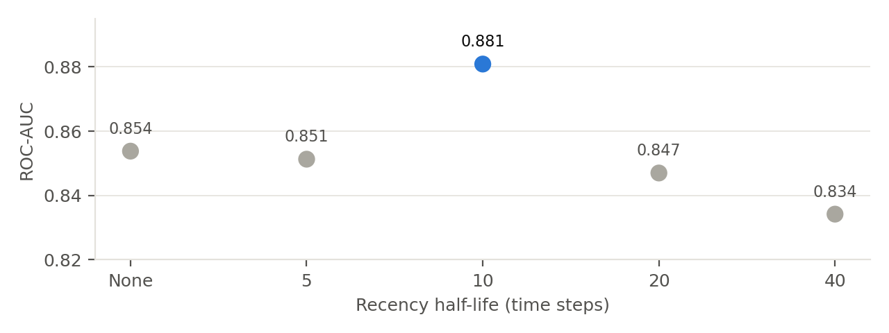
Figure 1. Gap-matched validation ROC-AUC of XGBoost by recency half-life.
Each row's final weight is the product (an illicit row from step 35 counts 7.6; a licit row from step 15 counts 0.25). It is passed to the model as sample_weight, which multiplies that row's error in the training loss, so the model concentrates on getting illicit and recent transactions right. LightGBM and the MLP used the same weights. A half-life of 10 clearly beat no weighting (0.881 vs. 0.854) and half-lives of 5, 20 and 40 (Figure 1), and raised the leaderboard score from 0.940 to 0.949, the largest single gain of the project.
Step 3: Hyperparameter tuning and overfitting control. Our XGBoost settings came from a first tuning round, before the graph features were added: depth 4, learning rate 0.1, 70% of features per tree and L2 penalty 5. Adding features can change which settings work best, so on the final 85 features we re-ran the full grid on the gap-matched split: every combination of tree depth {4, 6, 8}, learning rate {0.05, 0.1, 0.2}, fraction of rows and of features per tree {0.7, 1.0} and L2 penalty {1, 5} (72 setups, 300 trees each). The top setup was less regularised (learning rate 0.2, all features per tree, L2 penalty 1) and scored 0.900, against 0.881 for our settings, which ranked 18th. On the leaderboard, however, it scored lower (0.94936 vs. 0.95430), so we kept our settings. Shallow trees, the L2 penalty and feature sampling all limit how closely the model can fit the training period, which matters when the test period drifts. Picking the best of 72 scores on one window of about 4,900 rows favours setups that suit that window's quirks, so from then on we required the leaderboard to confirm small validation gains.
Step 4: SHAP-based feature selection. SHAP measures how much each feature moves the model's predictions; averaging its absolute value over all rows ranks the features by importance (Figure 2). We ranked the 85 features this way in a model trained on the gap-matched training rows only (so the ranking never saw validation labels), then retrained on the top-ranked ones. Gap-matched ROC-AUC: all 85, 0.881; top 75, 0.851; top 65, 0.859; top 55, 0.862; top 45, 0.882; top 35, 0.870. Only the top 45 matched all 85, and on the leaderboard it scored 0.95483 vs. 0.95430. We kept it as the simpler model, not for a meaningful gain.
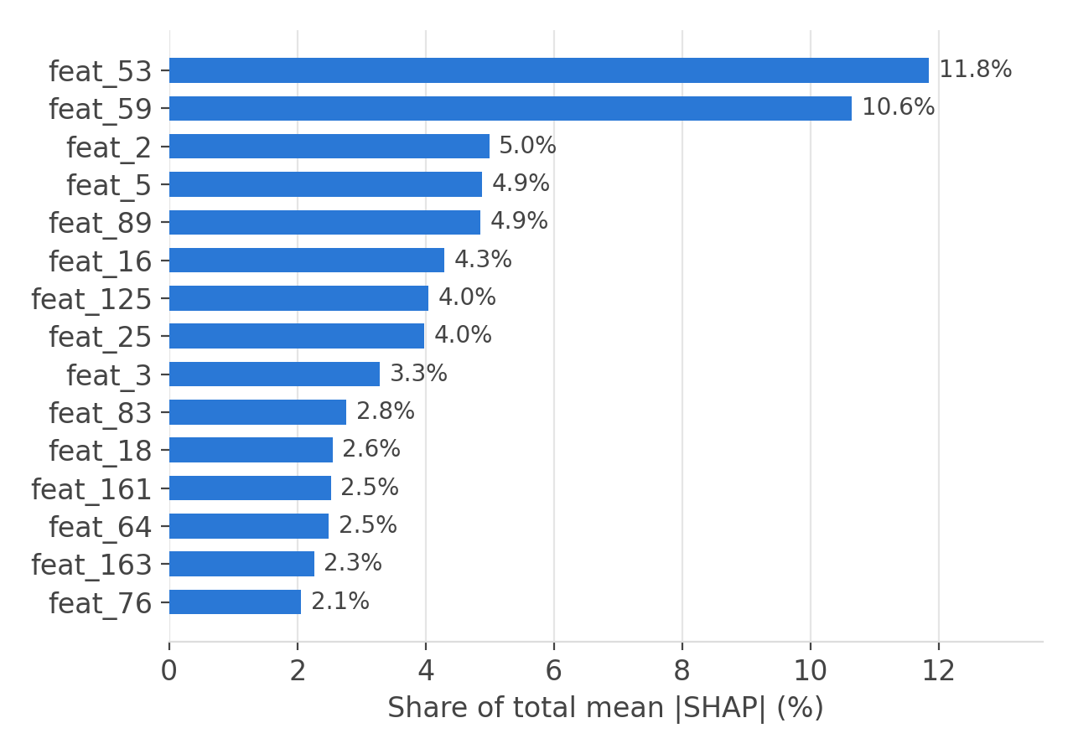
Figure 2. Top 15 features of the final model by share of total mean |SHAP|.

2.3 Model Exploration and Final Strategy
We explored models in three stages (Table 1):
- Baselines (adjacent split, default settings). Logistic Regression was far weaker (0.869), so the boundary between licit and illicit is strongly non-linear. Random Forest was precise (illicit precision 0.988) but missed over a quarter of illicit transactions. The two gradient-boosting models, XGBoost and LightGBM, were best (illicit F1 0.955 and 0.964 vs. 0.838; ROC-AUC ≈ 0.998 for all three tree models), and we built on XGBoost.
- Stronger alternatives. We then tried models that could beat the XGBoost recipe: a re-tuned XGBoost, a tuned LightGBM and a neural network (a multi-layer perceptron with one hidden layer of 64 units, quantile-scaled inputs and predictions averaged over five random seeds). Each scored higher than XGBoost on the gap-matched split, but all three scored lower on the leaderboard. A deeper two-layer network did worse still.
- Ensembles. We averaged the ranks of two models' predictions (ROC-AUC only scores the ordering). A blend only helps if the models make different mistakes: LightGBM ranked transactions almost like XGBoost (correlation 0.94), so blending gained nothing. The MLP was very different (0.68) but too weak. The Random Forest blend scored slightly higher on the adjacent split (0.998 vs. 0.997) but lower on the leaderboard.
Model | Adjacent split | Gap-matched split | Leaderboard
XGBoost, final recipe | 0.997 | 0.881 | 0.95483
XGBoost, re-tuned (less regularised) | — | 0.900 (better) | 0.94936 (worse)
LightGBM, 7 leaves (tuned) | — | 0.890 (better) | 0.95286 (worse)
MLP, one hidden layer | 0.962 (worse) | 0.899 (better) | 0.91393 (worse)
XGBoost + MLP rank blend (70/30) | 0.992 (worse) | 0.888 (better) | 0.95098 (worse)
Random Forest + XGBoost blend (50/50) | 0.998 (better) | — | Worse
Logistic Regression | 0.869 (worse) | — | —
Table 1. ROC-AUC of the main candidates; "better/worse" is relative to the XGBoost recipe on the same split. XGBoost validation uses all 85 features; other figures were recorded at the time of each experiment. "—" = not measured.
Final strategy. We accepted a change only when validation supported it and the leaderboard confirmed it. The final submission is the XGBoost model from Section 2.2, trained on all 31,235 labelled transactions with class and recency weights (half-life 10), using the top 45 features by SHAP.

3. Results and Discussion
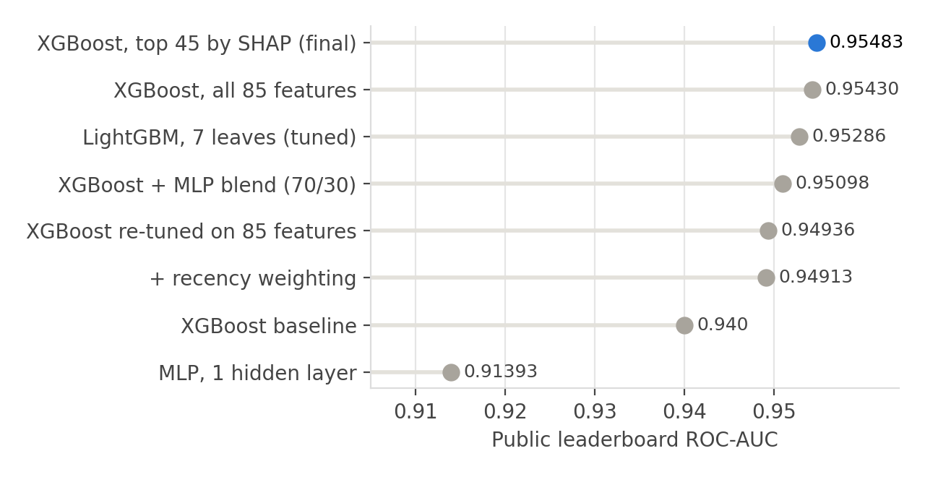
Figure 3. Public leaderboard ROC-AUC of our scored submissions.
Drift explains the gap between validation and leaderboard. Models scoring ≈ 0.998 on the adjacent split scored 0.94–0.95 on the leaderboard. A classifier trained to tell early from late time steps using only the features reached ROC-AUC 1.0, so the features themselves change over time. The test period also spans the shutdown of a major dark market (around step 43 in the original Elliptic study), a shift no training data covers. This is why recency weighting helped most.
Neither validation split was reliable on its own (Table 1). The gap-matched split was right about training choices (recency weighting, the half-life), but it favoured every more flexible model, and all of them lost on the leaderboard. The adjacent split also misled once, favouring the Random Forest blend. With one window of about 4,900 rows, differences of 0.01–0.02 are within noise, and a 72-configuration grid will find a model that fits that window's quirks. The adjacent split is near its ceiling, yet it correctly predicted the MLP's loss (−0.035 on validation, −0.041 on the leaderboard). We therefore used the gap-matched split for training choices, the adjacent split as a check on model families, and the leaderboard as the final arbiter. Across all experiments, more regularised models held up better.
What drives the model. By SHAP (Figure 2), two anonymised features dominate (feat_53 and feat_59, about 12% and 11% of total impact). No graph feature reaches the top 15, yet adding the graph features raised the leaderboard score: they add a small amount of information the anonymised features lack. Removing the most time-revealing features found by adversarial validation lowered the score, so drifting features can still carry signal.
Limitations. Each validation split is a single window; more than a dozen leaderboard submissions risk overfitting its public portion, and the final choice (0.95483 vs. 0.95430) rests on a difference of that size. The features are anonymised, which limits domain interpretation.

4. Conclusion and Reflection
We built a recency-weighted XGBoost model with redundancy- and VIF-based feature selection, label-free graph features and SHAP-based reduction, reaching a public leaderboard ROC-AUC of 0.95483. Recency weighting produced the largest gain and graph features the second, while more flexible models (LightGBM, a neural network), heavier tuning, ensembles and pseudo-labels did not beat a regularised XGBoost.
What worked was disciplined, time-aware validation: two splits testing different distances, with the leaderboard as a final check, kept us from adopting changes that only one split supported. What could be improved: rolling-origin validation over several windows would give more stable estimates and would have flagged misleading tuning results earlier, and features normalised within each period could reduce drift.
The project changed how we think about AI-driven fraud detection. Fraud is adversarial: as detection improves, criminals adapt, so accuracy decays over time. A production system needs time-aware validation, monitoring and regular retraining rather than a one-off model, and negative results deserve as much attention as positive ones, because understanding why an idea fails often reveals more about the data.
Code: notebooks 01–05 on GitHub (link above); running 02 then 03 reproduces the final submission exactly.

