The Opening Report of A Life Assistant for Solitary Elderly People Based on a Mobile App and a Web Console
Section 4 Technical Proposal · the caregiver console and cloud service · Lin Xianhai, Chen Qiuting
Draft note — delete before submission. The report follows the ten sections prescribed in class; this file is only the 4.2 block of Section 4, and the mobile client (4.1) is written separately by the app group. Renumber 4.2 if the group orders the proposal differently. Text in [amber brackets] could not be established from the project files and must be filled in or cut. If space is short, drop 4.2.6 and 4.2.7.

4. Technical Proposal 技术方案
The system is made of one mobile client on the elder's side, one web client on the caregiver's side, and a single cloud service that both speak to. The mobile client is described in 4.1; this subsection covers the caregiver console and the service behind it, together with the data model and the interface that the two clients are required to share.

4.2 Caregiver Web Console and Cloud Service 照护者端 Web 与云服务

4.2.1 Why a second client is required
Two clauses in the assignment assume that a second person is involved. Reminder plans are entered by the user or by a caregiver, and unconfirmed occurrences must be recorded — which is only meaningful if someone other than the elder can read the record. A system that lives only on the elder's phone satisfies neither clause, because that phone has no idea who should be told when a dose is missed.
The console and the cloud service behind it are therefore baseline scope rather than an optional extension, and they are the only place where data from two devices can meet: without a shared store, remote plan creation, missed-dose alerts and a weekly review are all impossible, whatever the interfaces look like.
It is a web application rather than a second mobile application because caregivers — usually adult children — are at a desk or on a laptop, so a URL removes an installation step and a version to maintain. It also keeps the deliverable small: two clients, one shared API and one data model that both sides must accept, which is three deployed tiers rather than four (the optional device tier is described in 4.2.3).

4.2.2 Function definition of the console
The console supports four caregiver tasks.
- Plan authoring. Create, edit, pause and delete plans, using the same seven recurrence patterns as the mobile client: daily, every N days, weekly on given weekdays, monthly on a given date, a course of N days, an offset relative to a meal, and a one-off. Editing a plan never rewrites occurrences that have already happened.
- Monitoring. Today's occurrences with their state, and the event log — enough to answer “why was this escalated at 08:17” without reading the source code.
- Alerting. Receiving an escalation when an occurrence is still unconfirmed past the threshold, and confirming on the elder's behalf, with the acting identity written into the log.
- Export. A CSV of records and events, so a family keeps an archive and can bring a month of raw records to a consultation. It is an archive, not a clinical report: drug names are free text and the number of planned doses is exported alongside the confirmed ones instead of being scored.
One negative decision belongs here. The accessibility rules required by the assignment — 24 pt body text, 7:1 contrast, at most four choices per screen, at most three steps per task — are applied to the elder side only. The console is optimised for information density instead, because its user is a younger adult scanning a week of data. Keeping the accessibility budget concentrated on one surface is what makes the numbers in 4.1 verifiable.

4.2.3 Architecture
Figure 1 shows the three tiers that are always deployed — mobile client, cloud service and web console — plus an optional device tier.
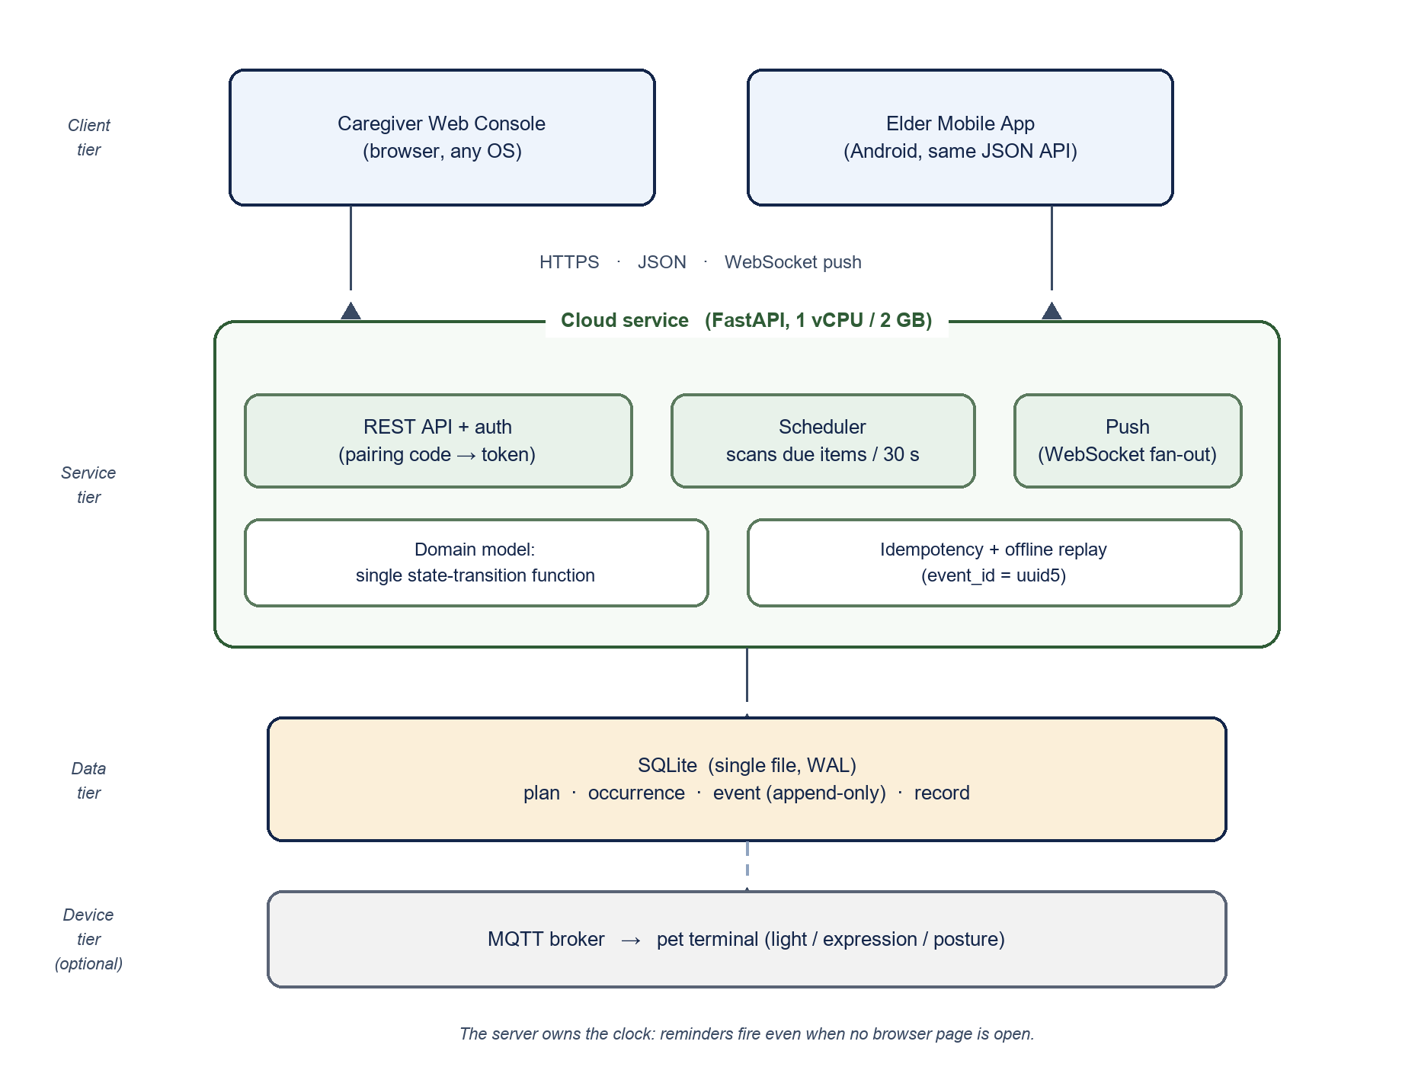
Figure 1. Three deployed tiers (mobile client, cloud service, web console) plus an optional device tier, which applies only if the advanced requirement on a pet-shaped terminal is attempted.
The placement of the scheduler is the most important decision in this subsection. It is placed twice: the mobile client runs a 30-second tick over its own local copy of the occurrences, so a reminder fires at the due second even when the device is offline; the service keeps a second scheduler that does not depend on the phone being reachable, and that one owns escalation and the final missed verdict. The division is deliberate: the phone owns what only it can observe (the elder is looking at the screen), the service owns what must happen when nobody answers. It runs inside the service process and scans for due occurrences every 30 seconds; it does not depend on any browser page being open. A design that schedules reminders with browser timers demonstrates perfectly and then fails in ordinary use, because the caregiver closes the tab. That is why the cloud component cannot be replaced by “just use the browser”. The scan interval is also the bound on dispatch latency: a reminder due at 08:00:00 leaves the server on the first scan after that moment, so worst-case delay is one interval, and the acceptance target in 4.2.6 is stated as 30 s rather than 5 s for that reason. The first transition to notified happens at the due instant, not after the escalation threshold, so the reminder itself is never late; the thresholds only govern how quickly an unconfirmed reminder reaches the caregiver. A snoozed occurrence returns to notified state when its gap expires, at most three times; a fourth request is recorded as missed by the same function that handles the other transitions.

4.2.4 Data model and interface
Four business tables carry the system. Four supporting tables hold what is not reminder state — user, link (which caregiver is bound to which elder), alarm and session (an issued token) — and an outbox table holds outbound events that a broker or webhook will pick up. The separation of plan and occurrence is the load-bearing decision: collapsing them would make it impossible to change a plan without falsifying the past. The seven recurrence patterns share one JSON rule object rather than seven columns: daily uses the times only; every N days adds a start date and N; weekly adds weekdays; monthly adds a day of month; a course adds a start date and a number of days; a meal offset adds an anchor meal and a signed minute offset; a one-off adds a single date. One resolver reads that object, so a new pattern needs no migration. The mobile client keeps a local mirror of the same three tables — plans, occurrences and events — and reads it on cold start before any network call, so the today screen works with no connectivity; events carry the client-generated event_id as primary key, which is what makes replayed queues idempotent on both sides.
Table | Purpose | Key fields
plan | One reminder rule: “take Amlodipine at 08:00” | id, elder_id, title, times[], rule (JSON: kind plus parameters), dose, note, active, paused_until, created_at
occurrence | One concrete instance of a plan on one day | id (uuid5 of plan_id + due_at), plan_id, due_at (UTC), state, level, snooze_count, notified_at, confirmed_at, missed_at
event | Append-only log of everything that happened | event_id (uuid5 of occurrence_id + action + client_ts), occurrence_id, action, actor, source, payload (prev_state, new_state, level, reason), at (UTC)
record | Measurement or lifestyle entry: sleep, water, activity, meal | id, elder_id, type, value, unit, at, note, revision, superseded_by, deleted
Table 1. The four business tables. Supporting tables are user, link, alarm, session and outbox; none of them carries reminder state.
The interface follows from the tables rather than the other way round: the console can only do what the data model allows, which is why the list is short. Table 2 gives the surface both clients share; every write is idempotent through the event table.
Method and path | Purpose | Note
POST /api/v1/auth/pair | Exchange the pairing code for a token | The only credential in the system
POST /api/v1/plans | Create a plan; PATCH edits or pauses it | Never touches occurrences that already exist
GET /api/v1/occurrences | Occurrences and their state, filtered by date | One call fills the console's main screen
POST /api/v1/occurrences/{id}/events | Confirm, snooze or report missed | Body carries event_id; a repeat is a no-op
POST /api/v1/records | Append a record; PATCH corrects one | A correction writes a new event, never overwrites
GET /api/v1/stats | Daily and weekly aggregates | The console computes nothing itself
GET /api/v1/alerts | Unconfirmed occurrences past the threshold | The same query the escalation job uses
Table 2. The endpoint surface shared by the console and the mobile client. All paths are relative to /api/v1. The endpoints listed here form the contract surface shared with the mobile client; the console-only endpoints (overview, occurrences/action, alarms, alarms/wait, metrics, preview, export.csv) are internal and carry no compatibility promise.

4.2.5 State and idempotency
An occurrence moves through a fixed set of states: pending, notified, snoozed, confirmed, missed and escalated, with a snoozed occurrence returning to notified when its gap expires. Exactly one function may change that state, core.transition(occurrence, action, actor, now), and every entry point calls it — the console, the mobile client and the scheduler. No interface writes the state column directly, which is what makes it possible to answer “who caused this, and why” from the log alone.
Duplicate submission is prevented by construction rather than by patches: every write carries an idempotency key, event_id = uuid5(occurrence_id, action, client_ts), with a unique index, so a retried request or a replayed offline queue is inserted once and then ignored. Correction works the same way. The log is append-only — a mistake is superseded by a correction event recording the old value, the new value and the author, never deleted — and every transition event also stores the state before and after the change together with the level that triggered it, so the escalation of one occurrence can be justified by a single query instead of by replaying the table. All timestamps are stored in UTC with an explicit zone, because storing local time without one is the usual way a reminder application develops duplicate or negative countdowns. Identity is carried separately from storage: each occurrence keeps a local wall-clock slot (slot_local) as its stable identity and a UTC due instant (due_at_utc) as the scheduled time. Storage stays entirely in UTC; the slot exists so that a time-zone change reinterprets the instant instead of creating a second row for the same reminder.

4.2.6 Deployment and measurable targets
The service runs on one student-tier virtual machine — one vCPU, two gigabytes — behind a reverse proxy that obtains TLS certificates automatically, with a single application worker. The reason is the scheduler rather than SQLite: WAL already allows concurrent readers with one writer, but two workers would run two escalation loops and dispatch every reminder twice. No container orchestration: it would add a failure mode without adding a capability this project needs. A night ly online backup (.backup into a second volume) runs from cron, and the service refuses new writes once free disk space drops below a fixed watermark, because on a single machine a full disk stops reminders silently.
The subsection is only credible if it states numbers that can be checked, so the following are proposed as acceptance criteria:
- Server-side dispatch delay at or below 30 s at the 95th percentile — one scan interval — measured from due time to the moment the notified state is written. The measurement counts forward dispatch only: an occurrence must already exist before its due instant, and backfilled rows are counted separately and excluded, because writing history is not dispatch. Measured with tools/sample_p95.py: p95 = 15.0 s at a 30 s scan interval, which satisfies the target; before the fix described below the same measurement produced p95 = 123 s. API response time is a different quantity and is targeted at or below 5 s at the 95th percentile over a hundred sequential requests; measured p95 = 34 ms. The two are reported as two numbers, not one.
- The escalation chain has three tiers: notified at the due instant; escalated to the caregiver after CAREMATE_THRESHOLD_1 (default 2 minutes); a second, level-3 alarm after CAREMATE_THRESHOLD_2 (default 5 minutes) so a caregiver who missed the first alert is reminded once more; and missed after CAREMATE_THRESHOLD_3 (default 15 minutes). The only change from the original 2/5/15 schedule is the first tier: the transition to notified happens at the due instant rather than two minutes later, because waiting before the first reminder was a defect rather than a design choice.
- A replayed batch of three queued events produces exactly three event rows and no duplicates, however many times the batch is retried. The client-side queue itself belongs to 4.1, which owns offline storage on the phone; 4.2 only guarantees that the server is idempotent when that queue is replayed.
- Across ten forced restarts, no occurrence is lost and none is duplicated.
- Every escalation is justified by a single query over the event table filtered by occurrence and time, because each transition row already carries the state before and after the change.
- A request for another family's data is rejected with 403, which shows the pairing model is enforced on the server and not only in the interface.

4.2.7 What we deliberately do not build
Scope control is part of the design. There are no accounts and passwords — a pairing code exchanged for a token keeps a stranger out at a fraction of the cost, and the code is protected the cheap way rather than the expensive one: the server accepts at most five pairing attempts per minute per address, so a four-digit code cannot be enumerated in any useful time. One elder may be bound by several caregivers, but each caregiver account serves a single elder; there is no mode in which one caregiver manages multiple elders. There is no integration with emergency services or hospitals, and no suggestion of a dose. There is no promise of round-the-clock availability, because a course project cannot deliver it and claiming it invites the one question we cannot answer.

