Shane Saunders & Tim Jensen

Dr. Mingrui Zhang

CS485

10/25/18

Art Database: Milestone II Report

Data

To import the data we will be using, which is in the form of JSON files, we have created a Java program that parses JSON files, formats and cleans the data as needed, then inserts it into the database using JDBC. Our program supports insertion into multiple different tables, and currently supports 14 out of 18 columns needed for the Object table (lacking a few foreign key constraints) as well as 4 out of 5 for the Artist table (lacking a foreign key). So far, we are capable of importing at least 1410 unique entries for Object, giving us 264 unique entries for Artist, however it is trivial to add much more. The Department table has been completetly filled, as there are only 11 department entries it is easily manually created. Further functionallity will need to be added to the program to support Culture_info, Spec, Room, and Exhibition tables, as well as the associated foreign keys that will need to be generated.

List of Variables

As far as the data goes for our tables, we will be keeping most variables from the object database the MIA has provided us. For the object, we will be keeping the following attributes:

* Artist name, title, description, signature, dated, markings, style, classification, approval, credit_line, accession_number, room name, dimensions, continent, country, nationality

We will be dropping information on the images for their database, as they are not available to us easily and many are under copyright law. We also will not keep the ‘culture’ attribute as it is null in all cases and appears to be unused. All variables from the other data groups we plan to keep. These are listed in our relational schema below.

Relational Schema

Object(object_id, artist_id, artist_id artist_name, culture_id, room_id, department_id, spec_id, exhibition_id, title, description, signature, dated, markings, style, classification, approval, credit_line, accession_number)

Room(room_id, room_name)

Department(department_id, department_name)

Spec(spec_id, dimensions)

Culture_info(culture_id, continent, country)

Artist(artist_id, artist_name, life_date, nationality, portfolio_id)

Functional dependencies

ER diagram

Program design: Object Search

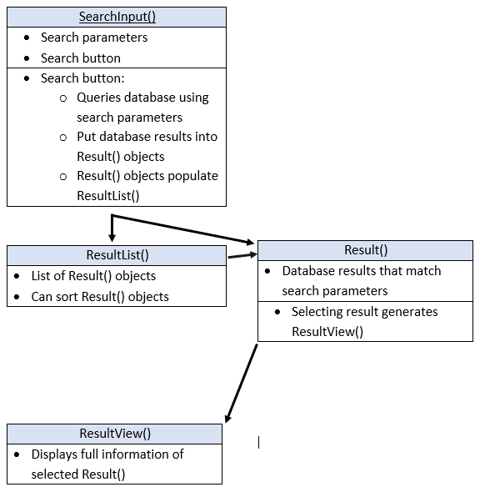

Program Design: Department Search

