Tracking Bipolar Mood States with Survey Data  
Individual Project: Design

Timothy Crone  
tcrone3@gatech.edu

# Project Summary

Bipolar disorder is a debilitating psychiatric mood disorder characterized by states of mania and depression (Goldstein, 2010). It is one of the most common psychiatric disorders, identified in more than 4% of Americans (Kessler et al., 2005). Clinicians often use the Bipolar Depression Rating Scale (BDRS) for bipolar-specific depression symptom scoring (Berk et al., 2007), and rely on patient-reported multivariate mood data (Perez-Arribas, Goodwin, Geddes, Lyons, & Saunders, 2018) for further diagnostic information.

This project automates collection and presentation of survey data using SMART on FHIR embedded apps; the patient-facing app collects and records mood state, while the provider-facing app collects and stores BDRS data. The provider app also displays charts of collated historical and current data, allowing a provider additional insight into mood trajectory or severity.

# Tools and Technology

Both SMART on FHIR apps use ECMAScript, loosely based on the architecture for lab 3.2 (Vansia & CS6440 Staff, 2020). Hosting will be through GitHub pages using the Georgia Tech GitHub server (GitHub, 2020). Delivery will be through the SMARTHealthIT interface (Computational Health Informatics Program, 2019); due to a lack of support for patient portal writes and FHIR v4 in the patient context, Cerner Code will not be supported (Cerner, 2020).

* smarthealthit.org (Computational Health Informatics Program, 2019)
* r4.smarthealthit.org (Computational Health Informatics Program, 2019)
* SMART on FHIR (Mandel, Kreda, Mandi, Kohane & Ramoni, 2016)
* ECMAScript (ECMA International, 2020)
* npm for package management (npm, 2020)
* client-js / fhirclient (Computational Health Informatics Program, 2020)
* jquery.barrating (antenna.io, 2020)
* moment.js (Moment Team, 2020)
* chart.js (chart.js contributors, 2020)

# Data Sources

In the SMART on FHIR framework, the apps’ FHIR servers are determined by the invoking interface context. For development purposes the smarthealthit.org server at r4.smarthealthit.org will be used, along with the standard patients and providers defined by the development portal. Because the generated patients in the public servers lack historical data, for demonstration purposes an option will be included in the provider app to populate synthetic mood state and depression scoring histories for the selected patient.

Multivariate patient-reported mood data collected during the Perez-Arribas, Goodwin, Geddes, Lyons, & Saunders study was redacted due to patient privacy concerns (2018); other collections of mood data tend to lack either depth or breadth. For example, Saari & Eerola collected instantaneous mood data across many users but inconsistently through time (2013); Lee collected a substantial history but only tracked a single mood state (2019). Due to the absence of an appropriate public dataset, all historical patient-reported mood data will be generated using a quasi-random process in a format consistent with the Perez-Arribas, Goodwin, Geddes, Lyons, & Saunders study.

While comprehensive time-based BDRS histories are unavailable for similar reasons, the depresjon dataset includes MADRS scores at multiple timepoints for a variety of patients (Garcia-Ceja, et al., 2018). Because BDRS and MADRS scores are strongly correlated (Berk, et al., 2007) comparable BDRS scores will be interpolated for the sake of generating historical BDRS data.

# Diagrams

1. System architecture.

# Screen Mock-Ups

1. Provider survey entry screen.
2. 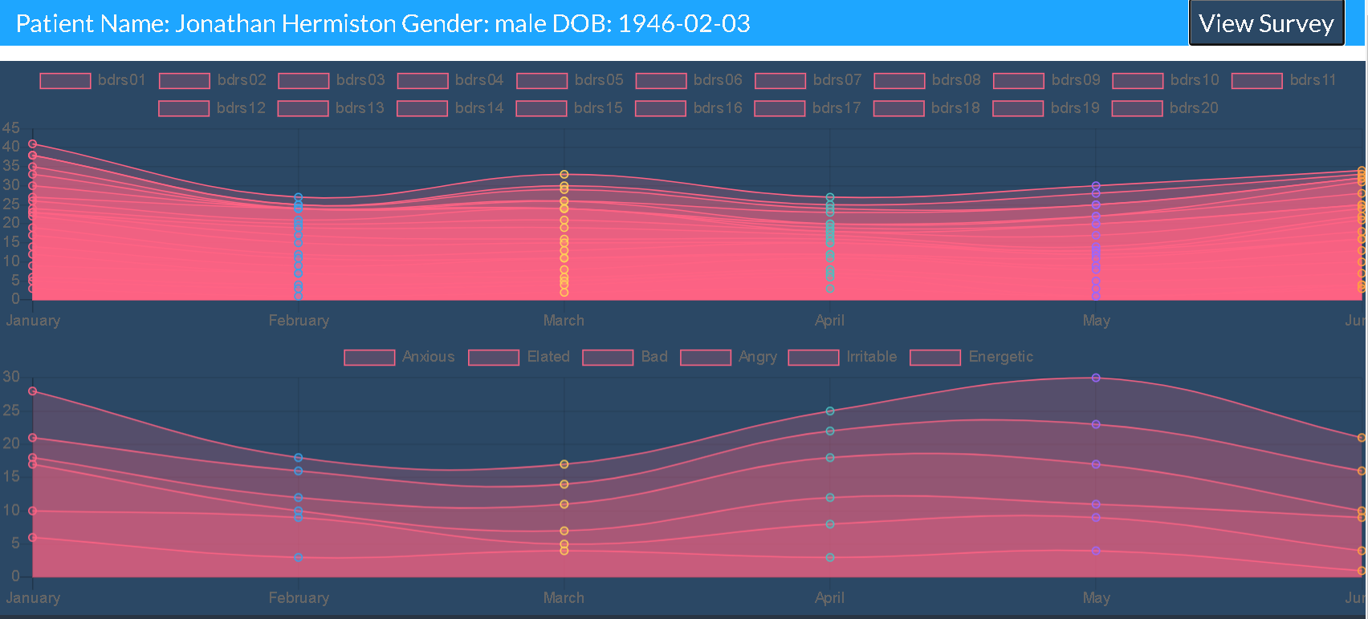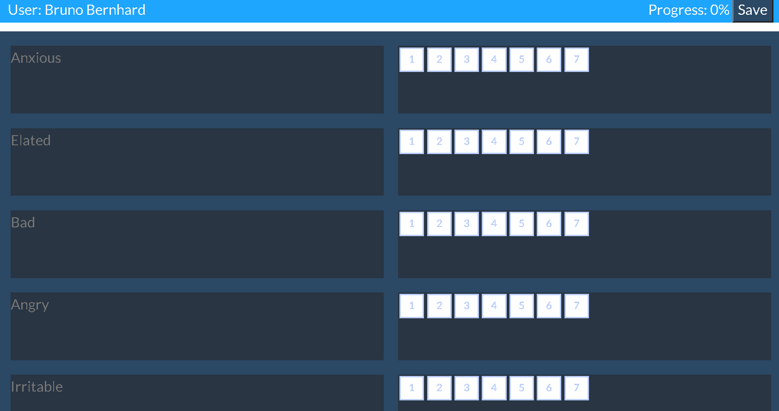Patient survey entry screen.
3. Provider history screen.

# References

1. antenna.io. (2020). *Antennaio/jquery-bar-rating*. GitHub. https://github.com/antennaio/jquery-bar-rating
2. Berk, M., Malhi, G. S., Cahill, C., Carman, A. C., Hadzi-Pavlovic, D., Hawkins, M. T., Tohen, M., & Mitchell, P. B. (2007). The Bipolar Depression Rating Scale (BDRS): its development, validation and utility. *Bipolar Disorders*, *9*(6), 571–579. https://doi.org/10.1111/j.1399-5618.2007.00536.x
3. Cerner. (2020). *App Registration*. Cerner Code. https://code.cerner.com/developer/smart-on-fhir/register
4. chart.js contributors. (2020). *chart.js*. Chartjs.Org. https://www.chartjs.org/
5. Computational Health Informatics Program. (2019). *SMART Health IT - Connecting health system data to innovators’ apps*. Boston Children’s Hospital. https://smarthealthit.org/
6. Computational Health Informatics Program. (2020). *SMART on FHIR JavaScript Library*. Boston Children’s Hospital. http://docs.smarthealthit.org/client-js/
7. ECMA International. (2020). *Standard ECMA-402*. ECMA. https://ecma-international.org/publications/standards/ecma-402.htm
8. Garcia-Ceja, E., Riegler, M., Jakobsen, P., Tørresen, J., Nordgreen, T., Oedegaard, K. J., & Fasmer, O. B. (2018). Depresjon. *Proceedings of the 9th ACM Multimedia Systems Conference*. https://doi.org/10.1145/3204949.3208125
9. GitHub. (2020). *GitHub Pages*. https://pages.github.com/
10. Goldstein, T.R. (2010). Bipolar Disorder. In *The Corsini Encyclopedia of Psychology* (eds I.B. Weiner and W.E. Craighead). doi:10.1002/9780470479216.corpsy0134
11. Kessler, R.C., Berglund, P.A., Demler, O., Jin, R., Merikangas, K.R., Walters, E.E. (2005). Lifetime prevalence and age-of-onset distributions of DSM-IV disorders in the National Comorbidity Survey Replication (NCS-R). *Archives of General Psychiatry*, 62(6), 593-602.
12. Lee, M. (2019, August 13). *MikeHLee/NeuroFlow-Patient-Analysis*. GitHub. https://github.com/MikeHLee/NeuroFlow-Patient-Analysis/
13. Mandel, J. C., Kreda, D. A., Mandl, K. D., Kohane, I. S., & Ramoni, R. B. (2016). SMART on FHIR: a standards-based, interoperable apps platform for electronic health records. *Journal of the American Medical Informatics Association*, *23*(5), 899–908. https://doi.org/10.1093/jamia/ocv189
14. Moment Team. (2020). *Moment.js | Home*. Momentjs. https://momentjs.com/
15. npm. (2020). *npm | build amazing things*. NPM JS. https://www.npmjs.com/
16. Perez-Arribas, I., Goodwin, G. M., Geddes, J. R., Lyons, T., & Saunders, K. E. A. (2018). A signature-based machine learning model for distinguishing bipolar disorder and borderline personality disorder. *Translational Psychiatry*, *8*(1), 274. https://doi.org/10.1038/s41398-018-0334-0
17. Saari, P., & Eerola, T. (2013, June 6). *Semantic computing of moods based on tags in social media of music*. Harvard Dataverse. https://dataverse.harvard.edu/dataset.xhtml?persistentId=doi:10.7910/DVN/TVYEGI
18. Vansia, R. & CS6440 Staff. (2020, August 23). *Lab 3.2*. GitHub. https://github.gatech.edu/cs6440-hub/lab-3-2