# Individual Project Implementation Plan

Timothy Crone

tcrone3@gatech.edu

## Background

The project is a pair of SMART on FHIR interfaces that supports treatment of bipolar patients. These interfaces collect patient- and provider-entered depression and mood state information using validated surveys. Additionally, the provider interface displays a collated graph of patient and provider data, as well as their individual components, that is collected over time. For the purposes of this project historical data will be generated.

## Project Tasks

A somewhat more legible version of the below is available at:

<https://github.gatech.edu/tcrone3/cs6440-individual/projects/1>

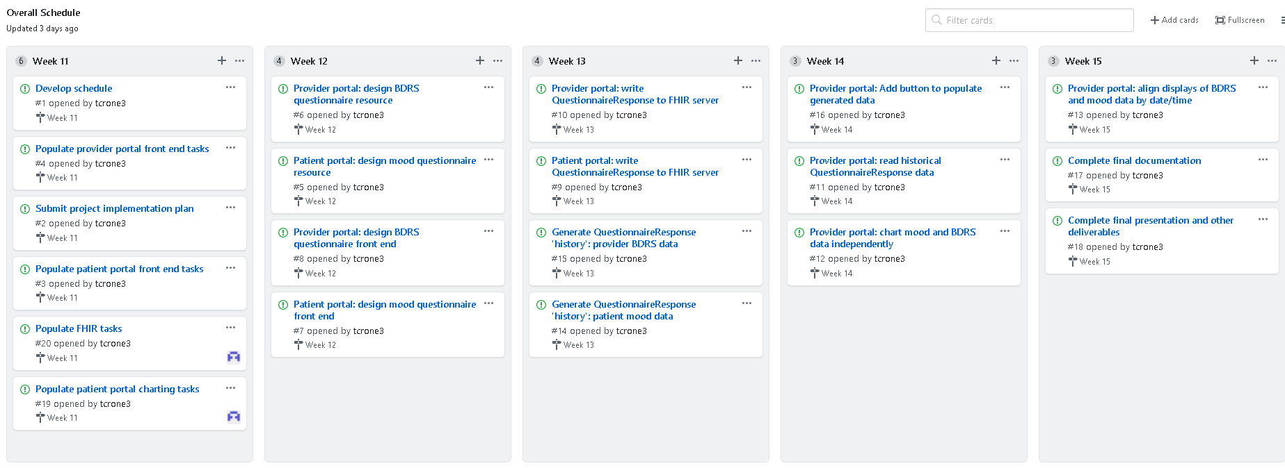

Functionally, the tasks break into several loose categories:

1. Questionnaire development in FHIR
2. Data collection front end for both patient and provider
3. QuestionnaireResponse saving in FHIR
4. Artificial QuestionnaireResponse generation
5. Provider charting front-end
6. Administration and deliverables

## Project Timeline

As displayed on the board, individual project tasks are aligned with their respective week-long sprints. To match the timing of deliverables each sprint begins on Monday:

1. Week 11 – 10/26-11/1
2. Week 12 – 11/2-11/8
3. Week 13 – 11/9-11/15
4. Week 14 – 11/16-11/22
5. Week 15 – 11/23-11/28

## Needs / Risks

Overall, the project will need consistent access to the Georgia Tech GitHub system, GitHub pages to work reliably, the smarthealthit.org site to respond reasonably, and the FHIR v4 smarthealthit.org server to be available. These external dependencies are relatively low risk. Assuming reasonable definition, deliverables required by the course will need a clear head and stable typing fingers but otherwise are similarly low risk.

Creating the Questionnaire resource depends on the FHIR implementation of the resource, and thus a stable FHIR interface. The surveys are not particularly complex, so there is little risk that the survey cannot be fully defined in the FHIR resource. Similarly, QuestionnaireResponse data will require the ability to write the resource to FHIR from both the patient and provider portals; it is possible that patient portal permissions may require some workaround due to security implementations. The FHIR interface is defined so this should be a modest risk.

Reading the QuestionnaireResponse resources and charting them through time – including aligning missing time points – will require development to properly organize the display. An additional significant step will be the proper alignment of the patient and provider responses. Finally, building an intuitive display of the individual contributions of each mood factor will be a complex use of the charting library. Because of the maturity of the library, however, these risks are only moderate.

Finally, creating a realistic history is non-trivial; while truly random data would be easy to create it also makes it hard to get a clear understanding of the project. However, creating non-random data: generated data needs to be both faithful and realistic while also being broad enough to demonstrate edge cases. The major risk of this effort is scheduling rather than external concerns, hence much of week 13 is allocated to this effort; this will allow for possible spillover into week 14.