Performance measures
Table 1: CMS codes and descriptions of the performance measures. Asterisks indicate that data were available for the corresponding year. Measure 014.01 was excluded because there were only two non-missing values; measure 018.01 was left out of the data set.
CMS ID | Description | Years available
 |  | 2016 | 2017 | 2018
 | Process measures
002.01 | Patients assessed and given influenza vaccination |  | *
008.01 | Percentage of patients whose functional abilities were assessed and whose functional goals were included in their treatment plan |  |  | *
016.01 | Influenza vaccination coverage among healthcare personnel |  | *
020.01 | Medicare spending per beneficiary (MSPB) in IRFs |  |  | *
 | Outcome measures
001.01 | Rate of pressure ulcers that are new or worsened (version 1) | * | *
001.02 | Rate of pressure ulcers that are new or worsened (version 2) |  |  | *
006.01 | Catheter-associated urinary tract infection (CAUTI) |  | * | *
007.01 | Rate of potentially preventable hospital readmissions 30 days after discharge | * | *
013.01 | Percentage of patients who fell with major injury during their stay |  |  | *
015.01 | Clostridium difficile infection (CDI) |  | * | *
019.01 | Rate of successful return to home and community |  |  | *
 | Excluded measures
014.01 | Rate of methicillin-resistant Staphylococcus aureas (MRSA) infection
018.01 | Rate of potentially preventable hospital readmissions during IRF stay

Descriptive statistics
Table 2: Descriptive statistics of facility characteristics and performance measures by year
 | Year
 | 2016 | 2017 | 2018
 | n = 1,273 | n = 1,242 | n = 1,228
Facility characteristics
Number of patients discharged [median (Q1, Q3)] | 219 [128, 438] | 222 [128, 436] | 226 [128, 455]
Cost-to-charge ratio [mean (sd)] | 0.48 (0.18) | 0.46 (0.17) | 0.46 (0.17)
Wage index [mean (sd)] | 0.95 (0.17) | 0.95 (0.18) | 0.95 (0.18)
Urban/rural [n (%)]
Urban | 978 (86.2%) | 982 (86.7%) | 993 (87.1%)
Rural | 157 (13.8%) | 151 (13.3%) | 147 (12.9%)
Disproportionate share [median (Q1, Q3)] | 0.1 [0.1, 0.2] | 0.1 [0.1, 0.2] | 0.1 [0.1, 0.2]
Census region [n (%)]
New England | 36 (3.2%) | 36 (3.2%) | 35 (3.1%)
Middle Atlantic | 155 (13.7%) | 156 (13.8%) | 154 (13.5%)
East North Central | 163 (14.4%) | 163 (14.4%) | 165 (14.5%)
West North Central | 204 (18.0%) | 198 (17.5%) | 203 (17.8%)
South Atlantic | 72 (6.3%) | 75 (6.6%) | 72 (6.3%)
East South Central | 96 (8.5%) | 95 (8.4%) | 97 (8.5%)
West South Central | 221 (19.5%) | 223 (19.7%) | 232 (20.4%)
Mountain | 84 (7.4%) | 84 (7.4%) | 81 (7.1%)
Pacific | 104 (9.2%) | 103 (9.1%) | 101 (8.9%)
Ownership type [n (%)]
Government | 142 (12.5%) | 129 (11.4%) | 120 (10.5%)
Non-profit | 661 (58.3%) | 653 (57.7%) | 634 (55.6%)
Profit | 331 (29.2%) | 350 (30.9%) | 386 (33.9%)
Teaching facility [n (%)]
Non-teaching | 1037 (91.4%) | 1029 (90.8%) | 1032 (90.5%)
Teaching | 98 (8.6%) | 104 (9.2%) | 108 (9.5%)
Freestanding facility [n (%)]
In-hospital | 884 (77.9%) | 870 (76.8%) | 864 (75.8%)
Freestanding | 251 (22.1%) | 263 (23.2%) | 276 (24.2%)
Population severity (avg_wt) [mean (sd)] | 1.19 (0.11) | 1.19 (0.11) | 1.21 (0.11)
Process measures
Patient flu vaccination [median (Q1, Q3)] | – | 95.5 [89.9, 98.6] | –
Functional assessment [median (Q1, Q3)] | – | – | 100.0 [99.9, 100.0]
Healthcare provider flu vaccination [median (Q1, Q3)] | – | 92.0 [80.0, 97.0] | –
MSPB [median (Q1, Q3)] | – | – | 1.0 [0.9, 1.1]
Outcome measures
Pressure ulcers (v1) [median (Q1, Q3)] | 0.5 [0.0, 1.1] | 0.4 [0.0, 0.8] | –
Pressure ulcers (v2) [median (Q1, Q3)] | – | – | 0.3 [0.0, 0.6]
CAUTI [median (Q1, Q3)] | – | 0.8 [0.0, 1.6] | 0.9 [0.0, 1.6]
Readmission within 30 days [median (Q1, Q3)] | 13.1 [12.6, 13.5] | 13.4 [13.0, 13.8] | –
Rate of falls with injury [median (Q1, Q3)] | – | – | 0.0 [0.0, 0.2]
CDI [median (Q1, Q3)] | – | 1.0 [0.5, 1.7] | 0.7 [0.3, 1.2]
Successful return home [median (Q1, Q3)] | – | – | 65.2 [61.2, 68.5]
Outcome measure grades
CAUTI grade [n (%)]
Better than the National Benchmark | – | 6 (1.5%) | 5 (1.4%)
No Different than the National Benchmark | – | 357 (92.0%) | 323 (92.0%)
Worse than the National Benchmark | – | 25 (6.4%) | 23 (6.6%)
Readmission grade [n (%)]
Better than the National Rate | 420 (38.4%) | 390 (37.1%) | –
No Different than the National Rate | 267 (24.4%) | 289 (27.5%) | –
Worse than the National Rate | 406 (37.1%) | 372 (35.4%) | –
CDI grade [n (%)]
Better than the National Benchmark | – | 46 (6.0%) | 69 (7.8%)
No Different than the National Benchmark | – | 637 (82.9%) | 782 (88.0%)
Worse than the National Benchmark | – | 85 (11.1%) | 38 (4.3%)
Successful return home grade [n (%)]
Better than the National Rate | – | – | 537 (50.1%)
No Different than the National Rate | – | – | 47 (4.4%)
Worse than the National Rate | – | – | 488 (45.5%)

Correlation between process and outcome measures

Pairwise associations
Table 3: Spearman rank correlations (p-values) between process and outcome measures
 | Process measure
 | Patient flu vaccination | Functional assessment | Healthcare provider flu vaccination | MSPB
Outcome measure | 2017 | 2018 | 2017 | 2018
Pressure ulcers (v1) | -0.03 (0.39) | – | 0.03 (0.39) | –
Pressure ulcers (v2) | – | -0.04 (0.14) | – | 0.09 (0.003)
CAUTI | -0.02 (0.75) | -0.05 (0.39) | 0.04 (0.39) | -0.09 (0.09)
Readmission with 30 days | -0.06 (0.06) | – | -0.08 (0.01) | –
Rate of falls with injury | – | -0.06 (0.07) | – | 0.11 (< 0.001)
CDI | 0.14 (< 0.001) | -0.01 (0.79) | 0.01 (0.71) | 0.12 (< 0.001)
Successful return home | – | -0.12 (< 0.001) | – | -0.16 (< 0.001)

Canonical correlations
Canonical correlation analysis was applied to the 350 facilities with complete process and outcome measures in 2018. For the unranked measures, the largest canonical correlation was 0.25 (p = 0.003 by Wilk's lambda). For the ranked measures, the largest correlation was 0.27 (p < 0.001 by Wilk's lambda).

Associations between outcome grades and facility characteristics

Clustering
Figure 1: Box-and-whisker plots of outcome measures by facility clusters identified by applying the k-means clustering algorithm (k=2) to the facility-level averages of the four graded outcome measures, CAUTI, readmission with 30 days, CDI, and successful return home.
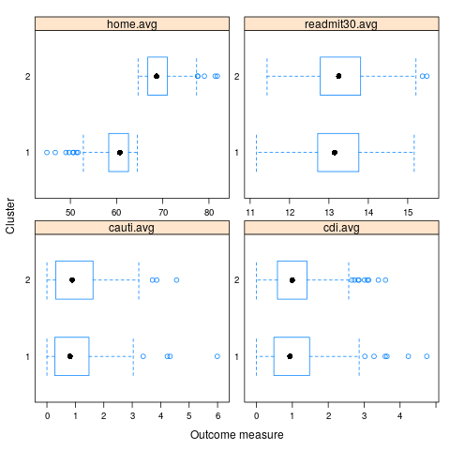
Table 4: Means, standard deviations, and two-sample t-tests comparing graded outcome measures between the two clusters identified by the k-means algorithm applied to the graded measures aggregated to the facility
 | Cluster 1  (n=178) | Cluster 2  (n=225) | t-statistic | p-value
CAUTI | 1.01 (0.99) | 1.00 (0.88) | -0.09 | 0.93
Readmission within 30 days | 13.19 (0.77) | 13.31 (0.75) | 1.64 | 0.10
CDI | 1.06 (0.80) | 1.08 (0.70) | 0.17 | 0.87
Successful return home | 59.85 (3.74) | 69.22 (3.16) | 26.72 | < 0.001

Facility characteristics as predictors of grades
Table 5: Odds ratios of having a “Better than national rating or benchmark grade” by facility characteristic.^{1,2}
 | Readmission within 30 days |  |  | CDI |  |  | Successful return home
 | Odds ratio | 95% CI | p-value | Odds ratio | 95% CI | p-value | Odds ratio | 95% CI | p-value
Number of patients discharged (/ 100) | 1.01 | (0.98, 1.04) | 0.44 | 1.16 | (1.08, 1.25) | < 0.001 | 1.09 | (1.04, 1.14) | < 0.001
Cost-to-charge ratio | 1.56 | (0.89, 2.75) | 0.12 | 7.10 | (2.13, 23.70) | 0.001 | 1.32 | (0.63, 2.78) | 0.46
Wage index | 4.24 | (2.36, 7.59) | < 0.001 | 0.47 | (0.14, 1.57) | 0.22 | 1.38 | (0.72, 2.63) | 0.33
Rural³ | 0.99 | (0.72, 1.35) | 0.94 | – | – | – | 0.65 | (0.45, 0.94) | 0.02
Disproportionate share | 1.12 | (0.51, 2.44) | 0.78 | 0.19 | (0.03, 1.46) | 0.11 | 0.15 | (0.06, 0.40) | < 0.001
Census region
New England | 1.00 |  |  | 1.00 |  |  | 1.00
Middle Atlantic | 0.51 | (0.27, 0.96) | 0.04 | 0.97 | (0.25, 3.76) | 0.97 | 1.71 | (0.72, 4.09) | 0.22
East North Central | 0.43 | (0.23, 0.81) | 0.008 | 1.38 | (0.37, 5.08) | 0.63 | 5.71 | (2.40, 13.60) | < 0.001
West North Central | 0.43 | (0.23, 0.79) | 0.006 | 0.62 | (0.15, 2.54) | 0.51 | 1.95 | (0.83, 4.57) | 0.13
South Atlantic | 0.31 | (0.15, 0.64) | 0.001 | 2.10 | (0.52, 8.41) | 0.29 | 6.27 | (2.43, 16.18) | < 0.001
East South Central | 0.50 | (0.26, 0.98) | 0.04 | 0.54 | (0.11, 2.70) | 0.45 | 1.74 | (0.70, 4.31) | 0.23
West South Central | 0.37 | (0.20, 0.67) | 0.001 | 1.47 | (0.40, 5.44) | 0.57 | 2.84 | (1.22, 6.60) | 0.02
Mountain | 0.66 | (0.34, 1.28) | 0.22 | 0.45 | (0.09, 2.16) | 0.32 | 3.00 | (1.20, 7.51) | 0.02
Pacific | 0.90 | (0.47, 1.73) | 0.76 | 0.66 | (0.15, 2.93) | 0.59 | 11.55 | (4.52, 29.55) | < 0.001
Ownership type
Government | 1.00 |  |  | 1.00 |  |  | 1.00
Non-profit | 1.36 | (0.98, 1.88) | 0.07 | 1.49 | (0.61, 3.60) | 0.38 | 0.95 | (0.63, 1.45) | 0.83
Profit | 0.84 | (0.58, 1.19) | 0.32 | 3.66 | (1.52, 8.81) | 0.004 | 2.35 | (1.52, 3.65) | < 0.001
Teaching facility | 1.15 | (0.82, 1.61) | 0.42 | 2.19 | (1.26, 3.82) | 0.006 | 0.35 | (0.22, 0.56) | < 0.001
Freestanding facility | 0.88 | (0.68, 1.14) | 0.32 | 6.32 | (3.98, 10.02) | < 0.001 | 2.15 | (1.62, 2.87) | < 0.001
Population severity (x 10) | 1.03 | (0.94, 1.12) | 0.54 | 1.39 | (1.16, 1.66) | < 0.001 | 1.58 | (1.36, 1.83) | < 0.001
Notes:
- All models are logistic regressions of the outcome with the characteristic as predictor. Generalized estimating equations (GEE) were used to estimate the models, assuming an exchangeable working correlation structure. Confidence intervals and p-values reflect robust SEs.
- CAUTI is not included in the table because it did not have enough better than national grades.
- Rural not reported for CDI because there were no rural facilities that had a better than national grade for CDI.

Change-over-time in relation to facility characteristics

Outcome measures
Table 6: Type III ANOVA significance tests of (1) facility characteristics and year in linear mixed effects models of pressure ulcers (v1), CAUTI, readmission within 30 days and CDI, and (2) facility characteristics in linear models of pressure ulcers (v2), rate of falls with injury, and successful return home.
 | Pressure ulcers (v1) | Pressure ulcers (v2) | CAUTI | Readmission within 30 days | Rate of falls with injury | CDI | Successful return home
Number of patients discharged
Main effect | F1,1010 = 3.13  p = 0.08 | F1,1052 = 0.05  p = 0.82 | F1,305 = 3.10  p = 0.08 | F1,1020 = 1.55  p = 0.21 | F1,1050 = 10.80  p = 0.001 | F1,722 = 12.08  p < 0.001 | F1,1059 = 15.78  p < 0.001
Year | F1,1010 = 45.88  p < 0.001 |  | F1,305 = 2.88  p = 0.09 | F1,1020 = 171.69  p < 0.001 |  | F1,722 = 131.02  p < 0.001
Year x Main effect | F1,1010 = 0.56  p = 0.46 |  | F1,305 = 2.54  p = 0.11 | F1,1020 = 0.07  p = 0.78 |  | F1,722 = 17.87  p < 0.001
Cost-to-charge ratio
Main effect | F1,1010 = 1.47  p = 0.23 | F1,1052 = 0.68  p = 0.41 | F1,305 = 4.35  p = 0.04 | F1,1020 = 7.76  p = 0.005 | F1,1050 = 1.00  p = 0.32 | F1,722 = 7.88  p = 0.005 | F1,1059 = 1.57  p = 0.21
Year | F1,1010 = 4.93  p = 0.03 |  | F1,305 = 6.98  p = 0.009 | F1,1020 = 33.02  p < 0.001 |  | F1,722 = 31.55  p < 0.001
Year x Main effect | F1,1010 = 0.76  p = 0.38 |  | F1,305 = 6.39  p = 0.01 | F1,1020 = 0.15  p = 0.69 |  | F1,722 = 3.92  p = 0.05
Wage index
Main effect | F1,1010 = 16.53  p < 0.001 | F1,1052 = 14.82  p < 0.001 | F1,305 = 0.00  p = 0.98 | F1,1020 = 23.49  p < 0.001 | F1,1050 = 11.89  p < 0.001 | F1,722 = 1.43  p = 0.23 | F1,1059 = 0.28  p = 0.59
Year | F1,1010 = 8.63  p = 0.003 |  | F1,305 = 0.00  p = 0.98 | F1,1020 = 2.84  p = 0.09 |  | F1,722 = 0.46  p = 0.50
Year x Main effect | F1,1010 = 1.78  p = 0.18 |  | F1,305 = 0.01  p = 0.92 | F1,1020 = 2.91  p = 0.09 |  | F1,722 = 2.81  p = 0.09
Urban/rural
Main effect | F1,1081 = 4.11  p = 0.04 | F1,1052 = 8.67  p = 0.003 | F1,424 = 0.51  p = 0.47 | F1,1104 = 0.25  p = 0.62 | F1,1050 = 3.14  p = 0.08 | F1,722 = 11.65  p < 0.001 | F1,1059 = 2.64  p = 0.10
Year | F1,1011 = 45.66  p < 0.001 |  | F1,306 = 2.44  p = 0.12 | F1,1021 = 135.59  p < 0.001 |  | F1,722 = 72.15  p < 0.001
Year x Main effect | F1,1011 = 1.01  p = 0.32 |  | F1,306 = 3.26  p = 0.07 | F1,1021 = 1.31  p = 0.25 |  | F1,722 = 8.06  p = 0.005
Disproportionate share
Main effect | F1,1010 = 13.92  p < 0.001 | F1,1052 = 1.81  p = 0.18 | F1,305 = 0.00  p = 0.99 | F1,1020 = 0.01  p = 0.94 | F1,1050 = 2.91  p = 0.09 | F1,722 = 3.36  p = 0.07 | F1,1059 = 20.24  p < 0.001
Year | F1,1010 = 57.91  p < 0.001 |  | F1,305 = 0.18  p = 0.67 | F1,1020 = 165.38  p < 0.001 |  | F1,722 = 36.87  p < 0.001
Year x Main effect | F1,1010 = 5.72  p = 0.02 |  | F1,305 = 0.00  p = 0.95 | F1,1020 = 1.13  p = 0.29 |  | F1,722 = 8.04  p = 0.005
Census region
Main effect | F8,1074 = 3.83  p < 0.001 | F8,1045 = 1.90  p = 0.06 | F8,417 = 2.14  p = 0.03 | F8,1097 = 5.73  p < 0.001 | F8,1043 = 2.36  p = 0.02 | F8,900 = 2.42  p = 0.01 | F8,1052 = 17.45  p < 0.001
Year | F1,1004 = 53.61  p < 0.001 |  | F1,299 = 1.48  p = 0.22 | F1,1014 = 292.03  p < 0.001 |  | F1,716 = 116.32  p < 0.001
Year x Main effect | F8,1004 = 1.14  p = 0.33 |  | F8,299 = 1.30  p = 0.24 | F8,1014 = 1.84  p = 0.07 |  | F8,716 = 1.95  p = 0.05
Ownership type
Main effect | F2,1008 = 0.61  p = 0.54 | F2,1051 = 0.43  p = 0.65 | F2,303 = 1.72  p = 0.18 | F2,1018 = 12.08  p < 0.001 | F2,1049 = 5.43  p = 0.004 | F2,720 = 4.82  p = 0.008 | F2,1058 = 18.71  p < 0.001
Year | F1,1008 = 36.62  p < 0.001 |  | F1,303 = 0.04  p = 0.85 | F1,1018 = 222.35  p < 0.001 |  | F1,720 = 111.13  p < 0.001
Year x Main effect | F2,1008 = 1.87  p = 0.16 |  | F2,303 = 0.98  p = 0.38 | F2,1018 = 0.76  p = 0.47 |  | F2,720 = 7.07  p < 0.001
Teaching facility
Main effect | F1,1010 = 0.88  p = 0.35 | F1,1052 = 0.06  p = 0.81 | F1,305 = 5.93  p = 0.02 | F1,1020 = 4.26  p = 0.04 | F1,1050 = 2.23  p = 0.14 | F1,722 = 2.50  p = 0.11 | F1,1059 = 31.30  p < 0.001
Year | F1,1010 = 19.09  p < 0.001 |  | F1,305 = 0.06  p = 0.81 | F1,1020 = 113.00  p < 0.001 |  | F1,722 = 63.89  p < 0.001
Year x Main effect | F1,1010 = 0.74  p = 0.39 |  | F1,305 = 1.09  p = 0.30 | F1,1020 = 0.04  p = 0.83 |  | F1,722 = 0.01  p = 0.93
Freestanding facility
Main effect | F1,1081 = 7.89  p = 0.005 | F1,1052 = 0.23  p = 0.63 | F1,424 = 1.85  p = 0.17 | F1,1104 = 3.11  p = 0.08 | F1,1050 = 15.30  p < 0.001 | F1,907 = 62.92  p < 0.001 | F1,1059 = 11.73  p < 0.001
Year | F1,1011 = 46.32  p < 0.001 |  | F1,306 = 0.28  p = 0.60 | F1,1021 = 209.69  p < 0.001 |  | F1,723 = 96.22  p < 0.001
Year x Main effect | F1,1011 = 1.88  p = 0.17 |  | F1,306 = 2.41  p = 0.12 | F1,1021 = 0.28  p = 0.60 |  | F1,723 = 41.88  p < 0.001
Population severity
Main effect | F1,1010 = 2.30  p = 0.13 | F1,1052 = 0.84  p = 0.36 | F1,305 = 0.12  p = 0.73 | F1,1020 = 0.01  p = 0.93 | F1,1050 = 0.69  p = 0.41 | F1,722 = 0.06  p = 0.80 | F1,1059 = 97.62  p < 0.001
Year | F1,1010 = 1.68  p = 0.19 |  | F1,305 = 0.00  p = 0.99 | F1,1020 = 14.90  p < 0.001 |  | F1,722 = 1.62  p = 0.20
Year x Main effect | F1,1010 = 4.39  p = 0.04 |  | F1,305 = 0.01  p = 0.94 | F1,1020 = 5.08  p = 0.02 |  | F1,722 = 0.05  p = 0.83

Process measures
Table 7: Type III ANOVA significance tests of facility characteristics in linear models of process measures.
 | Patient flu vaccination | Functional assessment | Healthcare provider flu vaccination | MSPB
Number of patients discharged | F1,1044 = 10.89  p = 0.001 | F1,1050 = 1.48  p = 0.22 | F1,1051 = 2.35  p = 0.13 | F1,1059 = 23.76  p < 0.001
Cost-to-charge ratio | F1,1044 = 0.68  p = 0.41 | F1,1050 = 0.00  p = 0.95 | F1,1051 = 4.14  p = 0.04 | F1,1059 = 3.11  p = 0.08
Wage index | F1,1044 = 1.11  p = 0.29 | F1,1050 = 1.72  p = 0.19 | F1,1051 = 3.70  p = 0.05 | F1,1059 = 0.07  p = 0.79
Urban/rural | F1,1044 = 0.82  p = 0.37 | F1,1050 = 3.13  p = 0.08 | F1,1051 = 1.08  p = 0.30 | F1,1059 = 0.45  p = 0.50
Disproportionate share | F1,1044 = 7.17  p = 0.008 | F1,1050 = 7.51  p = 0.006 | F1,1051 = 1.91  p = 0.17 | F1,1059 = 3.79  p = 0.05
Census region | F8,1037 = 2.20  p = 0.03 | F8,1043 = 1.51  p = 0.15 | F8,1044 = 4.49  p < 0.001 | F8,1052 = 11.98  p < 0.001
Ownership type | F2,1043 = 10.53  p < 0.001 | F2,1049 = 3.69  p = 0.03 | F2,1050 = 15.38  p < 0.001 | F2,1058 = 25.71  p < 0.001
Teaching facility | F1,1044 = 1.44  p = 0.23 | F1,1050 = 0.18  p = 0.67 | F1,1051 = 3.75  p = 0.05 | F1,1059 = 1.24  p = 0.27
Freestanding facility | F1,1044 = 41.70  p < 0.001 | F1,1050 = 0.86  p = 0.35 | F1,1051 = 8.62  p = 0.003 | F1,1059 = 42.51  p < 0.001
Population severity | F1,1044 = 0.03  p = 0.86 | F1,1050 = 0.67  p = 0.41 | F1,1051 = 2.38  p = 0.12 | F1,1059 = 239.48  p < 0.001

Simple effects
Table 8: Comparison of means from mixed effects models of outcome measures. First and third quartiles were used in the comparison of continuous facility characteristics. P-values were computed using Wald tests of the relevant contrasts, with a Bonferroni correction for multiple comparisons.
Characteristic | Year | Pressure ulcers (v1) | CAUTI | Readmission within 30 days | CDI
Number of patients discharged (/100)
1.35 | 2016 | 0.83 (0.03)a |  | 13.06 (0.03)a
1.35 | 2017 | 0.60 (0.03)b | 0.94 (0.06)a | 13.39 (0.03)b | 1.38 (0.04)a
1.35 | 2018 |  | 1.04 (0.07)a |  | 0.82 (0.04)b
4.61 | 2016 | 0.79 (0.03)a |  | 13.08 (0.02)a
4.61 | 2017 | 0.57 (0.03)b | 1.05 (0.06)a | 13.41 (0.02)b | 1.26 (0.04)a
4.61 | 2018 |  | 1.05 (0.06)a |  | 0.86 (0.03)c
Cost-to-charge ratio
0.35 | 2016 | 0.82 (0.03)a |  | 13.12 (0.03)a
0.35 | 2017 | 0.61 (0.03)b | 0.93 (0.06)a | 13.44 (0.03)c | 1.37 (0.04)a
0.35 | 2018 |  | 1.07 (0.06)a |  | 0.86 (0.04)b
0.55 | 2016 | 0.79 (0.03)a |  | 13.05 (0.02)b
0.55 | 2017 | 0.55 (0.03)b | 1.07 (0.06)a | 13.38 (0.03)c | 1.24 (0.04)a
0.55 | 2018 |  | 1.01 (0.06)a |  | 0.83 (0.04)c
Wage index
0.84 | 2016 | 0.87 (0.03)a |  | 13.14 (0.03)a
0.84 | 2017 | 0.63 (0.03)c | 1.00 (0.06)a | 13.45 (0.03)c | 1.27 (0.04)a
0.84 | 2018 |  | 1.04 (0.06)a |  | 0.85 (0.04)b
1.02 | 2016 | 0.76 (0.03)b |  | 13.04 (0.02)b
1.02 | 2017 | 0.55 (0.03)d | 1.00 (0.05)a | 13.38 (0.02)d | 1.31 (0.04)a
1.02 | 2018 |  | 1.04 (0.06)a |  | 0.84 (0.03)b
Urban/rural
Urban | 2016 | 0.78 (0.03)a |  | 13.08 (0.02)a
Urban | 2017 | 0.57 (0.03)bc | 1.00 (0.05)a | 13.42 (0.02)b | 1.27 (0.03)a
Urban | 2018 |  | 1.05 (0.05)a |  | 0.84 (0.03)b
Rural | 2016 | 0.94 (0.07)ab |  | 13.05 (0.06)a
Rural | 2017 | 0.65 (0.07)c | 1.29 (0.41)a | 13.32 (0.06)b | 1.76 (0.14)a
Rural | 2018 |  | 0.56 (0.41)a |  | 0.90 (0.11)c
Disproportionate share
0.06 | 2016 | 0.86 (0.03)a |  | 13.07 (0.03)a
0.06 | 2017 | 0.60 (0.03)b | 1.00 (0.06)a | 13.42 (0.03)b | 1.26 (0.04)a
0.06 | 2018 |  | 1.04 (0.06)a |  | 0.87 (0.04)b
0.18 | 2016 | 0.77 (0.03)a |  | 13.07 (0.02)a
0.18 | 2017 | 0.57 (0.03)c | 1.00 (0.06)a | 13.40 (0.02)b | 1.32 (0.04)a
0.18 | 2018 |  | 1.04 (0.06)a |  | 0.83 (0.03)b
Census region
New England | 2016 | 0.73 (0.14)abe |  | 12.61 (0.13)bdefhi
New England | 2017 | 0.59 (0.14)ce | 0.92 (0.30)a | 13.13 (0.13)k | 1.18 (0.18)adef
New England | 2018 |  | 1.39 (0.31)a |  | 0.90 (0.17)g
Middle Atlantic | 2016 | 0.91 (0.07)a |  | 12.99 (0.06)af
Middle Atlantic | 2017 | 0.64 (0.07)ac | 1.36 (0.14)a | 13.30 (0.06)cgik | 1.18 (0.09)ade
Middle Atlantic | 2018 |  | 1.16 (0.14)a |  | 0.86 (0.09)eg
East North Central | 2016 | 0.91 (0.07)ab |  | 13.20 (0.06)a
East North Central | 2017 | 0.71 (0.07)ac | 0.97 (0.11)a | 13.44 (0.06)defgj | 1.22 (0.08)a
East North Central | 2018 |  | 1.06 (0.11)a |  | 0.84 (0.08)adeg
West North Central | 2016 | 0.77 (0.06)ac |  | 13.11 (0.05)bdefg
West North Central | 2017 | 0.55 (0.06)ac | 1.19 (0.13)a | 13.47 (0.05)ik | 1.41 (0.08)ade
West North Central | 2018 |  | 1.12 (0.14)a |  | 0.78 (0.08)cdeg
South Atlantic | 2016 | 0.77 (0.10)ab |  | 13.19 (0.08)ab
South Atlantic | 2017 | 0.60 (0.10)ac | 0.91 (0.19)a | 13.69 (0.09)defi | 1.18 (0.13)ab
South Atlantic | 2018 |  | 0.87 (0.20)a |  | 0.84 (0.13)bcdeg
East South Central | 2016 | 0.78 (0.09)ac |  | 13.01 (0.08)bdefhi
East South Central | 2017 | 0.50 (0.09)cd | 1.17 (0.21)a | 13.34 (0.08)ijk | 1.31 (0.12)adef
East South Central | 2018 |  | 1.39 (0.22)a |  | 0.98 (0.11)dg
West South Central | 2016 | 0.92 (0.06)abd |  | 13.23 (0.05)defi
West South Central | 2017 | 0.64 (0.06)cde | 0.80 (0.12)a | 13.53 (0.05)hk | 1.20 (0.08)adef
West South Central | 2018 |  | 0.91 (0.12)a |  | 0.83 (0.07)fg
Mountain | 2016 | 0.72 (0.09)ab |  | 12.95 (0.08)ae
Mountain | 2017 | 0.41 (0.10)bc | 1.02 (0.16)a | 13.32 (0.08)efk | 1.72 (0.12)ad
Mountain | 2018 |  | 0.81 (0.18)a |  | 1.05 (0.12)def
Pacific | 2016 | 0.43 (0.08)ab |  | 12.85 (0.07)acd
Pacific | 2017 | 0.40 (0.08)ac | 0.62 (0.17)a | 13.16 (0.07)dfhi | 1.33 (0.11)ac
Pacific | 2018 |  | 0.96 (0.18)a |  | 0.67 (0.10)adeg
Ownership type
Government | 2016 | 0.75 (0.07)a |  | 13.08 (0.06)ab
Government | 2017 | 0.66 (0.08)b | 1.25 (0.16)a | 13.44 (0.06)cd | 1.46 (0.10)a
Government | 2018 |  | 1.08 (0.18)a |  | 0.82 (0.10)b
Non-profit | 2016 | 0.79 (0.03)a |  | 12.99 (0.03)a
Non-profit | 2017 | 0.55 (0.03)ab | 1.00 (0.07)a | 13.33 (0.03)c | 1.35 (0.05)a
Non-profit | 2018 |  | 1.11 (0.08)a |  | 0.82 (0.04)b
Profit | 2016 | 0.84 (0.05)ab |  | 13.23 (0.04)bc
Profit | 2017 | 0.61 (0.04)b | 0.93 (0.08)a | 13.52 (0.04)d | 1.16 (0.06)a
Profit | 2018 |  | 0.96 (0.08)a |  | 0.89 (0.05)b
Teaching facility
Non-teaching | 2016 | 0.81 (0.03)a |  | 13.09 (0.02)a
Non-teaching | 2017 | 0.58 (0.03)ab | 0.95 (0.05)a | 13.42 (0.02)b | 1.31 (0.04)a
Non-teaching | 2018 |  | 1.01 (0.06)a |  | 0.86 (0.03)b
Teaching | 2016 | 0.73 (0.08)a |  | 12.94 (0.07)a
Teaching | 2017 | 0.57 (0.08)b | 1.30 (0.13)a | 13.28 (0.07)b | 1.15 (0.10)a
Teaching | 2018 |  | 1.20 (0.13)a |  | 0.70 (0.09)b
Freestanding facility
In hospital | 2016 | 0.84 (0.03)a |  | 13.05 (0.03)a
In hospital | 2017 | 0.60 (0.03)b | 0.94 (0.07)a | 13.39 (0.03)b | 1.48 (0.04)a
In hospital | 2018 |  | 1.06 (0.07)a |  | 0.86 (0.04)a
Freestanding | 2016 | 0.67 (0.05)ab |  | 13.15 (0.05)a
Freestanding | 2017 | 0.51 (0.05)c | 1.08 (0.08)a | 13.46 (0.05)b | 0.91 (0.06)a
Freestanding | 2018 |  | 1.03 (0.08)a |  | 0.78 (0.06)b
Population severity
11.2 | 2016 | 0.78 (0.03)a |  | 13.07 (0.03)a
11.2 | 2017 | 0.59 (0.03)b | 1.01 (0.06)a | 13.43 (0.03)b | 1.29 (0.04)a
11.2 | 2018 |  | 1.05 (0.07)a |  | 0.83 (0.04)b
12.6 | 2016 | 0.83 (0.03)a |  | 13.08 (0.03)a
12.6 | 2017 | 0.57 (0.03)b | 0.99 (0.06)a | 13.38 (0.03)b | 1.30 (0.04)a
12.6 | 2018 |  | 1.04 (0.06)a |  | 0.85 (0.04)b

Profile plots

bedsores.v1

n.discharge
Expected value of bedsores.v1 as a function of year by n.discharge (p = 0.21)
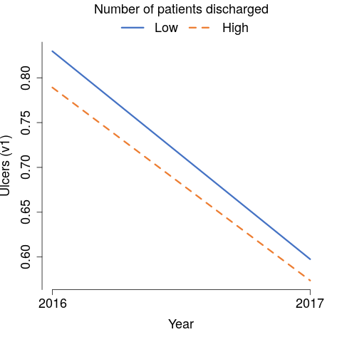

cost.charge.ratio
Expected value of bedsores.v1 as a function of year by cost.charge.ratio (p = 0.14)
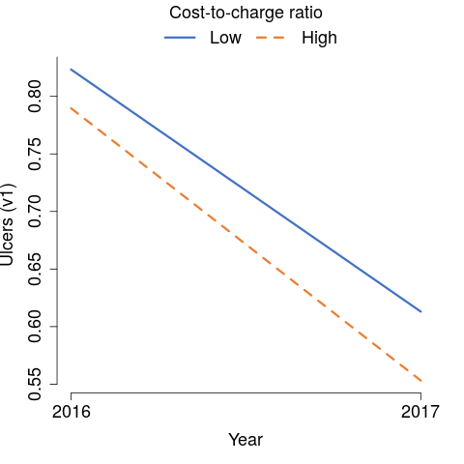

wage.index
Expected value of bedsores.v1 as a function of year by wage.index (p < 0.001)
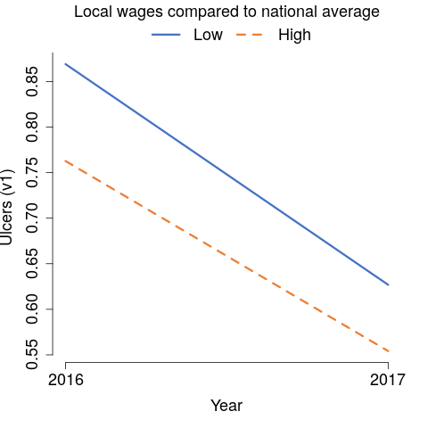

rural
Expected value of bedsores.v1 as a function of year by rural (p = 0.13)
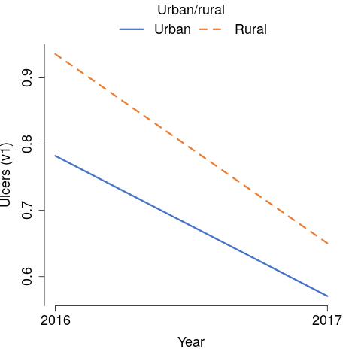

dsh
Expected value of bedsores.v1 as a function of year by dsh (p < 0.001)
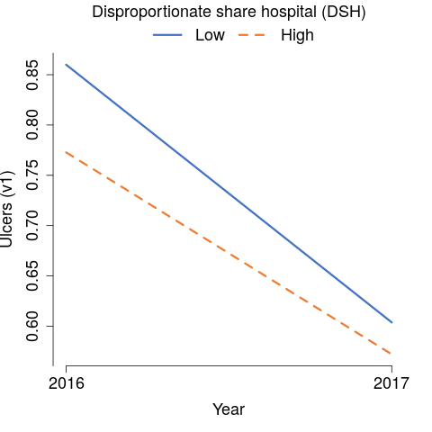

census
Expected value of bedsores.v1 as a function of year by census (p = 0.003)
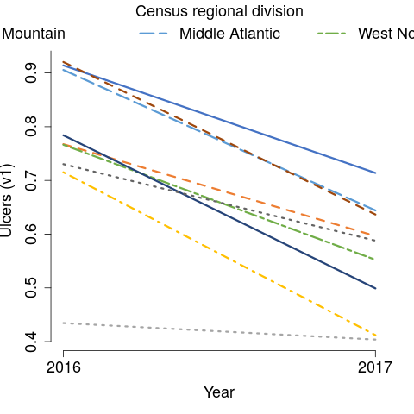

ownership
Expected value of bedsores.v1 as a function of year by ownership (p = 0.29)
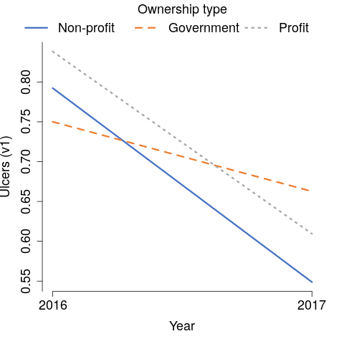

teaching.yn
Expected value of bedsores.v1 as a function of year by teaching.yn (p = 0.59)
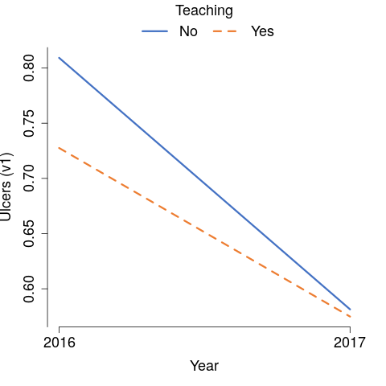

freestanding
Expected value of bedsores.v1 as a function of year by freestanding (p = 0.02)
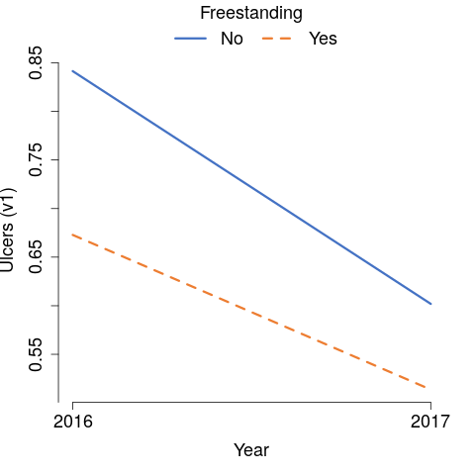

population.severity
Expected value of bedsores.v1 as a function of year by population.severity (p = 0.10)
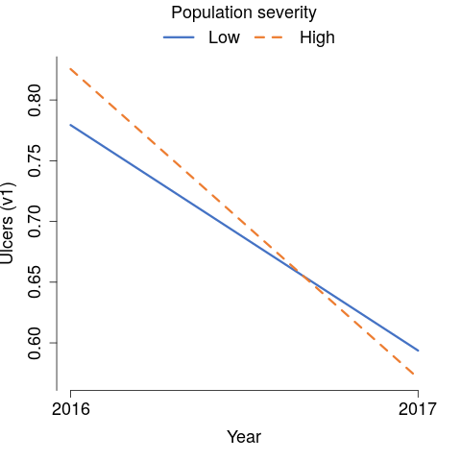

cauti

n.discharge
Expected value of cauti as a function of year by n.discharge (p = 0.15)
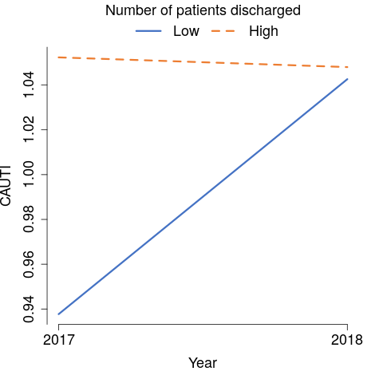

cost.charge.ratio
Expected value of cauti as a function of year by cost.charge.ratio (p = 0.03)
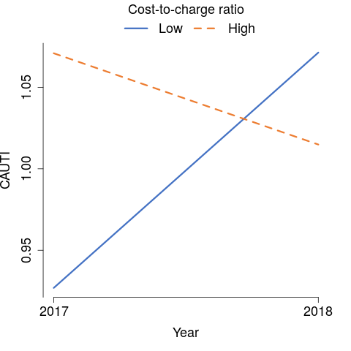

wage.index
Expected value of cauti as a function of year by wage.index (p = 0.99)
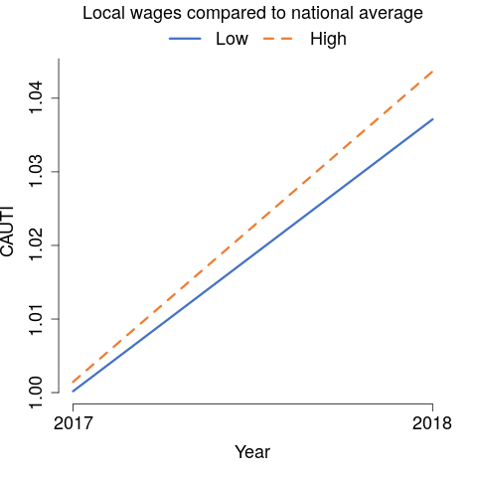

rural
Expected value of cauti as a function of year by rural (p = 0.19)
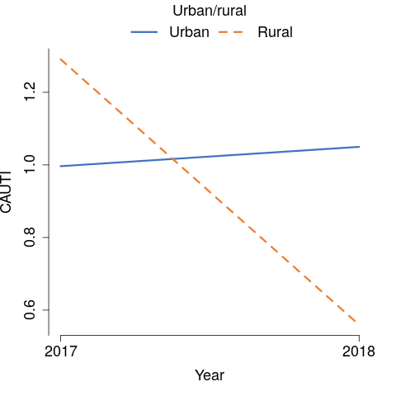

dsh
Expected value of cauti as a function of year by dsh (p = 1.00)
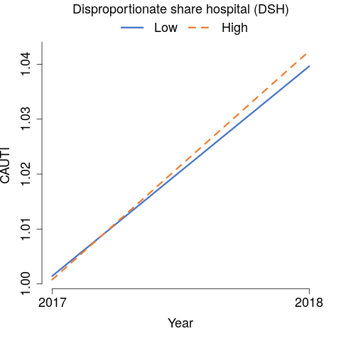

census
Expected value of cauti as a function of year by census (p = 0.08)
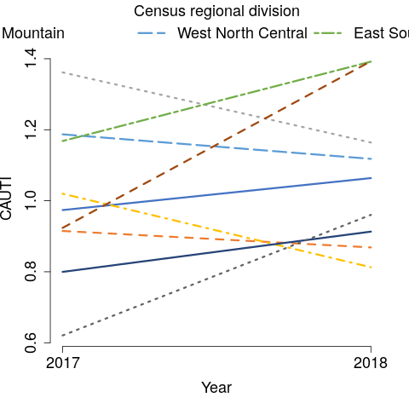

ownership
Expected value of cauti as a function of year by ownership (p = 0.27)
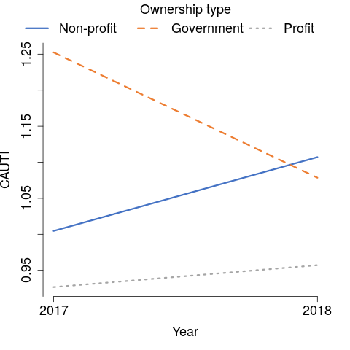

teaching.yn
Expected value of cauti as a function of year by teaching.yn (p = 0.05)
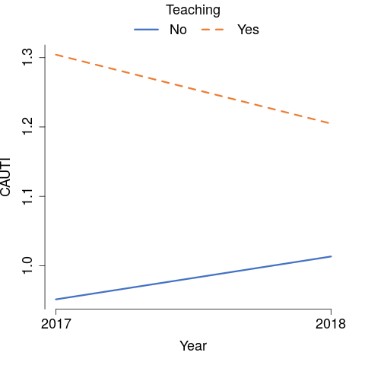

freestanding
Expected value of cauti as a function of year by freestanding (p = 0.24)
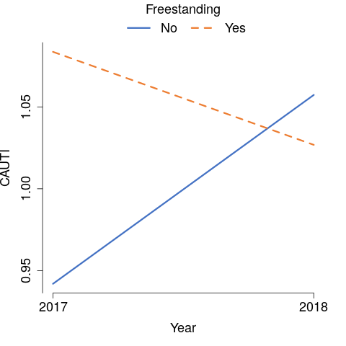

population.severity
Expected value of cauti as a function of year by population.severity (p = 0.94)
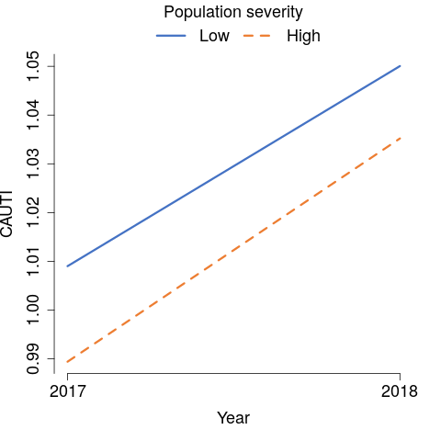

readmit30

n.discharge
Expected value of readmit30 as a function of year by n.discharge (p = 0.45)
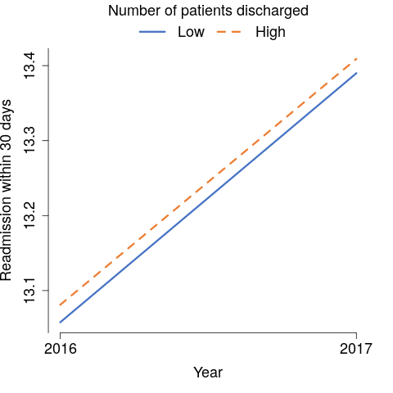

cost.charge.ratio
Expected value of readmit30 as a function of year by cost.charge.ratio (p = 0.02)
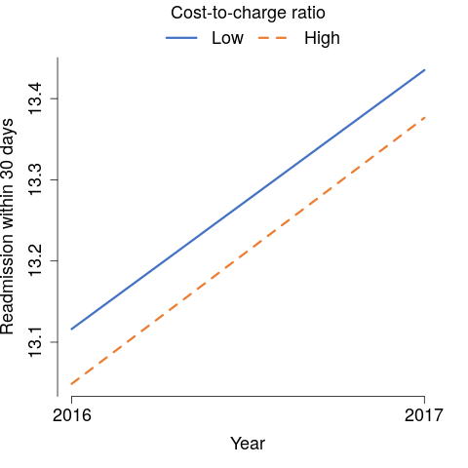

wage.index
Expected value of readmit30 as a function of year by wage.index (p < 0.001)
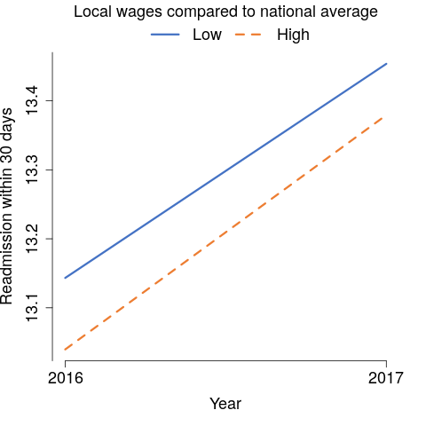

rural
Expected value of readmit30 as a function of year by rural (p = 0.30)
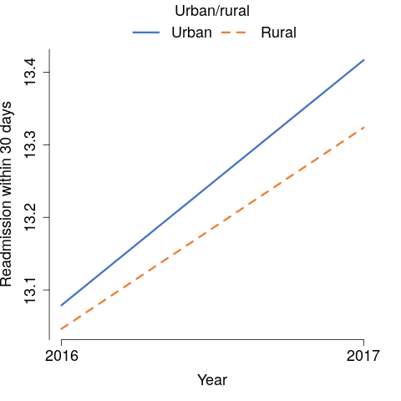

dsh
Expected value of readmit30 as a function of year by dsh (p = 0.51)
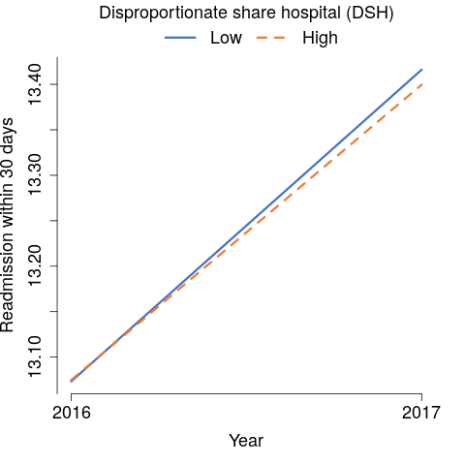

census
Expected value of readmit30 as a function of year by census (p < 0.001)
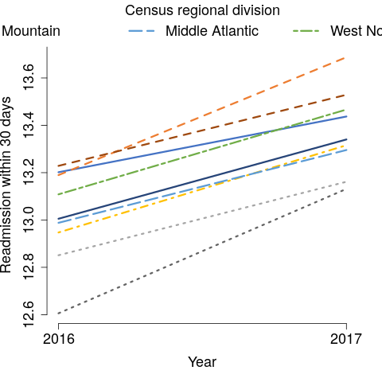

ownership
Expected value of readmit30 as a function of year by ownership (p < 0.001)
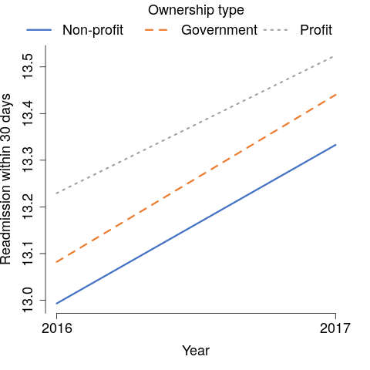

teaching.yn
Expected value of readmit30 as a function of year by teaching.yn (p = 0.08)
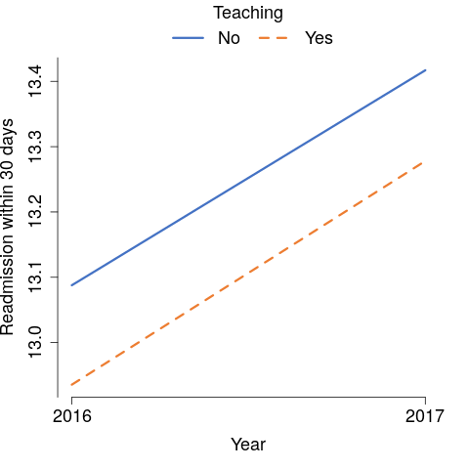

freestanding
Expected value of readmit30 as a function of year by freestanding (p = 0.21)
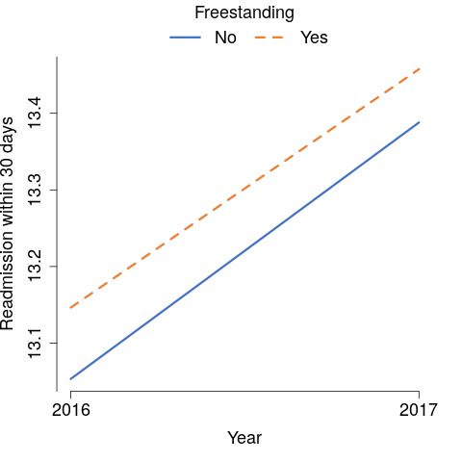

population.severity
Expected value of readmit30 as a function of year by population.severity (p = 0.05)
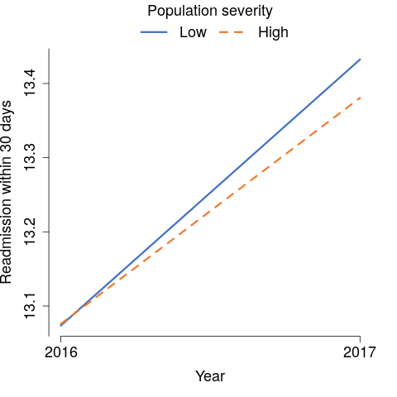

cdi

n.discharge
Expected value of cdi as a function of year by n.discharge (p < 0.001)
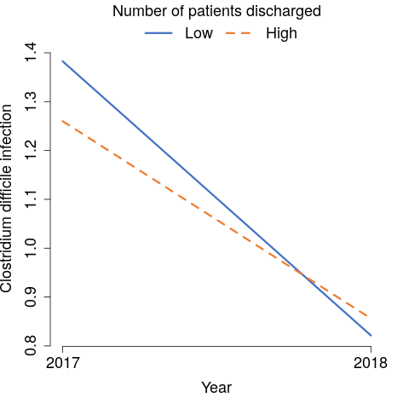

cost.charge.ratio
Expected value of cdi as a function of year by cost.charge.ratio (p = 0.02)
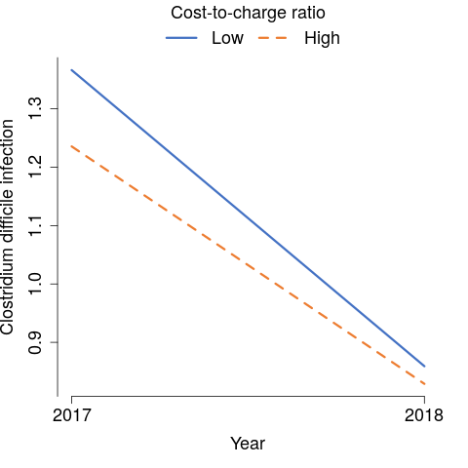

wage.index
Expected value of cdi as a function of year by wage.index (p = 0.24)
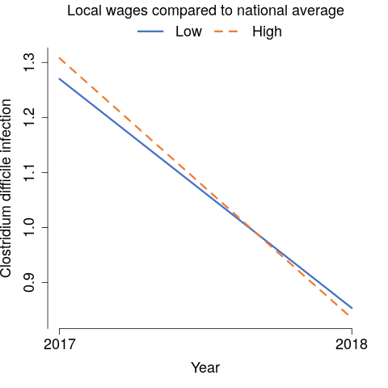

rural
Expected value of cdi as a function of year by rural (p = 0.002)
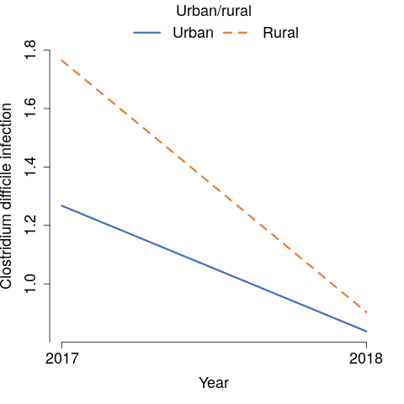

dsh
Expected value of cdi as a function of year by dsh (p = 0.02)
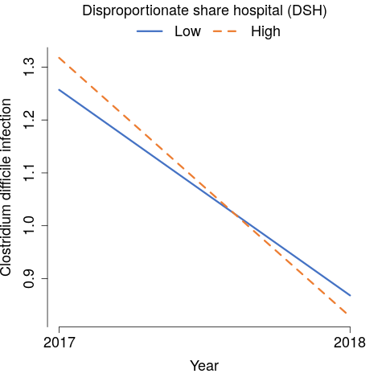

census
Expected value of cdi as a function of year by census (p = 0.03)
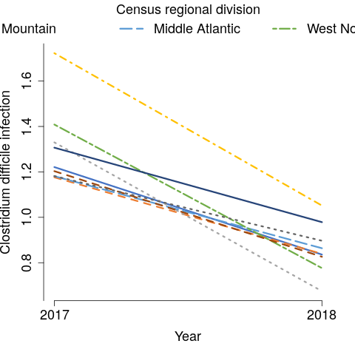

ownership
Expected value of cdi as a function of year by ownership (p = 0.004)
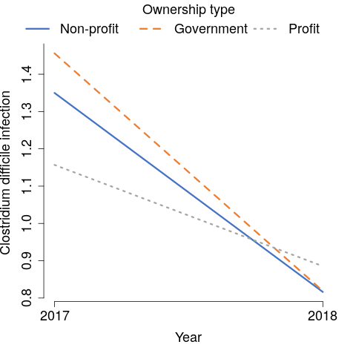

teaching.yn
Expected value of cdi as a function of year by teaching.yn (p = 0.17)
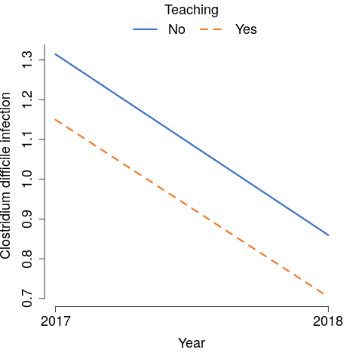

freestanding
Expected value of cdi as a function of year by freestanding (p < 0.001)
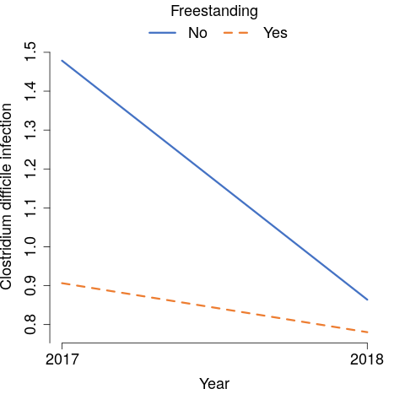

population.severity
Expected value of cdi as a function of year by population.severity (p = 0.86)
